The Only Team

cst-247 Shad Sluiter  6/30/21

Milestone 1

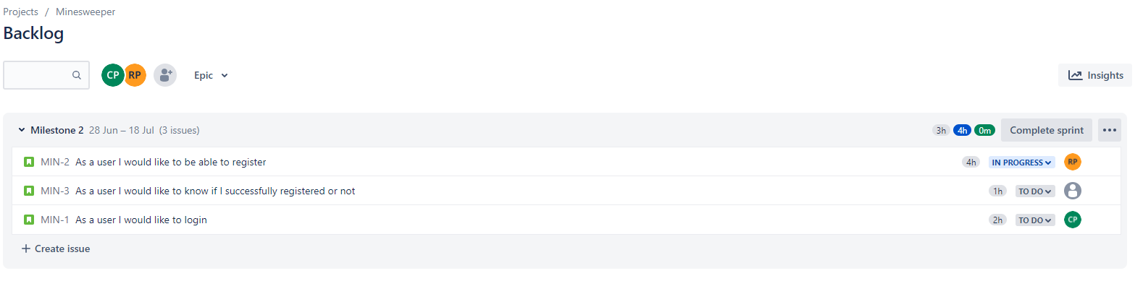

Jira Product backlog. Not very large as these are only the first user stories for the CLC project.

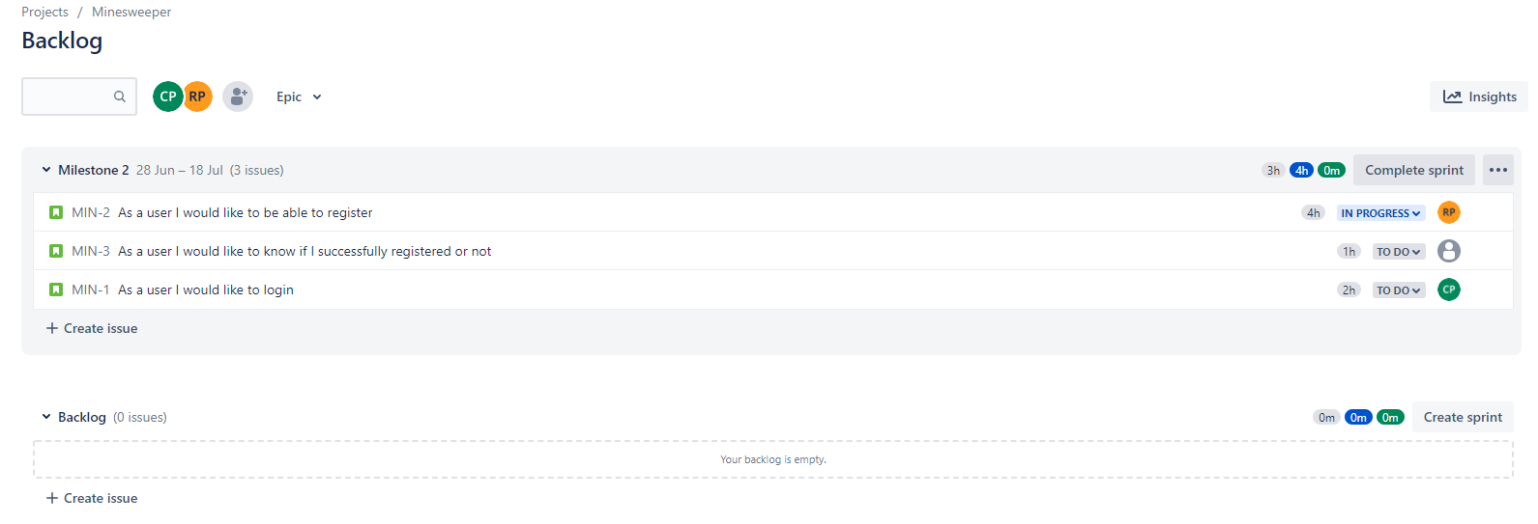

Jira Sprint backlog, using the previously shown user stories from our product backlog.

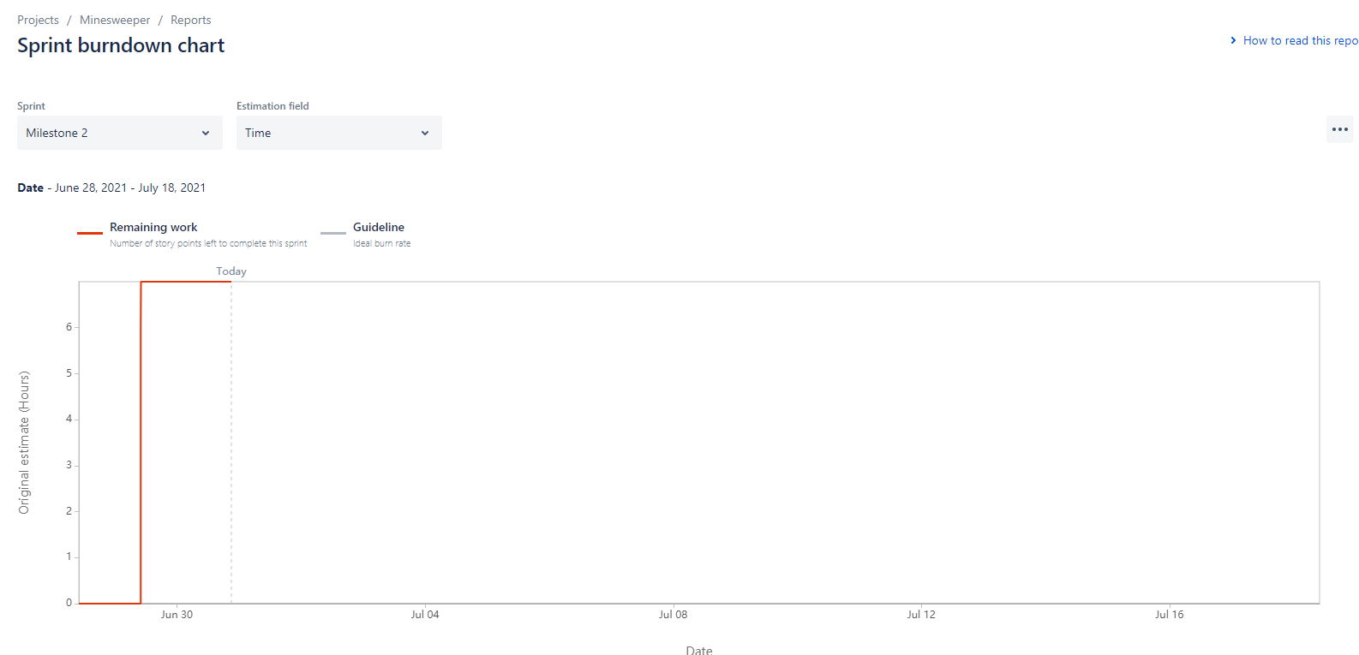

Jira Burndown chart. This is showing that we believe that for sprint 2, there are 7 expected hours of work, and there hasn’t been any done for milestone 2 yet. Therefore the bar’s at the top showing we still have 7 hours more to go for the sprint.