Carson Perry

Cst-247 Shad Sluiter  07/25/21

Activity 5

# Testing:

## Step 2:

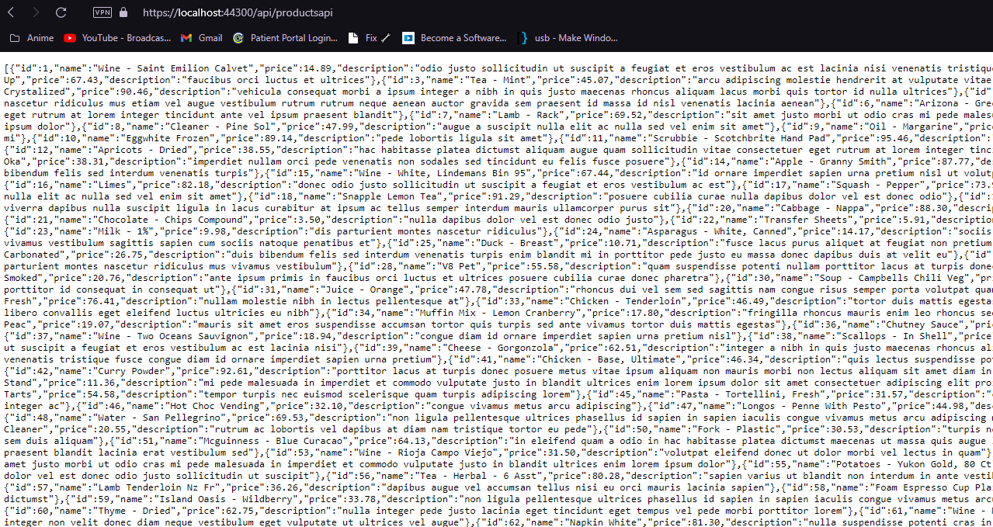

This is showing our API returning all products in a JSON format.

## Step 4:

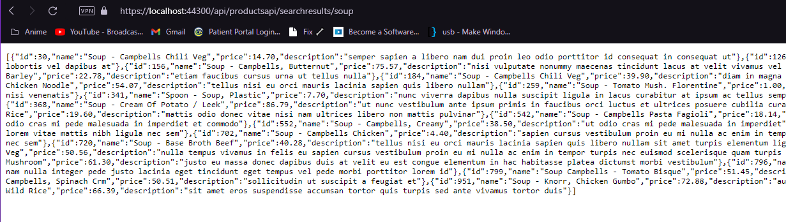

This is showing our API returning all products with “soup” in a JSON format.

## Step 6:

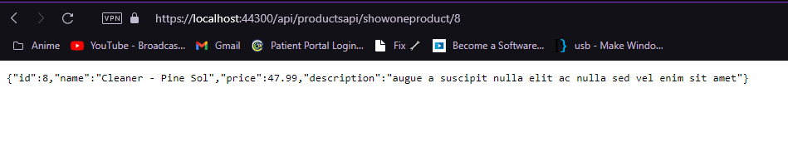

This is showing our API returning only the product with an ID of 8 in a JSON format.

# Postman:

## Step 3:

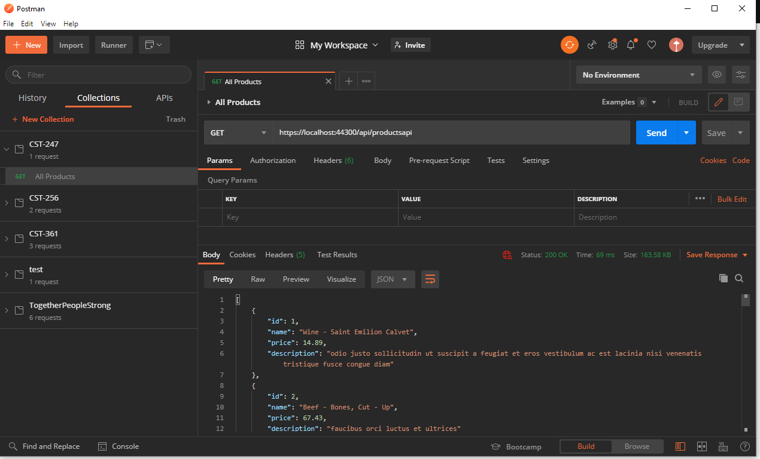

This is showing our api sending JSON to Postman (also in pretty print because Postman supports it).

## Step 4:

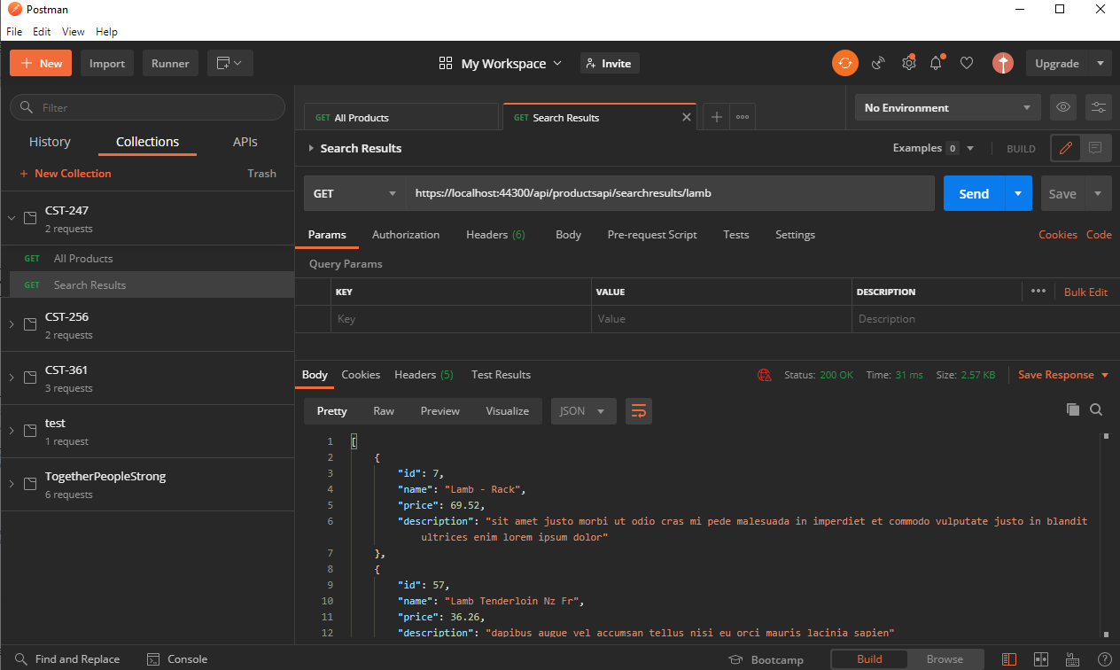

This is showing our api sending JSON to Postman searching for lamb.

## Step 5:

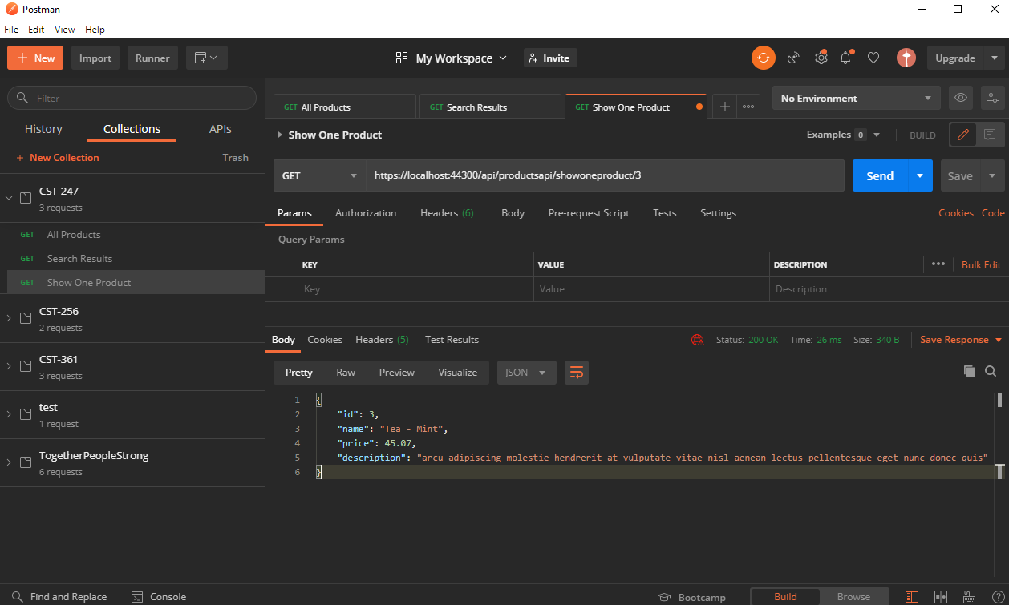

This is showing postman receiving JSON for a single product with the id of 3.

## Step 6:

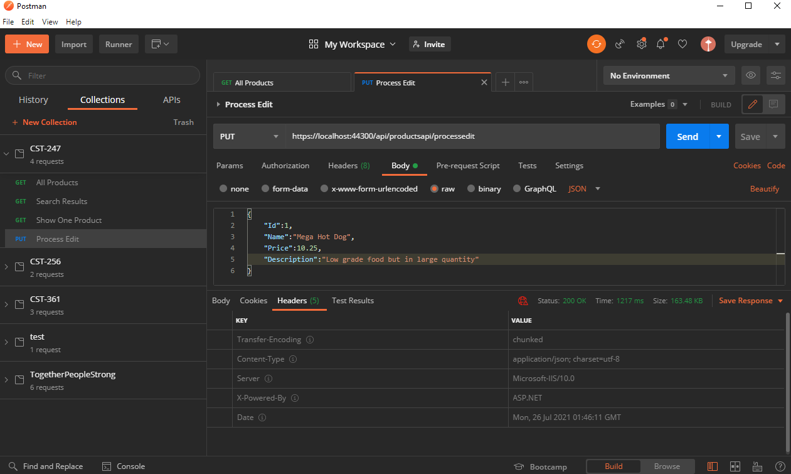

This is showing a Put request successfully being handled by our API.

## Summary:

This section covered how to implement a simple Rest API and accessing it through your browser as well as through postman.

# 5b:

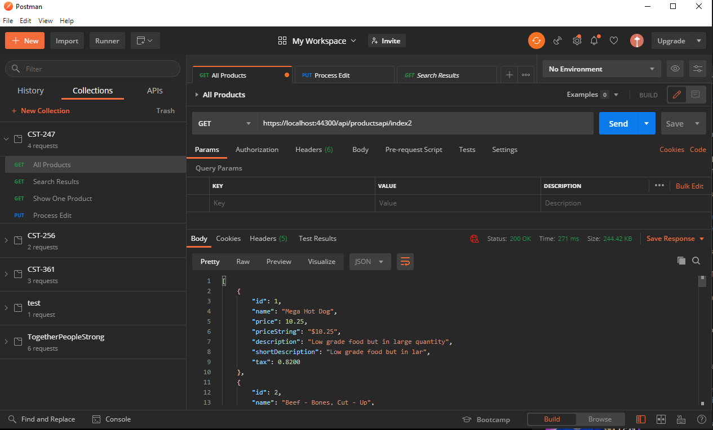

This is showing all products in the form of the DTO

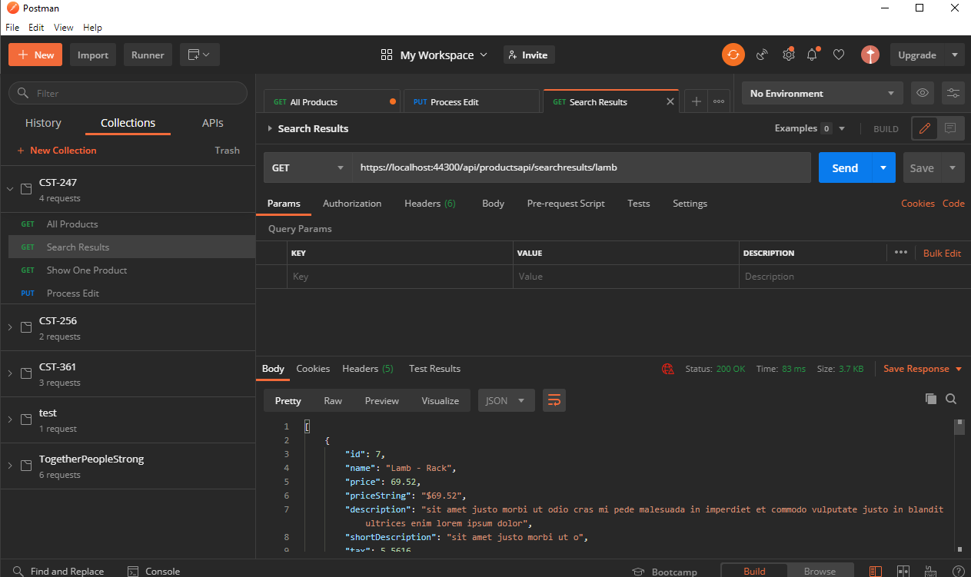

This is showing the SearchResults method of using the DTO model

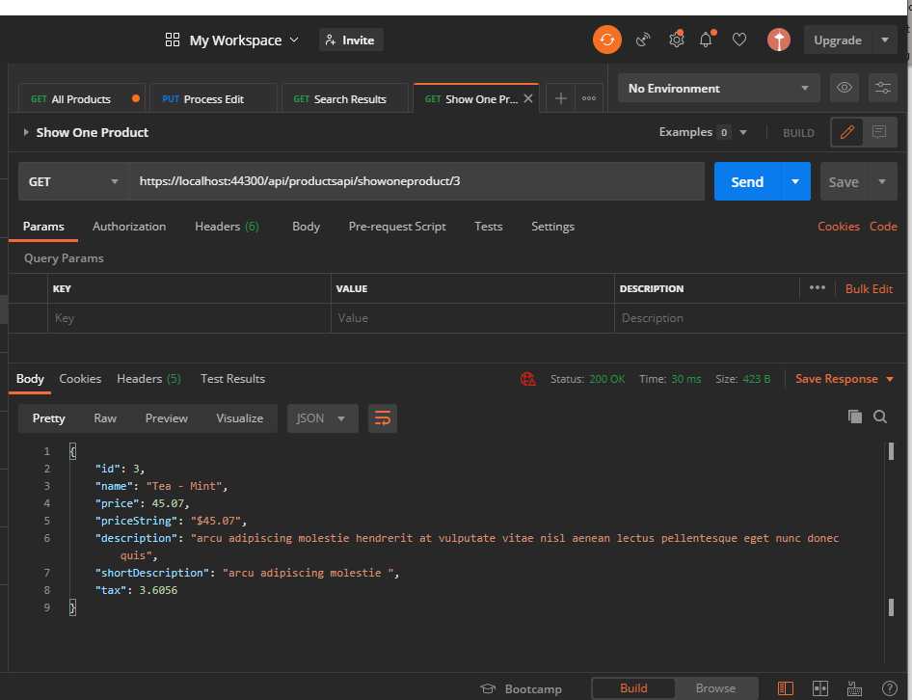

This is showing the Show One Product method using the DTO model

# Summary:

This section was all about incorporating a Data Transfer Object, a model who’s sole purpose is to format data and prepare it to be delivered to the user.

# ButtonGrid:

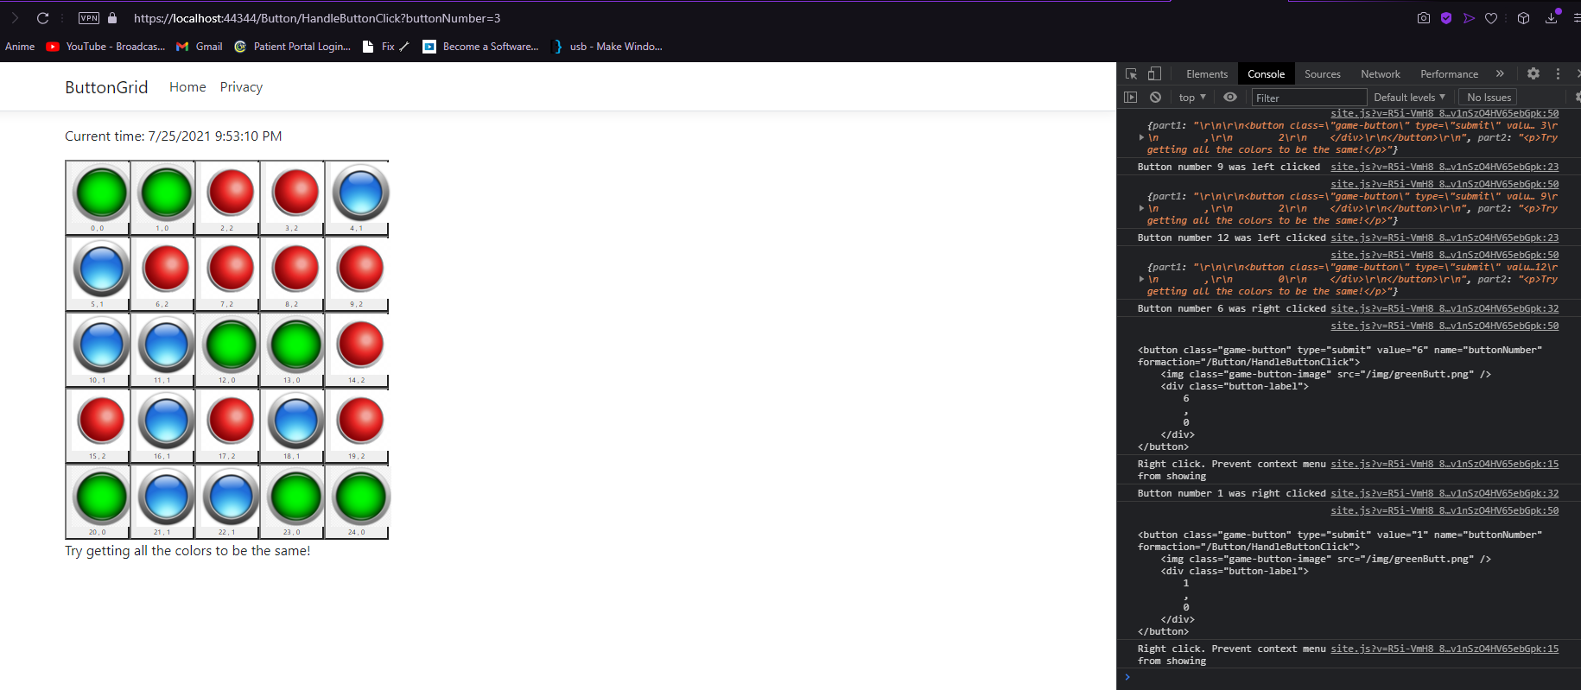

## Summary:

As there’s only one screenshot, I’ll encompass that with the Summary. This section was over-writing the default action for mouseclicks to instead run some Javascript to perform partialpage refreshes with our buttons controller. I actually had to look up how to open the console in my browser without right clicking so I could grab that information