Carson Perry

Cst-247 Shad Sluiter  07/17/21

Activity 4

# Part 2:

## Step 9:

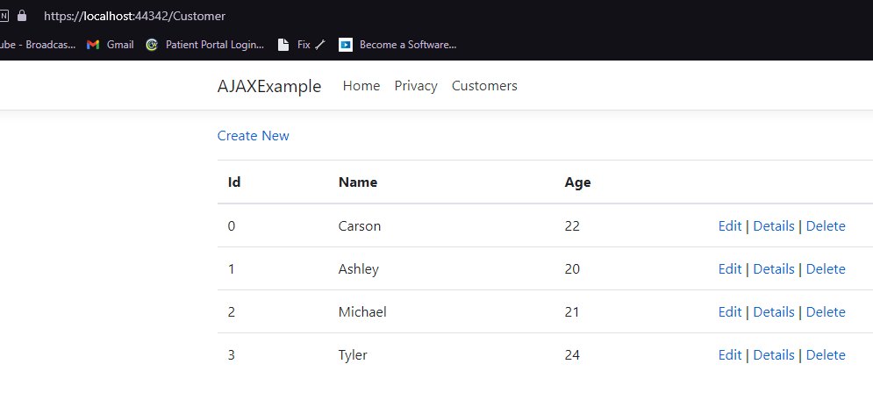

This is demonstrating a simple list of objects rendered to a page.

## Step 12:

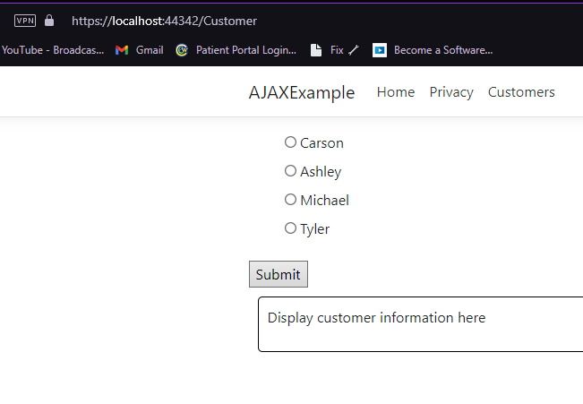

I have demonstrated rendering a list of objects in the form of a radio button form.

## Step 16:

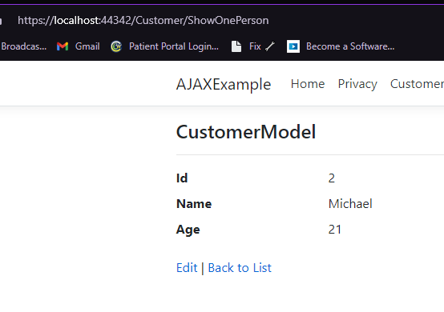

I have demonstrated sending and ID from the earlier form, to the controller through the submit button, then using that ID to render that specific object’s details in a separate page.

# AJAX for Partial Page Updates:

## Step 7:

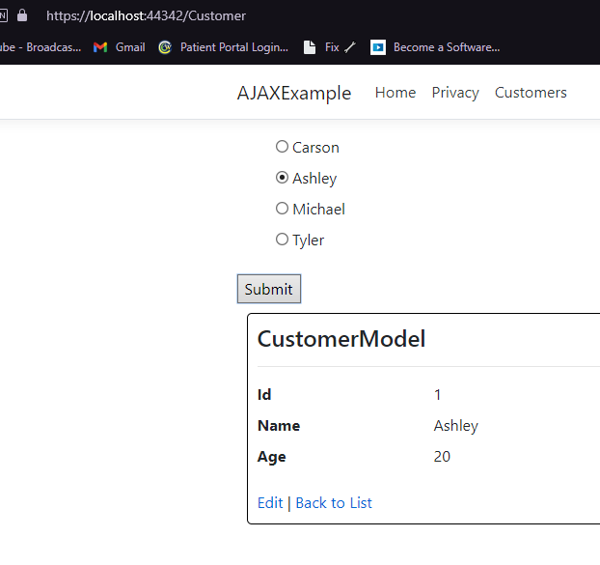

This is demonstrating generating a partial page on submit button click, rather than being taken to a new page.

# Date and Time Stamp:

## Step 2:

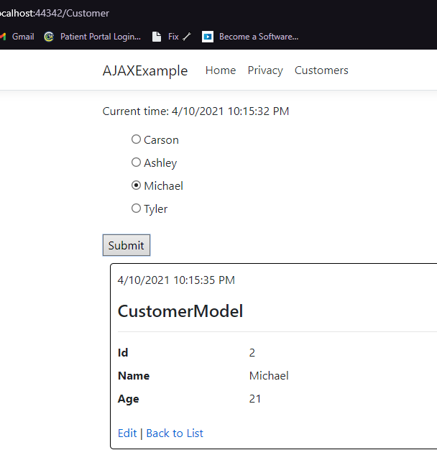

This demonstrates how the main page does not update.

## Summary:

This has shown how using ajax and partial pages can show data received from controllers without having to refresh the entire page

# Part 3:

## Step 6:

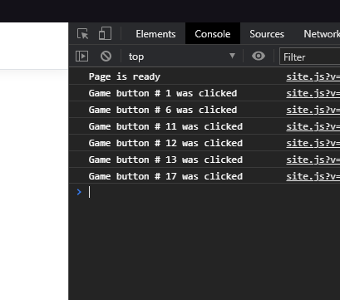

This is demonstrating getting the character button id when clicking on various buttons.

# Ajax Update:

## Step 3:

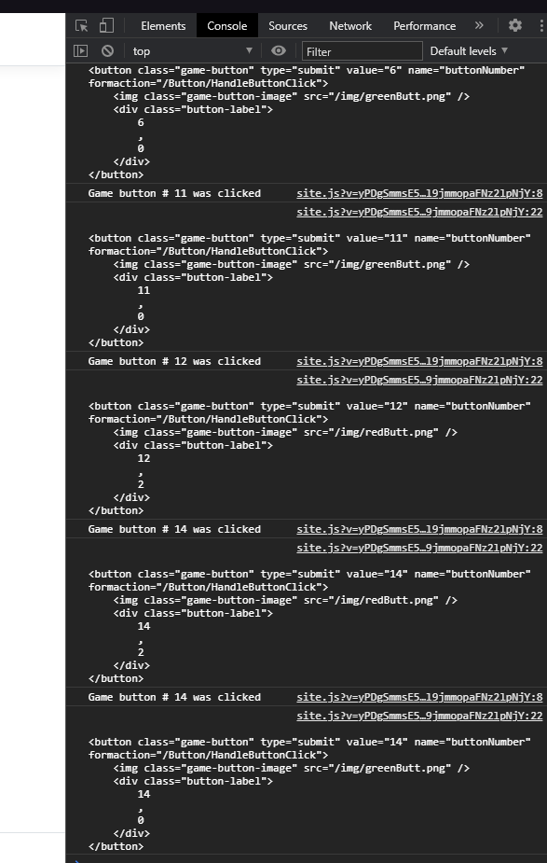

This demonstrates that the values for the button does change, and the data contains everything needed for a partial view.

## Step 8:

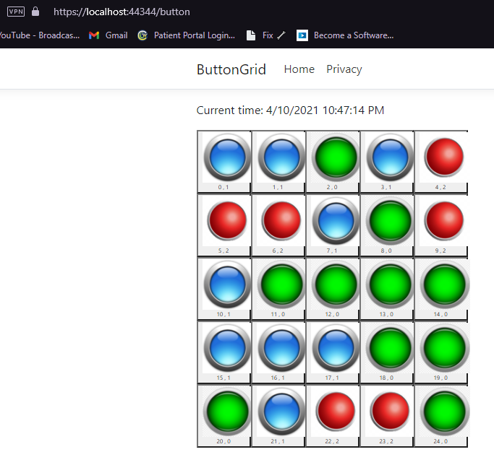

This demonstrates fixing the “Dynamically created button problem” by adding the JQuery on() method, overriding current and future click events.

## Summary:

After adding the last bit of code to have a win condition, and multiple parts of information through Json, that’s was a really good exercise on JQuery and understanding more of Json and using that data.

# Modals:

## Step 13:

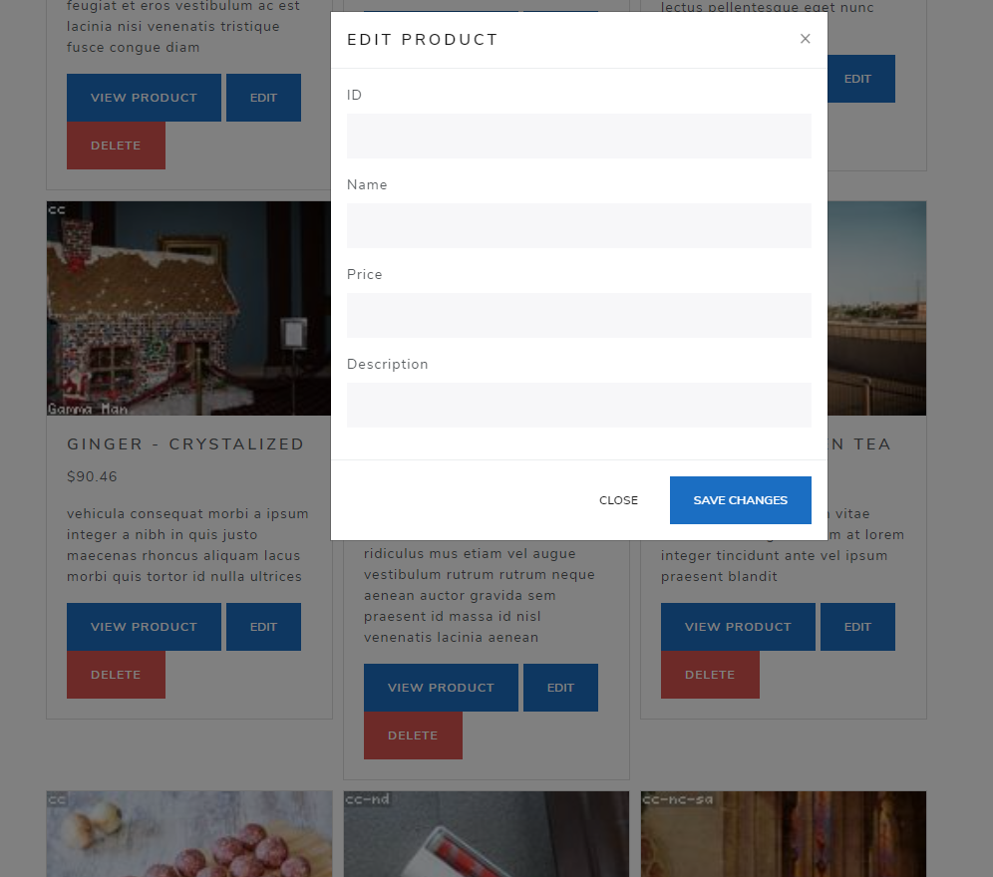

This is showing the modal that pops up when hitting the edit button.

## Summary:

In this part, we learned how to use Modals to have a popup box using Javascript and Bootstrap. This is a very nice way to show a form on a website. It takes a lot more work than just having a form page, but modals look far nicer. They don’t have to be for a form either, they can be used for the view product as well, which would increase efficiency so they can take a closer look at the products, while not having to load an entirely new page!