Carson Perry

CST-256 Bill Hughes  1/23/2021

ACtivity 1

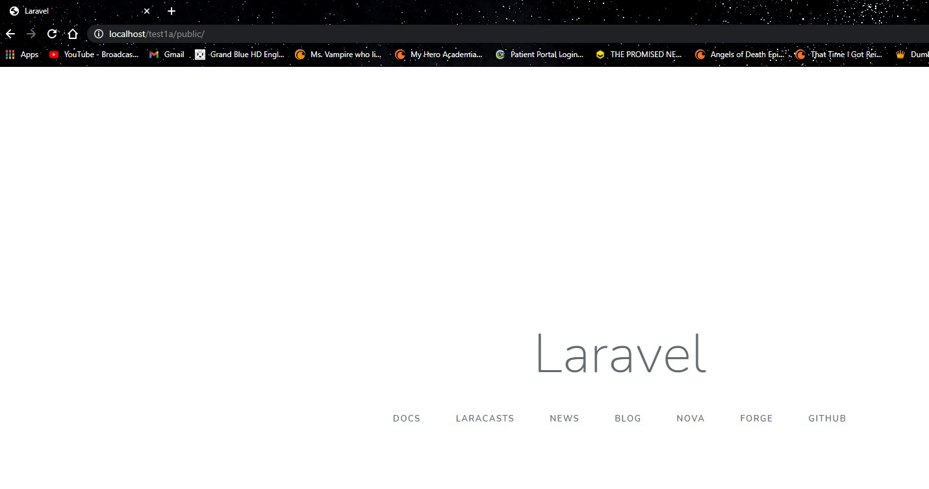

Default Laravel using the /public/ index.

Using Laravel without the /public/ in the URI.

Laravel Structure:

The app folder contains code specific to the app’s function, such as the Kernel.php, as well as exception handling and http handling. The bootstrap folder is pretty self-explanatory, this is where bootstrap is stored. The config folder is for any configuration php files to change how things work behind the scenes. The database folder holds all our database needs with a factories folder, as well as a seeding folder. The public folder is where our index page is, as well as some css and a javascript folder. Our resources folder is an important one in that it holds our views. It also holds some javascript, the used languages, and some css configs. Our routes folder is also pretty simple, in that this contains and routing and movement between pages. Our src folder is where we will be storing our models. The storage folder is where app information is stored, such as logs, cache data and other information we may store from use. The tests folder is where any unit or feature tests, as well as generic test are stored. And finally the vendor folder is where our imports live.

PART 2:

Our hello world

Our test() function output

Our test2() function output

Block Diagram

Login and Register UML

Logical Diagram