Carson Perry

CST-256 Bill hughes  02/23/21

Activity 2

# Part1:

# Block Diagram:

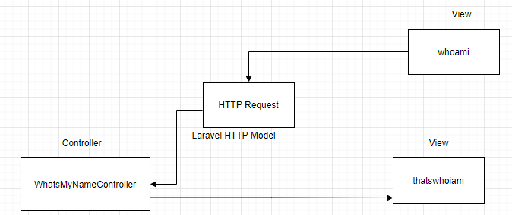

# N-Layer Logical Diagram:

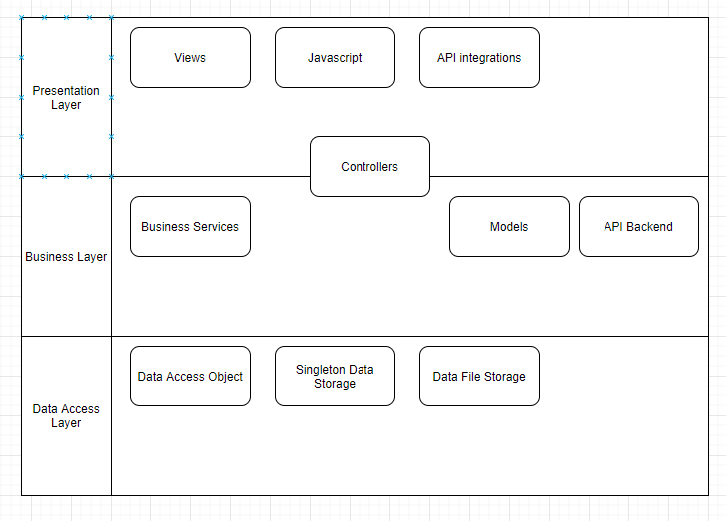

# Part 2:

# Github URL: <https://github.com/arsonull/arsonull.github.io/tree/master/Sem4/php-db3/act2/Activity2B>

# Part 3:

