Carson Perry

cst-256 Bill hughes  03/30/21

Activity 3

# Part 1:

## Step 3.c:

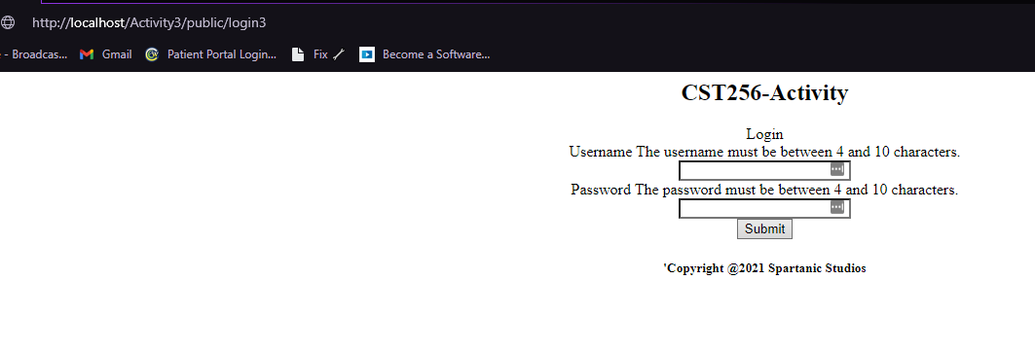

# Submission:

## 1.

Before test additions:

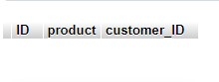

After test additions:

## 2.

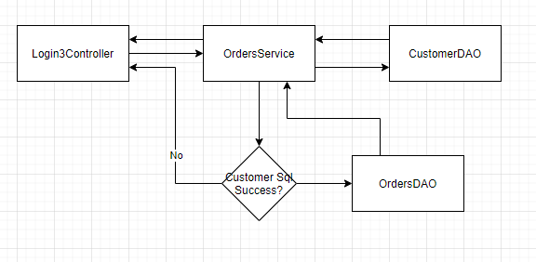

## 3.

ACID stands for Atomicity, Consistency, Isolation, and Durability. In essence, ACID ensures that your transactions are either a complete success and are committed to the database, or are a complete failure and are rolled back, not being committed to the database at all. This binary system of pass or fail ensures that faulty data isn’t committed to the database, especially if some of the data requires data that failed to pass.

## Github Link:

https://github.com/arsonull/arsonull.github.io/tree/master/Sem4/php-db3/act3