Carson Perry

CST-256 Bill Hughes  4/5/21

Activity 5

# Part 1:

## 4g:

## 5h:

# Part 2:

## Step 6.a:

## Step 6.i:

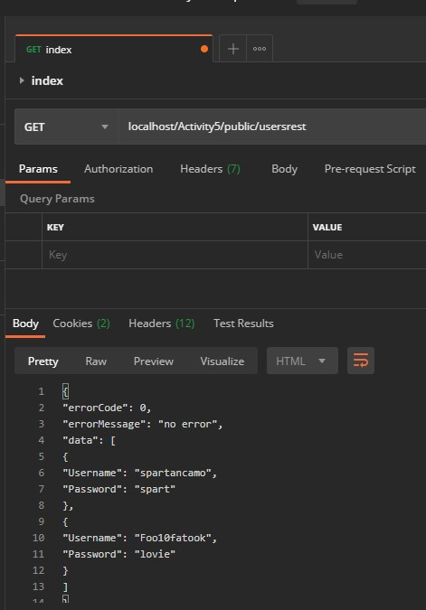

## Step 7.c:

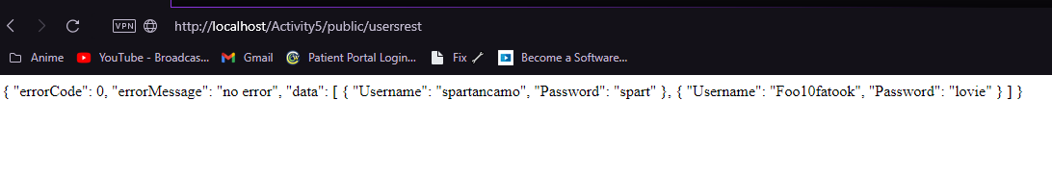

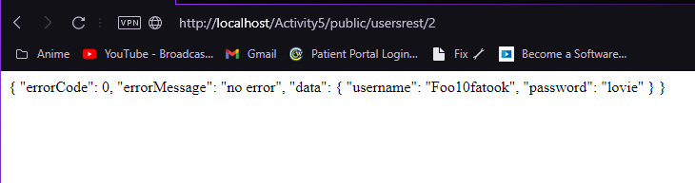

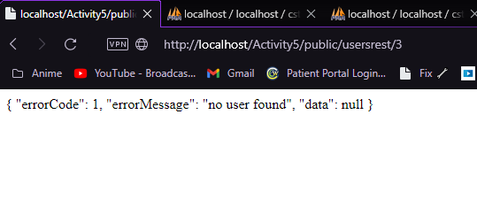

# Part 3:

## Step 1.e:

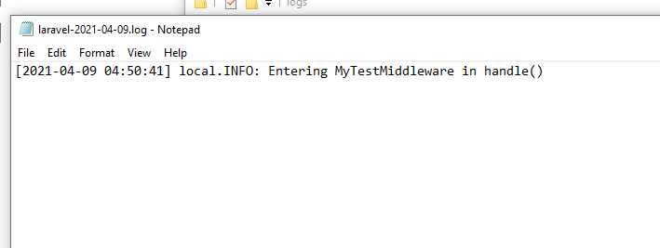

## Step 2.e:

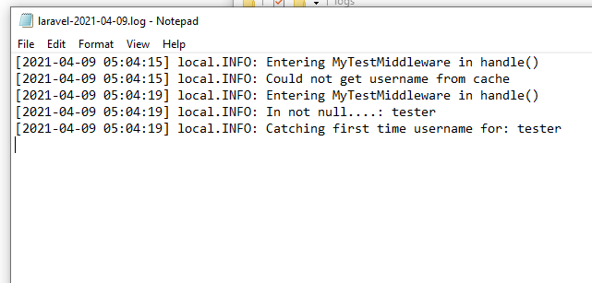

## Step 3.e.5:

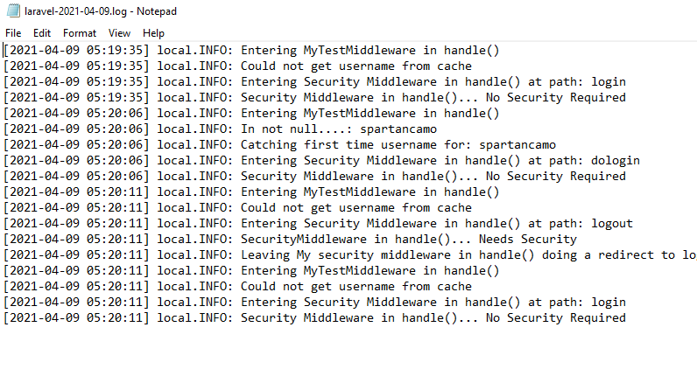

# Part 4:

## Step 8.a:

