Electrical Component Locations ECL-23

|  |  |  |
| --- | --- | --- |
| Table h. Junction box (A4010) fuses 09/2007 - 04/2010 | | |
| Fuse | Rating in amps | Protected circuits |
|  | 10 | Rear wiper and washer |
|  | 5 | Instrument cluster OBD Il plug |
|  | 20 | Passenger seat heating |
|  | 10 | Engine control module (ECM)' |
|  |  | not used |
|  | 5 | AUC sensor  DC converter |
|  | 20 | Roof function center (FZD)  Park distance control (PDC) |
|  | 20 | Cigar lighters  Utility 12 volt outlets |
|  | 5 | Driver door switch cluster Telephone |
| FIO | 5 | Front seat heating |
|  | 20 | Crankshaft sensor  Engine control module (ECM)  Fuel tank vent valve  Fuel volume control valve  Mass air flow sensor  Oil condition sensor  Variable intake manifold controllers |
|  |  | Vacuum pump relay |
|  |  | Telephone USB hub |
| F14 | 10 | Radio |
|  |  | Amplifier |
|  |  | EAC sensor  E-box fan  Engine control module (ECM)  Radiator shutter control  Secondary air pump relay |

Fuses - from 09 / 2007 to 04/2010

|  |  |  |
| --- | --- | --- |
| Table h. Junction box (A4010) fuses 09/2007 - 04/2010 | | |
| Fuse | Rating in amps | Protected circuits |
| F 17 | 10 | Engine control module (ECM)  Exhaust flap  Fuel tank leakage diagnostic module |
| F18 | 10 | Digital tuner Satellite radio |
| F19 | 5 | CD changer Convertible:  Diversity antenna |
| F20 | 10 | Seat control |
| F21 | 10 | Active cruise control |
| F22 | 15 | Automatic transmission control module |
| F23 | 20 | Auxiliary heater control |
| F24 | 15 | Towing module |
| F25 | 20 | Convertible top module  Roof control center (FZD) |
| F26 | 5 | Dynamic stability control (DSC) Transfer case control module |
| F27 | 5 | iDrive controller  Tire pressure control (RDC) |
| F28 | 5 | Cooling fan cut-out relay DC converter |
| F29 | 5 | Sunroof |
| F30 | 10 | Seat belt positioner controllers |
| F31 | 30 | Trailer module |
| F32 | 30 | Trailer module |
| F33 | 40 | Electric coolant pump (N51, N52KP)  For N54, N55 see E-box engine electronics fuse carriers |
| F34 | 5 | CD changer  Diversity antenna |
| F35 | 30 | DSC |
| F36 | 40 | Car access system (CAS) |
| F37 | 30 | Camshaft sensors  Coolant thermostat  ECM  Electric coolant pump  VANOS valves  Waste gate valves |
| F38 | 30 | Crankcase breather heating  Engine control module (ECM)  Oxygen sensor heating |
| F39 | 30 | Fuel injectors  Ignition coils  Ignition coil interference suppression capacitor |

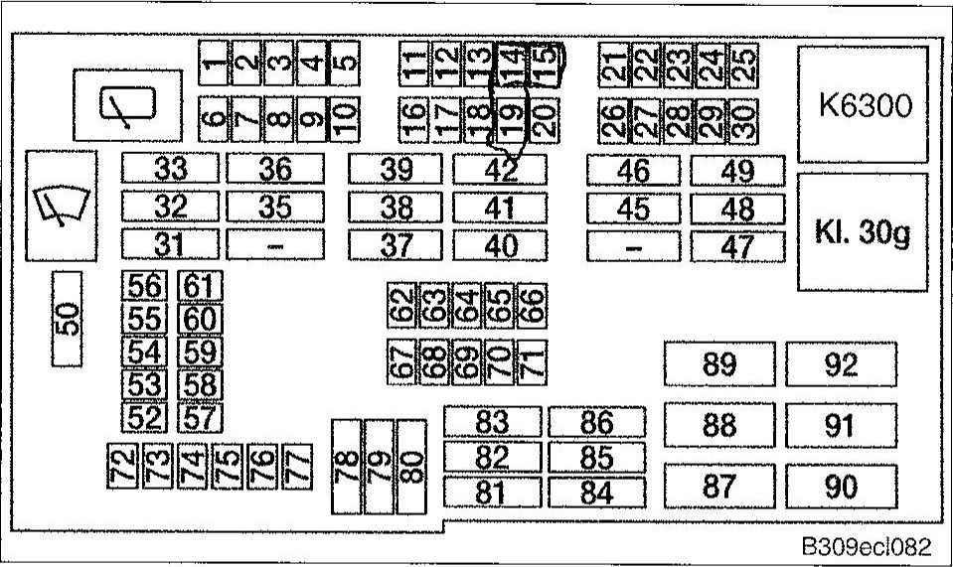Fuses - from 09 / 2007 to 04/2010

ECL-24 Electrical Component Locations

Fuses - from 09 / 2007 to 04/2010

|  |  |  |  |  |  |  |  |  |  |  |  |  |  |  |  |  |  |  |  |  |  |  |  |  |  |  |  |  |  |  |  |  |  |  |  |  |  |  |  |  |  |  |  |  |  |  |  |  |  |  |  |  |  |  |  |  |  |  |  |  |  |  |  |  |  |  |  |  |  |  |  |  |  |  |  |  |  |  |  |  |  |  |  |  |  |  |  |  |  |  |  |  |  |  |  |  |  |  |  |
| --- | --- | --- | --- | --- | --- | --- | --- | --- | --- | --- | --- | --- | --- | --- | --- | --- | --- | --- | --- | --- | --- | --- | --- | --- | --- | --- | --- | --- | --- | --- | --- | --- | --- | --- | --- | --- | --- | --- | --- | --- | --- | --- | --- | --- | --- | --- | --- | --- | --- | --- | --- | --- | --- | --- | --- | --- | --- | --- | --- | --- | --- | --- | --- | --- | --- | --- | --- | --- | --- | --- | --- | --- | --- | --- | --- | --- | --- | --- | --- | --- | --- | --- | --- | --- | --- | --- | --- | --- | --- | --- | --- | --- | --- | --- | --- | --- | --- | --- | --- |
|  | |  |  |  | | --- | --- | --- | | Table h. Junction box (A4010) fuses 09/2007 - 04/2010 | | | | Fuse | Rating in amps | Protected circuits | | F63 | 5 | Diversity antenna  Electrochromic rear-view mirror  Selector lever illumination | | F64 | 5 | OBD Il plug | | F65 | 10 | Selector lever illumination  Longitudinal dynamics management | | F66 | 7.5 | Driver door switch cluster Passenger outside mirror | | F67 | 20 | DSC | | F68 | 20 | Driver seat heating module | | F69 |  | not used | | F70 | 20 | Fuel pump (EKPS) | | F71 | 20 | Trailer module | | F72 | 15 | Central locking | | F73 | 15 | Central locking | | F74 | 5 | Instrument cluster | | F75 | 5 | Steering coiumn switch cluster | | F76 | 5 | Central information display (CID) | | F77 | 10 | Glove compartment light  Heating and air-conditioning  Trunk or cargo compartment light | | F78 | 30 | Window control | | F79 | 30 | Wiper control | | F80 | 30 | Window control | | F81 | 30 | Footwell module | | F82 | 30 | DSC control module | | F83 | 40 | Footwell module | | F84 | 40 | Footwell module | | F85 | 30 | Car access system (CAS) | | F86 | 40 | Footwell module | | F87 |  | not used | | F88 | 40 | Blower | | F89 | 40 | Secondary air pump relay | | F90 | 40 | DSC control module | | F91 |  | not used | | F92 | 50 | 400 watt engine cooling fan | | 60 | 600 watt engine cooling fan | |
| |  |  |  | | --- | --- | --- | | Table h. Junction box (A4010) fuses 09/2007 - 04/2010 | | | | Fuse | Rating in amps | Protected circuits | | F40 | 30 | Transfer case control | | F41 | 30 | Footwell module (FRM) | | F42 | 40 | Footweil module | | F43 | 30 | Headlight washer pump | | F44 | 30 | Trailer module | | F45 | 30 | Passenger seat module | | F46 | 30 | Driver seat module | | F47 | 30 | Rear window defogger | | F48 | 30 | Headlight washer  Rear wiper and washer control | | F49 | 40 | Passenger seat module | | F50 | 30 | Wiper control | | F51 | 40 | Car access system | | F52 |  | not used | | F53 | 10 | Rollover protection | | F54 | 7.5 | Anti-theft alarm siren, tilt sensor Convertible:  Door microwave sensors | | F55 | 5 | Car access system (CAS) | | F56 | 20 | CCC/M-ASK | | F57 | 15 | Horns | | F58 | 5 | Instrument cluster OBD Il socket | | F59 | 5 | Telephone | | F60 | 5 | Central information display | | F61 | 5 | Comfort access control module  Dual remote control receiver  Front door handle control module | | F62 | 7.5 | Roof function control center (FZD) | |