XMl第二次作业

1、构造函数与析构函数的调用关系

答：在调用派生类的构造函数时将优先调用声明在成员初始化表内的基类构造函数，也就是先初始化由基类派生来的成员，然后再执行自身的构造函数。即先基类，再对象成员，后派生类。而构造函数调用顺序相反，先调用派生类，后调用对象成员，最后调用基类。

例如：

#include<iostream>

using namespace std;

class person

{

char \*name;

int age;

char \*add;

public:

person()

{

cout << "the constructor of class person\n" << endl;

}

~person()

{

cout << "the destructor of class person\n" << endl;

}

};

class student:public person

{

char \*department;

int level;

public:

student()

{

cout << "the constructor of class student\n" << endl;

}

~student()

{

cout << "the destructor of class student\n" << endl;

}

};

class teacher:public person

{

char \*major;

float salary;

public:

teacher()

{

cout << "the constructor of class teacher\n" << endl;

}

~teacher()

{

cout << "the destructor of class teacher\n" << endl;

}

};

void main()

{

student d1;

teacher d2;

}

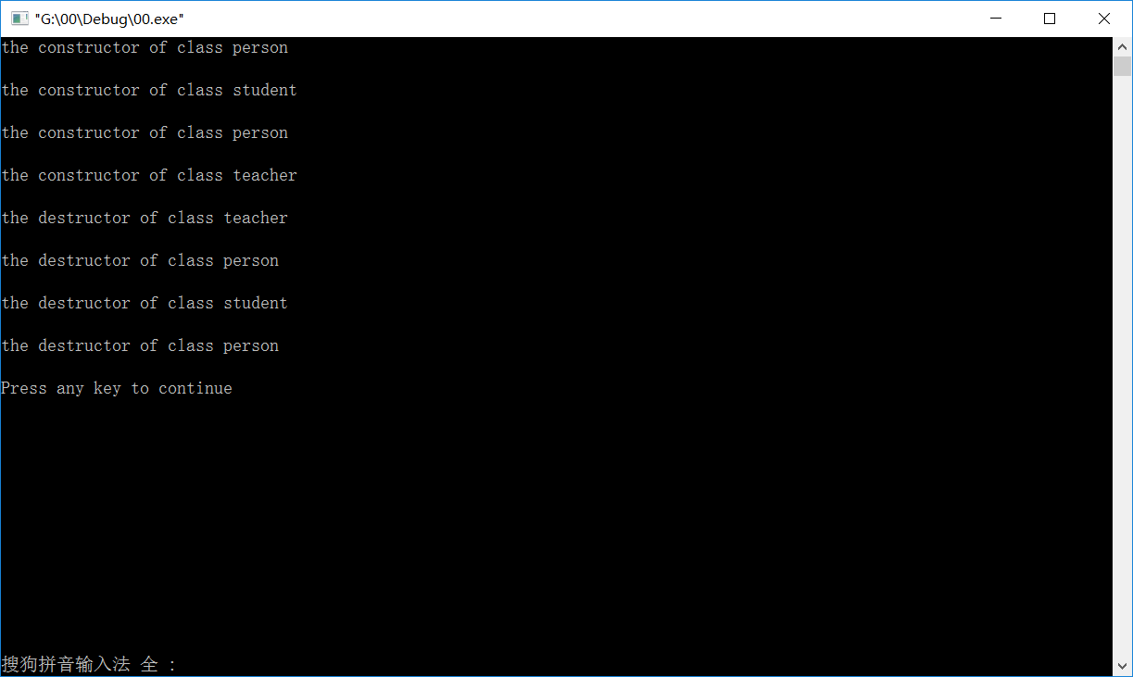

2、用XML文档来描述班级学生列表

<?xml version="1.0"?>

<classlist>

<![CDATA[the classlist is mine!]]>

<![CDATA[the population of our class!]]>

<people>9</people>

<![CDATA[the name of our class!]]>

<classname>ruangong1502</classname>

<![CDATA[the management of our class!]]>

<banzhuren>

<name>XH</name>

<age>30</age>

<sex>male</sex>

<phonenumber>15512346543</phonenumber>

</banzhuren>

<![CDATA[these are menbers of our class!]]>

<student>

<name>ZS</name>

<age>19</age>

<sex>male</sex>

<phonenumber>13324568794</phonenumber>

<xuehao>1001</xuehao>

<jidian>3.9</jidian>

<zhiwu>monitor</zhiwu>

</student>

<student>

<name>LS</name>

<age>18</age>

<sex>female</sex>

<phonenumber>13012143256</phonenumber>

<xuehao>1002</xuehao>

<jidian>3.6</jidian>

<zhiwu>xuexiweiyuan</zhiwu>

</student>

<student>

<name>WW</name>

<age>19</age>

<sex>female</sex>

<phonenumber>15523234646</phonenumber>

<xuehao>1003</xuehao>

<jidian>3.32</jidian>

</student>

<student>

<name>LY</name>

<age>19</age>

<sex>female</sex>

<phonenumber>13202305566</phonenumber>

<xuehao>1004</xuehao>

<jidian>4.1</jidian>

<zhiwu>xinliweiyuan</zhiwu>

</student>

<student>

<name>SDY</name>

<age>18</age>

<sex>male</sex>

<phonenumber>15242283556</phonenumber>

<xuehao>1005</xuehao>

<jidian>3.64</jidian>

</student>

<student>

<name>QSA</name>

<age>18</age>

<sex>male</sex>

<phonenumber>13126443100</phonenumber>

<xuehao>1006</xuehao>

<jidian>3.0</jidian>

<zhiwu>wenyiweiyuan</zhiwu>

</student>

<student>

<name>JQY</name>

<age>19</age>

<sex>male</sex>

<phonenumber>13122563535</phonenumber>

<xuehao>1007</xuehao>

<jidian>2.89</jidian>

<zhiwu>tiyuweiyuan</zhiwu>

</student>

<student>

<name>XM</name>

<age>19</age>

<sex>male</sex>

<phonenumber>13568867963</phonenumber>

<xuehao>1008</xuehao>

<jidian>3.92</jidian>

<zhiwu>zuxuanweiyuan</zhiwu>

</student>

<student>

<name>XWZ</name>

<age>18</age>

<sex>female</sex>

<phonenumber>15677107737</phonenumber>

<xuehao>1009</xuehao>

<jidian>3.16</jidian>

</student>

<![CDATA[this is some words to send my benison to our class!]]>

<comment>Our class is a great and beautiful class,and it is like our family!We need to care for it!</comment>

</classlist>

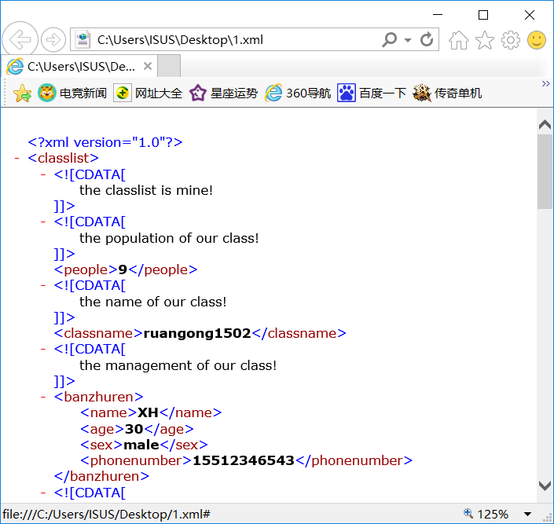

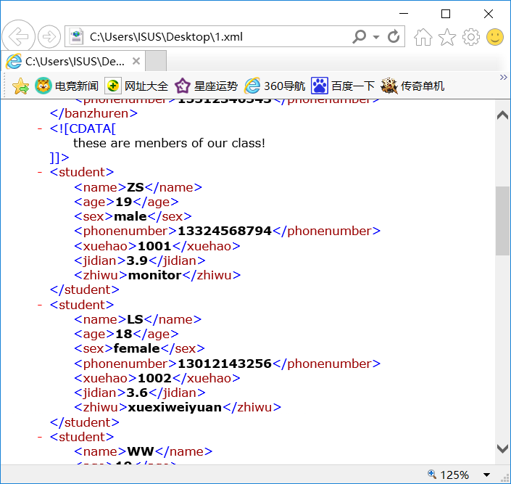

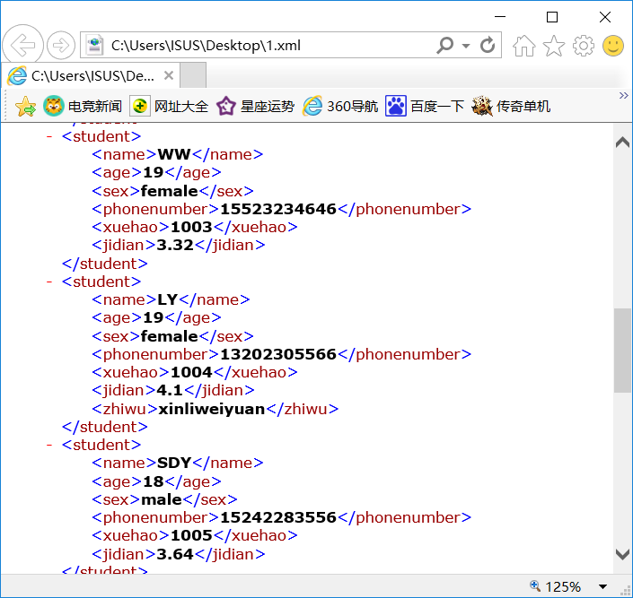

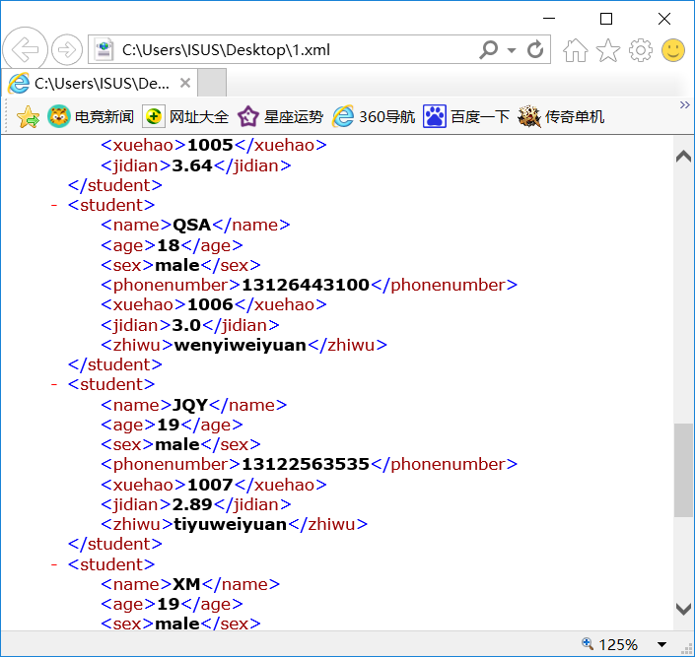

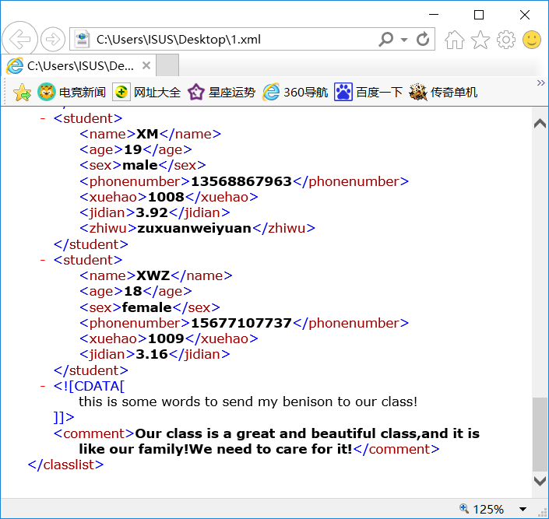

HTML：

<html>

<body>

<h4>软工1502班班级学生列表：</h4>

<table border="1">

<tr>

<td>姓名</td>

<td>班级</td>

<td>学号</td>

<td>绩点</td>

<td>职务</td>

<td>选课</td>

<td>年龄</td>

<td>性别</td>

<td>联系方式</td>

<td>班主任</td>

</tr>

<tr>

<td>ZS</td>

<td>软工1502班</td>

<td>2015001</td>

<td>3.9452</td>

<td>班长</td>

<td>XML</td>

<td>19</td>

<td>男</td>

<td>13324568794</td>

<td>XH</td>

</tr>

<tr>

<td>LS</td>

<td>软工1502班</td>

<td>2015002</td>

<td>3.6000</td>

<td>学习委员</td>

<td>XML</td>

<td>18</td>

<td>女</td>

<td>13012143256</td>

<td>XH</td>

</tr>

<tr>

<td>WW</td>

<td>软工1502班</td>

<td>2015003</td>

<td>3.3221</td>

<td>无</td>

<td>XML</td>

<td>19</td>

<td>女</td>

<td>15523234646</td>

<td>XH</td>

</tr>

<tr>

<td>LYT</td>

<td>软工1502班</td>

<td>2015004</td>

<td>4.1009</td>

<td>心理委员</td>

<td>XML</td>

<td>18</td>

<td>女</td>

<td>15677377139</td>

<td>XH</td>

</tr>

<tr>

<td>SDY</td>

<td>软工1502班</td>

<td>2015005</td>

<td>3.6400</td>

<td>无</td>

<td>XML</td>

<td>19</td>

<td>男</td>

<td>15242283556</td>

<td>XH</td>

</tr>

<tr>

<td>QSA</td>

<td>软工1502班</td>

<td>2015006</td>

<td>3.3321</td>

<td>文艺委员</td>

<td>XML</td>

<td>18</td>

<td>男</td>

<td>13126443100</td>

<td>XH</td>

</tr>

<tr>

<td>JQY</td>

<td>软工1502班</td>

<td>2015007</td>

<td>2.8924</td>

<td>体育委员</td>

<td>XML</td>

<td>19</td>

<td>男</td>

<td>13322563535</td>

<td>XH</td>

</tr>

<tr>

<td>XM</td>

<td>软工1502班</td>

<td>2015008</td>

<td>3.6446</td>

<td>团支书</td>

<td>XML</td>

<td>18</td>

<td>男</td>

<td>13558867963</td>

<td>XH</td>

</tr>

<tr>

<td>XL</td>

<td>软工1502班</td>

<td>2015009</td>

<td>3.1616</td>

<td>无</td>

<td>XML</td>

<td>19</td>

<td>女</td>

<td>15547492456</td>

<td>XH</td>

</tr>

</table>

</body>

</html>

