为一个xml文档创建外部DTD，该XML文档的结构要求如下：

（1）根元素名称为Library。

（2）Library必须包含两个元素：Book和Member，分别表示书的详细信息和发行人。

（3）Book必须包含一个BookId属性。所有其他的元素，例如Title、Author、Price、Publisher和Cost都只能作为Book的子元素。

（4）元素Member包含Name和Address两个子元素。元素Name包含FirstName、MiddleName和LastName三个子元素。元素Address包含HouseNumber、Street、City三个子元素。

（5）用C++的XML解析库来解析所做的XML文档，要有运行结果截图。

答：DTD文档：

<?xml version="1.0" encoding="UTF-8"?>

<!ELEMENT Library (Book,Member)+>

<!ELEMENT Book (Book_Title,Book_Author,Book_Price,Book_Publisher,Book_Cost)>

<!--#PCDATA??????????-->

<!ELEMENT Book_Title (#PCDATA)>

<!ELEMENT Book_Author (#PCDATA)>

<!ELEMENT Book_Price (#PCDATA)>

<!ELEMENT Book_Publisher (#PCDATA)>

<!ELEMENT Book_Cost (#PCDATA)>

<!ELEMENT Member (Member_Name,Member_Address)>

<!ELEMENT Member_Name (Name_FirstName,Name_MiddleName,Name_LastName)>

<!ELEMENT Member_Address (Address_HouseNumber,Address_Street,Address_City)>

<!ELEMENT Name_FirstName (#PCDATA)>

<!ELEMENT Name_MiddleName (#PCDATA)>

<!ELEMENT Name_LastName (#PCDATA)>

<!ELEMENT Address_HouseNumber (#PCDATA)>

<!ELEMENT Address_Street (#PCDATA)>

<!ELEMENT Address_City (#PCDATA)>

<!ATTLIST Book Book_Bookld CDATA #REQUIRED>

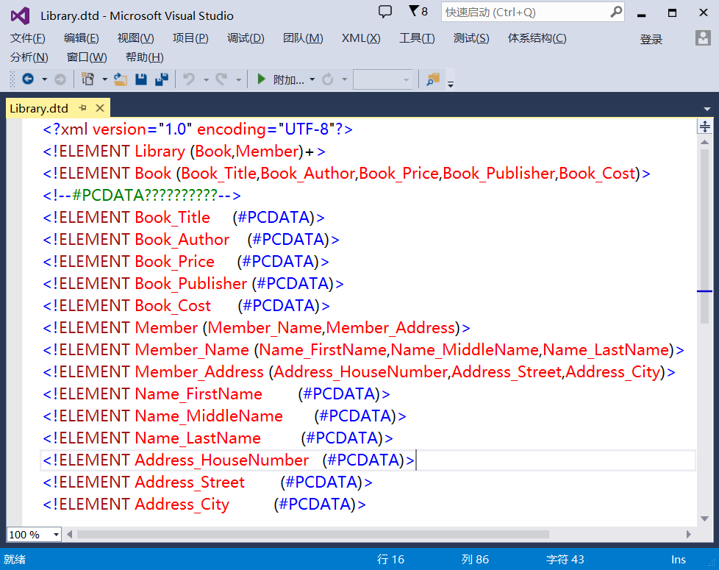

XML文件：

<?xml version="1.0" encoding="UTF-8"?>

<!DOCTYPE Library SYSTEM "Library.dtd">

<Library>

<Book>

<Book BookId="1942-1943"/>

<Book_Title>Le Petit Prince</Book_Title>

<Book_Author>Antoine.de.Saint-Exupery</Book_Author>

<Book_Price>22.0</Book_Price>

<Book_Publisher>Reynal Hitchcock Harcourt Brace Jovanovich Inc</Book_Publisher>

<Book_Cost>22.0</Book_Cost>

</Book>

<Member>

<Member_Name>

<Name_FirstName>Antoine</Name_FirstName>

<Name_MiddleName>de</Name_MiddleName>

<Name_LastName>Saint-Exupery</Name_LastName>

</Member_Name>

<Member_Address>

<Address_HouseNumber>18</Address_HouseNumber>

<Address_Street>123Street</Address_Street>

<Address_City>New York City</Address_City>

</Member_Address>

</Member>

<Book>

<Book_Title></Book_Title>

<Book_Author></Book_Author>

<Book_Price></Book_Price>

<Book_Publisher></Book_Publisher>

<Book_Cost></Book_Cost>

</Book>

<Member>

<Member_Name>

<Name_FirstName></Name_FirstName>

<Name_MiddleName></Name_MiddleName>

<Name_LastName></Name_LastName>

</Member_Name>

<Member_Address>

<Address_HouseNumber></Address_HouseNumber>

<Address_Street></Address_Street>

<Address_City></Address_City>

</Member_Address>

</Member>

</Library>

