思考题

1.考虑下面的XML文件，文件名为5.4.xml。

<?xml version=”1.0”?>

<!DOCTYPE Root[<!ENTITY First “<First>DOM</First>]>

<Root>

&First;

<Second>SAX</Second>

</Root>

建立一个使用DOM API的Java程序。该程序可以解析上面的XML文档，并且得到如下图所示的结果。

<?xml version=”1.0”?>

<Root>

<First>DOM</First>

<Second>SAX</Second>

</Root>

答：

**package** dom;

**import** javax.xml.transform.*;

**import** javax.xml.transform.stream.*;

**import** javax.xml.transform.dom.*;

**import** org.w3c.dom.*;

**import** org.xml.sax.SAXException;

**import** javax.xml.parsers.*;

**import** java.io.*;

**public** **class** XMLjiexi

{

**public** **static** **void** main(String[] args) **throws** Exception{

// **TODO** Auto-generated method stub

XMLjiexi domp=**new** XMLjiexi();

}

**public** XMLjiexi()

{

DocumentBuilderFactory factory=DocumentBuilderFactory. *newInstance*();

**try**

{

DocumentBuilder builder= factory.newDocumentBuilder();

Document doc=builder.parse(**new** File("5.4.xml"));

Element root=doc.getDocumentElement();

NodeList Root=root.getChildNodes();

**if**(Root!=**null**)

{

**for**(**int** i=0;i<Root.getLength();i++)

{

Node node=Root.item(i);

**if**(node.getNodeType()==Node.***ELEMENT_NODE***)

{

**if**(node.getNodeName().equals("First"))

{

String First=node.getNodeValue();

String First1=node.getFirstChild().getNodeValue();

System.***out***.println(First);

System.***out***.println(First1);

}

**if**(node.getNodeName().equals("Second"))

{

String Second=node.getFirstChild().getNodeValue();

System.***out***.println(Second);

}

}

}

}

}

**catch**(ParserConfigurationException e)

{

e.printStackTrace();

}

**catch**(FileNotFoundException e)

{

e.printStackTrace();

}

**catch**(SAXException e)

{

e.printStackTrace();

}

**catch**(IOException e)

{

e.printStackTrace();

}

}

}

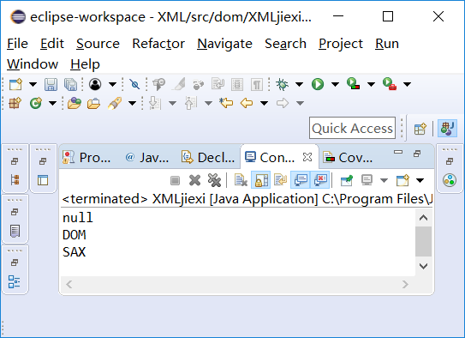

2.用DOM接口生成如下内容并且把它们写到一个新的XML文档中。

<?xml version=”1.0” encoding=”UTF-8”?>

<Team>

<TeamMember>

<Empno value=”30772”/>

<Name value=”Manjeet Singh”/>

<Designation value=”Team Leader.”/>

</TeamMember>

</Team>

答：用DOM接口生成XML的代码如下：

**package** dom;

**import** java.io.*;

**import** javax.xml.parsers.*;

**import** javax.xml.transform.*;

**import** javax.xml.transform.dom.*;

**import** javax.xml.transform.stream.*;

**import** org.w3c.dom.*;

**public** **class** xml {

**public** **static** **void** main(String[] args) {

// **TODO** Auto-generated method stub

**try**

{

DocumentBuilderFactory factory=DocumentBuilderFactory.*newInstance*();

DocumentBuilder builder=factory.newDocumentBuilder();

Document doc=builder.newDocument();

doc.setXmlVersion("1.0");

Element Team=doc.createElement("Team");

doc.appendChild(Team);

Element TeamMember=doc.createElement("TeamMember");

Team.appendChild(TeamMember);

Element Empno=doc.createElement("Empno");

TeamMember.appendChild(Empno);

NodeList nodelist=doc.getElementsByTagName("Empno");

**int** size=nodelist.getLength();

**for**(**int** k=0;k<size;k++)

{

Node node=nodelist.item(k);

**if**(node.getNodeType()==Node.***ELEMENT_NODE***)

{

Element elementNode=(Element)node;

elementNode.setAttribute("value","30772");

}

}

Element Name=doc.createElement("Name");

TeamMember.appendChild(Name);

nodelist=doc.getElementsByTagName("Name");

size=nodelist.getLength();

**for**(**int** k=0;k<size;k++)

{

Node node=nodelist.item(k);

**if**(node.getNodeType()==Node.***ELEMENT_NODE***)

{

Element elementNode=(Element)node;

elementNode.setAttribute("value","Manjeet Singh");

}

}

Element Designation=doc.createElement("Designation");

TeamMember.appendChild(Designation);

nodelist=doc.getElementsByTagName("Designation");

size=nodelist.getLength();

**for**(**int** k=0;k<size;k++)

{

Node node=nodelist.item(k);

**if**(node.getNodeType()==Node.***ELEMENT_NODE***)

{

Element elementNode=(Element)node;

elementNode.setAttribute("value","Team Leader.");

}

}

DOMSource domSource=**new** DOMSource(doc);

File file=**new** File("Team.xml");

FileOutputStream out=**new** FileOutputStream(file);

StreamResult xmlResult=**new** StreamResult(out);

Transformer t=TransformerFactory.*newInstance*().newTransformer();

t.transform(domSource,xmlResult);

}

**catch**(Exception e)

{

System.***out***.println(e);

}

}

}



