**How to Add a New Menu (EffortlessHRM)**

Follow the steps below to add a new menu to the application:

**1. Add Permission in the Admin Project**

* Run the **EffortlessHRM.Admin** project.
* Navigate to the permissions section and add a **new permission**.
* The **permission name** will be used in the Angular project and must match exactly.

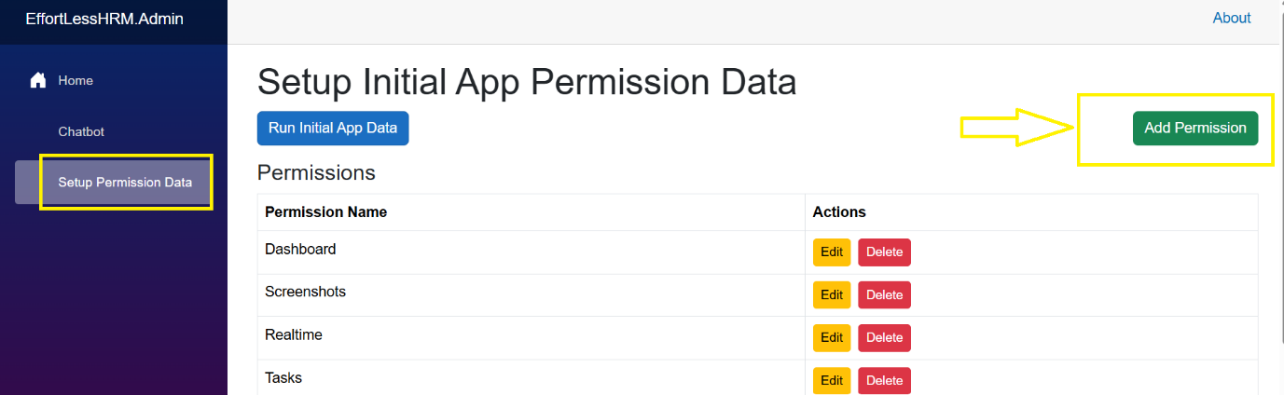

**2. Add Route in Angular Project**

* Open the **app-routing.module.ts** file.
* Add the new route and secure it using **AuthGuard** and the **permission key**, as shown below:

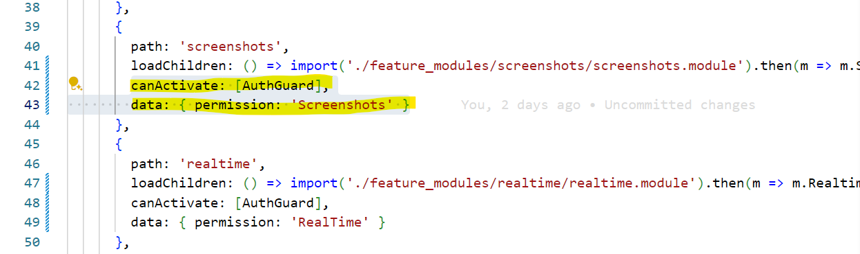

* The **permission key** must exactly match the permission name defined in the EffortlessHRML.Admin project.

**3. Add Menu Entry in menu.const.ts**

* Add the menu details in the **menu.const.ts** file.
* Use the same **title name** used for the permission to ensure consistency.

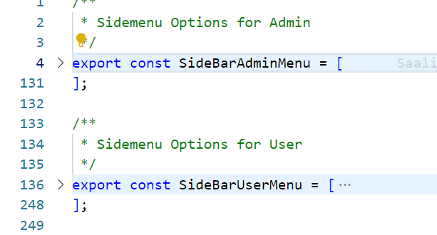

**4. Assign the Permission to a Role**

* In the **EffortlessHRMWeb** project, go to the **Permissions** (Assign Permissions).
* Assign a role to newly created permission that require access to the new menu.

