

Assignment#1

SP19-BCS-103



Arslan Ali

Submitted To: Dr. Allah Bux Sargano

Q#1

Main Class

package ebill;

public class ebill {

public static void main(String[] args) {

electricityBill std1 = new electricityBill("Arslan Ali",12445,"arslanali@gmail.com",255,500);

std1.callcualteBill();

std1.acInfo();

}

}

Class

package ebill;

public class electricityBill {

String name;

int accountNo;

String address;

int pReading;

int cReading;

int bill;

public electricityBill(String n,int acNo,String add,int pR,int cR)

{

name = n;

accountNo=acNo;

address = add;

pReading = pR;

cReading = cR;

}

public void callcualteBill()

{

int units = cReading - pReading;

if (units<=100)

{

bill = units*15;

}

else if (units<=300)

{

bill=100*15+(units-100)*30;

}

else if (units<=500)

{

bill=100*30+(units-100)*45;

}

else if (units>500)

{

bill = units*60;

}

else

{

System.out.println("Error! You entered the Wrong Readings");

}

}

public void acInfo()

{

System.out.println("Customer Name:"+name);

System.out.println("Account Number:"+accountNo);

System.out.println("Customer Address:"+address);

System.out.println("Current Readings:"+cReading);

System.out.println("Total Bill:"+bill);

}

}

Output

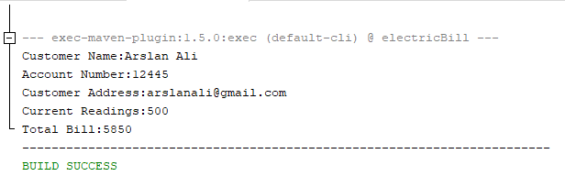

Q#2

Main Class

package numbers;

import java.util.Scanner;

public class numbers {

public static void main(String[] args) {

int numbers=0;

byte negative=0,positive=0,zero=0;

for (int i=0;i<5;i++)

{

Scanner input = new Scanner(System.in);

System.out.print("Enter the Nubers:");

numbers = input.nextInt();

if (numbers<0)

negative++;

if (numbers>0)

positive++;

if (numbers==0)

zero++;

}

System.out.println("Numbers of Positive Integers:"+positive);

System.out.println("Numbers of Negative Integers:"+negative);

System.out.println("Numbers of Zero Integers:"+zero);

}

}

Output

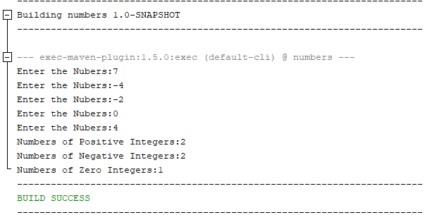

Q#3

Main Class

package bodymasscalculator;

import java.util.Scanner;

public class calculatorBMI {

public static void main(String[] arg){

int BMI=0,weightInkilogram=0,heightInMeters=0;

Scanner input = new Scanner(System.in);

System.out.print("Enter the Weith in Kilogram:");

weightInkilogram = input.nextInt();

System.out.print("\nEnter the Height in Meters:");

heightInMeters = input.nextInt();

BMI = weightInkilogram/(heightInMeters*heightInMeters);

System.out.println("Your BMI is "+BMI);

System.out.print("BMI Values\n"

+ "Underweight:\tless than 18.5\n"

+ "Normal:\t\tbetween 18.5 and 24.9\n"

+ "Overweight:\tbetween 25 and 29.9");

}

}

Output

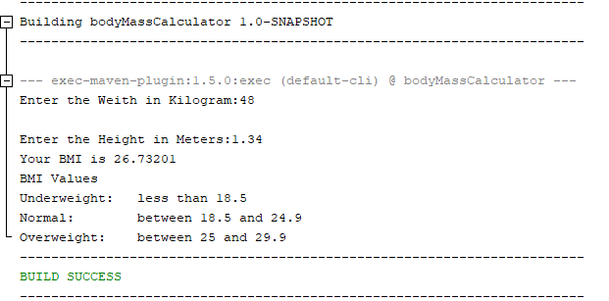

Q#4

Main Class

package convertor;

import java.util.Scanner;

public class convertor {

public static void main(String[] arg)

{

System.out.println("Press one for Binary to Decimal\nPress Two for Decimal to binary\n");

Scanner input = new Scanner(System.in);

byte choice = input.nextByte();

if (choice==1)

{

System.out.print("Enter Binary Number: ");

int bNumber=input.nextInt(),digit=0,sum=0,tsum=0;

for (int i=0;bNumber>0;i++)

{

digit = bNumber%10; //Taking the binary digit separate

bNumber = bNumber/10; //Reducing the lenght of digit

sum = (int)Math.pow(2,i)*digit; //Multiply the digit by zero or one

tsum +=sum; // Taking the collective sum

}

System.out.println("Decinmal Digit is "+tsum);

}

else if (choice==2)

{

System.out.print("Enter the Decimal Nubmer: ");

int number = input.nextInt();

int[] dNumbers = new int[32];

int i=0;

for (i=0;number>0;i++)

{

dNumbers[i] = number%2;

number = number/2;

}

for (int n = i-1;n>=0;n--)

{

System.out.printf("The Decimal Number is %d",dNumbers[n]); //Printing in reverse order

}

}

}

}

Output

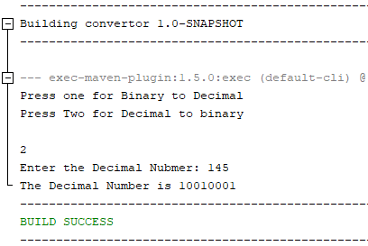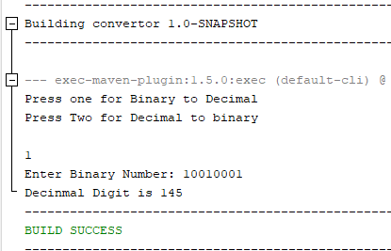

Q#5

Main Class

package carparking;

public class parking

{

int hours;

int charges;

public void calculatea(int hours )

{

if (hours<=3)

{

charges = 100;

}

else if (hours==4)

{

charges = 150;

}

else

{

charges = 200;

}

System.out.print("Toatl Charges == "+charges);

}

}

Output

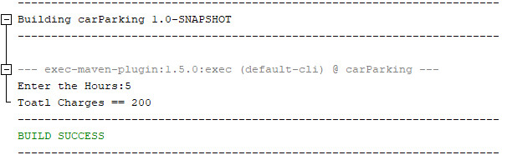

Q#6

Main Class

public class numGuessor

{

public static void main(String[] arg)

{

RandomTest game = new RandomTest();

game.randomNumberGenerator();

}

}

Class

import java.util.Scanner;

public class RandomTest {

public void randomNumberGenerator()

{

Scanner input = new Scanner(System.in);

int randomNum= (int)( Math.random() * 10);

int inputNum = 0;

for ( int i=3;i>0;i--)

{

System.out.print("Enter a guess:");

inputNum = input.nextInt();

if (randomNum==inputNum)

{

System.out.println("Right!\nYou won the game.");

break;

}

else

{

System.out.println("Wrong");

}

}

System.out.println("Correct number was "+randomNum);

System.out.println("You have lost the game.");

}

}

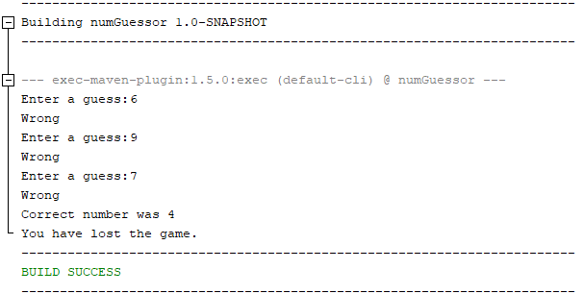

Q#7

Main Class

package predictPrice;

import java.util.Scanner;

public class PredictPrice

{

public static void main(String[] arg)

{

Scanner input = new Scanner(System.in);

System.out.print("Enter the Price:");

float price= input.nextFloat();

System.out.print("\nEnter the Inflaction:");

float inflaction= input.nextFloat();

System.out.print("\nEnter the Years:");

byte years=input.nextByte();

for ( int i=0; i<years;i++)

{

price = price + (inflaction/100)*price;// Calculating the price of good by runnig sum method

}

System.out.printf("Price after %d years are %.2f Rs.",years,price);

}

}

Output

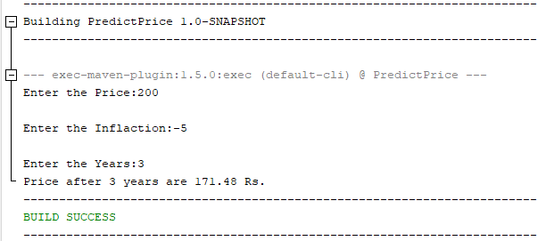

Q#8

Main Class

package test;

public class test

{

public static void main(String [] arg)

{

Odometer trip1 = new Odometer(300,45);

trip1.showInfo();

}

}

Class

package test;

public class Odometer

{

public float miles;

public float fuelEfficiency;

public Odometer(float m,float f)

{

miles = m;

fuelEfficiency = f;

}

public void resetOdometer()

{

miles=0;

}

public void setFuelEffeciency(float a)

{

fuelEfficiency = a;

}

public void setMiles(float a)

{

miles = miles + a;

}

public float fuleConsumed()

{

if (miles==0)

return 0;

else

return fuelEfficiency/miles;

}

public void showInfo()

{

System.out.printf("Miles = %f miles",miles);

System.out.printf("\nFuel Effeciency = %f miles/gallon",fuelEfficiency);

System.out.printf("\nFuel Consumed = %f gallon",fuleConsumed());

}

}

Output

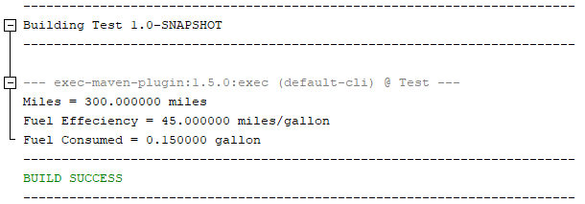

Q#9

Main Class

package gradecalculator;

import java.util.Scanner;

public class main {

public static void main(String[] arg)

{

int a=0,b=0,c=0,d=0,e=0;

Scanner input = new Scanner(System.in);

System.out.print("Enter the Quiz 1 marks: ");

a = input.nextInt();

System.out.print("Enter the Quiz 2 marks: ");

b = input.nextInt();

System.out.print("Enter the Quiz 3 marks: ");

c = input.nextInt();

System.out.print("Enter the Mid-Term marks: ");

d = input.nextInt();

System.out.print("Enter the Terminal marks: ");

e = input.nextInt();

GradeCalculator subject1 = new GradeCalculator(a,b,c,d,e);

subject1.grading();

}

}

Class

package gradecalculator;

public class GradeCalculator

{

int quiz1,quiz2,quiz3;

int midTerm;

int finalTerm;

float tPercentage;

public GradeCalculator(int q1,int q2,int q3,int mT,int fT)

{

quiz1 = q1; quiz2 = q2; quiz3 = q3;

midTerm = mT;

finalTerm = fT;

}

private float gradePersentage()

{

float pQuiz = (quiz1 + quiz2 + quiz3 )/30f*25;

float pMidTerm = (float)( midTerm / 100f)* 35;

float pFinalTerm = (float)(finalTerm/100f) * 40;

tPercentage = pQuiz + pMidTerm + pFinalTerm;

return tPercentage;

}

public void grading()

{

int p = (int) gradePersentage();

System.out.println("Your Score in this subject is "+p);

if (p>90)

System.out.print("Your Grade is A");

else if (p>80)

System.out.print("Your Grade is B");

else if (p>70)

System.out.print("Your Grade is C");

else if (p>60)

System.out.print("Your Grade is D");

else if (p<60)

System.out.print("Your Grade is F");

}

}

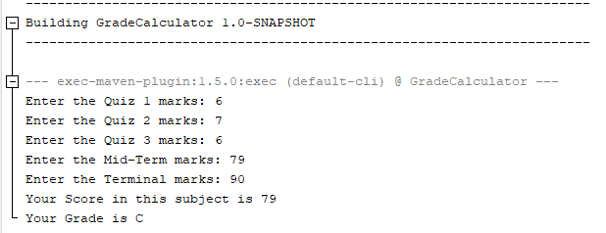

Q#10

Main Class

package animalspecies;

public class main {

public static void main(String[] arg)

{

AnimalSpecies a1 = new AnimalSpecies("Bengal Tiger",300,-30);

AnimalSpecies a2 = new AnimalSpecies("Bengal Tiger",300,-30);

System.out.println(a1);

}

}

Class

package animalspecies;

import java.util.Objects;

public class AnimalSpecies

{

String species_name;

int population;

float growthRate;

@Override

public boolean equals(Object obj) {

if (this == obj) {

return true;

}

if (obj == null) {

return false;

}

if (getClass() != obj.getClass()) {

return false;

}

final AnimalSpecies other = (AnimalSpecies) obj;

if (this.population != other.population) {

return false;

}

if (Float.floatToIntBits(this.growthRate) != Float.floatToIntBits(other.growthRate)) {

return false;

}

return Objects.equals(this.species_name, other.species_name);

}

public AnimalSpecies(String S_name,int p,float gRate)

{

species_name = S_name;

population = p;

growthRate = gRate;

}

public void changeSpeciesName(String s)

{

species_name = s;

}

public void changePopulation(int a)

{

population = a;

}

public void changeGrowthRate(float a)

{

growthRate = a;

}

@Override

public String toString()

{

return "Name of Species = \t"+species_name+"\nPopulation = \t\t"+population+"\nGrowth Rate = \t\t"+growthRate;

}

public boolean endengared()

{

return growthRate<0;

}

}

