**Theory Assignment#3**

**Question#1**

MainMethod

package com.mycompany.question1;

public class MainMethod {

public static void main(String[] args)

{

CashPayment ob1 = new CashPayment(2000);

CashPayment ob2 = new CashPayment(4000);

CreditCardPayment cp1 = new CreditCardPayment("Paypal","12/20/2021",304278,2500);

CreditCardPayment cp2 = new CreditCardPayment("Visa","06/01/2021",592857,1100);

ob1.PaymentDetails();

ob2.PaymentDetails();

cp1.PaymentDetails();

cp2.PaymentDetails();

}

}

Payment

package com.mycompany.question1;

public class Payment

{

private double payment;

public Payment(double payment)

{

this.payment = payment;

}

public void setPayment(double payment)

{

this.payment = payment;

}

public double getPayment()

{

return payment;

}

public void PaymentDetials()

{

System.out.print("You hava Payed "+payment);

}

}

CashPayment

package com.mycompany.question1;

public class CashPayment extends Payment

{

public CashPayment(double payment)

{

super(payment);

}

public void PaymentDetails()

{

super.PaymentDetials();

System.out.println(" in Cash!");

}

}

CreditCardPyament

package com.mycompany.question1;

public class CreditCardPayment extends Payment{

private String name;

private String expirationDate;

private int cardNumber;

public CreditCardPayment(String name, String expirationDate, int cardNumber, double payment)

{

super(payment);

this.name = name;

this.expirationDate = expirationDate;

this.cardNumber = cardNumber;

}

public void PaymentDetails()

{

super.PaymentDetials();

System.out.println("through Credit Card \nName: "+name);

System.out.println("Number: "+cardNumber);

System.out.println("Expiration Date: "+expirationDate);

}

}

Output

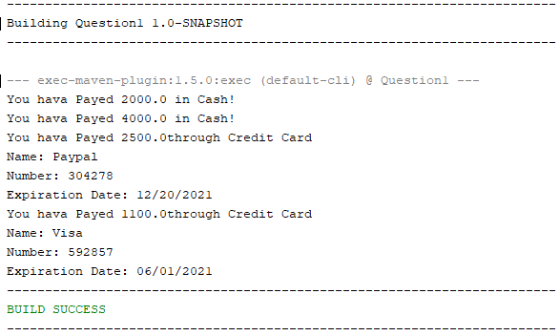

**Question#2**

MainMethod

package question2;

public class TestMain {

public static void main(String[] args)

{

Car ob1 = new Car(20,1500,2000);

Truck ob2 = new Truck(200,120,100);

Bicycle ob3 = new Bicycle(13,50);

RentedVehical array[] = new RentedVehical[]{ob1,ob2,ob3};

System.out.println("Car Rent:\t"+array[0].getCost());

System.out.println("Truck Rent:\t"+array[1].getCost());

System.out.println("Bicycle Rent:\t"+array[2].getCost());

}

}

RentedVehical

package question2;

public class RentedVehical

{

protected int baseFee;

public RentedVehical(int baseFee)

{

this.baseFee = baseFee;

}

public double getCost()

{

return baseFee;

}

}

FuelVehical

package question2;

public class FuelVehical extends RentedVehical

{

private final int nbKms; //Number of kilometer travelled

public FuelVehical(int nbKms ,int baseFee)

{

super(baseFee);

this.nbKms = nbKms;

}

public double getMileageFees()

{

if (nbKms<100)

return nbKms*0.2;

else if (nbKms>100 || nbKms<400)

return nbKms*0.3;

else if (nbKms>400)

return nbKms*0.3+(400-nbKms)*0.5;

else

return 0;

}

}

Bicycle

package question2;

public class Bicycle extends RentedVehical

{

private int nbDays;

public Bicycle(int nbDays, int baseFee)

{

super(baseFee);

this.nbDays = nbDays;

}

@Override

public double getCost()

{

return nbDays*super.baseFee;

}

}

Car

package question2;

public class Car extends FuelVehical{

private final int nbSeat;

public Car(int nbSeat,int nbKms,int baseFee)

{

super(nbKms,baseFee);

this.nbSeat = nbSeat;

}

/**

*

* @return

*/

@Override

public double getCost()

{

return super.getMileageFees()+ super.getCost()*baseFee;

}

}

Truck

package question2;

public class Truck extends FuelVehical{

private int capacity;

public Truck(int capacity, int nbKms, int baseFee)

{

super(nbKms,baseFee);

this.capacity = capacity;

}

@Override

public double getCost()

{

return super.getMileageFees()+super.baseFee*capacity;

}

}

Output

