315 Theory of Machines – Design of Elements
Spring 2018
HW No. 9 and review
No submission

1. From the class example we know that the cantilever length of a cantilever beam is important because it determines the maximum bending moment in the beam. Each of the cantilever beam design below uses a pair of Timken ISO 355 tapered roller bearings of the same size. The bevel gear pitch-circle radius is R =20mm at the location of gearing load application. Compare (I) face-to-face and (II) back-to-back designs, where spans L₁=40mm, L₂ = 60mm, and L₃=20mm are marked. The forces on the shaft due to the bevel gear are the total radial force W_{r}=F(N), axial force W_{a} (which is about W_{r}/2=F/2 for the current cases), bending moment due to the axial gear force (which is M_{a}=W_{a}*R=0.01F(Nm) for the current design), and torque T. Note that the bearing reaction force is NOT at the center of the bearing width; rather, it is offset by e=5mm. Please
- Determine the maximum bending moment in both designs, and plot the moment diagrams without solving the reaction forces.
- Which design seems to be more reasonable in terms of mechanics?
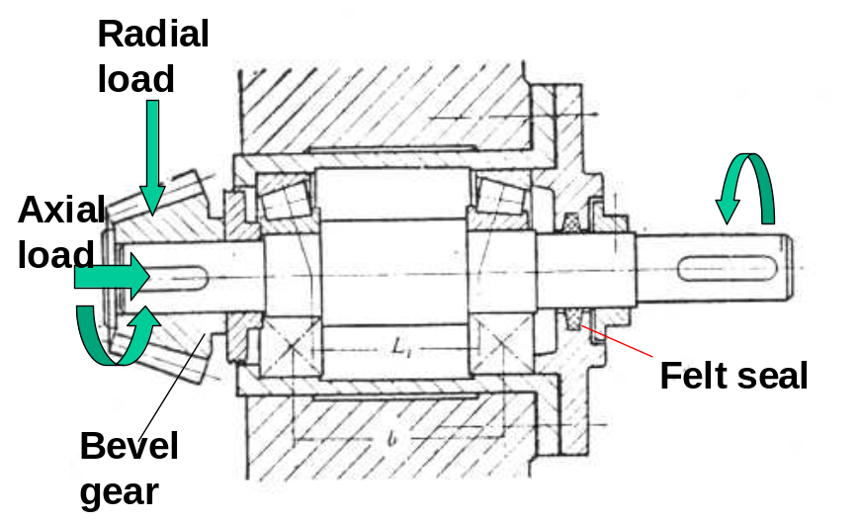

W_{r}
Torque

Design (I)
e
M_{a}
W_{r}
A
B
C
D
W_{a}

Torque

L₃
L₁
L₂

x
Bending Moment

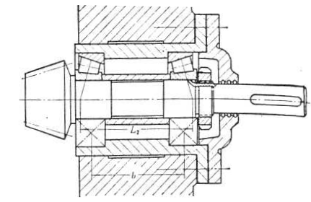

A
B
C
D

Design (II)

L₂
L₁
L₃

x
Bending Moment

2. Questions
1) Balls in a rolling-element bearing are in a pure-rolling motion between the inner and outer races. Here the inner race is rotating while the outer race is stationary. Pure rolling means that the surface speeds at a contact are the same. However, let’s neglect the motion first and assume that the load is supported by the contacts made by a single ball.

Which of the following contacts is more severe? the contact between the outer surface of the inner ring and the ball or the contact between the inner surface of the outer ring and the ball? Why?

Inner ring

Outer ring

ω
r
R

2) In a journal bearing, should the maximum pressure and the minimum film thickness appear at the same angular location or not? why?

3) Under the same load and speed and using the same lubricant (oil), should a wider (longer) journal bearing run with a thinner or thicker oil film between the surfaces of a journal and its bearing if the lubricant supply is sufficient?

4) For a bolted connection under shear loading, which of the following is proper for interface friction calculation?

(a) Preload (b) Bolt force (c) Member force

5) Mark, without calculation, the work stress point of a bolt after assembly but before loading and explain why.
S_{y}
σ_{a}

S’_{e}

S_{y}
S_{ut}
σ_{m’}

6) A gasket between members can increase/decrease (choose one) the member stiffness. Can you quickly estimate the member stiffness if the stiffness of a gasket is Kg?

7) Is the following form of the Goodman line proper for the analysis of the bolt factor of safety against fatigue? Why?

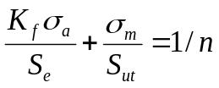

8) Four designs of a spherical thrust bearing are given below; each has a semi-spherical runner (red) and a seat (light green). The gap is determined by the tolerance of the runner and the seat. A lubricant will be supplied. Which one seems to be the most reasonable design? Why?
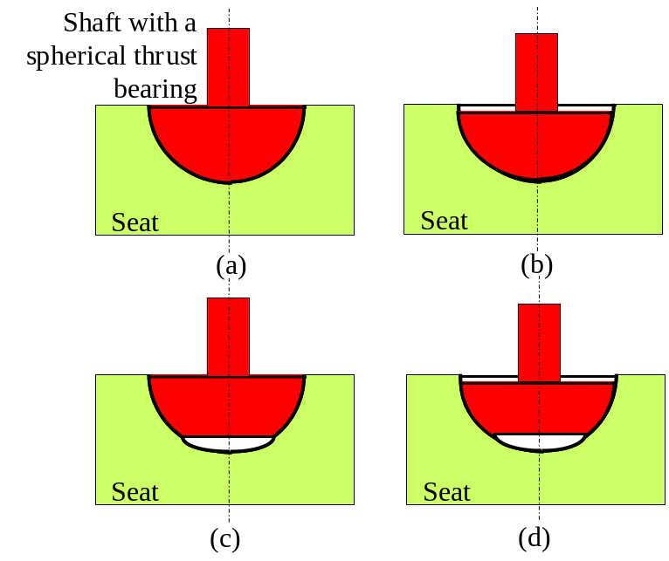

9) Point out the mistakes in the following bolted structures and explain the reason. Mark the mistakes as a-1,a-2, b-1, b-2, c-1, c-2, etc
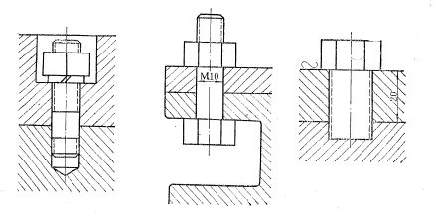

(a) (b) (c)

3. A steel cantilever structure is made with two members connected

by four bolts. Section I-I shows one of the bolts. The load on the cantilever is F. Four 8.8 M20x2 steel bolt (rolled) are used to make the connection. Ignore washers. The connection is reusable, the thickness of each member is t=25 mm, and the thickness of the nut is 15 mm. Without considering the wall effect for a conservative solution, determine
- Which bolt is under the maximum applied (external) shear force, and how large is the force?
- Length of the bolts, L, length of the threaded portion, L_{t}, and length of the shank, l_{d}, assuming that the bolt should have 3 mm outside of the nut after the assembly is completed.
- Joint constant and preload.
- Can the interfacial friction be sufficient to support F if friction coefficient is 0.3?

Parameters needed: E = 200 GPa for steels, F = 16000N, a= 150mm, d =150 mm, b= 200 mm, c= 300 mm, e= 50 mm.

