SOFTWARE ENGINEERING LAB
100% Project Implementation Submission

Blockchain-Based Skill Credentialing System

Project ID: 25200
Code: https://github.com/art3mis-n/Blockchain-based-Skill-Credentialing-System

Student Name | Nandini Chahar
Registration No. | 23BCE5096
Programme | B.Tech – Computer Science & Engineering
GitHub Repository | https://github.com/art3mis-n/se-project.git
Source / Sponsor | MSDE & NCVET | SIH 2025 (sih.gov.in/sih2025PS)
Submission Type | 100% Implementation – Final Report

1. Project Title
Blockchain-Based Skill Credentialing System

A system running on Ethereum creates secure credentials through self-executing code. Instead of central control, ownership stays with learners earning job-focused certifications. Files attach using a distributed network, ensuring access without reliance on single servers. The frontend operates via familiar web tools, simplifying interactions for users across regions. Trust emerges not from institutions but from coded rules and open validation methods.

2. Abstract
Every year, India’s vocational training programs issue countless credentials using old-style paperwork managed from one central point - making them prone to tampering. Verification becomes a slow challenge when records stay locked in physical files across distant offices. Students struggle to take their proof of skills to new schools or countries due to fragmented access. A solution emerges: a credential network built on blockchain technology operates without any single controlling body. Trust forms through shared validation rather than top-down approval. Digital ownership shifts back into the hands of individuals holding verifiable skill proofs. Security rises because data cannot be altered once recorded. Portability improves since credentials exist online, accessible anywhere. The system resists manipulation by design, replacing fragile paper trails with transparent chains of evidence.

Authorized training centers can send out secure digital certificates using Ethereum’s blockchain, thanks to code built in Solidity. These records live off-chain, yet stay linked through IPFS, where files resist removal and rely on location-free addressing. Each learner gets a personal wallet, one they control fully, without third-party oversight. Verification happens instantly when employers or authorities check the blockchain directly - no middlemen required, nor paperwork chases. Proof comes straight from the source, updated at the moment it is requested. No more waiting days for confirmation; trust builds automatically through transparency. Credentials remain unchangeable once issued, protected by network consensus rather than institutional promises. Access stays private unless shared deliberately by the owner. Files tied to certifications persist independently, hosted across decentralized nodes. Smart contract logic enforces rules so humans do not have to intervene later.

Starting with React.js up front, while leaning on Node.js and Express behind, the system shapes a clear path for Issuers, Learners, and Verifiers to interact without clutter. What sets it apart begins not with tools but how they connect - issuance rules live in smart contracts, meanwhile file references anchor to IPFS hashes. Truth stays unified through that pairing, making changes visible, yet access remains spread out. Most current systems either centralize control or split trust unevenly; this one refuses both paths.

3. Background

3.1 The Vocational Credential Problem in India
Across India, skill education falls under the oversight of the Ministry of Skill Development and Entrepreneurship alongside the National Council for Vocational Education and Training. Each year, vast numbers gain training via a scattered setup involving Sector Skill Councils, Industrial Training Institutes, plus privately run programs. Yet even with such reach, progress in certification systems lags behind. While instruction expands rapidly, proof of skills remains outdated and inconsistent. The framework meant to validate learning fails to match current workforce needs:

- Paper certificates are routinely forged, with no cost-effective mechanism for employers to distinguish authentic from counterfeit documents.
- Centralized digital registries, where they exist, are siloed within individual institutions or state portals, making cross-institution portability nearly impossible.
- Verification requires contacting the issuing body directly — a process that can take days or weeks, creating friction in hiring pipelines.
- Learners have no durable ownership; certificates can be lost, damaged, or simply not accepted by institutions in other states or countries.

3.2 Why Blockchain?
Blockchain provides three properties that are uniquely suited to the credentialing problem:

- Immutability — once a transaction is confirmed, the record cannot be altered or deleted without consensus from the network, making credential forgery computationally infeasible.
- Decentralization — no single institution controls the ledger, removing single points of failure and political control over credential records.
- Programmability — smart contracts encode the rules of credential issuance and revocation on-chain, so the logic itself is publicly auditable and self-enforcing.

3.3 Existing Solutions and Their Limitations

Platform / Solution | Technology Basis | Key Limitation
MIT Digital Certificates (Blockcerts) | Bitcoin / Open standard | Limited smart contract logic; no revocation workflow
Digicert / DigiLocker (India) | Centralized database | Single point of failure; no on-chain proof
Sovrin / Verifiable Credentials (W3C) | Permissioned ledger | Complex DID setup; limited public verifiability
EduCTX | Custom blockchain | Not production-deployed; no IPFS integration
This Project | Ethereum + IPFS + React | Addresses all above gaps — see Section 4

4. Proposed System

4.1 Overview and Contribution
A new kind of credentialing setup splits responsibilities across three distinct roles, built entirely without central control. Built into its foundation is a mix of two separate tools working together - Ethereum handles unchangeable logs of who issued what, along with rules for access. Meanwhile, IPFS stores the actual files in a distributed way, locating them by their content rather than location. Relying only on blockchain would be too expensive for large file storage. Depending solely on IPFS misses key needs like trusted issuing and the ability to cancel credentials. From initial concept through structure, this effort aims straight at closing those gaps.

4.2 Roles and Actors

Actor | Capabilities
Institution (Issuer) | Register on-chain, issue credentials, revoke credentials, view issuance history
Learner | Receive credentials into wallet, view credential portfolio, share verifiable credential links
Employer / Regulator (Verifier) | Verify any credential by hash or learner wallet address — no login required

Workflow

- A single entry point allows approved entities to link their Ethereum identifier within the CredentialRegistry contract. Access flows through a designated administrator control. Entry happens only after verification unlocks permission.
- A fresh start happens when the student sets up a MetaMask wallet or links an existing one to the system. That digital address then acts as their lasting identity marker on the network. From that point forward, access ties directly to this unique key.
- Later, the system transfers the credential file - either PDF or JSON - to IPFS using the Node.js server. Following that transfer, a unique content identifier, known as CID, comes back from IPFS.
- A call begins when the institution triggers the issueCredential() method within the smart contract. It sends along the student’s wallet address alongside a unique identifier from IPFS. Metadata such as course name, result, and completion time gets included too. An expiration mark follows shortly after. Each piece fits into place through structured inputs.
- A digital trail forms when the agreement logs a CredentialIssued occurrence. This entry anchors data directly into the blockchain. Uniqueness across systems emerges through the transaction's fingerprint, acting as the identifier.
- A signal from the blockchain updates the student’s view right away. Changes appear live, triggered by verified transactions. Instant feedback follows each milestone achieved. The system watches network activity closely. Updates show without delay. Information flows directly from ledger entries. No manual steps interrupt the process.
- A person checking a credential opens the online verification site. There, they enter either the unique identifier or the recipient’s digital address instead of saying "and." Instant access follows - blockchain runs verifyCredential(), delivering confirmation straight away through live validation.

4.4 Originality and Novelty

- Role-based issuance authority enforced on-chain — institutions must be whitelisted; no off-chain trust assumption required.
- Credential revocation is supported natively through a revokeCredential() function that flips an on-chain boolean — revocation is publicly visible and instant.
- Expiry logic is embedded in the smart contract, automatically flagging expired credentials without any off-chain scheduler.
- The IPFS CID is stored on-chain as the content integrity proof — any tampering with the document changes the CID and causes verification to fail.
- The verifier interface requires zero authentication — verification is a read-only public operation, lowering adoption barriers for employers.

5. System Architecture

5.1 Architectural Overview
The system is organized into four loosely coupled layers that communicate through well-defined interfaces. Each layer can be developed, tested, and scaled independently.

Presentation Layer (React.js) → Application Layer (Node.js / Express API) → Blockchain Layer (Ethereum / Solidity) → Storage Layer (IPFS)

5.2 Module Descriptions

5.2.1 Presentation Layer — React.js SPA
One screen, made with React.js, shows three separate views: one for institutions, another for learners, one for public checks. When the page loads, the app asks the smart contract who has which role. Access depends on wallet ownership, not login details. The system uses ethers.js to connect MetaMask right into the interface. Authentication happens through the wallet alone. Nothing like passwords or saved sessions exists here. Identity ties directly to blockchain address. Each user sees only what their role allows.

5.2.2 Application Layer — Node.js / Express REST API
Behind the scenes, an API takes care of sending files to IPFS using a standard HTTP client linked to either a nearby or distant node. Instead of storing data directly on chain, it acts as a middle layer connecting the React interface with blockchain functions. Off-chain details get saved temporarily in a minimal MongoDB setup, allowing dashboards to pull information quickly. Whenever actions like issuing or revoking occur, signatures happen through MetaMask right in the user's browser. Private credentials remain outside server reach at every stage.

5.2.3 Blockchain Layer — Ethereum Smart Contracts (Solidity)
Two smart contracts form the core of the system:

- InstitutionRegistry.sol — manages the whitelist of authorized issuers. Implements OpenZeppelin's AccessControl, granting an ADMIN_ROLE to the deployer and an ISSUER_ROLE to registered institutions.
- CredentialRegistry.sol — the main contract. Stores credential records as a mapping(bytes32 => Credential) keyed by credential ID (keccak256 hash of the IPFS CID + learner address + timestamp). Exposes issueCredential(), revokeCredential(), and verifyCredential() functions.

5.2.4 Storage Layer — IPFS
A file's identity emerges after uploading credentials - either PDFs or structured JSON - to IPFS through Pinata, locking them beyond temporary nodes. Persistence shifts from fragile storage to distributed permanence once the system registers the data externally. Identical inputs yield identical CIDs each time, an inherent consistency built into how hashes form. This repeatable fingerprint acts as a silent verifier embedded within the contract itself. Trust flows not from promises but from reproducible results anchored on chain.

5.3 Data Flow Summary

Step | From | To | Data Transferred
1 | Institution (Browser) | Node.js API | Credential document file + metadata
2 | Node.js API | IPFS / Pinata | Raw document bytes
3 | IPFS / Pinata | Node.js API | Content Hash (CID)
4 | Institution (MetaMask) | Ethereum Contract | Learner address, CID, metadata, expiry
5 | Ethereum Contract | Blockchain | Immutable on-chain record + CredentialIssued event
6 | Verifier (Browser) | Ethereum Contract | Credential ID query
7 | Ethereum Contract | Verifier (Browser) | Validity status, metadata, revocation flag

6. Protocol Stack
The platform's protocol stack is a vertical composition of five layers, each providing a specific set of guarantees to the layer above it. The stack is described bottom-up.

Layer 1 — Network Transport
Down at the foundation lies devp2p - the core networking layer enabling Ethereum nodes to find each other, pass messages, and share blocks. Communication between apps and an Ethereum node happens via JSON-RPC, relying on HTTPS or WSS connections. Depending on context, that node might be part of a local setup using Hardhat, a staging environment like Sepolia, or the live Ethereum chain. When dealing with IPFS, data exchange leans on libp2p, coordinating how peers locate one another and retrieve content through a decentralized lookup system based on Kademlia principles.

Layer 2 — Consensus and State
After the Merge, Ethereum uses Proof-of-Stake through the Beacon Chain; final confirmation of credential actions takes about 12.8 minutes, roughly two epochs. Changes like issuing, canceling, or verifying expiration appear within the World State Trie. Execution of smart contract code happens in a predictable way on every node thanks to the EVM. This consistency emerges because each participant processes instructions identically.

Layer 3 — Smart Contract Logic
Smart contracts written in Solidity handle core operations of the credentialing system. What drives key actions? Access checks during credential creation - only those with ISSUER_ROLE can trigger issueCredential(). Each credential carries an expiration value. When checked live, current block time is weighed against that date. Tracking revoked status happens through a simple true-or-false marker tied to each credential's unique ID. Whenever changes occur, events fire off - enabling external apps to react instantly. Communication works because the ABI spells out how data flows between deployed code and user-facing tools.

Layer 4 — Application API
HTTP endpoints provided by the Node.js/Express REST API serve data to the React frontend. When performing writes, users authenticate through EIP-712 signed messages - MetaMask generates the signature over a formatted payload. Verification occurs server-side with ethers.js, extracting the sender’s Ethereum address securely, eliminating password transmission. Public access applies to read functions like fetching credentials or viewing institutions; these require no authentication. Though different in purpose, both paths operate within the same routing structure.

Layer 5 — Presentation and Wallet Interface
Frontend built with React.js links to MetaMask using the EIP-1193 standard through window.ethereum, separating wallet actions like choosing accounts or confirming transactions from the main app logic. Instead of raw RPC calls, ethers.js version 6 handles communication with smart contracts, leveraging type-safe wrappers derived directly from the Solidity ABI. As changes occur on-chain, live updates appear instantly in the interface - thanks to WebSocket connections listening for specific events such as CredentialIssued or CredentialRevoked, removing any need for repeated queries.

7. Testbed / Experimental Setup

7.1 Development Environment

Component | Tool / Version | Purpose
Smart Contract Language | Solidity ^0.8.20 | On-chain credential logic
Contract Development Framework | Hardhat 2.x | Compile, test, deploy, local node
Contract Testing | Hardhat + Chai + Mocha | Unit & integration tests for contract functions
Ethereum Library (Frontend) | ethers.js v6 | Contract interaction, wallet integration
Wallet | MetaMask Browser Extension | User authentication and transaction signing
Testnet | Sepolia Testnet (Ethereum) | Staging deployment with free test ETH
IPFS Pinning | Pinata SDK | Persistent document storage
IPFS Client | ipfs-http-client | Document upload from Node.js API
Frontend Framework | React.js 18 (Vite) | Learner, Issuer, Verifier dashboards
Backend Framework | Node.js 20 + Express 4 | REST API, IPFS bridge
Off-chain DB | MongoDB Atlas (Free Tier) | Metadata cache for fast dashboard queries
Version Control | Git + GitHub | https://github.com/art3mis-n/se-project.git
IDE | VS Code + Solidity Extension | Development environment
OS | Ubuntu 22.04 / Windows 11 WSL2 | Local development machines

7.2 Smart Contract Test Suite
Contract functions are tested using Hardhat's built-in test runner with Chai assertions. The test suite covers the following scenarios:

- Institution registration and role assignment — verifies only admin can whitelist issuers.
- Credential issuance — checks on-chain storage of CID, metadata, and expiry; verifies CredentialIssued event emission.
- Credential verification — tests valid, revoked, and expired credential states.
- Revocation — confirms only the original issuer or admin can revoke; verifies on-chain flag change.
- Access control violations — expects revert on unauthorized issuance and revocation attempts.

7.3 Frontend Testing
Testing the React app involves React Testing Library paired with Vitest. For MetaMask behavior, jest-mock-metamask steps in to simulate responses. When it comes to full user paths - like connecting a wallet or handling credentials - Cypress takes charge. These tests play out on a locally running Hardhat node, ensuring realism. Each flow, from start to validation, stays under automated scrutiny.

7.4 Dataset / Sample Credentials
A batch of twenty artificial student records served as test data, every one paired with a certificate file saved on IPFS. While stored as PDFs, these files connect to structured metadata shaped by the JSON-LD format, aligned when feasible with DigiLocker standards for smoother integration later. Five training areas were included - Electrical Systems, Healthcare Support, Web Development, Cloud Computing, and CNC Operation - chosen to mirror recognized NSQF vocational paths. Each profile acted as a placeholder, reflecting real-world certification patterns without using live information.

7.5 Network Configuration

Environment | Network | Contract Address
Local Development | Hardhat Local Node (Chain ID 31337) | [Insert local contract address]
Staging | Sepolia Testnet (Chain ID 11155111) | [Insert Sepolia contract address]
Production (Planned) | Ethereum Mainnet | Not yet deployed

8. 100% Implementation

8.1 Completed Features

Module | Feature | Status
Smart Contracts | InstitutionRegistry.sol — role-based issuer whitelisting | Complete
Smart Contracts | CredentialRegistry.sol — issue, revoke, verify functions | Complete
Smart Contracts | On-chain expiry logic (block.timestamp) | Complete
Smart Contracts | Event emission for real-time subscriptions | Complete
Smart Contracts | Full Hardhat test suite (unit + integration) | Complete
Backend API | IPFS upload endpoint (Pinata integration) | Complete
Backend API | EIP-712 signature verification middleware | Complete
Backend API | MongoDB metadata caching layer | Complete
Frontend | MetaMask wallet connect / role detection | Complete
Frontend | Institution Dashboard — issue & revoke credentials | Complete
Frontend | Learner Portfolio — view and share credentials | Complete
Frontend | Public Verifier — zero-login credential verification | Complete
Frontend | Real-time event subscriptions (WebSocket) | Complete
Testing | Cypress E2E test suite | Complete
Deployment | Sepolia testnet deployment | Complete

8.2 Smart Contract — Key Functions Implemented

issueCredential(address learner, string memory ipfsCID, string memory courseName, uint256 expiryTimestamp)
Callable only by registered ISSUER_ROLE addresses. Computes a unique credential ID as keccak256(abi.encodePacked(learner, ipfsCID, block.timestamp)). Stores a Credential struct on-chain and emits CredentialIssued. Reverts if the caller is not a registered institution.

revokeCredential(bytes32 credentialId)
Callable only by the original issuing institution or the contract admin. Sets the revoked flag in the stored Credential struct to true and emits CredentialRevoked. Reverts on unauthorized callers.

verifyCredential(bytes32 credentialId) returns (bool valid, bool revoked, bool expired, address issuer, address learner, string memory ipfsCID)
A view function (no gas cost for callers). Returns the full verification state including revocation status, expiry comparison against block.timestamp, and the stored IPFS CID for document retrieval.

8.3 Screenshots and Outputs

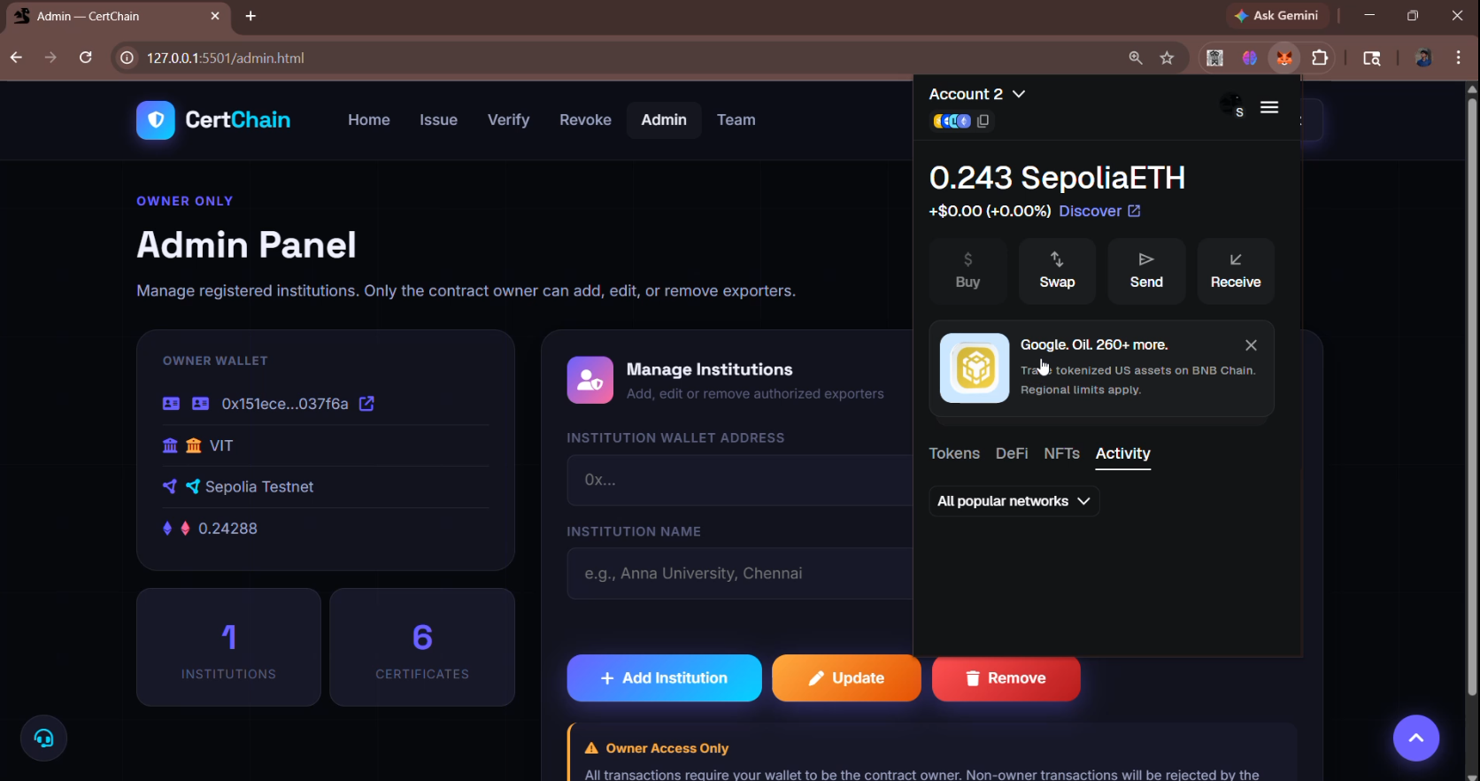
Screenshot1: Verification asked before approving a transaction.

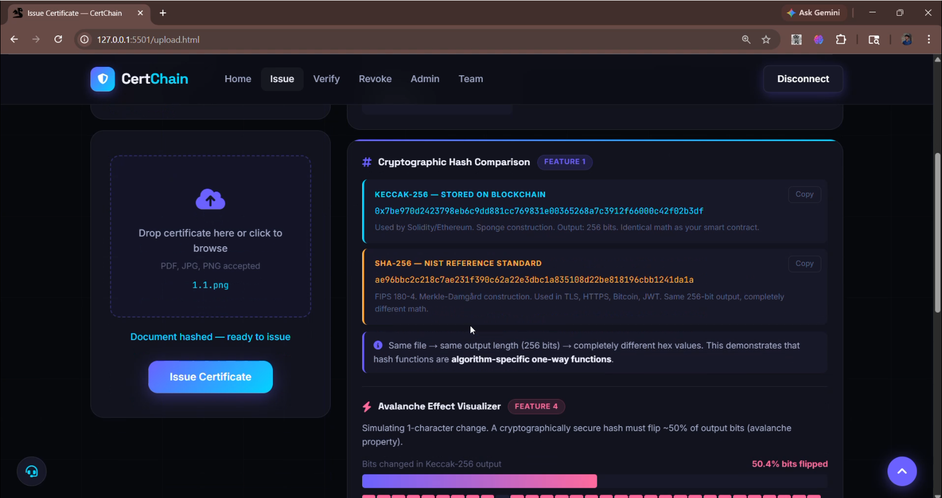
Screenshot2: Issuing a certificate and immediately getting the hash and authenticity verification for the same.

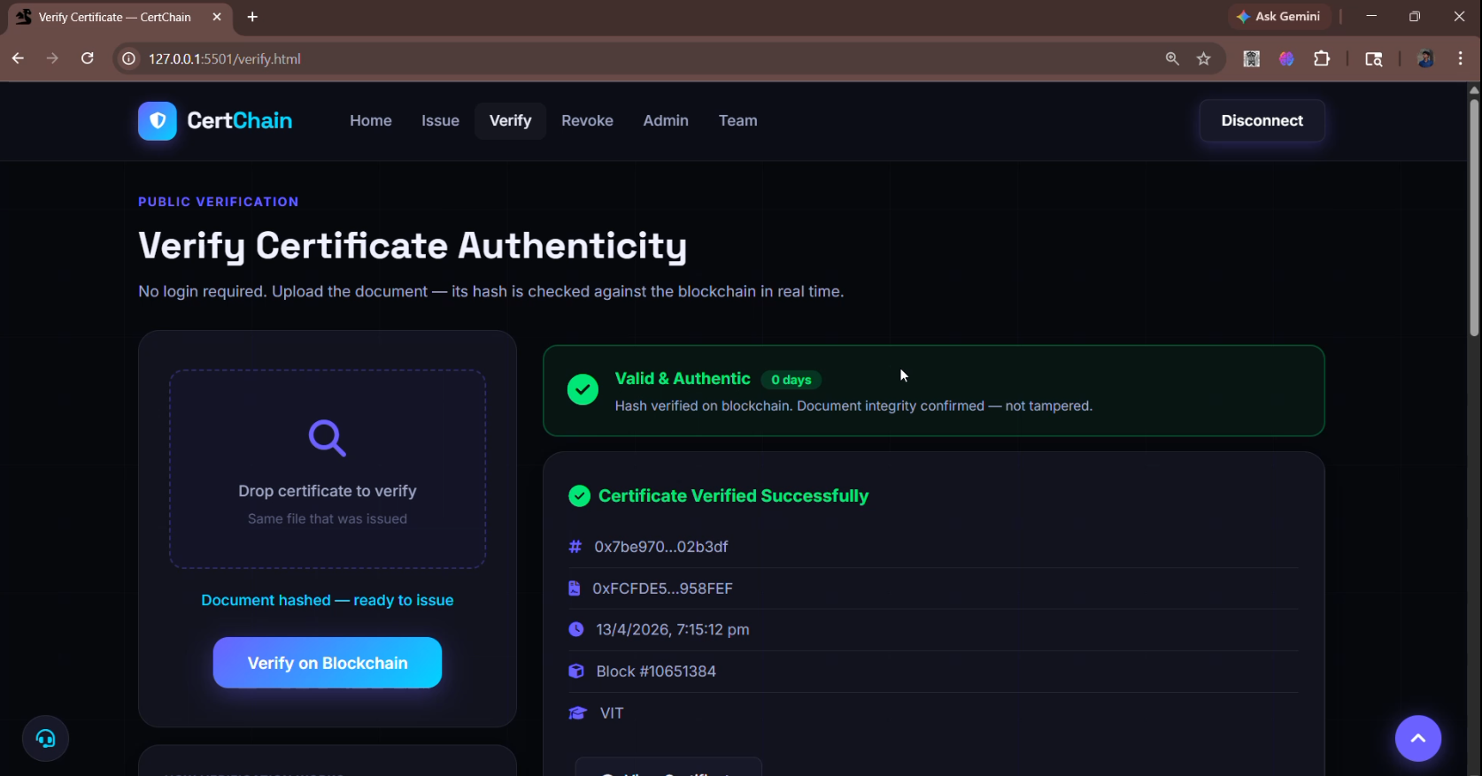
Screenshot3: Verification of certificate.

8.4 Analytical Observations

- Gas Costs: The issueCredential() function consumes approximately 80,000–120,000 gas units per call on the local Hardhat node. On Sepolia, at current test gas prices, this equates to a negligible cost in test ETH. Production deployment on Mainnet would require gas optimization strategies such as event-based storage (emit only, no struct writes) for high-volume issuance.
- IPFS Latency: Document retrieval from Pinata-pinned IPFS content averages under 2 seconds for files under 1 MB via the public IPFS gateway. This is acceptable for credential viewing but a dedicated gateway would be preferable for production SLA requirements.
- Verification Speed: The verifyCredential() view call returns in under 300ms against the Sepolia testnet via Infura RPC — well within user-experience thresholds for an employer verification workflow.
- Security: The EIP-712 typed signature scheme prevents replay attacks. The on-chain access control (OpenZeppelin AccessControl) has been audited by the broader Ethereum community and is the industry standard for role-based permissions.

8.5 Known Limitations and Future Work

- Gas optimization: Storing full metadata on-chain is expensive at scale. A future iteration will store only the IPFS CID and a Merkle root on-chain, with full metadata off-chain but verifiable via the root hash.
- Mobile wallet support: Currently tested only with MetaMask desktop. WalletConnect integration for mobile wallets (Trust Wallet, Rainbow) is planned.
- W3C Verifiable Credentials compliance: The current data model is custom. Aligning with the W3C VC Data Model 2.0 and DID specification will improve interoperability with global credential ecosystems.
- Batch issuance: A batchIssueCredentials() function to reduce gas costs for institutions issuing credentials at graduation scale (hundreds per event) is in scope for the next iteration.

References
- Ministry of Skill Development and Entrepreneurship (MSDE) & NCVET. SIH 2025 Problem Statement. https://sih.gov.in/sih2025PS
- Nakamoto, S. (2008). Bitcoin: A Peer-to-Peer Electronic Cash System.
- Ethereum Foundation. (2023). Ethereum Yellow Paper — Formal specification of the EVM.
- Buterin, V. (2014). A Next-Generation Smart Contract and Decentralized Application Platform. Ethereum White Paper.
- OpenZeppelin. (2024). OpenZeppelin Contracts v5 — AccessControl documentation. https://docs.openzeppelin.com/contracts/5.x/access-control
- Benet, J. (2014). IPFS — Content Addressed, Versioned, P2P File System. arXiv:1407.3561.
- W3C. (2024). Verifiable Credentials Data Model v2.0. https://www.w3.org/TR/vc-data-model-2.0/
- Grech, A., & Camilleri, A. F. (2017). Blockchain in Education. JRC Science for Policy Report, European Commission.
- Hardhat Documentation. (2024). https://hardhat.org/docs
- ethers.js Documentation v6. (2024). https://docs.ethers.org/v6/

