

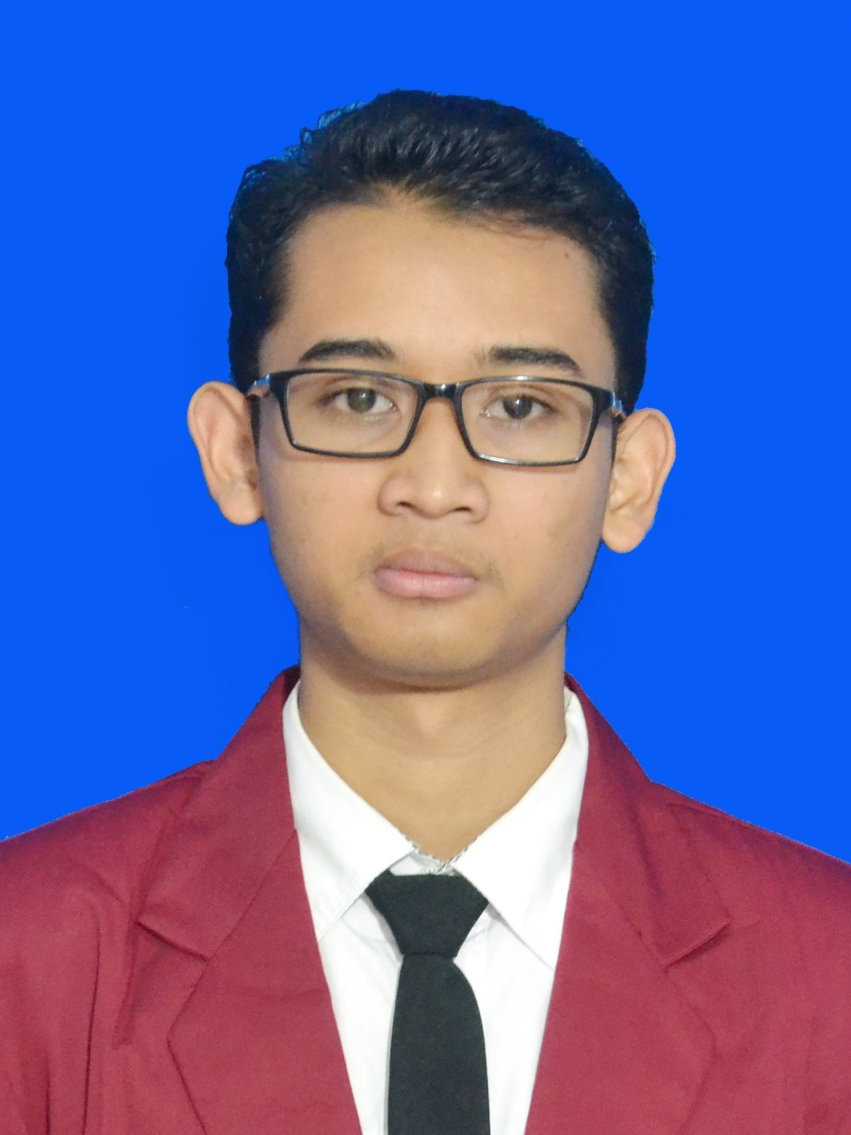
Nama : I Gede Arta Wiguna
NIM : 16101468
Jurusan : TM-MTI

Syntax Program

<!DOCTYPE html>
<html lang="en">
<head>
<title>KTM milik Arta Wiguna</title>
<style type="text/css">
body {
background-color: white;
font-family: "arial", sans-serif;
font-size: 11px;
}
table {
background-color: white;
border-spacing: 0;
border-radius: 10px;
margin: 30px auto;
box-shadow: 0 2px 4px 0 rgba(0,0,0, .3);
}
.tabel-logo {
padding-left: 10px;
background-color: #802020;
border-top-right-radius: 10px;
border-top-left-radius: 10px;
}
.logo-stiki {
width: 200px;
height: 40px;
}
.foto-saya {
width: 75px;
height: 95px;
border: 1px solid black;
margin: 20px 10px 10px 10px;
}
.data{
padding-right: 5px;
height: 10px;
}
.kartu-mahasiswa{
padding-left: 10px;
width: 200px;
height: 40px;
}
</style>
</head>

<body>
<table border="0">
<tr>
<td colspan="2" class="tabel-logo"><img src="GAMBAR/STIKI_image.png" class="logo-stiki"></td>
</tr>
<tr>
<td class="kartu-mahasiswa" >KARTU MAHASISWA</td>
<td rowspan="5"><img src="GAMBAR/16101468_arta_wiguna.jpeg" class="foto-saya"></td>
</tr>
<tr>
<td align="right" class="data"><strong>I GEDE ARTA WIGUNA</strong></td>
</tr>
<tr>
<td align="right" class="data" >16101468</td>
</tr>
<tr>
<td align="right" class="data" >TEKNIK INFORMATIKA</td>
</tr>
<tr>
<td align="right" ></td>
</tr>

</table>
</body>
</html>

