


Nama : I Gede Arta Wiguna
NIM : 16101468
Jurusan : TM-MTI
Tugas : WEB 1

Hasil

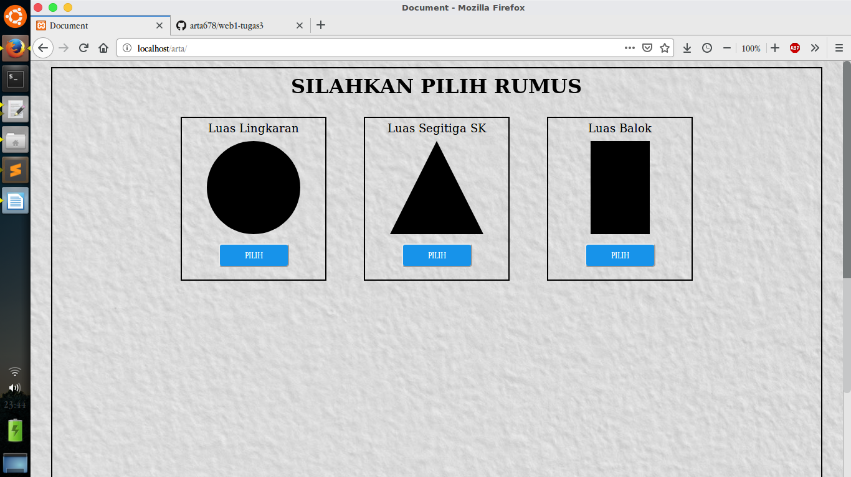
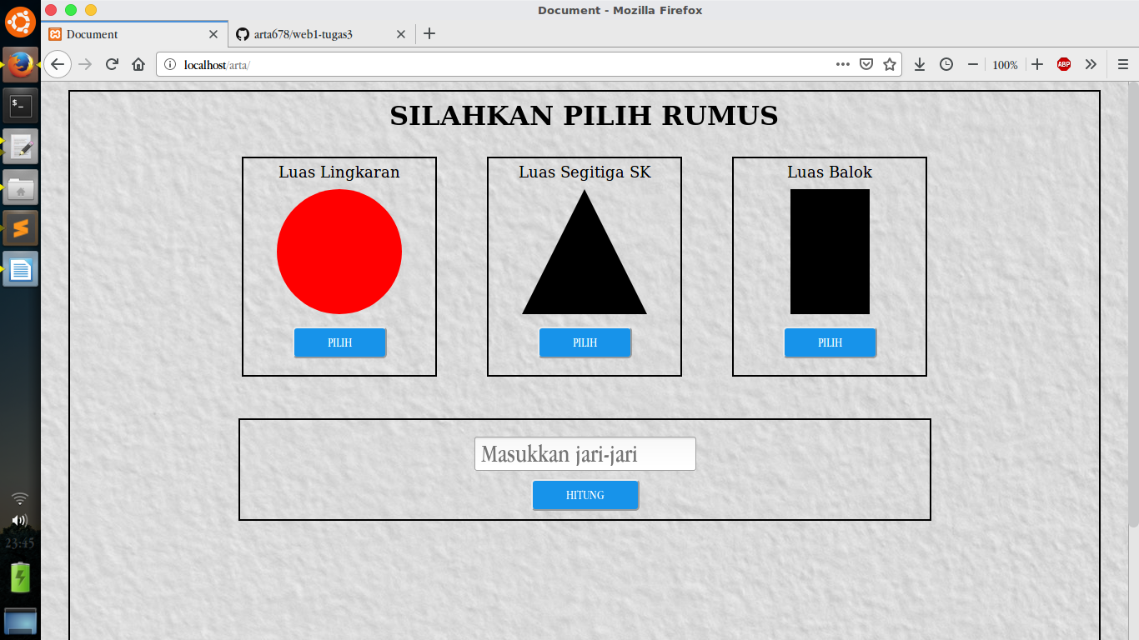
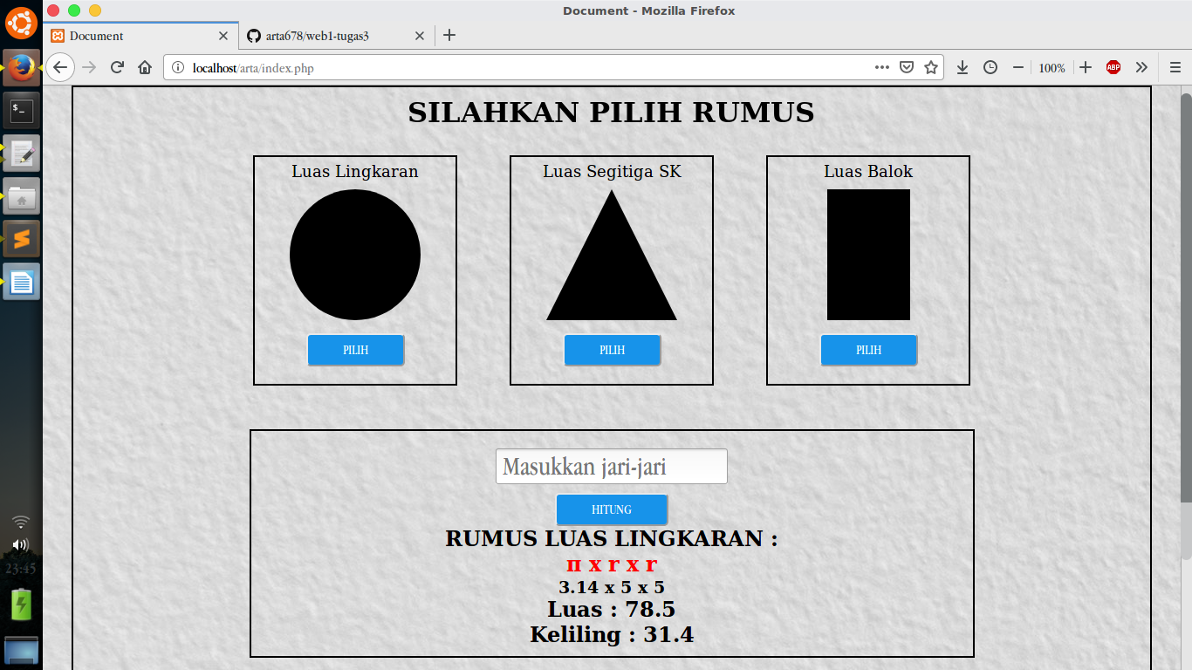

Syntax Program

File index.php

<!DOCTYPE html>
<html lang="en">
<head>
<title>Document</title>
<link rel="stylesheet" type="text/css" href="style.css">
<link rel="stylesheet" type="text/css" href="animations.css">
<script src="JQuery-3.3.1.min.js"></script>
</head>
<body >

<div class="kulit-luar">
<div class="kulit-seg-ling-bal">
<dir class="animated zoomIn">
<h1>SILAHKAN PILIH RUMUS</h1>
</dir>

<!-- Konten atau pilihan rumus -->
<div class="bungkus-konten">

<!-- pilihan lingkaran -->
<div id="pilih-lingkaran">
<p>Luas Lingkaran</p>
<dir id="ling"></dir>
<button id="tmbl-ling" onclick="gantiWarnaLingkaran()">PILIH</button>
</div>

<!-- pilihan segitiga -->
<div id="pilih-segitiga">
<p>Luas Segitiga SK</p>
<div id="segi"></div>
<button id="tmbl-seg" onclick="gantiWarnaSegitiga()">PILIH</button>
</div>

<!-- pilihan balok -->
<div id="pilih-balok">
<p>Luas Balok</p>
<div id="balok"></div>
<button id="tmbl-bal" onclick="gantiWarnaBalok()">PILIH</button>
</div>
</div>

<!-- PERHITUNGAN -->
<div class="bungkus-konten-perhitungan">

<!-- ====================PERHITUNGAN LINGKARAN================== -->
<div class="bungkus-perhitungan-ling <?=isset($_POST['btn-lingkaran']) ? "lihat-data" : "" ?>">
<div class="konten-perhitungan-ling">
<form action="index.php" method="post">
<div class="group">

<input type="text" name="jari2" placeholder="Masukkan jari-jari">
</div>
<button id="btn-lingkaran" class="btn-lingkaran" name="btn-lingkaran">HITUNG</button>
</form>
</div>
<div class="output-ling">
<?php
if(isset($_POST['btn-lingkaran'])){
$jari2 = $_POST['jari2'];
$phi = 3.14;
$luas_lingkaran = $phi * $jari2 * $jari2;
$keliling_lingkraran = $phi*($jari2 + $jari2);
echo "<h2>RUMUS LUAS LINGKARAN : <br></h2> ";
echo "<h2 style='color:red'> π x r x r <br></h2> ";
echo "<h3>$phi x $jari2 x $jari2 <br></h3> ";
echo "<h2>Luas : $luas_lingkaran <br></h2>";
echo "<h2>Keliling : $keliling_lingkraran</h2>";
}
?>
</div>
</div>

<!-- =======================PERHITUNGAN SEGITIGA=================== -->

<div class="bungkus-perhitungan-seg <?=isset($_POST['btn-segitiga']) ? "lihat-data" : "" ?>">
<div class="konten-perhitungan-seg">
<form action="index.php" method="post">
<div class="group">

<input type="text" name="alas" placeholder="Masukkan alas">

<input type="text" name="tinggi" placeholder="Masukkan tinggi">
</div>
<button id="btn-segitiga" class="btn-segitiga" name="btn-segitiga">HITUNG</button>
</form>
</div>
<div class="output-seg">
<?php
if(isset($_POST['btn-segitiga'])){
$alas= $_POST['alas'];
$tinggi = $_POST['tinggi'];
$luassegitiga = round(1/2*$alas*$tinggi,2);
echo "<h2>RUMUS LUAS SEGITIGA SAMA KAKI : <br></h2> ";
echo "<h2 style='color:red'> 1/2 x alas x tinggi <br></h2> ";
echo"<h3>1/2 x $alas x $tinggi";
echo"<h2>Luas Segitiga SK = ".$luassegitiga."<h2>";
};
?>
</div>
</div>

<!-- =======================PERHITUNGAN BALOK=================== -->

<div class="bungkus-perhitungan-bal <?=isset($_POST['btn-balok']) ? "lihat-data" : "" ?>">
<div class="konten-perhitungan-bal">
<form action="index.php" method="post">
<div class="group">
<input type="text" name="panjang" placeholder="Masukkan Panjang">
<input type="text" name="lebar" placeholder="Masukkan Lebar">
<input type="text" name="tinggi-balok" placeholder="Masukkan Tinggi">
</div>
<button id="btn-balok" class="btn-balok" name="btn-balok">HITUNG</button>
</form>
</div>
<div class="output-bal">
<?php
if(isset($_POST['btn-balok'])){
$panjang= $_POST['panjang'];
$lebar = $_POST['lebar'];
$tinggi = $_POST['tinggi-balok'];
$luasb = round(2*(($panjang*$lebar)+($panjang*$tinggi)+($lebar*$tinggi)),2);

echo "<h2>RUMUS LUAS BALOK : <br></h2> ";
echo "<h2 style='color:red'> 2 (p.l + p.t + l.t)<br></h2> ";
echo"<h3>2 ( $panjang * $lebar + $panjang * $tinggi + $lebar * $tinggi )";

echo"<h2>LUAS BALOK = ".$luasb."<h2>";
};
?>
</div>
</div>

<!-- ============================================================================= -->
</div>
</div>
</div>
<script>
// JQuery
$(document).ready(function() {
$('#tmbl-ling').click(function(){
$('.bungkus-perhitungan-ling').toggleClass('lihat-data animated bounceInLeft');
$('.bungkus-perhitungan-seg').removeClass('lihat-data');
$('.bungkus-perhitungan-bal').removeClass('lihat-data');

});
$('#tmbl-seg').click(function(){
$('.bungkus-perhitungan-seg').toggleClass('lihat-data animated zoomIn ');
$('.bungkus-perhitungan-ling').removeClass('lihat-data');
$('.bungkus-perhitungan-bal').removeClass('lihat-data');
});

$('#tmbl-bal').click(function(){
$('.bungkus-perhitungan-bal').toggleClass('lihat-data animated bounceInRight');
$('.bungkus-perhitungan-ling').removeClass('lihat-data');
$('.bungkus-perhitungan-seg').removeClass('lihat-data');

});

});
// JavaScript

function gantiWarnaLingkaran(){
document.getElementById("ling").style.background = "red";
document.getElementById("segi").style.borderBottom = "150px solid black";
document.getElementById("segi").style.borderLeft = "75px solid transparent";
document.getElementById("segi").style.borderRIght = "75px solid transparent";
document.getElementById("balok").style.background = "black";
}
function gantiWarnaSegitiga(){
document.getElementById("ling").style.background = "black";
document.getElementById("segi").style.borderBottom = "150px solid red";
document.getElementById("segi").style.borderLeft = "75px solid transparent";
document.getElementById("segi").style.borderRIght = "75px solid transparent";

document.getElementById("balok").style.background = "black";
}

function gantiWarnaBalok(){
document.getElementById("ling").style.background = "black";
document.getElementById("segi").style.borderBottom = "150px solid black";
document.getElementById("segi").style.borderLeft = "75px solid transparent";
document.getElementById("segi").style.borderRIght = "75px solid transparent";
document.getElementById("balok").style.background = "red";
}

</script>
</body>
</html>
File style.css

* {
padding: 0;
margin: 0;
}
p {
font-size: 18px;
margin-bottom: 10px;
margin-top: 5px;

}
.h3{
color: red;
margin: 20px;
}

#ling{

width: 150px;
height: 150px;
background: black;
border-radius: 100%;
margin-bottom: 15px;
}

#segi{
height: 0;
width: 0;
border-left: 75px solid transparent;
border-right: 75px solid transparent;
border-bottom: 150px solid black;
margin-bottom: 15px;
}
#balok{
width: 95px;
height: 150px;
background: black;
margin-bottom: 15px;
}

body {
width: 100%;
height: 100%;
background-image: url("gambar/bg.jpg");
}

h1 {
margin-bottom: 0px;
}

.kulit-luar {
height: 100%; height: 600px;
}

.kulit-seg-ling-bal {
margin: 10px auto;
padding: 10px 30px 30px 30px;
display: flex;
flex-direction: column;
text-align: center;
width: 90%;
height: 760px;
border: 2px solid black;
}

.bungkus-konten {
display: flex;
justify-content: center;
}

#pilih-lingkaran, #pilih-segitiga, #pilih-balok {
display: flex;
flex-direction: column;
align-items: center;
width: 230px;
height: 260px;
border: 2px solid black;
margin: 30px;
background-color:
}

button {
padding: 8px 40px;
color: #FFF;
background-color: #1793EA;
border-radius: 5px;
cursor: pointer;
font-size: 15px;
text-align: center;
margin: 0 auto;
}
#tmbl-ling:hover, #tmbl-seg:hover, #tmbl-bal:hover{
background-color: #2F4F4F;
box-shadow: 0 2px 6px 0 rgba(0,0,0, .50);
transform: scale(1.06);
}

/* PERHITUNGAN */
.bungkus-konten-perhitungan {
width: 100%;
height:auto;
margin-top: 20px;
display: flex;
justify-content: center;
align-items: left;
}

.bungkus-perhitungan-ling, .bungkus-perhitungan-seg, .bungkus-perhitungan-bal {
display: none;
flex-direction: column;
align-items: left;
border: 2px solid black;
width: 827px;
padding: 10px 0;
}

.lihat-data {
display: flex;
}

.group {
flex-direction: column;
align-items: center;
display: flex;
}

input {
margin: 10px 0;
width: 250px;
height: 30px;
font-size:30px;
}

