


Nama : I Gede Arta Wiguna
NIM : 16101468
Jurusan : TM-MTI
Tugas : Tugas 4 WEB 1

Hasil

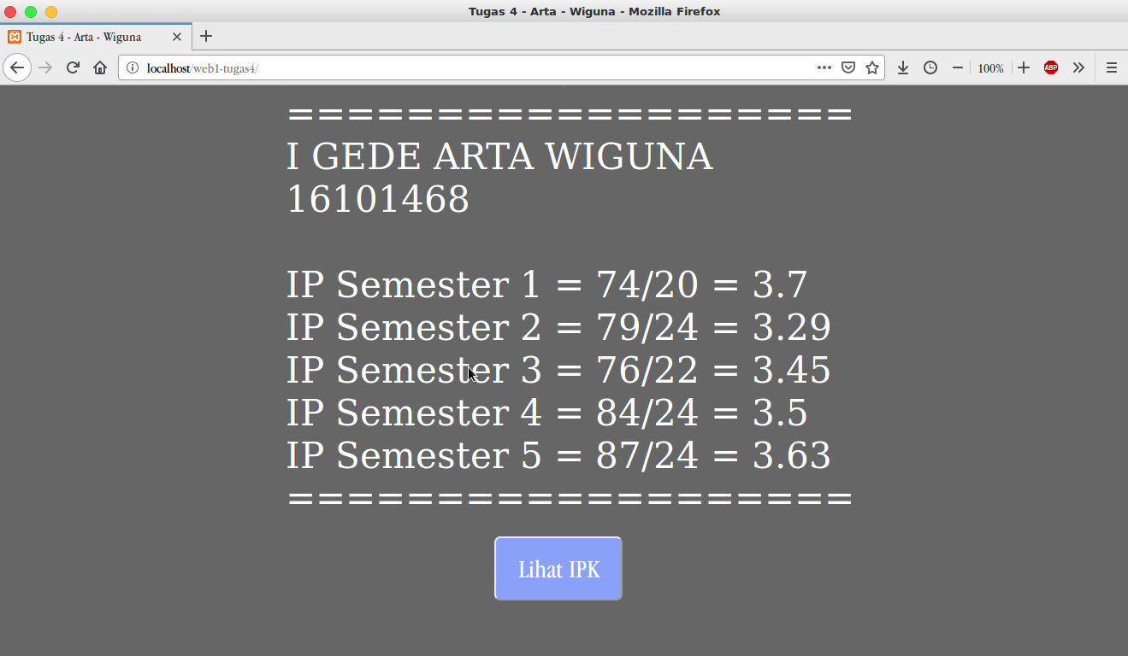

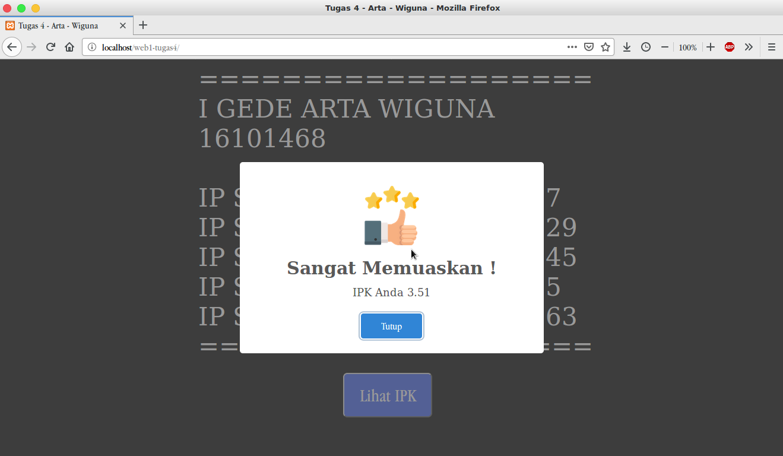

Syntax Program

File index.php

<!DOCTYPE html>
<html>
<head>
<title>Tugas 4 - Arta - Wiguna</title>
<link rel="stylesheet" type="text/css" href="style.css">
</head>
<body>
<div class="bos">
<?php

$bobot = [74,79,76,84,87];
$sks = [20,24,22,24,24];

$ipk = (( ($bobot[0]/$sks[0])+
($bobot[1]/$sks[1])+
($bobot[2]/$sks[2])+
($bobot[3]/$sks[3])+
($bobot[4]/$sks[4]))/count($bobot));

$nilaiIPK = round($ipk,2);

echo " ===================<br>
I GEDE ARTA WIGUNA<br>
16101468<br><br>";

for ($i=0; $i < count($bobot); $i++) {

$ips = $bobot[$i] /$sks[$i];

$cekIPS ="";
if ($ips>4) {
$cekIPS = "(IPS > 4)";
} elseif ($ips<0) {
$cekIPS = "(IPS < 0)";
}

echo "IP Semester ",$i+1," = ",
$bobot[$i],"/",$sks[$i]," = ",
round($ips,2)," ",$cekIPS,"<br>";
}

// ---------CEK KONDISI IPK----------
if ($ipk >= 3.75 && $ipk<= 4) {
$keterangan = "Cum Laude !";
$urlgambar = "gambar/up.png";
$warna = "#fff";
}elseif ($ipk <= 3.74 && $ipk >= 3.50 ) {
$keterangan = "Sangat Memuaskan !";
$urlgambar = "gambar/up.png";
$warna = "#fff";
}elseif ($ipk<=3.49 && $ipk>=3) {
$keterangan = "Memuaskan !";
$urlgambar = "gambar/up.png";
$warna = "#fff";
}elseif($ipk<3 && $ipk>0){
$keterangan ="IPK Kurang Memuaskan!";
$urlgambar = "gambar/down.png";
$warna = "#F8AEAE";
}else{
$keterangan = "Ups Sepertinya Anda salah Input Nilai!";
$urlgambar = "gambar/error.png";
$warna = "#F8AEAE";
}

echo " ===================<br>";
echo " <script>
function sw(){
Swal.fire({
imageUrl: '$urlgambar',
imageHeight: 100,
imageWidth:100,
title: '$keterangan',
text: 'IPK Anda $nilaiIPK',
confirmButtonText: 'Tutup',
background: '$warna',

})
}
</script>";
?>

<button onclick="sw()" class="btnLihatIpk">Lihat IPK</button>

</div>
<script src="sweetalert2/dist/sweetalert2.all.js"></script>
<script src="https://cdn.jsdelivr.net/npm/sweetalert2@8"></script>
</body>
</html>
File style.css

body{
background-color: #666666;
color: #fff;
}
.btnLihatIpk{
background-color: #8AA1F9;
color: white;
height: 75px;
width: 150px;
font-size: 30px;
border-radius: 7px;
margin-left: 25%;
cursor: pointer;
margin-top: 20px;
}
.bos{
font-size: 42px;
margin-left: 25%;
}

.btnLihatIpk:hover{
transform: scale(1.1);
transition: all .2s ease-in-out;
text-decoration: none;
}

