**DOCUMENTATION OF  
“NEXT.JS STORE” APPS**

1. Use case

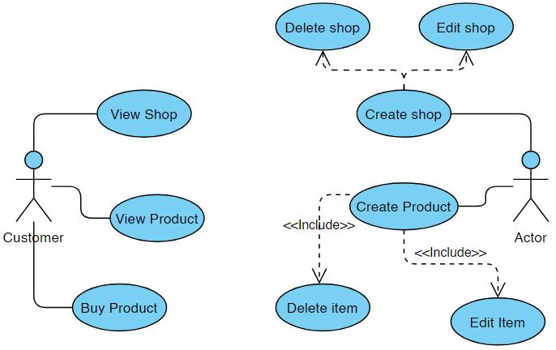

1. Flowchart

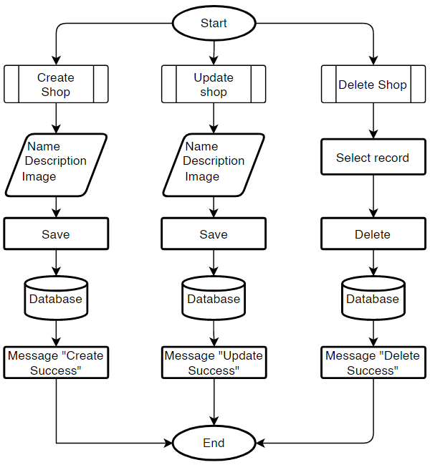

1. ERD (Entity Relationship Diagram)

