





Capella SysML Bridge

User Guide

Table of content

1 Installation 4

1.1 Prerequisite 4

1.2 Delivrable 4

1.3 Install CapellaMapping_VP_1_2_1-1.0.4 viewpoint 4

2 SysML to Capella import 6

2.1 Supported input data 6

2.2 Configuration 7

2.3 Execution 8

2.3.1 Set the default XML configuration file. 8

2.3.2 Launch the SysML to Capella Import. 9

3 Capella to SysML export 12

3.1 Supported output 12

3.2 Configuration 12

3.3 Execution 12

# Installation

## Prerequisite

**Capella 1.2.x** is needed to execute Capella SysML Bridge.

*Rem*: the tool has been developed and validated with Capella 1.2.1 but should be compliant with other patch releases of the 1.2 version.

## Install CapellaMapping_VP_1_2_1-1.0.4 viewpoint

* Unzip the “*CapellaMapping_VP_1_2_1-<version>-dropin.zip”* and copy the “*CapellaMapping_VP_1_2_1-<version>”* viewpoint root directory in the Capella 1.2.1 **dropins** folder.

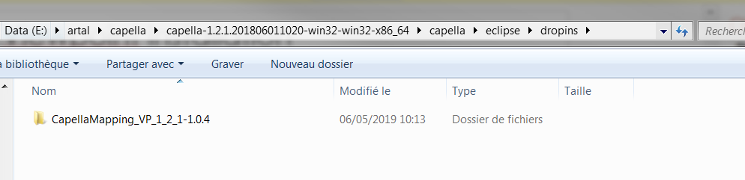

* Launch Capella 1.2.1.
  + Open the “Window -> Preferences -> Capella -> SysML” wizard to check the Capella Bridge is correctly installed.

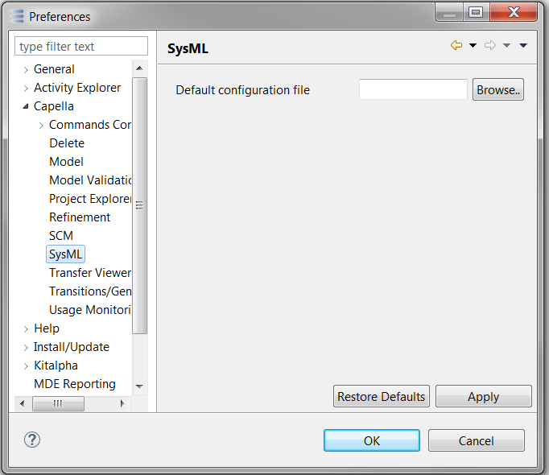

# SysML to Capella import

## Supported input data

* The SysML model shall be exported from Cameo Systems Modeler in the *Eclipse UML2 (v5.x) XMI file* format.

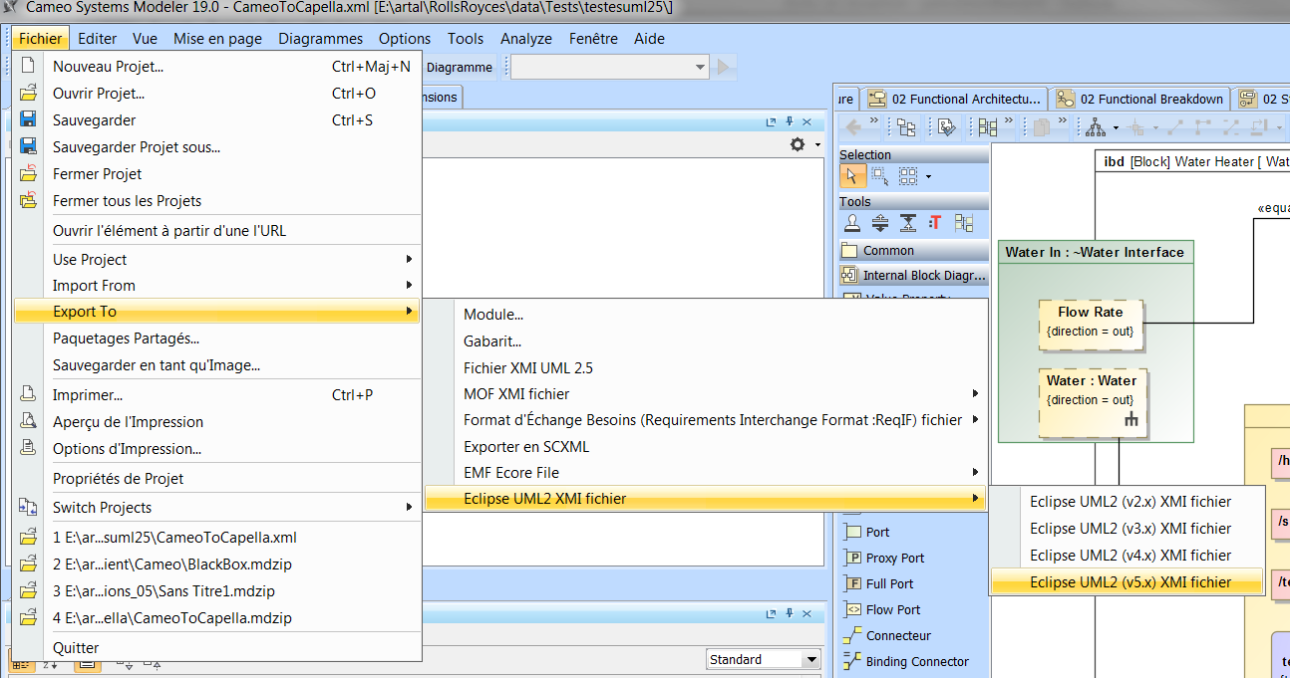

* Among the different exported files, the one used for the import into Capella is the *<Project Name>.uml* file.

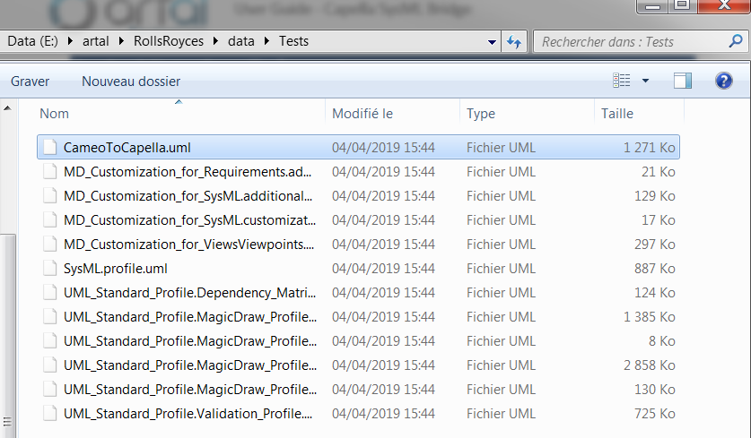

## Configuration

* The SysML model in Cameo System Modeler can follow a specific organization of packages. An example is presented here below:

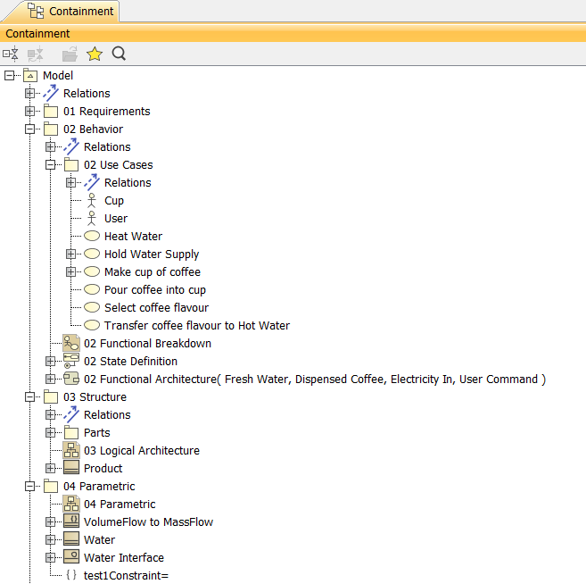

* Capella Bridge requires a configuration file to read this specific structure.

This configuration file is an XML file with the following structure:

<?xml version=*"1.0"* encoding=*"UTF-8"*?>

<configurations>

<useCasesPath path=*"02 Behavior/02 Use Cases"* />

<activitiesPath path=*"02 Behavior/02 Functional Architecture"* />

<partPath path=*"03 Structure/Parts"* />

<productPath path=*"03 Structure/Product"* />

<parametricPath path=*"04 Parametric"* />

</configurations>

1. **Use cases path** defines the Cameo packages containing the Actors, Capabilities and Associations (between Actors and Capabilities) to be transposed into Capella LogicalActor and CapabilityRealization elements.
2. **Activities path** defines the Cameo packages containing the Activities to be transposed into a Capella LogicalFunction breakdown structure.
3. **Part path** defines the Cameo package containing the Blocks to be transposed into Capella LogicalComponent elements.
4. **Product path** defines the Cameo package containing the root block (i.e. the Logical System)
5. **Parametric path** defines the Cameo package containing the Blocks to be transposed into ExchangeItem and Class Capella elements.

## Execution

**Prerequisite:** Before to launch the mapping, the Capella user shall create the Capella project where the SysML elements shall be imported.

### Set the default XML configuration file.

* Select the “Window -> Preferences -> Capella -> SysML” preference to display the following wizard.

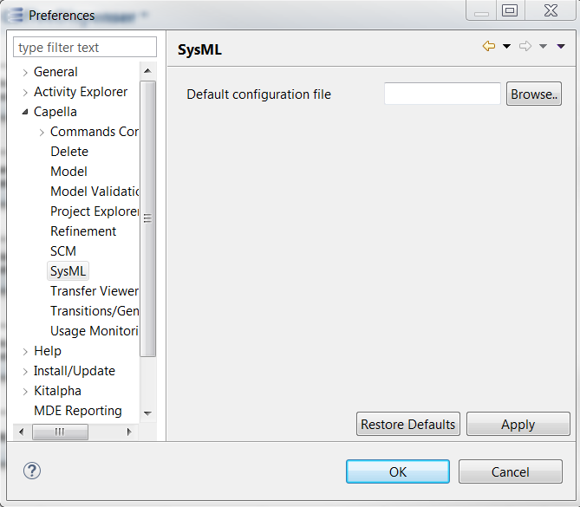

* Set the XML configuration file in the “Default configuration file” field, and click on “OK” button. In this way, this configuration file is automatically set in the import SysML launcher.

### Launch the SysML to Capella Import.

* Right-click on the Logical Architecture node in the Capella Project Explorer and the following menu displayed.

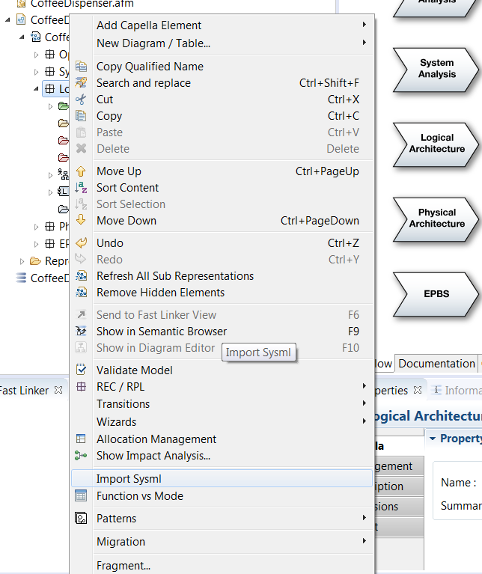

* To launch the SysML to Capella import, click on the “Import Sysml” action. The following wizard is displayed:

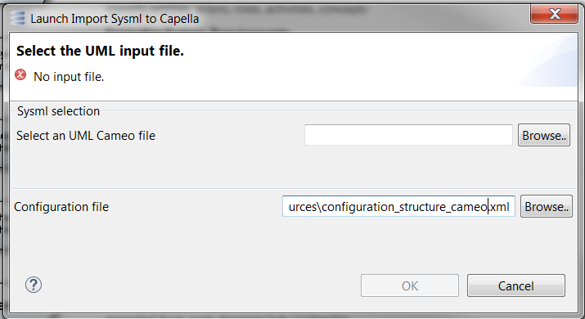

* Select, in the “Select an UML Cameo file” field, the UML input file and click on the “OK” button.
* In the Capella Package Explorer, under the Logical Architecture node, the following datas are imported:

The Logical Functions breakdown structure.

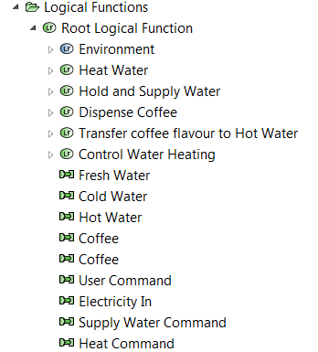

The Capabilities

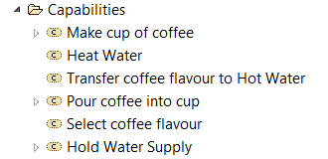

The exchange Items, the classes and the constraints

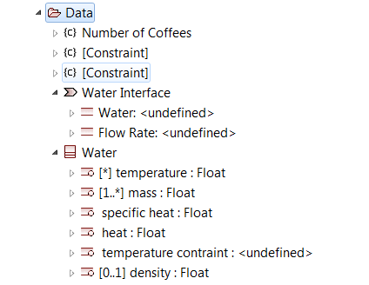

The Logical Sytem breakdown structure.

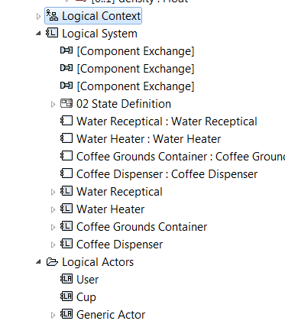

The State Definition structure

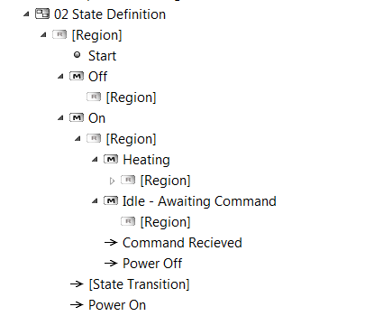

# Capella to SysML export

## Supported output

## Configuration

## Execution

END OF THE DOCUMENT