


Republika ng Pilipinas
Kagawaran ng Edukasyon
Rehiyon XI
Sangay ng Lungsod ng Dabaw
Purok ng Piedad
PIEDAD CENTRAL ELEMENTARY SCHOOL
Lungsod ng Dabaw

LESSON  PLAN | School | Piedad Central Elem. School | Grade Level | Non-Graded
 | Teacher | Anthony M. Castro | Learning Area | Functional Mathematics
 | Date: | December 09, 2025 | Quarter | 3

- CURRICULUM CONTENT, STANDARDS, AND LESSON COMPETENCIES
- CONTENT STANDARD: | The learner demonstrates understanding of the concept of whole numbers
- PERFORMANCE  STANDARD: | The learner recognizes and organizes numbers according to value up to 20
- LEARNING COMPETENCY/OBJECTIVES: | - Rote count up to 5 (TF_MFP_nv_NG-1)  - Identify numerals up to 5 (TF_MFP_nv_NG-3)  - Develop enthusiasm towards rote counting & identifying numerals
- CONTENT: | Rote counting & Identifying numeral up to 5
REFERENCE: | DO 21, S. 2020 – K-12 Transition Curriculum for Learners with Disabilities (p. 37 or in the p. 48)
- INTEGRATION | - Identification of Animals  - Gross motor exercise  - Music  - Fine motor: Tracing and Writing
- LEARNING RESOURCES | Laptop, videos, number cards,
- TEACHING AND LEARNING PROCEDURE
- REVIEWING THE PREVIOUS LESSON | - Preliminaries:  - Prayer  - Exercise (Psychomotor Activities)  - Greetings  - Fine Motor Exercise  - Review  “Tap and Count”  - Learner will be instructed to tap the number (something rough or fury) on the table while they are counting from 1-3  - The teacher model first the task to undertake  - Teacher will lead the learner and when they can do it on their own, then the teacher will let them do the task  - The teacher will emphasize that the numbers presented were the number introduced in the previous lesson and will paste it on the board.
- ESTABLISHING PURPOSE OF THE LESSON | - Motivation: “Number Detective Mission”  - The teacher will show a magnifying glass to the learner (The magnifying glass is just a mockup to represent that they need to search for an object.)  - The learner will collect the number that they will find.  - The teacher will show a star and this will be a sign that the number they are searching is on that place.  - The teacher will lead the learner towards the first station up until to the last.  - A medal will be given after completing the task as a reward!  - Lesson Presentation  - After the task, the teacher will paste the numbers on the board and will slowly arrange it together with the learners according to its correct sequence. A set of number will be placed above as a visual guide to the learner.  
- LESSON LANGUAGE PRACTICE | - Present a fun video of numbers from 1-5 with words  - The teacher will give an emphasis to it by presenting the numbers 1 – 5 with words.  - The teacher will help spell out each number to the learners  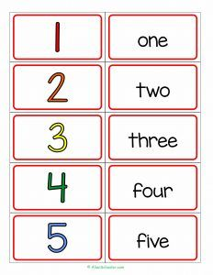
- DEVELOPING AND DEEPINING UNDERSTANDING | - Let’s practice Counting:  - Learners will be instructed to count the set of animals that the teacher will present  - Teacher will guide the learners in identifying the animals and will guide them to count it.  - The teacher will model first the task and have the learners do it with guidance and necessary prompts.  - Fill in the missing number:  - The learner with the guidance of the teacher will fill in the missing number on the given (2) set of number.  - The teacher will slowly count the sets of number and ask the learners what is the missing number.  - The learner will be given choices and they will paste the correct number on the space provided.  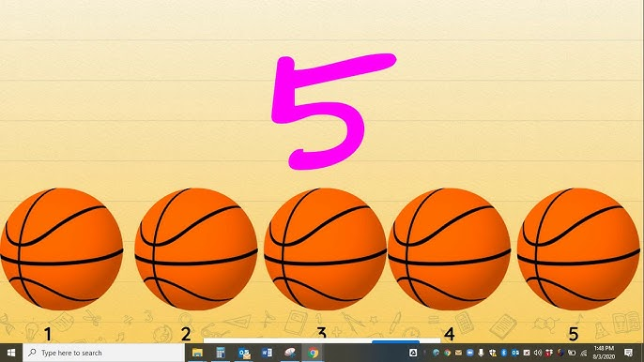  ____  2  1  3    2  1  3  ____  4
- MAKING GENARALIZATION | - Let’s Count and Hop  - Teacher will put numbers on the floor  - Learners will hop while counting in each number (1-5)  - The teacher will remind learners to be careful and guide them one-by-one  - The teacher will explain that counting follows sequence like how they hop on the numbers.  - After, the teacher will let the learners count again with the video.
- EVALUATING LEARNING: FORMATIVE ASSESSMNET & TEACHER’S REFLECTION
A. EVALUATING LEARNING | - Identifying no. 4 2. Identifying no. 5  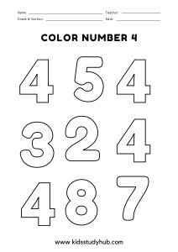  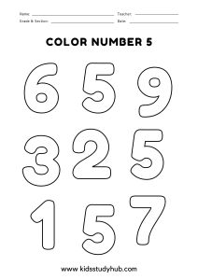  3. Fill in the missing number.  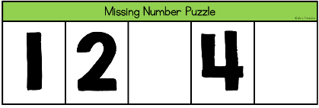  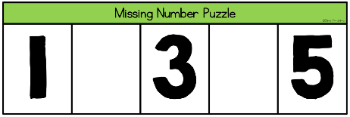  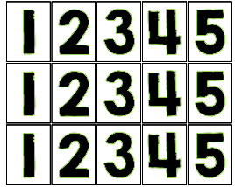  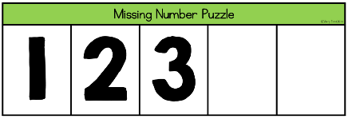  - Additional Activity (Note: this task will be supplemented once the learner finished the task early, however, if not, the task can be brought home to practice fine motor, tracing and writing numbers.  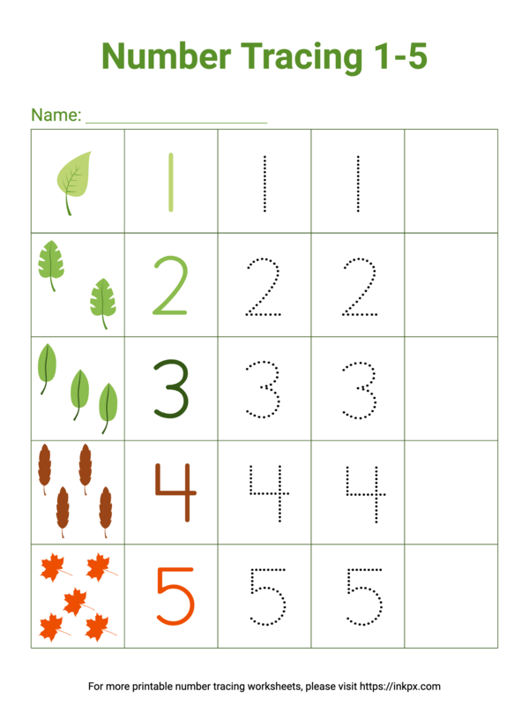
- TEACHER’S REMARKS | Learner A | Learner B
- TEACHER’S REFLECTION

Prepared by: Observed by:
ANTHONY M. CASTRO LEILA ESPITH B. CARNICE
SPET-II Master Teacher II

