LOCATING A RADIO TRANSMITTER WITH TDOA
A step-by-step build guide for two low-cost demonstrators using hardware you already own
Solution 1 - RTL-SDR receivers, ADALM-Pluto reference, bladeRF target (433 MHz)
Solution 2 - bladeRF + Pluto receivers, ESP32 Wi-Fi reference and target (2.4 GHz)
Written for a reader with little radio experience. Every step says what to do, how to check it worked, and why it is needed.
Includes: block diagrams, node drawings, frequency plans, site layouts, a field-day plan, troubleshooting tables and complete, tested software (simulator included).
Version 1.0 - October 2026

Read this first
This guide takes you from a box of radios to a working demonstration that finds where a transmitter is, and reports how far off the answer is. It is written so that you can follow it on site, one step at a time.

What you will have at the end
- Three (or four) receiver stations spread 150-300 m apart, each built from a Raspberry Pi and a radio you already own.
- A 'reference' transmitter at a known point and a 'target' transmitter you pretend not to know.
- Software on a laptop that prints the target's estimated latitude/longitude, a Google-Maps link, the error in metres, and draws a map (examples in section B12).

The two solutions in one table
 | Solution 1 (start here) | Solution 2 (after Solution 1 works)
Receivers | 3-4 RTL-SDR dongles on Raspberry Pis | 2 bladeRF + 1 ADALM-Pluto on Raspberry Pis
Reference transmitter | ADALM-Pluto, own test signal | ESP32 board sending short Wi-Fi packets
Target transmitter | bladeRF, own test signal | ESP32 board sending long Wi-Fi packets
Band / signal width | 433 MHz / 0.54 MHz | 2.4 GHz Wi-Fi / about 20 MHz
Extra money | about $0-60 | about $20-40 (+ Solution 1 items)
Realistic accuracy | 10-50 m open site; 50-150 m between buildings | 5-30 m open site
Difficulty | Lowest | Medium

How to use this guide
- Read Part A once (about 30 minutes): the ideas everything else depends on. No maths needed.
- Do Solution 1 in this order: install software, run the simulator at your desk, do the bench test in one room, then go to the field. Do not skip the simulator and bench test: they find 90% of problems while you are still near a power socket.
- Only then start Solution 2. It reuses everything from Solution 1.
- Use Part D to turn your results into a funding demonstration, and to see the upgrade path to real-time and longer range.
Software kit
All programs are in the folder tdoa_kit (delivered with this guide as tdoa_kit.zip) and printed in full in Appendix B. They were tested end-to-end on simulated recordings that include every real-world problem described here (clock errors, start-time errors, frequency errors, reflections, neighbouring Wi-Fi). They have not yet been run on your particular hardware, so the bench test in each solution is where you confirm that.
CAUTION: Transmitting legally
Both solutions use small test transmitters. Use the lowest power that works, keep transmissions short, stay inside the frequencies given here, and get written permission from your university (and, if they advise it, from PTA) before transmitting outdoors. Receiving is passive and harmless; transmitting is what needs care. Section A8 covers this.

Contents
Part A - The ideas behind TDOA
A1 What a time difference tells you - A2 Why timing is everything - A3 The four problems with cheap receivers
A4 The reference-transmitter trick - A5 Correlation - A6 From time differences to a position
A7 What accuracy to expect - A8 Safety, permissions and good practice
Part B - Solution 1: RTL-SDR receivers at 433 MHz
B1 What you are building - B2 Equipment list - B3 Frequency plan and test signals
B4 Installing the software - B5 Desk rehearsal (simulator) - B6 Bench test
B7 Building a field node - B8 Choosing and surveying the site - B9 Power and gain
B10 Field-day procedure - B11 Processing and results - B12 Troubleshooting - B13 More accuracy
Part C - Solution 2: Wi-Fi with bladeRF + Pluto at 2.4 GHz
C1 What changes - C2 Equipment - C3 Wi-Fi signal and channel - C4 Programming the ESP32s
C5 Receiver software - C6 Desk rehearsal - C7 Bench test - C8 Field procedure
C9 How the drift correction works - C10 Troubleshooting
Part D - Turning results into a funding demonstration
D1 What to show - D2 Near-real-time operation - D3 Upgrade path
Appendices
A Glossary - B Complete program listings - C Command cheat sheet
D Hardware facts - E Field log sheet - F References

Part A - The ideas behind TDOA (no maths needed)
TDOA stands for Time Difference Of Arrival. A radio signal travels from the transmitter to every receiver at the speed of light. A receiver that is closer hears it slightly earlier. If we can measure *how much earlier* one receiver hears it than another, we know something about where the transmitter is.

A1. What a time difference tells you
Take two receivers, A and B. Suppose the signal reaches B 300 nanoseconds (ns) later than A. Light travels about 30 cm per ns, so the transmitter must be 90 m further from B than from A. There are many points that are exactly 90 m further from B than from A. Together they form a curve called a hyperbola. One pair of receivers therefore tells you the transmitter is somewhere on one curve.
Add a third receiver C. The pair A-C gives a second curve. The transmitter is where the two curves cross (Figure 1). That is the whole principle. A fourth receiver adds more curves, which makes the answer more reliable and lets the software notice when one receiver is giving a bad measurement.
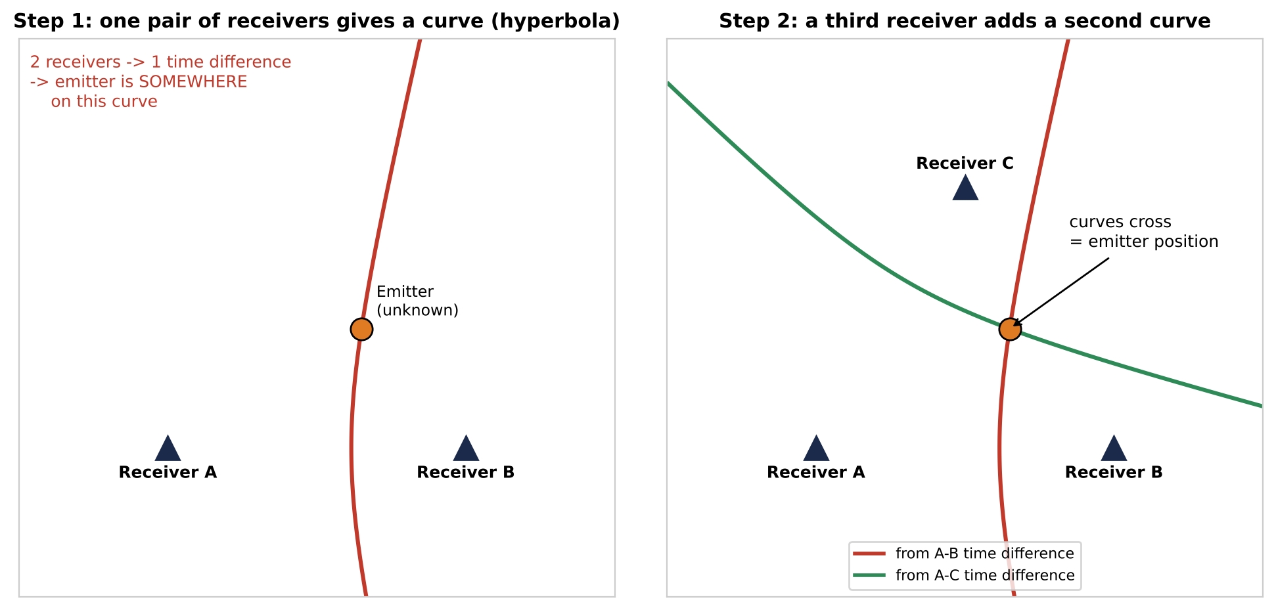
Figure 1. Two receivers give a curve of possible positions; a third receiver gives a second curve, and the crossing point is the transmitter.
WHY: Why at least three receivers?
On flat ground the position has two unknowns (east and north). Each independent time difference gives one equation. Three receivers give two independent time differences, which is exactly enough. A fourth receiver gives a check on the other three.

A2. Why timing is everything
Because light is so fast, tiny timing mistakes turn into large distance mistakes (Figure 2). For your 100 m target, the time differences must be right to about 0.3 microseconds (333 ns) or better. A Raspberry Pi's own clock, even when corrected over the internet, is only good to a few milliseconds - that is 10,000 times too coarse. So the Pi's clock alone can never be used to time the signal.
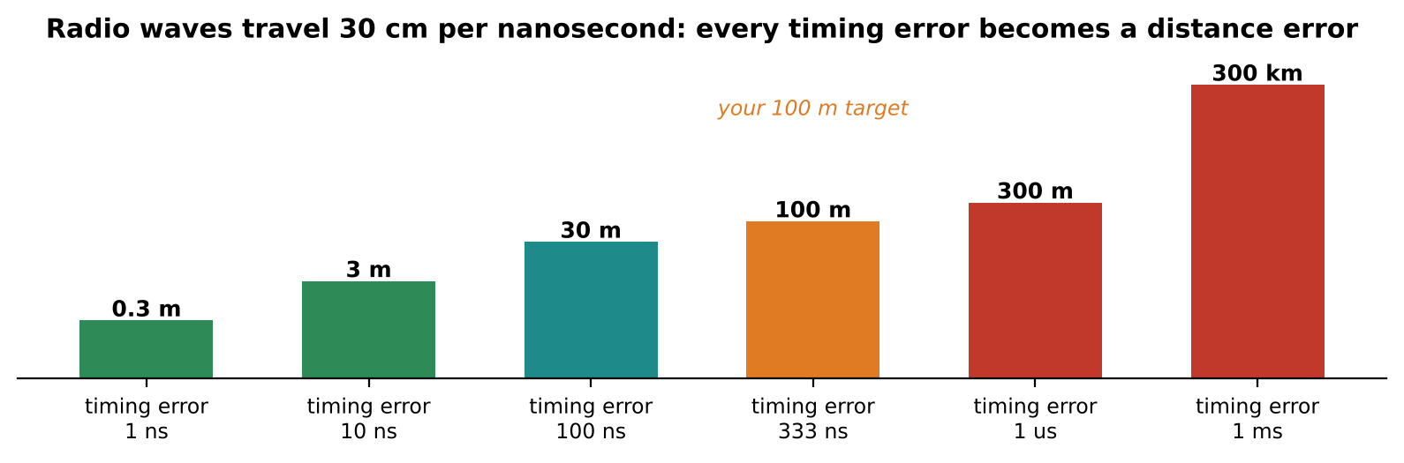
Figure 2. Timing error versus distance error. A 1 ms clock error (a typical internet-synchronised Pi) is 300 km.
Timing error | Distance error | Comment
1 ns | 0.3 m | professional systems
10 ns | 3 m | very good GPS-disciplined systems
100 ns | 30 m | what this guide aims for
333 ns | 100 m | your stated target
1 ms | 300 km | Raspberry Pi clock with NTP: useless for timing the signal itself

A3. The four problems with cheap receivers
Every receiver station has its own small 'clock' (a crystal oscillator) that sets when samples are taken and what frequency it is tuned to. With independent, cheap receivers four things go wrong:
Problem | What it means | Typical size | How this guide solves it
1. Start time | Each Pi starts its recording at a slightly different moment. | 1-50 ms | Reference transmitter (A4)
2. Frequency error | Each radio is tuned a little off. Measured in ppm (parts per million). | 1-25 ppm = 0.4-11 kHz at 433 MHz | Measured from the reference signal and removed (squaring trick)
3. Clock drift | Each radio's sample clock runs slightly fast or slow, so timing slides during a recording. | 1-25 ppm = 1-25 us per second | Short measurement pieces (Sol. 1); a straight-line drift fit (Sol. 2)
4. Internal delays | Cables, filters and USB add delay that differs between stations. | 10 ns - several us | Cancels automatically with the reference method

Professional systems fix problems 1-3 with a GPS-disciplined oscillator (GPSDO) at every station, costing about $150-250 each. This guide fixes them with a cleverer measurement instead, which costs nothing.

A4. The trick: a reference transmitter at a known spot
We place a second transmitter, the reference, at a spot whose position we have measured carefully. Every receiver records the reference and the target in the same recording, at the same time.
Now compare two receivers, node 1 and node 2. When we line up their recordings using the reference signal, the shift we find contains two things: the unknown start-time difference between the two Pis, plus the known geometry of the reference (we know exactly how far the reference is from each node). When we line them up using the target signal, the shift contains the same unknown start-time difference plus the unknown target geometry we want.
Subtract the two shifts and the unknown start-time difference disappears (Figure 3). Add back the known reference geometry and you have the target's true time difference. Anything else that is the same for both signals inside one station - cable length, filter delay, USB delay - disappears in the same subtraction.
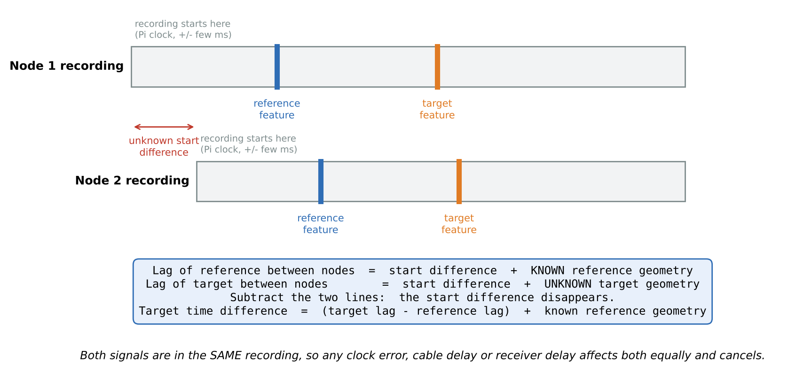
Figure 3. The reference method. Both features are in the same recording, so the start-time difference cancels when the two lags are subtracted.

A worked example with real numbers
Quantity | Value | Where it comes from
Reference lag, node 2 vs node 1 | 12,300,582 ns | measured by correlation
Target lag, node 2 vs node 1 | 12,300,007 ns | measured by correlation
Difference (target - reference) | -575 ns | subtraction: the 12.3 ms start difference is gone
Reference geometry: (distance ref-node2 - distance ref-node1) / c | +582 ns | from your survey: (497.4 - 323.0) m = 174.4 m, / 0.2998 m per ns
Target time difference | +7 ns -> 2.1 m | -575 + 582 ns; this goes to the solver

WHY: Why not just use GPS timing?
You can, later (Part D). GPS timing needs extra hardware at every node and the RTL-SDR cannot accept an external clock without modification. The reference method needs no extra hardware and also removes cable and receiver delays, which a GPSDO alone does not. It is a well-established technique: DC9ST used it with RTL-SDRs and Raspberry Pis, and a Charles University thesis (Hrach) used it with unmodified RTL-SDRs.

A5. How a time difference is measured: correlation
We cannot see a sharp 'tick' in the radio signal, so we use correlation: slide one recording past the other and, at every shift, measure how similar they are. At the right shift they match and the similarity jumps to a sharp peak (Figure 4). The position of that peak is the lag.
- The signal must look like noise. A pure tone or a slowly changing signal matches itself at many shifts and gives a broad, ambiguous peak. A pseudo-random (PN) signal, or digital data like Wi-Fi, matches only at one shift. That is why Solution 1 transmits our own PN signal.
- Wider signals give sharper peaks. The peak width is roughly 1 / bandwidth. Solution 1's 540 kHz signal gives a peak about 2 us wide; Wi-Fi's 20 MHz gives about 50 ns. Narrower peak means more precise timing - and better rejection of reflections.
- We find the peak to a fraction of a sample. The RTL-SDR takes one sample every 417 ns (2.4 million per second). The software interpolates between samples, like reading between the marks on a ruler, so it finds the peak to a few nanoseconds when the signal is clean.
- Averaging helps against noise, not against reflections. The software measures 60 pieces of 10 ms each and takes the median. Noise averages away; a reflection that is always there does not.
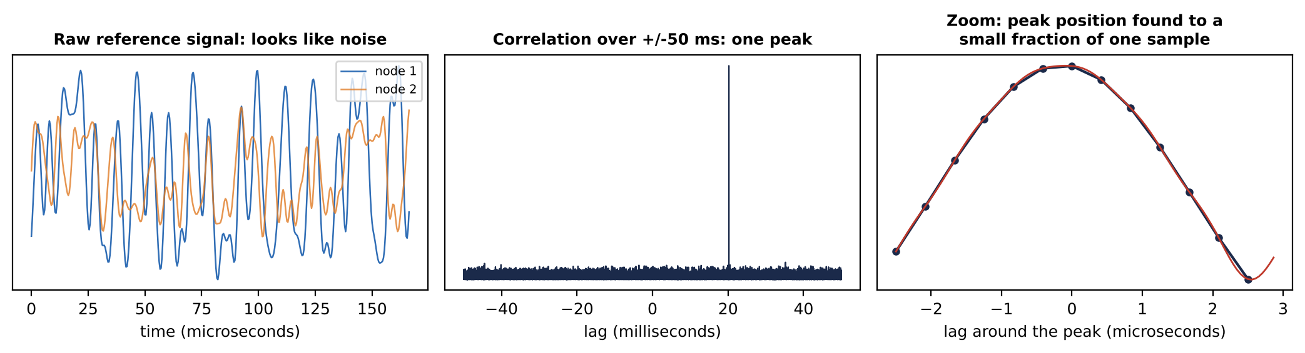
Figure 4. Correlation on real (simulated) recordings. Left: the signal looks like noise. Middle: correlation over +/-50 ms has one sharp peak. Right: the peak is found between samples.

A6. From time differences to a position
Each measured time difference, multiplied by the speed of light, is a 'range difference' in metres. The software then looks for the point on the map that agrees best with all of them:
- Grid search: it tries every point on a 5 m grid over a 3 km x 3 km area and scores how well each agrees. This cannot get stuck on a wrong answer.
- Polish: starting from the best grid point, a least-squares routine moves to the exact best point.
- Report: it converts back to latitude/longitude, compares with the true target position if you gave it, and draws the map with the hyperbolas.
WHY: Why the target should be inside the triangle
Inside the triangle of receivers the hyperbolas cross at large angles, so a small timing error moves the crossing point only a little. Far outside, the curves become nearly parallel and the same timing error slides the crossing a long way. This effect is called geometric dilution of precision (GDOP).

A7. What accuracy to expect, and why
The electronics are rarely the limit. In simulation the software reaches below 1 m with a clean signal. Real sites add the errors in Figure 5. The single biggest one is reflections (multipath): a signal bouncing off a building arrives slightly later and blurs the correlation peak. Open sites with clear line of sight between all stations give the best results.
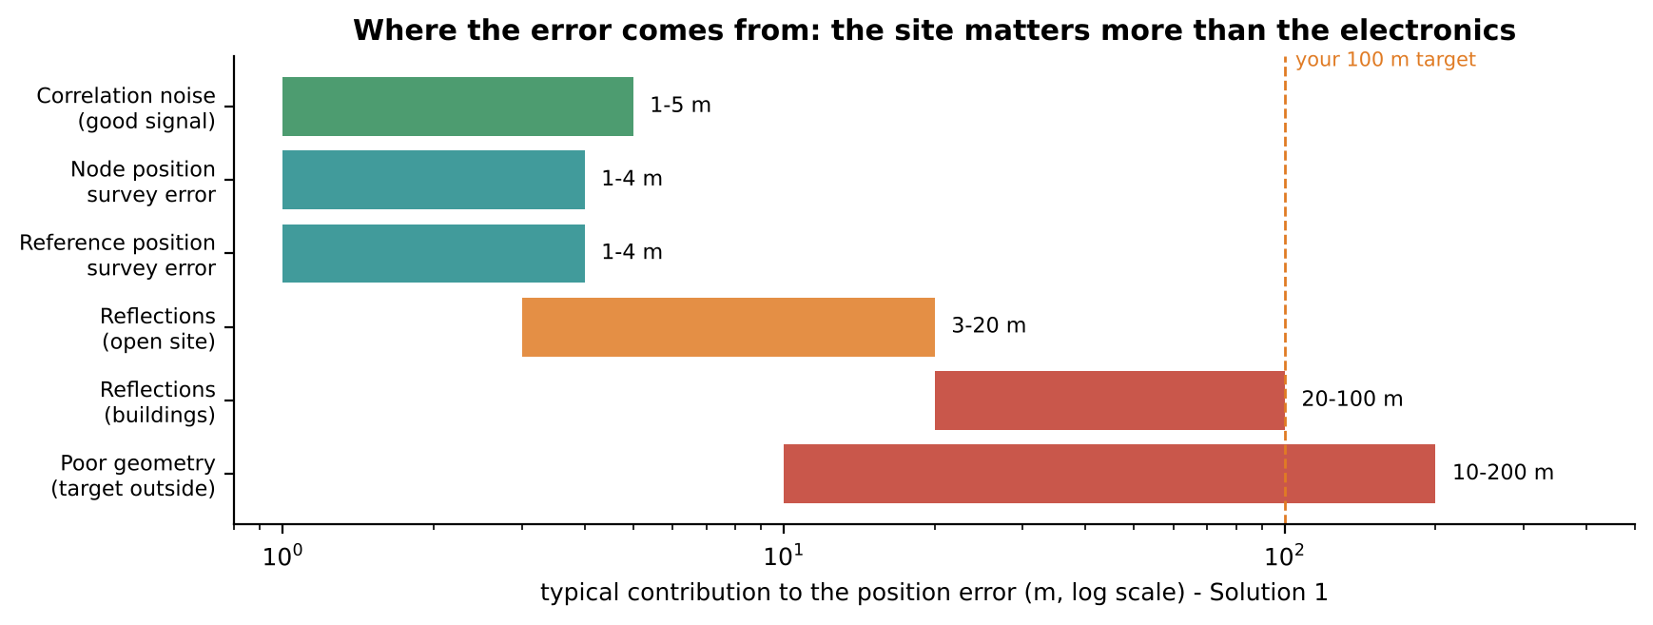
Figure 5. Typical error contributions for Solution 1. Choose the site well and the 100 m target is comfortably met.
Situation | Solution 1 (0.54 MHz) | Solution 2 (20 MHz Wi-Fi) | Simulation result
Open field / rooftops, target inside triangle | 10-50 m | 5-30 m | 0.1-0.6 m (ideal)
Between buildings | 50-150 m | 15-50 m | Sol. 1: 4-45 m, median 27 m (6 trials with 2 strong echoes)
Target outside the triangle | can exceed 200 m | can exceed 100 m | -

A8. Safety, permissions and good practice
- Receiving is passive; the Pis and dongles only listen.
- Transmitting: Solution 1 uses 433.05-434.79 MHz (the 433 MHz short-range-device band in many countries). Solution 2 uses one Wi-Fi channel at very low power. Ask your university's RF or lab safety officer to confirm what is allowed at your site, and keep a short written note of frequencies, power and dates.
- Power: start every transmitter at its lowest setting and raise it only until the furthest receiver sees it clearly (the procedures show how). Typical needed power is below 1 mW.
- Bench tests: connect transmitters to receivers with cables and 30 dB attenuators, or keep them a few metres apart at minimum power.
- Never connect a transmitter output directly to a receiver input without an attenuator - it can destroy the receiver.
- Outdoors: tripods in public spaces need someone nearby; tie down cables; keep electronics out of direct sun (Pis throttle above 80 degrees C).

Part B - Solution 1: zero-cost demonstrator (RTL-SDR, 433 MHz)

B1. What you are building
Three receiver stations (a fourth is optional) each record a 2.4 MHz-wide slice of the 433 MHz band every 30 seconds. Inside that slice are two test signals: the reference from the ADALM-Pluto at a surveyed point, and the target from the bladeRF. Afterwards the laptop compares the recordings and computes where the target is (Figure 6).
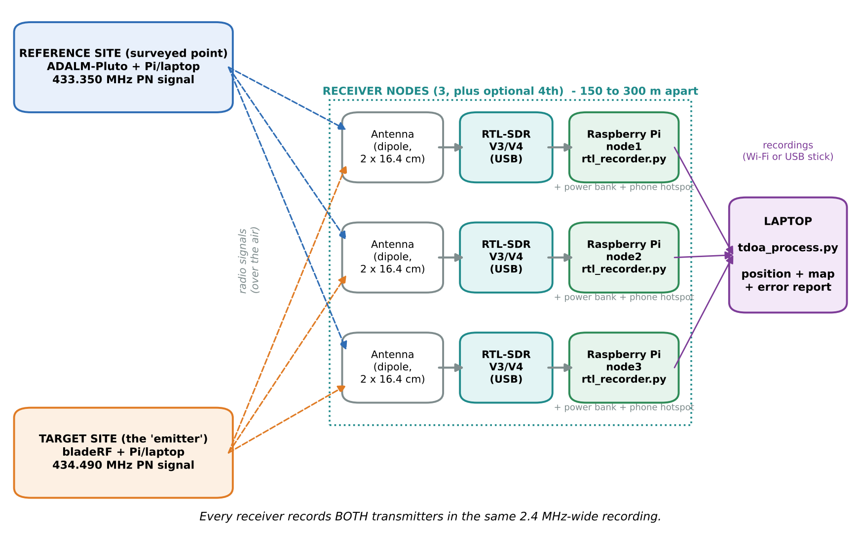
Figure 6. Solution 1 block diagram. Dashed lines are radio signals over the air; solid lines are cables or file transfers.
WHY: Why this design
RTL-SDR receivers are what you own in the largest number, and they work on a Raspberry Pi with a single USB cable.
Both transmitters inside one recording means the reference method (A4) works perfectly: same recording, same clock, same cable, same everything.
433 MHz is inside the RTL-SDR, Pluto and bladeRF ranges, travels well over a few hundred metres, needs only a 35 cm antenna, and has a short-range-device allocation in many countries.
Our own PN test signal gives a clean, single correlation peak, so first results are not spoiled by an awkward real-world signal.

B2. Equipment list
Item | Qty | Have it? | Approx. cost if not | Notes
RTL-SDR dongle (RTL-SDR Blog V3 or V4 preferred) | 3 (+1 spare node) | Yes | - | V3/V4 have a 1 ppm TCXO. Generic dongles also work (see B12).
Raspberry Pi 4 or 5 + microSD card (32 GB) | 3-4 receivers | Yes | SD card ~$5 each | Any Pi 4/5. Pi 3 is too slow for continuous 2.4 MS/s plus Python.
ADALM-Pluto (reference transmitter) | 1 | Yes | - | Comes with antennas; 433 MHz needs the dipole below.
bladeRF (target transmitter) | 1 | Yes | - | 2.0 micro or older x40/x115 both fine.
Pi or laptop to drive each transmitter | 2 | Yes | - | Same software runs on a Pi or a Linux laptop.
433 MHz dipole antennas (RTL-SDR Blog dipole kit, or 433 MHz whips) | 5-6 | Partly | $5-15 each | Same type at every receiver.
Coax extension cable, SMA, same length (e.g. 3 m) | 5 | Maybe | $5 each | Lets the antenna sit high while the Pi stays shaded.
Tripod / 2-3 m pole (camera tripod, PVC pipe, broom handle) | 5 | Maybe | $0-10 | Antenna 2-3 m above ground, vertical.
USB power bank 5 V 3 A, about 20,000 mAh | 5 | Maybe | $15-25 | Runs a Pi 4 + dongle for 8-10 hours.
Phone with mobile hotspot (internet time for the Pis) | 1 per node | Yes | - | Or one Wi-Fi router whose signal reaches all nodes.
SMA 30 dB attenuators (bench test) | 2 | Maybe | $5-10 each | Optional but recommended for the bench test.
Laptop with Python 3 | 1 | Yes | - | Windows, macOS or Linux.

Total new spend: about $0-60, depending on how many antennas, power banks and cables you need to buy.

B3. The frequency plan and the test signals
One RTL-SDR recording is 2.4 MHz wide. We tune every RTL-SDR to 433.920 MHz and place the two signals either side of it (Figure 7):
Item | Frequency | Set where | Why there
RTL-SDR centre | 433.920 MHz | rtl_recorder.py --freq | middle of the 433.05-434.79 MHz band
Recording covers | 432.720 - 435.120 MHz | (2.4 MS/s) | both signals fit, with room to spare
Reference signal (Pluto) | 433.350 MHz, 540 kHz wide | Pluto LO 433.750 MHz, shifted -400 kHz in software | left half, away from the RTL-SDR's centre spike
Target signal (bladeRF) | 434.490 MHz, 540 kHz wide | bladeRF LO 434.090 MHz, shifted +400 kHz in software | right half
Pluto leakage spike | 433.750 MHz | - | falls in the empty middle; filtered out
bladeRF leakage spike | 434.090 MHz | - | falls in the empty middle; filtered out

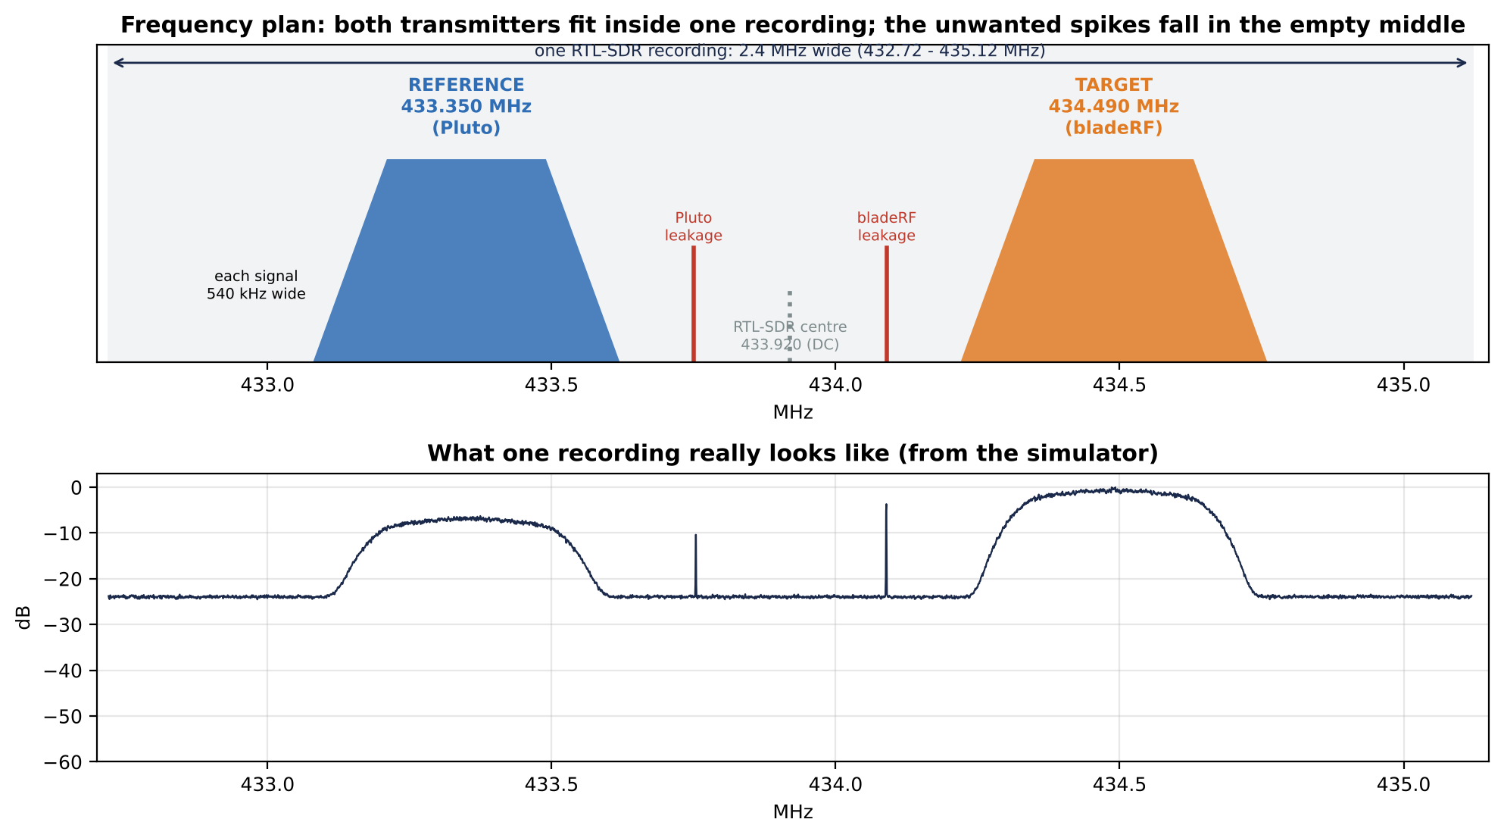
Figure 7. Top: the plan. Bottom: what a recording really looks like (simulator output). The two spikes in the middle are the transmitters' carrier leakage.
WHY: Why the 400 kHz software shift?
Every transmitter leaks a little of its own centre frequency (a narrow spike). If that spike sat inside our signal it would add a tone that correlates at every lag and blurs the peak. By shifting the signal 400 kHz away in software, the spike lands in the empty middle where the processing simply ignores it.

The test signal
- What: a stream of pseudo-random +1/-1 values ('chips') at 400,000 per second, smoothed so it occupies 540 kHz. It sounds like hiss.
- Repeats every 0.655 s (262,144 chips). The recordings of different Pis only need to start within about +/-0.3 s of each other, which internet time easily achieves.
- Reference and target use different random sequences (seeds 11 and 22), so they can never be confused.
- Created once by make_waveforms.py, which writes the files the transmitters play in an endless loop.

B4. Installing the software

B4.1 Laptop (processing)
- Install Python 3.10 or newer (python.org; on Windows tick 'Add Python to PATH').
- Open a terminal (Windows: PowerShell) and install the three libraries: pip install numpy scipy matplotlib
- Unzip tdoa_kit.zip into a folder, e.g. Documents/tdoa_kit. You will work in tdoa_kit/solution1.

B4.2 Prepare each Raspberry Pi (receivers and transmitter hosts)
- On the laptop install Raspberry Pi Imager (raspberrypi.com/software).
- Choose Raspberry Pi OS Lite (64-bit). Before writing, open the settings (gear icon / 'Edit settings') and set:
  - hostname: node1 (then node2, node3, node4, and reftx, tgttx for the transmitter Pis)
  - username pi and a password you will remember
  - Wi-Fi: the name and password of the phone hotspot (or router) the Pi will use
  - Services: enable SSH with password login
- Write the card, put it in the Pi, power it on, wait 2 minutes.
- From the laptop (connected to the same hotspot/router): ssh pi@node1.local. If the name does not work, find the Pi's address in the hotspot's 'connected devices' list and use ssh pi@<address>.
- Copy the kit to the Pi (run on the laptop, inside the folder that contains tdoa_kit): scp -r tdoa_kit pi@node1.local:~/

B4.3 Receiver Pis: driver, time sync and dongle test
- On the Pi: cd ~/tdoa_kit/solution1 && chmod +x *.sh && ./pi_setup.sh (takes about 5-10 minutes), then sudo reboot.
- Plug in the RTL-SDR and run rtl_test -t. You should see 'Found 1 device(s)' and a tuner name (R820T or R828D).
- Run rtl_test -s 2400000 for 30 seconds, then press Ctrl+C. It must not keep printing 'lost at least ... bytes'. One message at start-up is normal.
- Check the clock: chronyc tracking. The line System time must be below 0.010 seconds, and timedatectl must say 'System clock synchronized: yes'.
WHY: Why the special driver and the time sync?
The RTL-SDR Blog driver supports both V3 and V4 dongles; the older Debian package does not handle the V4 correctly. The 'blacklist' line stops Linux from grabbing the dongle as a TV tuner.
chrony keeps the Pi clock within a few milliseconds of true time using the internet. That is how all Pis agree on 'save a recording at 10:15:00'. The reference method takes care of everything finer than that.

B4.4 Transmitter hosts (Pluto and bladeRF)
- On the Pi/laptop that will drive the Pluto: cd ~/tdoa_kit/solution1 && ./tx_host_setup.sh
- Plug in the Pluto. iio_info -s must list a PlutoSDR. (The Pluto also appears as a network device at 192.168.2.1.)
- On the bladeRF host run the same setup script, plug in the bladeRF, and run bladeRF-cli -p (it must list the device).
- Load the bladeRF FPGA image: download the 'hosted' image for your model from nuand.com (xA4, xA9, x40 or x115) and run bladeRF-cli -l hostedxA4-latest.rbf (use your model's file). bladeRF-cli -e info then shows 'FPGA loaded: yes'.
- On both hosts create the test signals: python3 make_waveforms.py. It prints 'Wrote ref_pluto.npy, target.npy, target_bladerf_sc16q11.bin'.
File (tdoa_kit/solution1) | Runs on | Job
make_waveforms.py | transmitter hosts | creates the two test signals (once)
pluto_tx_reference.py | reference host | Pluto transmits the reference, endlessly
bladerf_tx_target.sh | target host | bladeRF transmits the target, endlessly
rtl_recorder.py | every receiver Pi | saves 2 s recordings every 30 s
collect_captures.sh | laptop | copies recordings from all Pis
tdoa_process.py | laptop | computes the position, map and error
simulate_captures.py | laptop | makes fake recordings for the desk rehearsal
../common/quicklook.py | laptop | checks one recording (levels, clipping)
config.json | laptop | your surveyed positions and the frequency plan
pi_setup.sh, tx_host_setup.sh | Pis | one-time installation

B5. Desk rehearsal with the simulator (do this first)
Before touching any radio, prove that the processing works on your laptop. The simulator writes recordings in exactly the RTL-SDR file format, with every real problem included: Pis starting up to 50 ms apart, 8-10 ppm frequency errors, carrier leakage, noise and 8-bit rounding.
cd tdoa_kit/solution1
python3 simulate_captures.py
python3 tdoa_process.py --config config_sim.json --dir captures_sim
You should see a block like this for each of the three capture times (shown here for the first one):
=== Capture 20261020_101500: nodes node1, node2, node3 ===
node1: frequency error +3888 Hz (+8.96 ppm) ref tone SNR 28.0 dB ref power -19.8 dB target power -13.6 dB
node2: frequency error +3317 Hz (+7.65 ppm) ref tone SNR 27.3 dB ref power -22.7 dB target power -13.1 dB
node3: frequency error +4367 Hz (+10.06 ppm) ref tone SNR 28.4 dB ref power -19.1 dB target power -13.8 dB
pair node1-node2: target TDOA 7.2 ns -> range difference 2.2 m (+/-0.5 m, 60 pieces)
pair node1-node3: target TDOA -38.3 ns -> range difference -11.5 m (+/-0.5 m, 60 pieces)
pair node2-node3: target TDOA -42.3 ns -> range difference -12.7 m (+/-0.5 m, 60 pieces)
Fit residual (all nodes): 0.3 m
ESTIMATED TARGET: 33.000856, 73.001338 https://maps.google.com/?q=33.000856,73.001338
Error vs. surveyed true target position: 0.1 m
Map saved: captures_sim/result_20261020_101500.png

SUMMARY over 1 captures: median error 0.1 m, worst 0.1 m
Results appended to captures_sim/results.csv
Output line | Meaning | Good value
frequency error ... ppm | how far this receiver is tuned from the reference transmitter | any value up to about +/-50 ppm; it is measured and removed
ref tone SNR | how clearly the reference was received (used for the frequency measurement) | above 15 dB
ref power / target power | signal level in each band (relative) | within 20 dB of each other
target TDOA ... range difference | the result for that pair of nodes | -
(+/-0.5 m, 60 pieces) | spread of the 60 measurements and how many passed the quality check | spread under a few metres; 40-60 pieces
Fit residual | how well all pairs agree on one position | under 5 m
Error vs. surveyed true target | distance between estimate and truth | the number you report

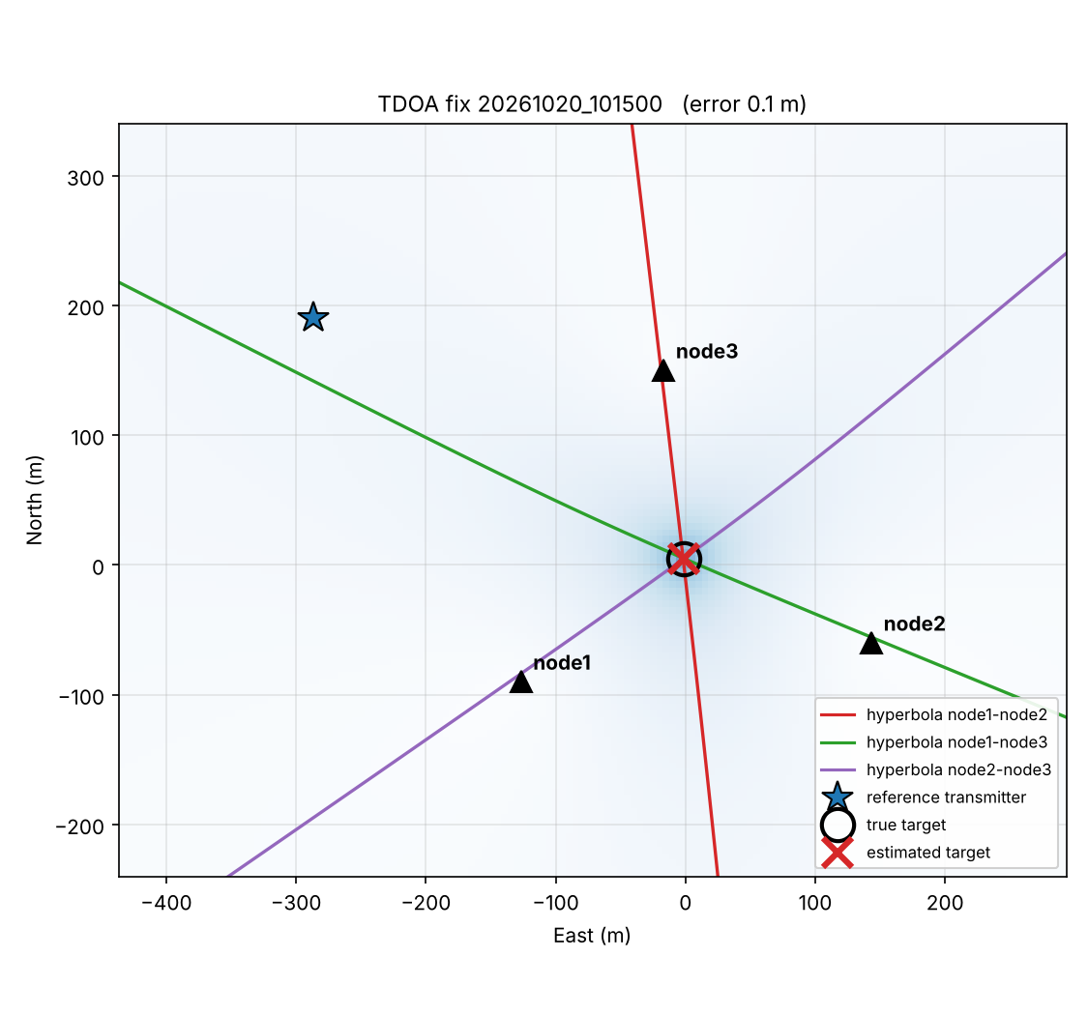
Figure 8. Desk-rehearsal map from the simulator (open site). Each coloured curve is one node pair's hyperbola; the cross is the estimate, the circle the truth.
Now run the harsher version with building reflections and compare: python3 simulate_captures.py --urban --out captures_urban then python3 tdoa_process.py --config config_sim.json --dir captures_urban. In our runs the error grew to 4-45 m (median 27 m). This shows, before you go outside, why the site choice in B8 matters.
CHECK: Pass condition
Errors below 2 m on the open-site simulation. If you get an error message instead, fix it now (B12) - the field is a bad place to debug Python.

B6. Bench test with the real hardware (one room)
This proves the radios, drivers, recorders and transmitters all work together, while everything is on one table. Because all receivers are in the same place, every range difference should come out close to zero.
- Put the three receiver Pis with dongles and antennas together on one table, within 1 m of each other. Put the Pluto at one end of the room and the bladeRF at the other, each with a 433 MHz antenna (or connect each transmitter through a 30 dB attenuator to a small antenna).
- On the laptop, copy config.json to config_bench.json and set all three nodes, the reference and the truth_target to the same latitude/longitude (the room's). The solver cannot place a target among nodes that are all at one point, but the pair results are what we want to see.
- On each receiver Pi: cd ~/tdoa_kit/solution1 && python3 rtl_recorder.py --node node1 --count 4 (node2, node3 on the others). Each prints when its first capture will be.
- On the reference host: python3 pluto_tx_reference.py --gain -70. On the target host: ./bladerf_tx_target.sh with a low gain (see B9 for finding the gain range).
- Wait for the four captures (2 minutes). Stop the transmitters (Enter / Ctrl+C).
- Collect the files: edit the three addresses at the top of collect_captures.sh, then on the laptop ./collect_captures.sh (Windows: copy with WinSCP or a USB stick into a folder called captures).
- Check one file: python3 ../common/quicklook.py captures/node1_<time>.cu8 - both signals visible, clipping 'OK'.
- Process: python3 tdoa_process.py --config config_bench.json --dir captures
CHECK: Pass conditions
Every node shows a frequency error and a ref tone SNR above 15 dB.
Every pair shows 40-60 good pieces.
Every range difference lies within about +/-15 m of zero (indoor reflections cause the rest).
Cable test: replace one node's antenna cable with a much longer one and repeat. The results must not move by more than a few metres. This proves that the reference method cancels cable and receiver delays.

B7. Building a field receiver node
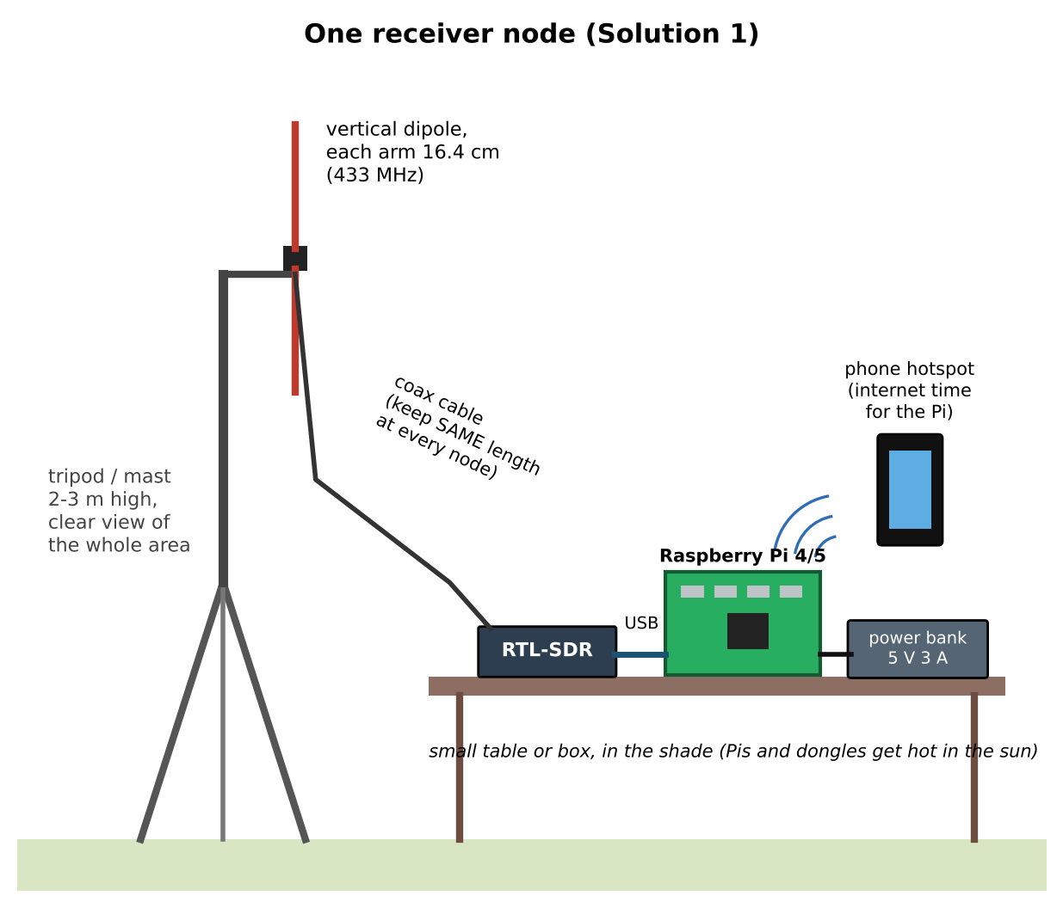
Figure 9. One Solution 1 receiver node. Identical at every station: same antenna type, same height, same cable length.
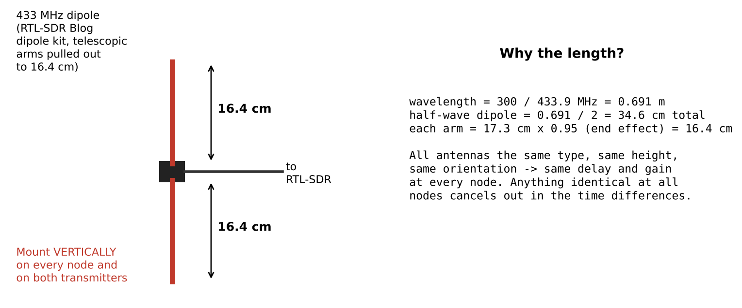
Figure 10. 433 MHz dipole dimensions.
- Set the dipole arms to 16.4 cm each and mount it vertically at the top of the tripod/pole, 2-3 m above ground, on a short side arm so the pole does not touch the elements.
- Run the coax down to a small table or box in the shade; connect it to the RTL-SDR, and the RTL-SDR to a blue USB 3 port on the Pi (or directly into the Pi; avoid long USB extension cables).
- Power the Pi from the power bank with a short, thick USB-C cable. A red/yellow lightning symbol or 'undervoltage' in dmesg means the cable or bank is too weak.
- Switch on the phone hotspot; the Pi joins it automatically. Label each node with its name (node1 ...) on tape.
WHY: Why everything identical?
Delays and gains that are the same at every station cancel out in the time differences. Different antennas or heights change how strongly each station hears the reflections, which shifts the correlation peaks differently at each node.

B8. Choosing and surveying the site
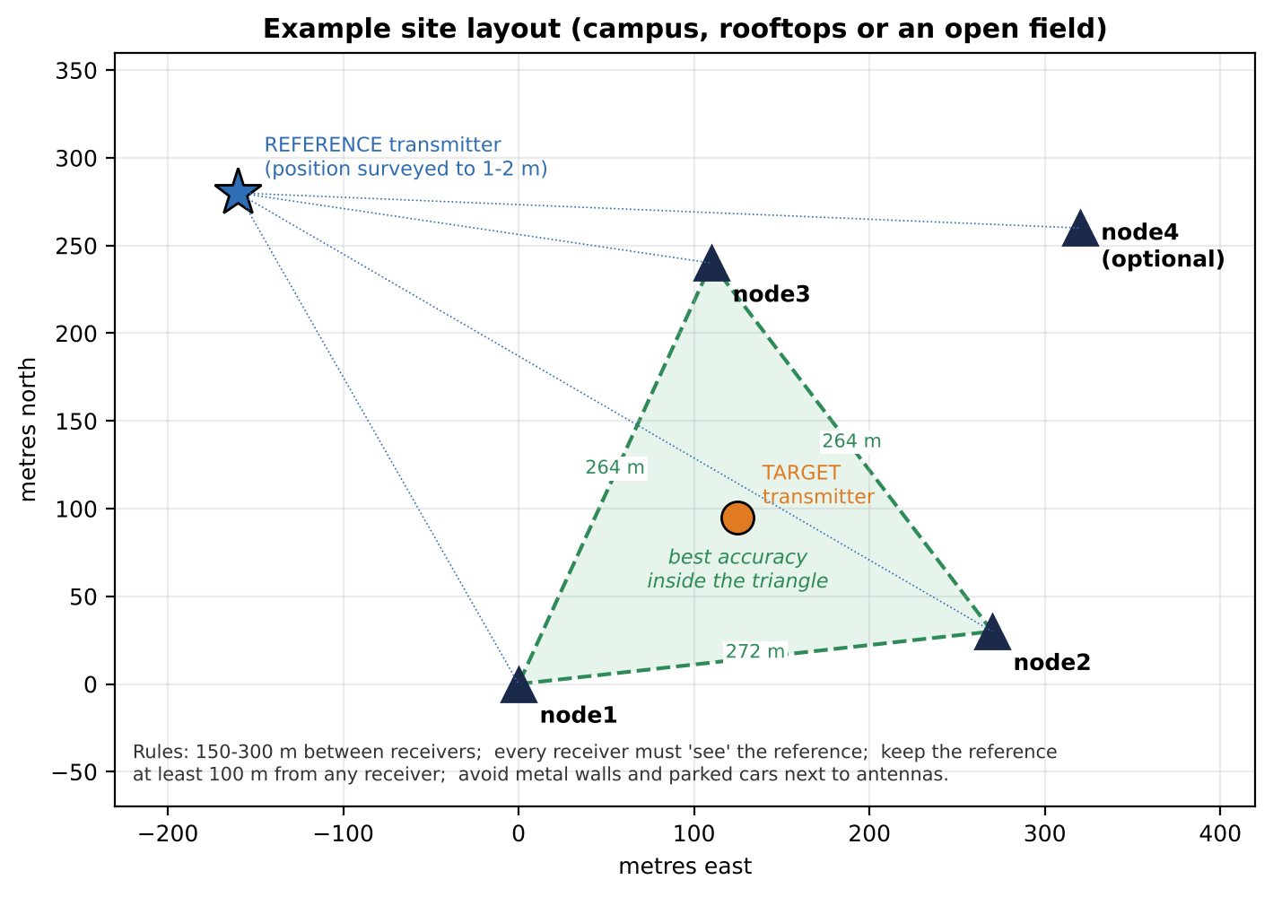
Figure 11. Example site layout. Green triangle: where the target gives the best accuracy.

Rules for the layout
- Receivers 150-300 m apart, forming a roughly equal-sided triangle. Closer than 100 m and the time differences become too small to measure well; much further and the signals get weak.
- Line of sight from every receiver to the area where the target will be. Rooftops, sports fields and open campus areas are ideal. Avoid placing antennas next to metal walls, fences, parked cars or under trees.
- Reference at a surveyed spot that every receiver can 'see', at least 100 m from every receiver (so it does not swamp the nearest one), ideally high up (a roof edge).
- Target positions (points A, B, C ...) inside the triangle for the main demonstration; one point outside shows what geometry does.

How to survey a position to 1-2 m
- Pick each station at a feature you can recognise on satellite images (a corner of a building, a pole base, a marked spot).
- In Google Maps or Google Earth, right-click exactly on that feature; the first line shows latitude, longitude (e.g. 33.0002700, 73.0029000). Copy it with at least 6 decimals.
- Cross-check on site with a phone GPS app that averages for 3-5 minutes (search the app store for 'GPS averaging'). If the two disagree by more than 3 m, look again - satellite images are sometimes shifted a few metres; use the same method for every point so shifts are common to all.
- Write every node, the reference and each target point into config.json (and a copy per target point - see B11).
WHY: Why so careful?
Every metre of survey error moves the answer by about a metre. The reference position matters as much as the nodes: its distances are used to correct every measurement.

B9. Setting transmitter power and receiver gain
An RTL-SDR has only 8-bit samples, so it can handle about 45 dB between the loudest and quietest thing in one recording. The goal is: both signals clearly above the noise at the furthest node, nothing clipped at the nearest node, and the two signals within about 20 dB of each other everywhere.
- Start every receiver at gain 30 (--gain 30, the default). Start the Pluto at --gain -40. For the bladeRF run bladeRF-cli -i, type print gain tx1 to see the setting and set gain tx1 <value>; if a value is out of range the CLI tells you the allowed range. Start near the bottom of the range.
- Take one capture (--count 1) on every node and run quicklook on each file.
- Furthest node: each signal should be at least 15 dB above the noise (look at the spectrum picture). If not, raise that transmitter's gain by 5 dB and repeat.
- Nearest node: 'clipped samples' must say OK (below 0.1%). If not, lower that node's --gain to 20 or 10, or lower the transmitter.
- If one signal is more than 20 dB stronger than the other at some node, lower the stronger transmitter or move it a little further away.
- Write the final settings in the field log (Appendix E). Use the same settings for the whole session.
CAUTION: Never use automatic gain
Automatic gain changes during a recording and distorts the timing. The recorder always sets a fixed gain.

B10. Field-day procedure
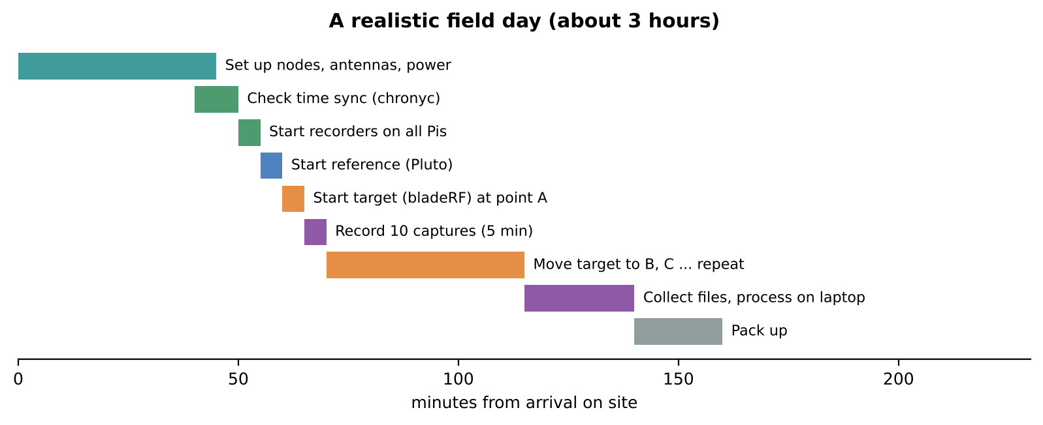
Figure 12. A realistic schedule. With two people, the receiver nodes can be left running unattended while you move the target.

Before leaving
- All Pis boot, join the hotspot and pass chronyc tracking (System time < 0.010 s).
- Power banks charged; spare cables; tape and labels; printed field log; config.json with all surveyed positions.
- Bench test passed; transmit settings from B9 written down.
- Everyone agrees: all times in the log are written in UTC (Pakistan time minus 5 hours) because the Pis name files in UTC.

On site, in order
- Set up all receiver nodes (B7) at the surveyed spots. Switch on hotspots and Pis.
- Log in to each Pi from the laptop or a phone SSH app and check chronyc tracking again.
- Start the recorder so it keeps running even if you disconnect: cd ~/tdoa_kit/solution1 && nohup python3 rtl_recorder.py --node node1 > rec.log 2>&1 & (node2, node3 ... on the others). Check it with tail -f rec.log (Ctrl+C stops only the viewing).
- Set up the reference at its surveyed point; start python3 pluto_tx_reference.py --gain <your value>.
- Put the target at point A; start ./bladerf_tx_target.sh <gain>. Write the UTC start time of point A in the log.
- Let it run for 5 minutes (10 captures). Write the end time.
- Move the target to point B (stop and restart the bladeRF script if you unplug it). Log the times. Repeat for every point.
- At the end: stop transmitters, then on each Pi pkill -f rtl_recorder.py. Collect the files (collect_captures.sh or a USB stick).
TIP: Saving effort
Captures taken while the target was being moved are useless; the time log tells you which files belong to which point. Put each point's files in its own folder, e.g. captures/posA.

B11. Processing and reading the results
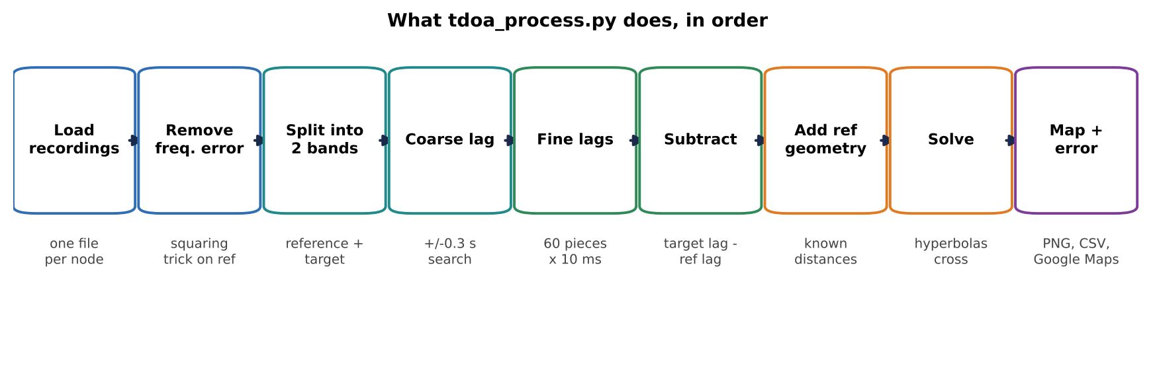
Figure 13. The processing steps.
- Make one config per target point: copy config.json to config_posA.json and set truth_target to point A's surveyed position (repeat for B, C ...).
- Move each point's capture files into its folder (captures/posA, captures/posB ...).
- Run python3 tdoa_process.py --config config_posA.json --dir captures/posA (and the same for the others).
- Read the SUMMARY line (median and worst error) and open the result_*.png maps. results.csv in the folder collects every fix.
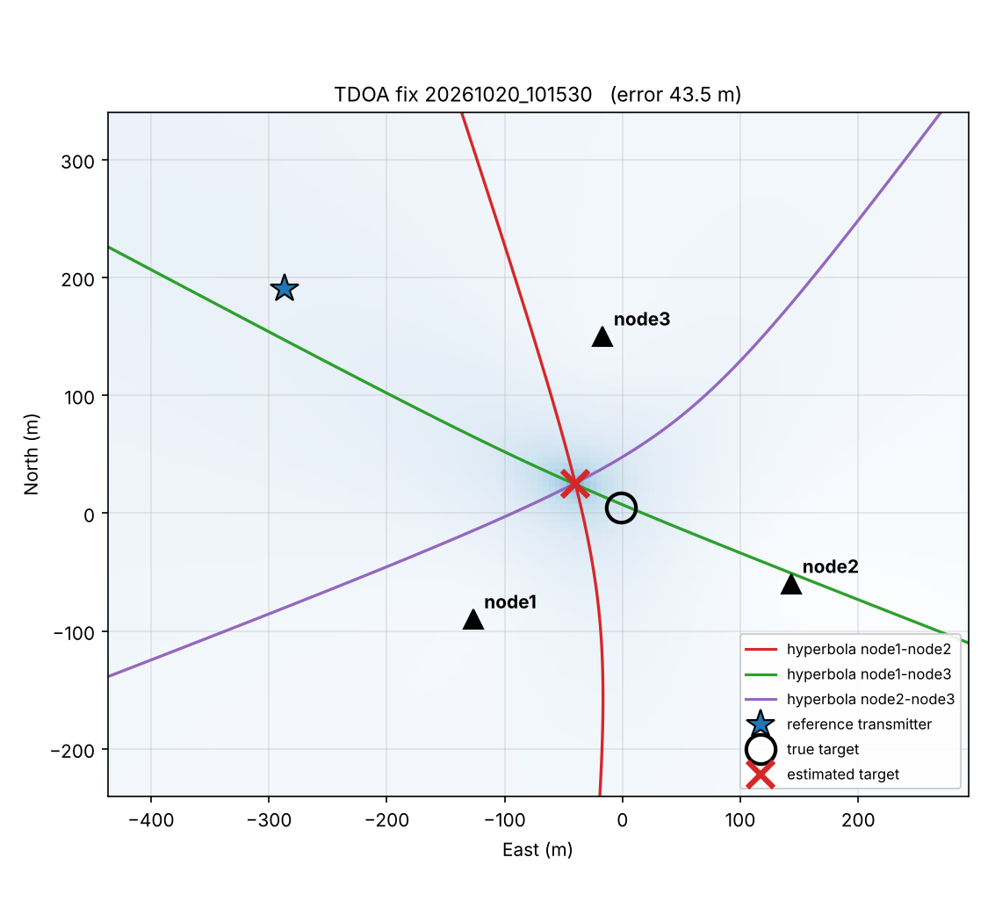
Figure 14. Example with strong reflections (simulator, 'urban' mode): the hyperbolas still cross close to the truth, but with a few tens of metres error.
WHY: Why several captures per point
Ten captures show whether results are stable. If they scatter by tens of metres, the signal is too weak (raise power). If they agree with each other but are all off by the same amount, the cause is reflections or a survey error, not noise - moving one receiver a few metres to a clearer spot usually helps.

B12. Troubleshooting
Symptom | Likely cause | What to do
rtl_test: 'No supported devices found' | dongle not seen; kernel driver grabbed it | re-plug; reboot after pi_setup.sh; check the blacklist file exists
rtl_test keeps printing 'lost ... bytes' | USB or power problem | plug the dongle directly into the Pi; better power bank/cable; avoid USB hubs
Recorder: 'rtl_sdr stopped' | dongle unplugged or overheating | check cable; shade; restart recorder
Files from one node missing for some times | Pi rebooted (power) or clock not synced | check rec.log, power bank, chronyc tracking
'only 2 node files found' | file times do not match between Pis | a Pi clock is wrong: check chronyc; all must be within 0.3 s
ref tone SNR below 10 dB | reference too weak at that node | raise Pluto gain 5 dB; improve that node's line of sight
pair FAILED (coarse quality ...) | reference not received, or start times more than 0.3 s apart | check quicklook spectrum for the reference; check chrony
frequency error near the limit (about +/-50 ppm) | generic dongle with a poor crystal | set cfo_margin_hz to 60000 in config.json, or use the dongle's --ppm correction
clipped samples TOO HIGH | gain too high or transmitter too close | lower --gain on that node or the transmitter power
Results scatter a lot between captures | weak signals | raise transmitter power a little; check 'pieces' is near 60
Results stable but consistently wrong | reflections, survey error, target outside triangle | re-survey; move nodes to clearer spots; put target inside the triangle
Pluto script: cannot connect | wrong address | try --uri usb: or check iio_info -s for the address
bladeRF: 'FPGA not loaded' | FPGA image missing | bladeRF-cli -l <image file> (B4.4)

B13. Squeezing out more accuracy
- Add the fourth node (spare RTL-SDR). The software uses all pairs and prints a warning when they disagree, which flags a node with bad reflections.
- Raise antennas higher and keep them away from walls; it reduces reflections more than anything else.
- Use longer recordings (--duration 4) or more captures per point when signals are weak.
- Re-survey with care; ensure the reference position is right.
- Next step for accuracy: Solution 2's 20 MHz Wi-Fi signals give peaks 40 times narrower, which resists reflections much better.

Part C - Solution 2: Wi-Fi upgrade (bladeRF + Pluto, 2.4 GHz)

C1. What changes, and why it is worth it
Solution 2 keeps the same idea - a reference at a known spot, a target, three receivers, reference method - but replaces the narrow test signal with real Wi-Fi packets about 20 MHz wide. Wider signal means a sharper correlation peak (about 50 ns instead of 2 us), which gives better accuracy and much better resistance to reflections. It also shows a funding panel that the system works on an everyday signal type, not only on a cooperative test tone.
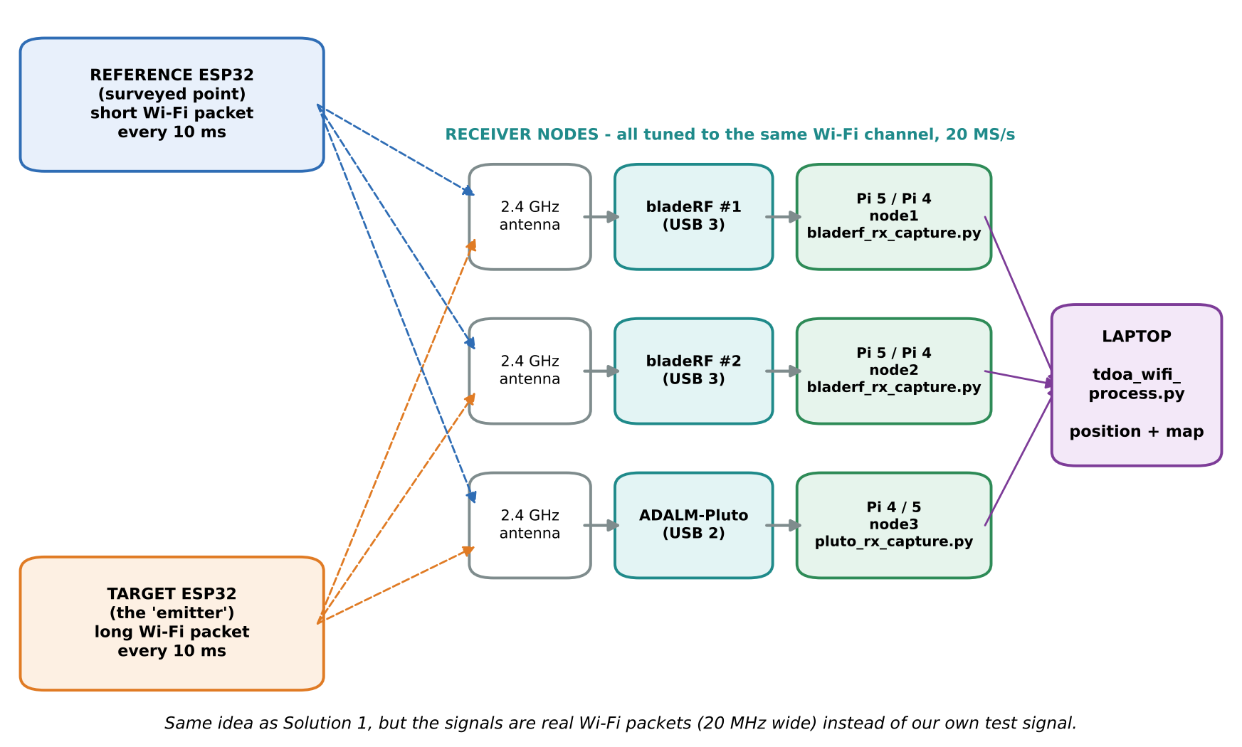
Figure 15. Solution 2 block diagram.

What makes it harder (and how the software handles it)
Difficulty | Why | How it is handled
Packets, not a continuous signal | Wi-Fi sends short bursts; reference and target are never on the air at the same instant | Every packet is found and measured separately
Which packet is which? | Both ESP32s, and the neighbours' Wi-Fi, use the same channel | Reference packets are made 0.64 ms long and target packets 1.8 ms long; anything else is ignored
Clock drift between packets | A reference packet and the next target packet are milliseconds apart; the Pluto's clock can drift 10-25 ppm against the bladeRFs (10-25 ns per ms) | A straight line is fitted through all reference-packet lags (start offset + drift) and evaluated at each target packet's time (Figure 19)
Pluto cannot stream 20 MS/s over USB 2 | Too much data for USB 2.0 | The Pluto records a 0.21 s burst into its own memory; the bladeRFs record 0.4 s so the windows always overlap
Mixed radio types | Pluto and bladeRF have different internal delays | Cancels with the reference method, because both packet types pass through the same radio

C2. Equipment list
Item | Qty | Have it? | Approx. cost | Notes
bladeRF (receiver) | 2 | Yes | - | 2.0 micro: 47 MHz-6 GHz. Older x40/x115 reach 3.8 GHz: also fine for 2.4 GHz.
ADALM-Pluto (receiver) | 1 | Yes | - | Moves from transmitter (Solution 1) to receiver.
Raspberry Pi 5 (best) or Pi 4 | 3 | Yes | - | bladeRF nodes need a USB 3 (blue) port; Pi 5 preferred.
ESP32 development board (e.g. ESP32-DevKitC) | 2 (+1 spare) | Buy | $4-8 each | One reference, one target.
2.4 GHz antennas, SMA, vertical, about 5 dBi | 3 | Maybe | $5-10 each | Same type at all three receivers.
64 GB microSD or USB SSD per bladeRF node | 2 | Maybe | $8-15 | Each bladeRF capture is 32 MB.
Everything else from Solution 1 | - | Yes | - | Tripods, cables, power banks, hotspots, laptop.

Extra spend: about $20-40.

C3. The Wi-Fi signal and channel choice
- The ESP32 sends beacon packets at 1 Mbit/s (the original 802.11b format). Each bit is spread into 11 'chips' at 11 million chips per second, so the signal is about 20 MHz wide and noise-like: perfect for correlation, and the same squaring trick as Solution 1 measures the frequency error.
- Reference packet: short name, no padding: about 640 microseconds on air. Target packet: long name plus 120 padding bytes: about 1800 microseconds.
- Each board sends one packet every 10 ms, so a 0.21 s Pluto recording contains about 20 of each.
- Channel: pick the quietest channel at your site with a phone Wi-Fi analyser app. Channel centre frequency = 2407 + 5 x channel MHz (channel 1 = 2412, 6 = 2437, 11 = 2462 MHz). The same channel must be set in the ESP32 sketch, the capture scripts (--freq) and config_wifi.json (rx_center_hz).

C4. Programming the two ESP32 boards
- Install Arduino IDE 2 on the laptop. In Boards Manager install 'esp32 by Espressif Systems'.
- Open tdoa_kit/solution2/esp32_beacon/esp32_beacon.ino. If needed, change CHANNEL (C3).
- Plug in board 1, choose board 'ESP32 Dev Module' and its port, click Upload. This is the REFERENCE (the line #define ROLE_REFERENCE is active). Label it REF.
- Put // in front of #define ROLE_REFERENCE, plug in board 2 and upload again. This is the TARGET. Label it TGT.
- Open the Serial Monitor (115200 baud): each board prints its name, channel and packet size (REF about 56 bytes, TGT about 201 bytes).
- In the field each board runs from a small power bank. Mount it on a pole at the same height as the receiver antennas.
CAUTION: Compile error on esp_wifi_config_80211_tx_rate
Older Arduino-ESP32 versions do not have this function. Update the 'esp32' package in Boards Manager first. If it still fails, delete that line: most versions already send beacons at 1 Mbit/s. C8 shows how to confirm it from the packet lengths.
WHY: Transmit power
esp_wifi_set_max_tx_power(8) sets 2 dBm (1.6 mW). If the furthest receiver finds only a few packets, raise it to 40 (10 dBm) and re-upload. Do not go higher than needed.

C5. Installing the receiver software
- On each receiver Pi (prepared as in B4.2, hostnames node1, node2, node3): copy the kit and run cd ~/tdoa_kit/solution2 && chmod +x *.sh && ./rx_host_setup_s2.sh. It installs the Pluto library, the bladeRF tools and the bladeRF Python bindings, and finishes with 'bladeRF python bindings OK'.
- On the bladeRF nodes, load the FPGA image (B4.4) and check bladeRF-cli -e info.
- On the Pluto node, iio_info -s must list the Pluto.
- Check time sync on all three (chronyc tracking, System time < 0.010 s).
File (tdoa_kit/solution2) | Runs on | Job
esp32_beacon/esp32_beacon.ino | ESP32 boards | reference / target Wi-Fi packets
bladerf_rx_capture.py | bladeRF node Pis | streams continuously, saves 0.4 s every 30 s
pluto_rx_capture.py | Pluto node Pi | records a 0.21 s burst every 30 s
tdoa_wifi_process.py | laptop | packets -> drift-corrected TDOA -> position
simulate_wifi.py | laptop | fake recordings for the desk rehearsal
config_wifi.json | laptop | positions, channel and packet lengths
rx_host_setup_s2.sh | receiver Pis | one-time installation

C6. Desk rehearsal with the simulator
The Wi-Fi simulator creates 2 bladeRF files and 1 Pluto file with: different start times (Pluto up to 80 ms late), clock errors of +0.7, -1.1 and +12 ppm, transmitter frequency errors, neighbouring Wi-Fi packets of random length from a third location, and (with --urban) building reflections.
cd tdoa_kit/solution2
python3 simulate_wifi.py --urban --out captures_wifi_urban
python3 tdoa_wifi_process.py --config captures_wifi_urban/config_used.json --dir captures_wifi_urban
=== Capture 20261020_101500: nodes node1, node2, node3 ===
node1: most common packet lengths (us): 650 x41, 1810 x40, 2060 x1, 1940 x1
node1: 400 ms recorded, 44 reference + 41 target packets, frequency error +12916 Hz (+5.30 ppm)
node2: most common packet lengths (us): 1810 x40, 640 x37, 650 x5, 2060 x1
node2: 400 ms recorded, 44 reference + 40 target packets, frequency error +17302 Hz (+7.10 ppm)
node3: most common packet lengths (us): 650 x22, 1810 x21, 2060 x1, 1940 x1
node3: 210 ms recorded, 23 reference + 21 target packets, frequency error -14622 Hz (-6.00 ppm)
pair node1-node2: 39 ref + 40 target packets, clock drift -1.81 ppm -> range difference 1.6 m (+/-0.4 m)
pair node1-node3: 21 ref + 21 target packets, clock drift +11.32 ppm -> range difference -11.7 m (+/-0.5 m)
pair node2-node3: 21 ref + 21 target packets, clock drift +13.14 ppm -> range difference -14.1 m (+/-0.6 m)
ESTIMATED TARGET: 33.000861, 73.001338 https://maps.google.com/?q=33.000861,73.001338
Error vs. surveyed true target position: 0.5 m
Map saved: captures_wifi_urban/result_20261020_101500.png

SUMMARY over 1 captures: median error 0.5 m, worst 0.5 m
Output line | Meaning | Good value
most common packet lengths | every burst found, rounded to 10 us, with counts | two big groups near 640 and 1800 us
N reference + M target packets | packets classified for this node | Pluto about 20 + 20; bladeRF about 40 + 40
frequency error | this radio relative to the reference ESP32 | any value up to about +/-50 ppm
clock drift ... ppm | slope of the drift line for this pair | small for bladeRF-bladeRF; 5-25 ppm involving the Pluto
range difference (+/- m) | pair result and its spread | spread under 2 m

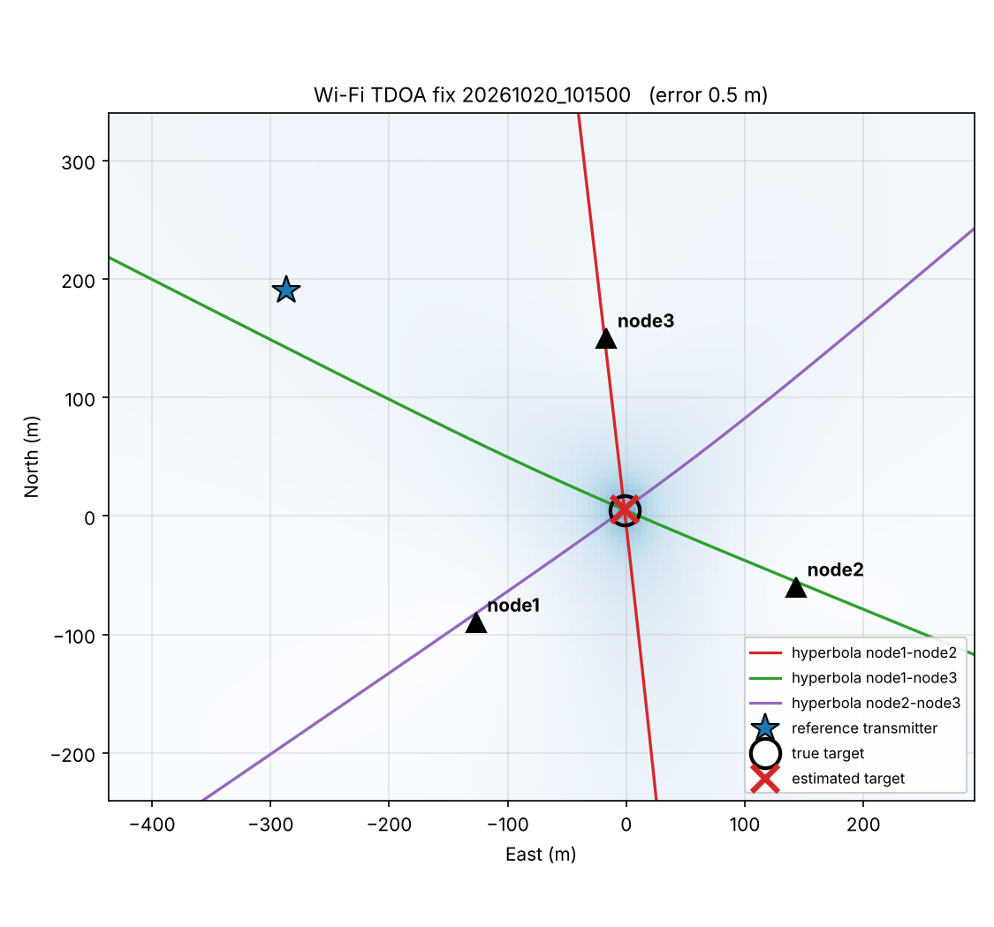
Figure 16. Wi-Fi simulator result with reflections: estimate within 0.5 m of the truth. Real sites will be worse (5-30 m), because real reflections are richer than the simulator's two echoes.

C7. Bench test
- All three receivers and both ESP32 boards in one room, receivers within 1 m of each other, ESP32s at opposite ends.
- config_wifi_bench.json: copy config_wifi.json and set every position to the same point (as in B6).
- Start the captures: python3 bladerf_rx_capture.py --node node1 --count 3 (node2 likewise) and python3 pluto_rx_capture.py --node node3 --count 3.
- Collect the files to the laptop, check them with quicklook (--rate 20e6 --center 2437e6), and run python3 tdoa_wifi_process.py --config config_wifi_bench.json --dir captures.
CHECK: Pass conditions
Packet lengths show the two groups (near 640 and 1800 us). If they are very short (under 200 us), the ESP32 is not using 1 Mbit/s: see C4.
No clipping on any node (lower the gain if needed: --gain 20).
All three pairs work, range differences within about +/-10 m of zero.
CAUTION: If the Pluto reports a buffer error
Use a smaller burst: --samples 2097152 (0.1 s). The bladeRF's 0.4 s window still overlaps it.

C8. Field set-up and procedure
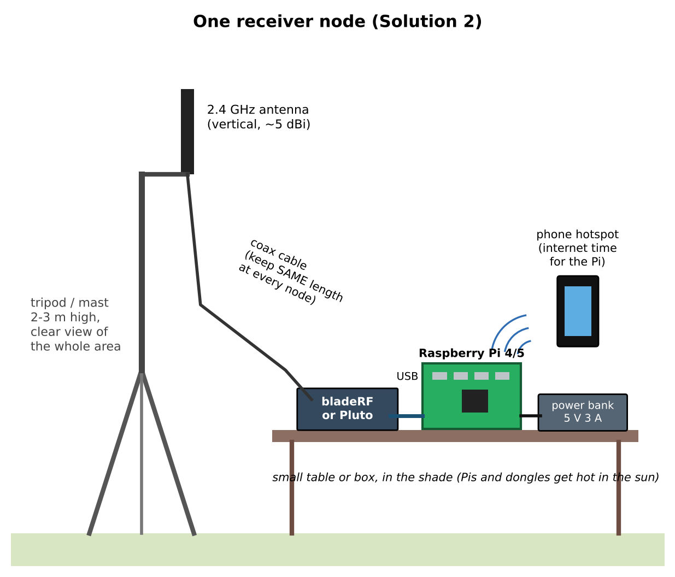
Figure 17. Solution 2 receiver node.
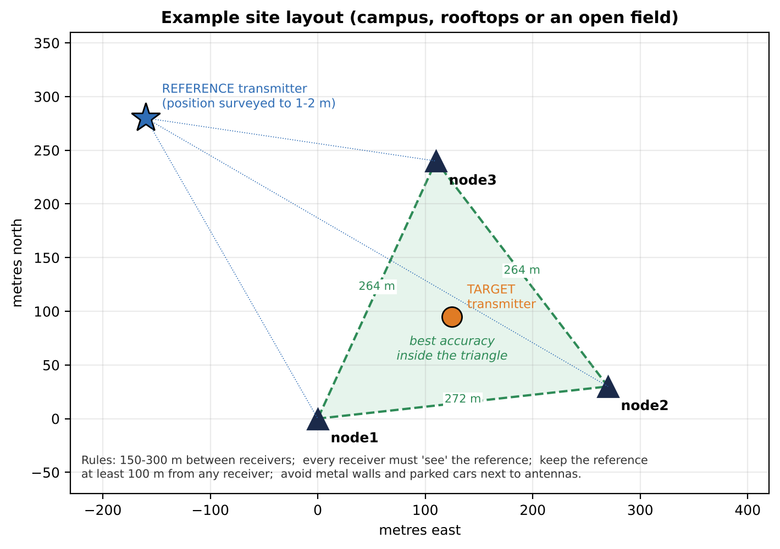
Figure 18. Example Solution 2 layout (three receivers).
- Same rules as B8, but keep receivers 150-270 m apart: the ESP32 is a low-power transmitter.
- Mount the 2.4 GHz antennas vertically, 2-3 m up, with a clear view. At 2.4 GHz, trees and people block the signal much more than at 433 MHz.
- Survey positions as in B8 and write them into config_wifi.json.
- Set up nodes; start captures with nohup, e.g. nohup python3 bladerf_rx_capture.py --node node1 > rec.log 2>&1 & and nohup python3 pluto_rx_capture.py --node node3 > rec.log 2>&1 &.
- Power the REF ESP32 at its surveyed spot and the TGT ESP32 at point A. Log UTC times.
- Take one capture, copy the three files to the laptop and run the processing once. Check the packet-length line and the packet counts at every node. Adjust gains or ESP32 power if a node finds few packets.
- Run 5 minutes per target point; move the TGT board; repeat. Collect and process exactly as in B11.
Storage
A bladeRF capture is 32 MB, so one node fills about 3.8 GB per hour at one capture per 30 s. Use --period 60 for long sessions.

C9. How the drift correction works
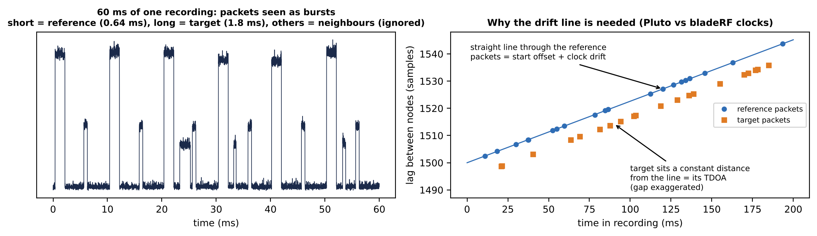
Figure 19. Left: the packets in one recording. Right: lags of reference packets lie on a straight line (start offset + clock drift); the target's TDOA is the distance of its packets from that line.
For each pair of receivers the software measures the lag of every reference packet. If the two radios' clocks run at slightly different speeds, these lags slowly increase or decrease during the recording - in a straight line. The software fits that line, then for every target packet subtracts the line's value at that packet's own time. What is left is the target-minus-reference difference without any drift, exactly as in Solution 1. Adding the known reference geometry gives the target TDOA.
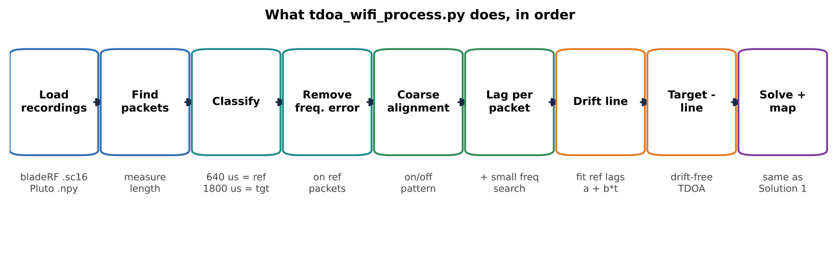
Figure 20. Processing steps in tdoa_wifi_process.py.

C10. Troubleshooting
Symptom | Likely cause | What to do
ImportError: bladerf | Python bindings not installed | re-run rx_host_setup_s2.sh; check its last line
bladeRF capture stops with a timeout | USB 2 port or weak power | use a blue USB 3 port; powered hub or better power bank
0 reference or 0 target packets | wrong channel, ESP32 off, or lengths differ | check channel everywhere; read the packet-length line and update config_wifi.json
Many packets at an unexpected length | busy channel (neighbours) | choose a quieter channel; the length filter already ignores most of them
pair FAILED (matched packets ...) | recordings do not overlap in time | check chrony; on the Pluto node make sure the capture starts on time (rec.log)
frequency error looks wrong / random | too few clean reference packets | raise REF ESP32 power; check the reference is 640 us
Large spread on one pair | weak packets at one node | antenna height; raise ESP32 power; check clipping

Part D - Turning results into a funding demonstration

D1. What to show
- The problem in one sentence: finding where a radio transmitter is, using cheap distributed receivers.
- The method in one picture: Figure 1 (hyperbolas) and Figure 3 (reference trick).
- The hardware: a photo of one node next to Figure 9 - stress that it is built from inexpensive, off-the-shelf parts.
- The site map with nodes, reference and the true target points.
- Results table: for each target point, number of captures, median error, worst error. Example layout below.
- One live fix: run tdoa_process.py on a fresh capture in front of the panel; the map appears in about 30 seconds.
- Limits and next steps (D2, D3): honest limits make the proposal more credible.
Target point | Inside triangle? | Captures | Median error (m) | Worst error (m) | Solution
A | yes | 10 |  |  | 1
B | yes | 10 |  |  | 1
C | no | 10 |  |  | 1
A | yes | 10 |  |  | 2
B | yes | 10 |  |  | 2

TIP: What reviewers look for
Repeatability (many captures agree), ground truth (surveyed target positions), and a clear statement of cost per node. All three come for free with the procedure in this guide.

D2. From post-processing to near-real-time
Real-time does not need continuous streaming. The same snapshot approach works live:
- Shorten the recordings to 0.5 s and the period to 5-10 s (--duration 0.5 --period 5).
- Each Pi copies each new file to the laptop as soon as it is written (for example with rsync over the phone hotspot or a site Wi-Fi network). A 0.5 s RTL-SDR file is 2.4 MB.
- A small loop on the laptop waits until all nodes' files for a time slot have arrived, runs the same processing, and updates the map.
- Result: a new position every 5-10 seconds over an ordinary mobile-data link. The processing itself takes a few seconds per fix on a laptop.
A further step is to cut the two signal bands out on each Pi and send only those (about 4 times less data).

D3. Upgrade path after the demonstration
Step | What it adds | Approx. cost
Fourth (and fifth) node | redundancy; bad-node detection; larger area | $0-30 per node with spare dongles
GPS-disciplined oscillator (10 MHz + PPS) per node, with radios that accept it (bladeRF 2.0, USRP B-series / NI USRP-2901) | no reference transmitter needed, so any signal at any frequency can be located; wider bandwidth | about $150-250 per node for the GPSDO
Wider-band radios (20-56 MHz) | sharper correlation, better against reflections | already owned (bladeRF) or borrowed (USRP)
Continuous streaming + live map | tracking of moving transmitters | software effort

Locating unknown, non-cooperative transmitters
The processing never uses knowledge of the target's waveform: it only compares receivers with each other. What Solution 1 does rely on is that the target is within the same 2.4 MHz recording as the reference. For a transmitter at another frequency, either move the reference near it, use frequency switching between the reference and target frequencies inside each recording (the DC9ST approach), or move to GPSDO-disciplined receivers (D3).

Appendix A - Glossary
Term | Plain meaning
TDOA | Time Difference Of Arrival: how much earlier one receiver hears a signal than another.
Hyperbola | The curve of all points with the same distance difference to two receivers.
Correlation | Sliding two recordings past each other to find the shift where they match best.
PN signal | Pseudo-random noise: a deliberately noise-like test signal that correlates to one sharp peak.
Sample rate (MS/s) | Millions of measurements per second a radio makes; 2.4 MS/s = one every 417 ns.
Bandwidth | How wide a signal is in frequency. Wider = sharper correlation peak = better timing.
ppm | Parts per million. A 1 ppm clock error at 433 MHz is 433 Hz; for timing, 1 us per second.
Frequency error / CFO | How far a radio is tuned from where it thinks it is.
Carrier leakage | A small spike at a transmitter's own centre frequency that leaks into its output.
Multipath / reflections | Copies of the signal bouncing off buildings that arrive slightly late and blur the peak.
GDOP | How much the geometry magnifies timing errors; small inside the triangle of receivers, large outside.
NTP / chrony | Internet time synchronisation for the Pi clocks; good to a few milliseconds.
GPSDO | GPS-disciplined oscillator: a clock locked to GPS satellites, used in professional TDOA.
DSSS / 802.11b | The 1 Mbit/s Wi-Fi format; each bit is spread into 11 chips, making it 20 MHz wide.
UTC | World time used in file names. Pakistan Standard Time = UTC + 5 hours.

Appendix B - Complete program listings
These are the same files as in tdoa_kit.zip. Use the files from the zip rather than retyping.

B1. common/tdoa_lib.py (shared functions)
"""
tdoa_lib.py - Shared functions for the low-cost TDOA demo kit.

Used by Solution 1 (RTL-SDR, PN signals) and Solution 2 (bladeRF/Pluto, Wi-Fi).
Every function is written to be read by a beginner: each one does ONE job.

Units used everywhere:
- time in seconds, frequency in Hz, distance in metres
- positions are local x (east) / y (north) in metres around an origin
"""
import json
import math
import numpy as np
from scipy import signal
from scipy.optimize import least_squares

C = 299_792_458.0 # speed of light (m/s)

# ----------------------------------------------------------------------------
# 1. Geography: convert GPS latitude/longitude to flat x/y metres and back.
# Over a few kilometres the earth is flat enough for this simple formula.
# ----------------------------------------------------------------------------
def latlon_to_xy(lat, lon, lat0, lon0):
"""Return (x_east_m, y_north_m) of a point relative to origin (lat0, lon0)."""
k_lat = 111_132.92 - 559.82 * math.cos(2 * math.radians(lat0))
k_lon = 111_412.84 * math.cos(math.radians(lat0))
return (lon - lon0) * k_lon, (lat - lat0) * k_lat

def xy_to_latlon(x, y, lat0, lon0):
k_lat = 111_132.92 - 559.82 * math.cos(2 * math.radians(lat0))
k_lon = 111_412.84 * math.cos(math.radians(lat0))
return lat0 + y / k_lat, lon0 + x / k_lon

def load_config(path):
"""Read config.json and convert every surveyed point to local x/y metres."""
with open(path) as f:
cfg = json.load(f)
pts = dict(cfg["nodes"])
pts["_reference"] = cfg["reference"]
if "truth_target" in cfg:
pts["_truth"] = cfg["truth_target"]
lat0 = np.mean([p["lat"] for p in cfg["nodes"].values()])
lon0 = np.mean([p["lon"] for p in cfg["nodes"].values()])
cfg["_origin"] = (lat0, lon0)
xy = {name: np.array(latlon_to_xy(p["lat"], p["lon"], lat0, lon0)) for name, p in pts.items()}
cfg["_node_xy"] = {n: xy[n] for n in cfg["nodes"]}
cfg["_ref_xy"] = xy["_reference"]
cfg["_truth_xy"] = xy.get("_truth")
return cfg

# ----------------------------------------------------------------------------
# 2. Reading recordings from disk.
# ----------------------------------------------------------------------------
def load_cu8(path, max_samples=None):
"""RTL-SDR files (rtl_sdr output): unsigned 8-bit I,Q,I,Q... -> complex."""
raw = np.fromfile(path, dtype=np.uint8, count=-1 if max_samples is None else 2 * max_samples)
raw = raw[: len(raw) // 2 * 2].astype(np.float32)
raw = (raw - 127.4) / 128.0
return (raw[0::2] + 1j * raw[1::2]).astype(np.complex64)

def load_sc16(path, scale=2048.0):
"""bladeRF files: signed 16-bit I,Q (SC16 Q11, full scale = 2048) -> complex."""
raw = np.fromfile(path, dtype=np.int16).astype(np.float32) / scale
raw = raw[: len(raw) // 2 * 2]
return (raw[0::2] + 1j * raw[1::2]).astype(np.complex64)

# ----------------------------------------------------------------------------
# 3. Basic signal processing.
# ----------------------------------------------------------------------------
def mix(x, fs, f_shift, n0=0):
"""Move a signal down in frequency by f_shift Hz (so f_shift ends up at 0 Hz)."""
n = np.arange(n0, n0 + len(x), dtype=np.float64)
return (x * np.exp(-2j * np.pi * f_shift * n / fs)).astype(np.complex64)

def lowpass(x, fs, bandwidth, numtaps=255):
"""Keep only -bandwidth/2 ... +bandwidth/2 around 0 Hz (zero-delay FIR)."""
taps = signal.firwin(numtaps, bandwidth / 2, fs=fs, window=("kaiser", 8.0))
y = signal.fftconvolve(x, taps, mode="same")
return y.astype(np.complex64)

def extract_band(x, fs, f_center, bandwidth):
"""Cut out one signal from a wider recording and bring it to 0 Hz."""
return lowpass(mix(x, fs, f_center), fs, bandwidth)

def estimate_cfo_bpsk(x_bb, fs, max_cfo, nfft=1 << 20):
"""
Frequency-offset estimate for a BPSK-type signal (our PN test signals, and
802.11b Wi-Fi). Squaring a BPSK signal removes the +1/-1 data and leaves a
pure tone at 2 x (frequency offset). We find that tone with an FFT.
"""
y = x_bb[: min(len(x_bb), nfft)].astype(np.complex128) ** 2
y = y * np.hanning(len(y))
spec = np.abs(np.fft.fftshift(np.fft.fft(y, nfft)))
freqs = np.fft.fftshift(np.fft.fftfreq(nfft, 1 / fs))
keep = np.abs(freqs) <= 2 * max_cfo
k = np.argmax(spec * keep)
# parabolic refinement of the tone position
if 0 < k < nfft - 1:
a, b, c = spec[k - 1], spec[k], spec[k + 1]
delta = 0.5 * (a - c) / (a - 2 * b + c) if (a - 2 * b + c) != 0 else 0.0
else:
delta = 0.0
f2 = freqs[k] + delta * fs / nfft
snr_db = 10 * np.log10(spec[k] / (np.median(spec[keep]) + 1e-12))
return f2 / 2.0, snr_db

def parabolic_peak(mag, k):
"""Sub-sample peak position using the two neighbours of the highest point."""
if k <= 0 or k >= len(mag) - 1:
return float(k)
a, b, c = mag[k - 1], mag[k], mag[k + 1]
den = a - 2 * b + c
return float(k) if den == 0 else k + 0.5 * (a - c) / den

def xcorr_lag(a, b, lag_center, lag_halfwidth, upsample=8):
"""
Find D (in samples, fractional) such that b[n] ~= a[n - D].

a : short piece of recording from node i (len N)
b : recording from node j, starting at the SAME index as a minus
(lag_center + lag_halfwidth) samples, length N + 2*lag_halfwidth.
Returns (D, quality) where quality = peak / median sidelobe (bigger = better).
"""
z = signal.correlate(b, a, mode="valid", method="fft")
mag = np.abs(z)
k = int(np.argmax(mag))
# refine: upsample the correlation around the peak (band-limited interpolation)
lo, hi = max(k - 16, 0), min(k + 17, len(z))
seg = z[lo:hi]
if upsample > 1 and len(seg) >= 8:
up = signal.resample(seg, len(seg) * upsample)
mu = np.abs(up)
ku = int(np.argmax(mu))
kf = lo + parabolic_peak(mu, ku) / upsample
else:
kf = parabolic_peak(mag, k)
quality = mag[k] / (np.median(mag) + 1e-12)
return kf - lag_halfwidth + lag_center, float(quality)

def segment_lag(x_i, x_j, start, n, lag_center, lag_halfwidth, upsample=8):
"""Cut matching pieces out of two recordings and measure their lag D."""
lc = int(round(lag_center))
b0 = start + lc - lag_halfwidth
b1 = start + lc + n + lag_halfwidth
if b0 < 0 or b1 > len(x_j) or start + n > len(x_i):
return None, 0.0
D, q = xcorr_lag(x_i[start:start + n], x_j[b0:b1], 0, lag_halfwidth, upsample)
return D + lc, q

# ----------------------------------------------------------------------------
# 4. Position solver.
# Input: for each node pair (i, j) the measured range difference
# dd_ij = |P - node_j| - |P - node_i| (metres)
# Output: the point P that best agrees with all of them.
# ----------------------------------------------------------------------------
def model_dd(p, xi, xj):
return np.hypot(*(p - xj)) - np.hypot(*(p - xi))

def solve_position(node_xy, pair_dd, pair_w=None, search_radius=1500.0, grid_step=5.0):
"""
Two-stage solver:
(1) grid search over the whole area (cannot get stuck in a wrong solution)
(2) least-squares polish starting from the best grid point.
Returns (best_xy, cost_map, (gx, gy)).
"""
pairs = list(pair_dd.keys())
w = np.ones(len(pairs)) if pair_w is None else np.array([pair_w[p] for p in pairs])
centre = np.mean(np.array(list(node_xy.values())), axis=0)
gx = np.arange(centre[0] - search_radius, centre[0] + search_radius, grid_step)
gy = np.arange(centre[1] - search_radius, centre[1] + search_radius, grid_step)
X, Y = np.meshgrid(gx, gy)
cost = np.zeros_like(X)
for wk, (i, j) in zip(w, pairs):
xi, xj = node_xy[i], node_xy[j]
model = np.hypot(X - xj[0], Y - xj[1]) - np.hypot(X - xi[0], Y - xi[1])
cost += wk * (model - pair_dd[(i, j)]) ** 2
r, c = np.unravel_index(np.argmin(cost), cost.shape)
p0 = np.array([gx[c], gy[r]])

def resid(p):
return [np.sqrt(wk) * (model_dd(p, node_xy[i], node_xy[j]) - pair_dd[(i, j)])
for wk, (i, j) in zip(w, pairs)]

lo_b = [gx[0], gy[0]]
hi_b = [gx[-1], gy[-1]]
sol = least_squares(resid, p0, bounds=(lo_b, hi_b)) # stay inside the search area
return sol.x, cost, (gx, gy)

def plot_solution(node_xy, ref_xy, est_xy, truth_xy, pair_dd, cost, grid, out_png, title=""):
"""Draw the map: nodes, reference, hyperbolas, estimate and (if known) truth."""
import matplotlib
matplotlib.use("Agg")
import matplotlib.pyplot as plt
gx, gy = grid
X, Y = np.meshgrid(gx, gy)
fig, ax = plt.subplots(figsize=(7.5, 7.0), dpi=150)
ax.imshow(np.log10(cost + 1.0), origin="lower", extent=[gx[0], gx[-1], gy[0], gy[-1]],
cmap="Blues_r", alpha=0.55)
colors = ["#d62728", "#2ca02c", "#9467bd", "#ff7f0e", "#8c564b", "#e377c2"]
for k, (i, j) in enumerate(pair_dd):
xi, xj = node_xy[i], node_xy[j]
model = np.hypot(X - xj[0], Y - xj[1]) - np.hypot(X - xi[0], Y - xi[1])
ax.contour(X, Y, model - pair_dd[(i, j)], levels=[0], colors=[colors[k % 6]], linewidths=1.6)
ax.plot([], [], color=colors[k % 6], label=f"hyperbola {i}-{j}")
for n, p in node_xy.items():
ax.plot(*p, "k^", ms=11)
ax.annotate(n, p, xytext=(6, 6), textcoords="offset points", fontsize=10, weight="bold")
ax.plot(*ref_xy, "*", color="#1f77b4", ms=16, mec="k", label="reference transmitter")
if truth_xy is not None:
ax.plot(*truth_xy, "o", mfc="none", mec="k", ms=16, mew=2, label="true target")
ax.plot(*est_xy, "x", color="#d62728", ms=14, mew=3, label="estimated target")
allp = np.array(list(node_xy.values()) + [ref_xy, est_xy] + ([truth_xy] if truth_xy is not None else []))
pad = 150
ax.set_xlim(allp[:, 0].min() - pad, allp[:, 0].max() + pad)
ax.set_ylim(allp[:, 1].min() - pad, allp[:, 1].max() + pad)
ax.set_aspect("equal")
ax.set_xlabel("East (m)")
ax.set_ylabel("North (m)")
ax.grid(alpha=0.3)
ax.legend(loc="lower right", fontsize=8, framealpha=0.9)
ax.set_title(title, fontsize=11)
fig.tight_layout()
fig.savefig(out_png)
plt.close(fig)

B2. solution1/make_waveforms.py
#!/usr/bin/env python3
"""
make_waveforms.py - Solution 1: create the two test signals (run ONCE on any computer).

Creates:
ref_pluto.npy reference signal for the ADALM-Pluto (complex64)
target_bladerf_sc16q11.bin target signal for the bladeRF (int16 I/Q)
target.npy same target signal as complex64 (used by the simulator)

Signal design (why):
* Pseudo-random +1/-1 "chips" at 400 kchip/s -> a noise-like signal whose
correlation has ONE sharp peak. Sharp peak = precise timing.
* Smoothed (raised-cosine spectrum, alpha 0.35) so it occupies only
~540 kHz and two of them fit inside one RTL-SDR recording (2.4 MHz).
* 2^18 chips long, repeated forever: one repeat lasts 0.655 s. Our capture
start times only need to agree to better than +/-0.3 s.
* Digitally shifted 400 kHz away from the transmitter's centre frequency,
so the transmitter's small unwanted "carrier leakage" spike falls in an
empty gap and is filtered out later.
"""
import numpy as np

FS_TX = 2_000_000 # transmitter sample rate (samples/s)
CHIP_RATE = 400_000 # chips per second
N_CHIPS = 2 ** 18 # chips per repeat (period = 0.655 s)
ALPHA = 0.35 # spectrum roll-off (occupied bandwidth = 1.35 x chip rate = 540 kHz)
REF_DIGITAL_OFFSET = -400_000 # Pluto LO 433.750 MHz -> signal at 433.350 MHz
TGT_DIGITAL_OFFSET = +400_000 # bladeRF LO 434.090 MHz -> signal at 434.490 MHz

def make_pn_waveform(seed, fs=FS_TX, chip_rate=CHIP_RATE, n_chips=N_CHIPS,
digital_offset=0.0, alpha=ALPHA):
sps = int(round(fs / chip_rate)) # samples per chip (5)
rng = np.random.default_rng(seed)
chips = rng.choice([-1.0, 1.0], size=n_chips) # the pseudo-random code
x = np.repeat(chips, sps).astype(np.complex128) # rectangular chips
# Smooth the chips with a raised-cosine spectrum (done with an FFT, so the
# waveform stays perfectly periodic and loops without a glitch).
X = np.fft.fft(x)
f = np.abs(np.fft.fftfreq(len(x), 1 / fs))
f1, f2 = (1 - alpha) * chip_rate / 2, (1 + alpha) * chip_rate / 2
H = np.where(f <= f1, 1.0, np.where(f >= f2, 0.0, 0.5 * (1 + np.cos(np.pi * (f - f1) / (f2 - f1)))))
x = np.fft.ifft(X * H)
# Digital frequency shift (whole number of cycles per repeat -> seamless loop)
n = np.arange(len(x))
x = x * np.exp(2j * np.pi * digital_offset * n / fs)
x = 0.8 * x / np.max(np.abs(x)) # leave headroom, no clipping
return x.astype(np.complex64)

if __name__ == "__main__":
ref = make_pn_waveform(seed=11, digital_offset=REF_DIGITAL_OFFSET)
tgt = make_pn_waveform(seed=22, digital_offset=TGT_DIGITAL_OFFSET)
np.save("ref_pluto.npy", ref)
np.save("target.npy", tgt)
# bladeRF wants interleaved signed 16-bit I,Q with full scale 2048 ("SC16 Q11")
iq = np.empty(2 * len(tgt), dtype=np.int16)
iq[0::2] = np.round(tgt.real * 2047).astype(np.int16)
iq[1::2] = np.round(tgt.imag * 2047).astype(np.int16)
iq.tofile("target_bladerf_sc16q11.bin")
print(f"Wrote ref_pluto.npy, target.npy, target_bladerf_sc16q11.bin "
f"({len(ref)} samples each = {len(ref) / FS_TX:.3f} s per repeat)")

B3. solution1/pluto_tx_reference.py
#!/usr/bin/env python3
"""
pluto_tx_reference.py - Solution 1: make the ADALM-Pluto transmit the REFERENCE signal.

Run on the Pi (or laptop) that the Pluto is plugged into, at the SURVEYED reference point.
python3 pluto_tx_reference.py --gain -40
Keep it running for the whole session. Press Enter to stop.

--gain is the Pluto transmit attenuation in dB (0 = maximum power, -89 = minimum).
Start low (-40) and only raise it if the far nodes cannot see the signal.
"""
import argparse
import numpy as np
import adi # pip3 install pyadi-iio

p = argparse.ArgumentParser()
p.add_argument("--uri", default="ip:192.168.2.1", help="Pluto address (or usb:...)")
p.add_argument("--lo", type=float, default=433.750e6, help="transmitter centre frequency (Hz)")
p.add_argument("--gain", type=float, default=-40.0, help="TX gain in dB, -89..0")
p.add_argument("--file", default="ref_pluto.npy")
a = p.parse_args()

iq = np.load(a.file)
sdr = adi.Pluto(a.uri)
sdr.sample_rate = 2_000_000 # must match make_waveforms.py
sdr.tx_rf_bandwidth = 1_500_000
sdr.tx_lo = int(a.lo)
sdr.tx_hardwaregain_chan0 = a.gain
sdr.tx_cyclic_buffer = True # repeat the buffer forever, without gaps
sdr.tx((iq * 2 ** 14).astype(np.complex64)) # pyadi-iio expects +/-2^14 full scale
print(f"Reference transmitting: LO {a.lo/1e6:.3f} MHz, signal centre {(a.lo-400e3)/1e6:.3f} MHz, gain {a.gain} dB")
input("Press Enter to stop transmitting... ")
sdr.tx_destroy_buffer()
print("Stopped.")

B4. solution1/bladerf_tx_target.sh
#!/bin/bash
# bladerf_tx_target.sh - Solution 1: make the bladeRF transmit the TARGET signal.
#
# Run on the Pi/laptop the bladeRF is plugged into, at the target position.
# ./bladerf_tx_target.sh (uses gain 0)
# ./bladerf_tx_target.sh 10 (uses gain 10)
# Stop with Ctrl+C.
#
# Written for bladeRF 2.0 micro (xA4 / xA9). For an OLD bladeRF x40/x115 replace the
# three "tx1" lines with: set frequency tx 434090000 ; set samplerate tx 2000000 ;
# set bandwidth tx 1500000 ; set txvga1 -35 ; set txvga2 0
GAIN=${1:-0}
FILE=$(dirname "$0")/target_bladerf_sc16q11.bin

bladeRF-cli -e "set frequency tx1 434090000; \
set samplerate tx1 2000000; \
set bandwidth tx1 1500000; \
set gain tx1 ${GAIN}; \
tx config file=${FILE} format=bin repeat=0 delay=0; \
tx start; \
tx wait"
# repeat=0 means "repeat forever". Signal centre = 434.090 + 0.400 = 434.490 MHz.

B5. solution1/rtl_recorder.py
#!/usr/bin/env python3
"""
rtl_recorder.py - Solution 1: runs on EVERY receiver Pi.

What it does:
* Starts the RTL-SDR once and keeps it streaming (so it never re-starts and
the start-up delay cannot differ between Pis).
* Every PERIOD seconds, exactly on the clock (e.g. at hh:mm:00 and hh:mm:30),
it saves DURATION seconds of samples to <capture_dir>/<node>_<UTC time>.cu8
* Because all Pis keep their clocks right with NTP (chrony), all Pis save
"the same" two seconds, to within a few milliseconds. That is all we need:
the reference transmitter fixes the rest.

Usage (on node1):
python3 rtl_recorder.py --node node1
Stop with Ctrl+C.
"""
import argparse
import datetime as dt
import json
import os
import subprocess
import sys
import time

p = argparse.ArgumentParser()
p.add_argument("--node", required=True, help="node name, must match config.json (node1, node2 ...)")
p.add_argument("--freq", type=int, default=433_920_000, help="RTL-SDR centre frequency (Hz)")
p.add_argument("--rate", type=int, default=2_400_000, help="sample rate (samples/s)")
p.add_argument("--gain", default="30", help="fixed tuner gain in dB (never use automatic gain)")
p.add_argument("--ppm", type=int, default=0, help="frequency correction, 0 for TCXO dongles")
p.add_argument("--duration", type=float, default=2.0, help="seconds saved per capture")
p.add_argument("--period", type=int, default=30, help="capture every N seconds (aligned to the clock)")
p.add_argument("--count", type=int, default=0, help="stop after N captures (0 = run forever)")
p.add_argument("--dir", default=os.path.expanduser("~/tdoa/captures"))
a = p.parse_args()
os.makedirs(a.dir, exist_ok=True)

BLOCK = 16384 # bytes per read = 8192 samples = 3.4 ms
need_bytes = int(a.duration * a.rate) * 2 # 2 bytes (I and Q) per sample
cmd = ["rtl_sdr", "-f", str(a.freq), "-s", str(a.rate), "-g", str(a.gain),
"-p", str(a.ppm), "-b", str(BLOCK), "-"]
print("Starting:", " ".join(cmd), flush=True)
proc = subprocess.Popen(cmd, stdout=subprocess.PIPE, stderr=subprocess.DEVNULL, bufsize=0)

# Let the dongle warm up and settle (temperature changes its frequency slightly).
t_warm = time.time() + 5
while time.time() < t_warm:
proc.stdout.read(BLOCK)

def next_slot(now):
return (int(now) // a.period + 1) * a.period

done = 0
slot = next_slot(time.time())
print(f"[{a.node}] first capture at {dt.datetime.fromtimestamp(slot, dt.timezone.utc):%H:%M:%S} UTC", flush=True)
try:
while True:
chunk = proc.stdout.read(BLOCK)
if not chunk:
sys.exit("rtl_sdr stopped - check the dongle / USB cable")
if time.time() < slot:
continue # not yet: throw samples away
# Slot reached: this chunk is the first one we keep.
t_first = time.time()
name = f"{a.node}_{dt.datetime.fromtimestamp(slot, dt.timezone.utc):%Y%m%d_%H%M%S}"
path = os.path.join(a.dir, name + ".cu8")
with open(path, "wb") as f:
got = 0
while got < need_bytes:
f.write(chunk)
got += len(chunk)
chunk = proc.stdout.read(BLOCK)
meta = {"node": a.node, "slot_utc": slot, "first_chunk_time": t_first,
"late_by_ms": round((t_first - slot) * 1000, 2), "freq": a.freq,
"rate": a.rate, "gain": a.gain, "ppm": a.ppm}
with open(os.path.join(a.dir, name + ".json"), "w") as f:
json.dump(meta, f)
print(f"[{a.node}] saved {name}.cu8 (late by {meta['late_by_ms']} ms)", flush=True)
done += 1
if a.count and done >= a.count:
break
slot = next_slot(time.time())
except KeyboardInterrupt:
pass
finally:
proc.terminate()

B6. solution1/tdoa_process.py
#!/usr/bin/env python3
"""
tdoa_process.py - Solution 1: turn the recordings into a position. Runs on the laptop.

python3 tdoa_process.py --config config.json --dir captures (all captures)
python3 tdoa_process.py --config config.json --dir captures --slot 20261020_101500

For each capture time ("slot") it:
1. loads one recording per node (node1_<slot>.cu8 ...)
2. measures and removes each dongle's small frequency error (from the reference signal)
3. cuts out the reference band and the target band
4. for each node pair, cross-correlates short pieces (10 ms) of both bands
-> lag of the reference D_ref and lag of the target D_tgt
The unknown recording start-time difference is inside BOTH lags and
cancels when we subtract them: d = D_tgt - D_ref
5. adds back the reference's known geometry -> target TDOA -> range difference
6. finds the point that matches all range differences (hyperbola crossing)
7. prints the answer, a Google-Maps link and the error vs. truth (if given),
saves a map picture result_<slot>.png and appends to results.csv
"""
import argparse
import csv
import glob
import os
import sys

import numpy as np

sys.path.insert(0, os.path.join(os.path.dirname(os.path.abspath(__file__)), "..", "common"))
from tdoa_lib import (C, load_config, load_cu8, extract_band, mix, estimate_cfo_bpsk,
segment_lag, solve_position, plot_solution, xy_to_latlon, model_dd)

p = argparse.ArgumentParser()
p.add_argument("--config", default="config.json")
p.add_argument("--dir", default="captures")
p.add_argument("--slot", default=None, help="process only this capture time, e.g. 20261020_101500")
p.add_argument("--seg_ms", type=float, default=10.0, help="length of each correlation piece")
p.add_argument("--nseg", type=int, default=60, help="how many pieces per recording")
p.add_argument("--max_residual", type=float, default=15.0,
help="with 4+ nodes: warn when pairs disagree by more than this (m)")
p.add_argument("--min_quality", type=float, default=8.0, help="reject weak correlation peaks")
a = p.parse_args()

cfg = load_config(a.config)
fs = cfg["sample_rate"]
fc = cfg["rx_center_hz"]
f_ref = cfg["ref_signal_hz"] - fc # reference position inside the recording (Hz)
f_tgt = cfg["target_signal_hz"] - fc # target position inside the recording (Hz)
bw = cfg["band_hz"]
margin = cfg.get("cfo_margin_hz", 25_000)
nodes = list(cfg["nodes"].keys())
node_xy, ref_xy, truth_xy = cfg["_node_xy"], cfg["_ref_xy"], cfg["_truth_xy"]
lat0, lon0 = cfg["_origin"]

def prepare(path):
"""Load one recording, remove its frequency error, return (ref_band, target_band)."""
x = load_cu8(path)
x = x - np.mean(x) # remove the DC spike
rough = extract_band(x, fs, f_ref, bw + 2 * margin) # reference band, extra wide
cfo, cfo_snr = estimate_cfo_bpsk(rough, fs, max_cfo=margin)
x = mix(x, fs, cfo) # remove frequency error
ref = extract_band(x, fs, f_ref, bw)
tgt = extract_band(x, fs, f_tgt, bw + 2 * margin) # target's own TX error is unknown
p_ref = 10 * np.log10(np.mean(np.abs(ref) ** 2) + 1e-20)
p_tgt = 10 * np.log10(np.mean(np.abs(tgt) ** 2) + 1e-20)
return ref, tgt, cfo, cfo_snr, p_ref, p_tgt

def pair_tdoa(ri, ti, rj, tj):
"""Measured target range difference for the pair (i, j), in metres, and its spread."""
n = int(a.seg_ms * 1e-3 * fs)
L = int(0.30 * fs) # coarse search: +/-0.30 s
s0 = len(ri) // 2 - n // 2
D0, q0 = segment_lag(ri, rj, s0, n * 4, 0, L, upsample=1) # 1) coarse lag of reference
if D0 is None or q0 < a.min_quality:
return None, None, 0, q0
lo = max(0, -int(D0)) + 1000 # keep pieces inside BOTH recordings
hi = min(len(ri), len(rj) - int(D0)) - n - 1000
starts = np.linspace(lo, hi, a.nseg).astype(int)
d_list, lag_now = [], D0
for s in starts:
Dr, qr = segment_lag(ri, rj, s, n, lag_now, 64) # 2) fine lag of reference
if Dr is None or qr < a.min_quality:
continue
lag_now = Dr # follow slow clock drift
Dt, qt = segment_lag(ti, tj, s, n, Dr, 48) # 3) fine lag of target near it
if Dt is None or qt < a.min_quality:
continue
d_list.append(Dt - Dr) # 4) start-time error cancels
if len(d_list) < 5:
return None, None, len(d_list), q0
d = np.array(d_list)
med = np.median(d)
spread = 1.4826 * np.median(np.abs(d - med)) / np.sqrt(len(d)) # robust std of the mean
return med / fs, spread / fs, len(d), q0

def residual_rms(p, pair_dd):
"""How well a position agrees with the measurements (metres, small = good)."""
r = [model_dd(p, node_xy[i], node_xy[j]) - v for (i, j), v in pair_dd.items()]
return float(np.sqrt(np.mean(np.square(r))))

def process_slot(slot):
files = {n: os.path.join(a.dir, f"{n}_{slot}.cu8") for n in nodes}
have = [n for n in nodes if os.path.exists(files[n])]
if len(have) < 3:
print(f"[{slot}] only {len(have)} node files found - need at least 3, skipping")
return None
print(f"\n=== Capture {slot}: nodes {', '.join(have)} ===")
data = {}
for n in have:
ref, tgt, cfo, cfo_snr, p_ref, p_tgt = prepare(files[n])
data[n] = (ref, tgt)
print(f" {n}: frequency error {cfo:+8.0f} Hz ({cfo / fc * 1e6:+.2f} ppm) "
f"ref tone SNR {cfo_snr:4.1f} dB ref power {p_ref:6.1f} dB target power {p_tgt:6.1f} dB")
pair_dd, pair_w = {}, {}
pairs = [(have[i], have[j]) for i in range(len(have)) for j in range(i + 1, len(have))]
for base, n in pairs: # every pair of nodes
ri, ti = data[base]
rj, tj = data[n]
d, sd, used, q0 = pair_tdoa(ri, ti, rj, tj)
if d is None:
print(f" pair {base}-{n}: FAILED (coarse quality {q0:.1f}, good pieces {used})")
continue
ref_geom = (np.hypot(*(ref_xy - node_xy[n])) - np.hypot(*(ref_xy - node_xy[base]))) / C
tdoa = d + ref_geom # target TDOA (s), node n minus base
pair_dd[(base, n)] = C * tdoa
sd_m = max(C * sd, 0.5)
pair_w[(base, n)] = 1.0 / sd_m ** 2
print(f" pair {base}-{n}: target TDOA {tdoa * 1e9:9.1f} ns -> range difference "
f"{C * tdoa:8.1f} m (+/-{sd_m:.1f} m, {used} pieces)")
if len(pair_dd) < 2:
print(" Not enough good pairs for a 2-D fix.")
return None
est, cost, grid = solve_position(node_xy, pair_dd, pair_w)
rms = residual_rms(est, pair_dd)
print(f" Fit residual (all nodes): {rms:.1f} m")
if len(node_xy) >= 4 and rms > a.max_residual:
print(" NOTE: the node pairs disagree by more than "
f"{a.max_residual:.0f} m - reflections at one site? Check each node's line of sight to the target area.")
lat, lon = xy_to_latlon(est[0], est[1], lat0, lon0)
print(f" ESTIMATED TARGET: {lat:.6f}, {lon:.6f} https://maps.google.com/?q={lat:.6f},{lon:.6f}")
err = None
if truth_xy is not None:
err = float(np.hypot(*(est - truth_xy)))
print(f" Error vs. surveyed true target position: {err:.1f} m")
title = f"TDOA fix {slot}" + (f" (error {err:.1f} m)" if err is not None else "")
png = os.path.join(a.dir, f"result_{slot}.png")
plot_solution(node_xy, ref_xy, est, truth_xy, pair_dd, cost, grid, png, title)
print(f" Map saved: {png}")
return slot, lat, lon, err

slots = [a.slot] if a.slot else sorted({os.path.basename(f).split("_", 1)[1][:-4]
for f in glob.glob(os.path.join(a.dir, "*_*.cu8"))})
results = [r for r in (process_slot(s) for s in slots) if r]
if results:
out = os.path.join(a.dir, "results.csv")
new = not os.path.exists(out)
with open(out, "a", newline="") as f:
w = csv.writer(f)
if new:
w.writerow(["slot", "lat", "lon", "error_m"])
w.writerows(results)
errs = [r[3] for r in results if r[3] is not None]
if errs:
print(f"\nSUMMARY over {len(errs)} captures: median error {np.median(errs):.1f} m, "
f"worst {np.max(errs):.1f} m")
print(f"Results appended to {out}")

B7. solution1/config.json (template)
{
"_comment": "Solution 1 site file. Replace every lat/lon with YOUR surveyed values (decimal degrees, 7 decimals). Delete truth_target if you do not know it.",
"sample_rate": 2400000,
"rx_center_hz": 433920000,
"ref_signal_hz": 433350000,
"target_signal_hz": 434490000,
"band_hz": 600000,
"cfo_margin_hz": 25000,
"nodes": {
"node1": {"lat": 33.0000000, "lon": 73.0000000},
"node2": {"lat": 33.0002700, "lon": 73.0029000},
"node3": {"lat": 33.0021600, "lon": 73.0011800}
},
"reference": {"lat": 33.0025200, "lon": 72.9982800},
"truth_target": {"lat": 33.0008600, "lon": 73.0013400}
}

B8. solution1/pi_setup.sh
#!/bin/bash
# pi_setup.sh - run ONCE on every Raspberry Pi (Raspberry Pi OS 64-bit, Bookworm or newer).
# chmod +x pi_setup.sh && ./pi_setup.sh
set -e
sudo apt update
sudo apt install -y git cmake build-essential pkg-config libusb-1.0-0-dev \
python3-numpy python3-scipy python3-matplotlib chrony

# --- RTL-SDR driver (RTL-SDR Blog version: supports both V3 and V4 dongles) ---
sudo apt purge -y ^librtlsdr rtl-sdr || true
cd ~ && rm -rf rtl-sdr-blog && git clone https://github.com/rtlsdrblog/rtl-sdr-blog
cd rtl-sdr-blog && mkdir -p build && cd build
cmake ../ -DINSTALL_UDEV_RULES=ON && make -j4 && sudo make install && sudo ldconfig
# stop the TV-tuner kernel driver from grabbing the dongle
echo 'blacklist dvb_usb_rtl28xxu' | sudo tee /etc/modprobe.d/blacklist-rtl.conf

# --- Accurate clock: chrony (NTP) ---
sudo systemctl enable --now chrony

# --- Folder for recordings ---
mkdir -p ~/tdoa/captures
echo "Done. Reboot now (sudo reboot), then test with: rtl_test -t"

B9. solution1/tx_host_setup.sh
#!/bin/bash
# tx_host_setup.sh - run ONCE on each Pi/laptop that drives a TRANSMITTER (Pluto or bladeRF).
set -e
sudo apt update
sudo apt install -y python3-numpy python3-pip libiio-utils python3-libiio bladerf
pip3 install --break-system-packages pyadi-iio
echo "Pluto check: iio_info -s (should list the PlutoSDR)"
echo "bladeRF check: bladeRF-cli -p (should list the bladeRF)"
echo "bladeRF FPGA: download the 'hosted' FPGA image for your model from nuand.com/fpga"
echo " then load it with: bladeRF-cli -l hostedxA4-latest.rbf (xA9: hostedxA9-latest.rbf)"

B10. solution1/collect_captures.sh
#!/bin/bash
# collect_captures.sh - run on the LAPTOP to copy every node's recordings into ./captures
# Edit the addresses below to match your Pis (see "hostname -I" on each Pi).
NODES=("node1:pi@node1.local" "node2:pi@node2.local" "node3:pi@node3.local")
mkdir -p captures
for entry in "${NODES[@]}"; do
name=${entry%%:*}; host=${entry#*:}
echo "Copying from $name ($host) ..."
scp "$host:~/tdoa/captures/${name}_*" captures/ || echo " !! could not reach $name - copy its files by USB stick instead"
done
ls -1 captures | wc -l | xargs echo "Files now in ./captures:"

B11. solution1/simulate_captures.py
#!/usr/bin/env python3
"""
simulate_captures.py - Solution 1: create FAKE recordings that look exactly like the
real RTL-SDR files, so you can test the whole software chain at your desk first.

python3 simulate_captures.py # line-of-sight site
python3 simulate_captures.py --urban # adds building echoes (multipath)
python3 tdoa_process.py --config config_sim.json --dir captures_sim

The fake recordings include everything that goes wrong in real life:
* each Pi starts recording at a slightly different time (up to tens of ms)
* each dongle and each transmitter has its own frequency error (ppm)
* transmitter carrier-leakage spikes, DC offset, receiver noise, 8-bit rounding
"""
import argparse
import datetime
import json
import os
import sys

import numpy as np

sys.path.insert(0, os.path.join(os.path.dirname(os.path.abspath(__file__)), "..", "common"))
from tdoa_lib import C, xy_to_latlon
from make_waveforms import make_pn_waveform, FS_TX, REF_DIGITAL_OFFSET, TGT_DIGITAL_OFFSET

p = argparse.ArgumentParser()
p.add_argument("--urban", action="store_true", help="add multipath echoes")
p.add_argument("--slots", type=int, default=3)
p.add_argument("--snr_db", type=float, default=12.0, help="signal-to-noise at 200 m, per sample")
p.add_argument("--out", default="captures_sim")
p.add_argument("--seed", type=int, default=1)
p.add_argument("--four", action="store_true", help="use 4 receiver nodes")
a = p.parse_args()
rng = np.random.default_rng(a.seed)

FS = 2_400_000
DUR = 2.0
FC = 433_920_000
LO_REF, LO_TGT = 433_750_000, 434_090_000 # transmitter centre frequencies
LAT0, LON0 = 33.000000, 73.000000 # example origin - replace in real config

# Site layout in metres (east, north). Triangle sides ~230-280 m.
nodes = {"node1": (0.0, 0.0), "node2": (270.0, 30.0), "node3": (110.0, 240.0)}
if a.four:
nodes["node4"] = (300.0, 250.0)
ref_xy = (-160.0, 280.0) # reference transmitter (surveyed)
tgt_xy = (125.0, 95.0) # true target (unknown to the software)

def periodic_resample(x, n_new):
"""Exact resampling of a periodic signal by FFT zero-padding."""
X = np.fft.fft(x)
n = len(x)
Y = np.zeros(n_new, dtype=complex)
h = n // 2
Y[:h] = X[:h]
Y[-h:] = X[-h:]
return np.fft.ifft(Y) * (n_new / n)

ref_tx = make_pn_waveform(seed=11, digital_offset=REF_DIGITAL_OFFSET)
tgt_tx = make_pn_waveform(seed=22, digital_offset=TGT_DIGITAL_OFFSET)
Q = int(len(ref_tx) * FS / FS_TX)
S_ref = np.fft.fft(periodic_resample(ref_tx, Q))
S_tgt = np.fft.fft(periodic_resample(tgt_tx, Q))
f_axis = np.fft.fftfreq(Q, 1 / FS)
N = int(DUR * FS)

err_ref_tx = 9e-6 * LO_REF # Pluto 9 ppm off
err_tgt_tx = -2e-6 * LO_TGT # bladeRF -2 ppm off
rx_ppm = {n: rng.uniform(-1.5, 1.5) for n in nodes} # TCXO dongles, +/-1.5 ppm

def receive(S, tx_lo, tx_err, src_xy, node_xy, t0, rx_err, amp_ref):
d = np.hypot(src_xy[0] - node_xy[0], src_xy[1] - node_xy[1])
amp = amp_ref * 200.0 / d
a_shift = t0 - d / C # sample n <-> emitted time t0 + n/FS - d/C
paths = [(0.0, 1.0)]
if a.urban: # two building echoes
paths += [(rng.uniform(50e-9, 250e-9), 0.5 * np.exp(2j * np.pi * rng.random())),
(rng.uniform(200e-9, 600e-9), 0.25 * np.exp(2j * np.pi * rng.random()))]
spec = sum(g * S * np.exp(2j * np.pi * f_axis * (a_shift - extra)) for extra, g in paths)
y = np.resize(np.fft.ifft(spec), N)
f_off = (tx_lo + tx_err) - (FC + rx_err) # where it lands in the recording
n = np.arange(N)
tone = 0.02 * np.exp(2j * np.pi * f_off * (t0 + n / FS)) # carrier leakage
return amp * (y * np.exp(2j * np.pi * f_off * (t0 + n / FS)) + tone)

os.makedirs(a.out, exist_ok=True)
sig_rms = np.sqrt(np.mean(np.abs(ref_tx) ** 2))
noise_sigma = sig_rms / (10 ** (a.snr_db / 20))
for k in range(a.slots):
slot_time = 30.0 * k # seconds since session start (kept small: float precision!)
slot = (datetime.datetime(2026, 10, 20, 10, 15, 0) + datetime.timedelta(seconds=30 * k)).strftime("%Y%m%d_%H%M%S")
for name, nxy in nodes.items():
t0 = slot_time + rng.uniform(-0.010, 0.040) # this Pi starts a bit early/late
rx_err = rx_ppm[name] * 1e-6 * FC
y = receive(S_ref, LO_REF, err_ref_tx, ref_xy, nxy, t0, rx_err, 1.0)
y += receive(S_tgt, LO_TGT, err_tgt_tx, tgt_xy, nxy, t0, rx_err, 1.0)
y += noise_sigma * (rng.standard_normal(N) + 1j * rng.standard_normal(N)) / np.sqrt(2)
y += 0.01 + 0.008j # DC offset
scale = 30.0 / np.sqrt(np.mean(np.abs(y) ** 2)) # gain setting -> ~30 counts rms
iq = np.empty(2 * N, dtype=np.float32)
iq[0::2], iq[1::2] = y.real * scale + 127.4, y.imag * scale + 127.4
np.clip(np.round(iq), 0, 255).astype(np.uint8).tofile(os.path.join(a.out, f"{name}_{slot}.cu8"))
print("wrote slot", slot)

def ll(xy):
lat, lon = xy_to_latlon(xy[0], xy[1], LAT0, LON0)
return {"lat": round(lat, 7), "lon": round(lon, 7)}

# The solver re-centres on the node average, so we store real lat/lon like a real survey.
cfg = {
"sample_rate": FS, "rx_center_hz": FC,
"ref_signal_hz": LO_REF + REF_DIGITAL_OFFSET, "target_signal_hz": LO_TGT + TGT_DIGITAL_OFFSET,
"band_hz": 600_000, "cfo_margin_hz": 25_000,
"nodes": {n: ll(xy) for n, xy in nodes.items()},
"reference": ll(ref_xy), "truth_target": ll(tgt_xy),
}
for path in ("config_sim.json", os.path.join(a.out, "config_used.json")):
with open(path, "w") as f:
json.dump(cfg, f, indent=2)
print("wrote config_sim.json (copy kept in the capture folder)")

B12. common/quicklook.py
#!/usr/bin/env python3
"""
quicklook.py - check ONE recording before trusting it (works for both solutions).

python3 quicklook.py captures/node1_20261020_101500.cu8 (RTL-SDR, Solution 1)
python3 quicklook.py captures/node1_20261020_101500.sc16 --rate 20e6 --center 2437e6
python3 quicklook.py captures/node3_20261020_101500.npy --rate 20e6 --center 2437e6

Prints: how much of the recording is clipped (too much gain), the noise floor and
the strongest peaks; saves <file>_quicklook.png with the spectrum and the signal level.
"""
import argparse
import os
import sys

import numpy as np
import matplotlib
matplotlib.use("Agg")
import matplotlib.pyplot as plt

sys.path.insert(0, os.path.dirname(os.path.abspath(__file__)))
from tdoa_lib import load_cu8, load_sc16

p = argparse.ArgumentParser()
p.add_argument("file")
p.add_argument("--rate", type=float, default=2.4e6)
p.add_argument("--center", type=float, default=433.92e6)
a = p.parse_args()

if a.file.endswith(".cu8"):
raw = np.fromfile(a.file, dtype=np.uint8)
clip = np.mean((raw == 0) | (raw == 255)) * 100
x = load_cu8(a.file)
elif a.file.endswith(".sc16"):
raw = np.fromfile(a.file, dtype=np.int16)
clip = np.mean(np.abs(raw) >= 2040) * 100
x = load_sc16(a.file)
else:
x = np.load(a.file)
clip = np.mean((np.abs(x.real) >= 0.995) | (np.abs(x.imag) >= 0.995)) * 100
x = x - np.mean(x)
nf = 4096
seg = x[: len(x) // nf * nf].reshape(-1, nf)
P = np.mean(np.abs(np.fft.fftshift(np.fft.fft(seg * np.hanning(nf), axis=1), axes=1)) ** 2, axis=0)
PdB = 10 * np.log10(P + 1e-20)
f = (a.center + np.fft.fftshift(np.fft.fftfreq(nf, 1 / a.rate))) / 1e6
floor = np.median(PdB)
print(f"File: {a.file}")
print(f" length : {len(x) / a.rate:.3f} s ({len(x)} samples)")
print(f" clipped samples : {clip:.3f} % {'OK' if clip < 0.1 else 'TOO HIGH - reduce gain'}")
print(f" noise floor : {floor:.1f} dB (relative)")
print(f" strongest level : {PdB.max() - floor:.1f} dB above the noise at {f[np.argmax(PdB)]:.3f} MHz")

fig, axs = plt.subplots(2, 1, figsize=(9, 6))
axs[0].plot(f, PdB - floor, lw=0.8)
axs[0].set_xlabel("MHz")
axs[0].set_ylabel("dB above noise")
axs[0].set_title(os.path.basename(a.file) + " - spectrum")
axs[0].grid(alpha=0.3)
dec = max(1, int(a.rate * 1e-4))
env = np.abs(x[: len(x) // dec * dec]).reshape(-1, dec).max(1)
axs[1].plot(np.arange(len(env)) * dec / a.rate * 1e3, env, lw=0.6)
axs[1].set_xlabel("time (ms)")
axs[1].set_ylabel("level")
axs[1].set_title("signal level over time")
fig.tight_layout()
out = a.file.rsplit(".", 1)[0] + "_quicklook.png"
fig.savefig(out, dpi=120)
print(f" picture saved : {out}")

B13. solution2/esp32_beacon/esp32_beacon.ino
/*
esp32_beacon.ino - Solution 2: turns a ~$5 ESP32 board into a Wi-Fi test transmitter.

Flash TWO boards with this sketch (Arduino IDE, board "ESP32 Dev Module"):
* Board 1 = REFERENCE : keep the line #define ROLE_REFERENCE
* Board 2 = TARGET : put // in front of that line (comment it out)

Each board sends a short Wi-Fi "beacon" packet every PERIOD_MS milliseconds on CHANNEL.
The REFERENCE packet is short (~0.64 ms), the TARGET packet is long (~1.8 ms),
so the software can tell them apart just by their length.
Packets are sent at 1 Mbit/s (802.11b, DSSS): a ~20 MHz wide, noise-like signal
that gives a sharp correlation peak.
*/
#include <WiFi.h>
#include "esp_wifi.h"

#define ROLE_REFERENCE // <-- comment out for the TARGET board

const uint8_t CHANNEL = 6; // pick the quietest channel at your site (1..13)
const uint32_t PERIOD_MS = 10; // one packet every 10 ms

#ifdef ROLE_REFERENCE
const char* SSID = "TDOA-REF";
const uint8_t PAD_LEN = 0; // no padding -> short packet
uint8_t MAC[6] = {0x02, 0x54, 0x44, 0x4F, 0x41, 0x01};
#else
const char* SSID = "TDOA-TARGET-0123456789ABCDEFGHI"; // long name
const uint8_t PAD_LEN = 120; // extra bytes -> long packet
uint8_t MAC[6] = {0x02, 0x54, 0x44, 0x4F, 0x41, 0x02};
#endif

uint8_t pkt[400];
int pkt_len = 0;

void build_beacon() {
int i = 0;
pkt[i++] = 0x80; pkt[i++] = 0x00; // frame type: beacon
pkt[i++] = 0x00; pkt[i++] = 0x00; // duration
for (int k = 0; k < 6; k++) pkt[i++] = 0xFF; // to: everyone
for (int k = 0; k < 6; k++) pkt[i++] = MAC[k]; // from
for (int k = 0; k < 6; k++) pkt[i++] = MAC[k]; // network id (BSSID)
pkt[i++] = 0x00; pkt[i++] = 0x00; // sequence (filled in by the ESP32)
for (int k = 0; k < 8; k++) pkt[i++] = 0x00; // timestamp
pkt[i++] = 0x64; pkt[i++] = 0x00; // beacon interval
pkt[i++] = 0x01; pkt[i++] = 0x00; // capabilities (long preamble)
uint8_t n = strlen(SSID);
pkt[i++] = 0x00; pkt[i++] = n; // network name
memcpy(&pkt[i], SSID, n); i += n;
pkt[i++] = 0x01; pkt[i++] = 0x01; pkt[i++] = 0x82; // supported rate: 1 Mbit/s
pkt[i++] = 0x03; pkt[i++] = 0x01; pkt[i++] = CHANNEL;// channel number
if (PAD_LEN > 0) { // vendor element used as padding
pkt[i++] = 0xDD; pkt[i++] = PAD_LEN;
for (int k = 0; k < PAD_LEN; k++) pkt[i++] = (uint8_t)(k * 37 + 11);
}
pkt_len = i;
}

void setup() {
Serial.begin(115200);
WiFi.mode(WIFI_STA); // radio on, not connected anywhere
esp_wifi_set_promiscuous(true);
esp_wifi_set_channel(CHANNEL, WIFI_SECOND_CHAN_NONE);
esp_wifi_set_max_tx_power(8); // units of 0.25 dBm -> 2 dBm (keep it low)
// Force 1 Mbit/s long-preamble DSSS. If your Arduino-ESP32 version does not know this
// function, delete the line - the beacons are usually sent at 1 Mbit/s anyway.
esp_wifi_config_80211_tx_rate(WIFI_IF_STA, WIFI_PHY_RATE_1M_L);
build_beacon();
Serial.printf("TDOA beacon '%s' on channel %d, %d bytes every %lu ms\n",
SSID, CHANNEL, pkt_len, (unsigned long)PERIOD_MS);
}

void loop() {
esp_wifi_80211_tx(WIFI_IF_STA, pkt, pkt_len, true);
delay(PERIOD_MS);
}

B14. solution2/bladerf_rx_capture.py
#!/usr/bin/env python3
"""
bladerf_rx_capture.py - Solution 2: a bladeRF used as a RECEIVER node.

Streams continuously (USB 3.0) and, on every capture slot, saves a gap-free piece
of 0.4 s (8M samples). Longer than the Pluto's 0.2 s piece so the two always overlap.

python3 bladerf_rx_capture.py --node node1
Saves ~/tdoa/captures/node1_<UTC>.sc16 (signed 16-bit I/Q, full scale 2048)

Needs the libbladeRF Python bindings (see the guide, section "Installing software").
"""
import argparse
import datetime as dt
import json
import os
import shutil
import time

from bladerf import _bladerf

p = argparse.ArgumentParser()
p.add_argument("--node", required=True)
p.add_argument("--freq", type=float, default=2437e6)
p.add_argument("--rate", type=float, default=20e6)
p.add_argument("--gain", type=int, default=40)
p.add_argument("--samples", type=int, default=8_000_000)
p.add_argument("--period", type=int, default=30)
p.add_argument("--count", type=int, default=0)
p.add_argument("--dir", default=os.path.expanduser("~/tdoa/captures"))
a = p.parse_args()
os.makedirs(a.dir, exist_ok=True)

sdr = _bladerf.BladeRF()
ch = sdr.Channel(_bladerf.CHANNEL_RX(0))
ch.frequency = int(a.freq)
ch.sample_rate = int(a.rate)
ch.bandwidth = int(a.rate * 0.9)
ch.gain_mode = _bladerf.GainMode.Manual
ch.gain = a.gain
sdr.sync_config(layout=_bladerf.ChannelLayout.RX_X1, fmt=_bladerf.Format.SC16_Q11,
num_buffers=32, buffer_size=16384, num_transfers=16, stream_timeout=3500)
ch.enable = True

CHUNK = 65536 # samples per read (3.3 ms)
chunk = bytearray(CHUNK * 4)
capture = bytearray(a.samples * 4) # kept in RAM: SD cards are too slow
done = 0
try:
while True:
slot = (int(time.time()) // a.period + 1) * a.period
while time.time() < slot: # keep the stream flowing, discard samples
sdr.sync_rx(chunk, CHUNK)
view, got = memoryview(capture), 0
while got < a.samples:
n = min(CHUNK, a.samples - got)
sdr.sync_rx(view[got * 4:(got + n) * 4], n)
got += n
name = f"{a.node}_{dt.datetime.fromtimestamp(slot, dt.timezone.utc):%Y%m%d_%H%M%S}"
tmp = os.path.join("/dev/shm", name + ".sc16")
with open(tmp, "wb") as f:
f.write(capture)
shutil.move(tmp, os.path.join(a.dir, name + ".sc16"))
with open(os.path.join(a.dir, name + ".json"), "w") as f:
json.dump({"node": a.node, "slot_utc": slot, "rate": a.rate, "freq": a.freq,
"gain": a.gain, "samples": a.samples}, f)
print(f"[{a.node}] saved {name}.sc16", flush=True)
done += 1
if a.count and done >= a.count:
break
except KeyboardInterrupt:
pass
finally:
ch.enable = False
sdr.close()

B15. solution2/pluto_rx_capture.py
#!/usr/bin/env python3
"""
pluto_rx_capture.py - Solution 2: the ADALM-Pluto used as a RECEIVER node.

The Pluto's USB 2.0 link is too slow to stream 20 MS/s continuously, but it can
record a burst of up to a few million samples into its own memory and then send it.
That is all TDOA needs: one short, gap-free piece per capture time.

python3 pluto_rx_capture.py --node node3
Saves ~/tdoa/captures/node3_<UTC>.npy every --period seconds (aligned to the clock).
"""
import argparse
import datetime as dt
import json
import os
import time

import numpy as np
import adi # pip3 install pyadi-iio

p = argparse.ArgumentParser()
p.add_argument("--node", required=True)
p.add_argument("--uri", default="ip:192.168.2.1")
p.add_argument("--freq", type=float, default=2437e6, help="Wi-Fi channel 6 centre")
p.add_argument("--rate", type=float, default=20e6)
p.add_argument("--gain", type=float, default=40, help="manual RX gain in dB (0..70)")
p.add_argument("--samples", type=int, default=2 ** 22, help="4M samples = 0.21 s at 20 MS/s")
p.add_argument("--period", type=int, default=30)
p.add_argument("--count", type=int, default=0)
p.add_argument("--dir", default=os.path.expanduser("~/tdoa/captures"))
a = p.parse_args()
os.makedirs(a.dir, exist_ok=True)

sdr = adi.Pluto(a.uri)
sdr.sample_rate = int(a.rate)
sdr.rx_rf_bandwidth = int(a.rate)
sdr.rx_lo = int(a.freq)
sdr.gain_control_mode_chan0 = "manual" # never automatic gain for TDOA
sdr.rx_hardwaregain_chan0 = a.gain
sdr.rx_buffer_size = a.samples
sdr.rx() # one warm-up capture, thrown away

done = 0
while True:
slot = (int(time.time()) // a.period + 1) * a.period
sdr.rx_destroy_buffer() # make sure the next capture is fresh
while time.time() < slot - 0.002:
time.sleep(0.001)
t_call = time.time()
x = sdr.rx().astype(np.complex64) / 2048.0
name = f"{a.node}_{dt.datetime.fromtimestamp(slot, dt.timezone.utc):%Y%m%d_%H%M%S}"
np.save(os.path.join(a.dir, name + ".npy"), x)
with open(os.path.join(a.dir, name + ".json"), "w") as f:
json.dump({"node": a.node, "slot_utc": slot, "call_time": t_call, "rate": a.rate,
"freq": a.freq, "gain": a.gain, "samples": len(x)}, f)
print(f"[{a.node}] saved {name}.npy ({len(x)} samples)", flush=True)
done += 1
if a.count and done >= a.count:
break

B16. solution2/tdoa_wifi_process.py
#!/usr/bin/env python3
"""
tdoa_wifi_process.py - Solution 2: positions from Wi-Fi packets. Runs on the laptop.

python3 tdoa_wifi_process.py --config config_wifi.json --dir captures
python3 tdoa_wifi_process.py --config config_wifi.json --dir captures --slot 20261020_101500

Steps for every capture time:
1. load one recording per node (bladeRF .sc16 or Pluto .npy)
2. find every Wi-Fi packet ("burst") and measure how long it lasts
about 640 us long -> REFERENCE packet
about 1800 us long -> TARGET packet anything else (neighbours' Wi-Fi) is ignored
3. remove each radio's frequency error (squaring trick on the reference packets)
4. line up the recordings roughly by matching the on/off pattern of the packets
5. for every packet seen by both nodes of a pair, measure the exact lag (sub-sample)
6. reference packets: fit a straight line lag(t) = a + b*t
a = start-time difference, b = the two radios' clock-speed difference (drift)
7. target packets: subtract that line at the target packet's time -> drift-free TDOA
8. add the reference geometry, solve for position, draw the map
"""
import argparse
import csv
import glob
import os
import sys

import numpy as np
from scipy import signal

sys.path.insert(0, os.path.join(os.path.dirname(os.path.abspath(__file__)), "..", "common"))
from tdoa_lib import (C, load_config, load_sc16, mix, xcorr_lag,
solve_position, plot_solution, xy_to_latlon, model_dd)

p = argparse.ArgumentParser()
p.add_argument("--config", default="config_wifi.json")
p.add_argument("--dir", default="captures")
p.add_argument("--slot", default=None)
a = p.parse_args()

cfg = load_config(a.config)
fs = cfg["sample_rate"]
fc = cfg["rx_center_hz"]
REF_US = cfg.get("ref_packet_us", 640) # length of a reference packet (microseconds)
TGT_US = cfg.get("tgt_packet_us", 1800) # length of a target packet
TOL_US = cfg.get("packet_tolerance_us", 80) # accepted difference
MIN_LEN = 250e-6
nodes = list(cfg["nodes"].keys())
node_xy, ref_xy, truth_xy = cfg["_node_xy"], cfg["_ref_xy"], cfg["_truth_xy"]
lat0, lon0 = cfg["_origin"]

def load_any(path):
if path.endswith(".npy"):
return np.load(path).astype(np.complex64)
return load_sc16(path)

def find_bursts(x):
"""Return list of (start, end, kind) for every packet found in x."""
pw = np.abs(x) ** 2
win = int(10e-6 * fs) # 10 microsecond smoothing
env = signal.fftconvolve(pw, np.ones(win) / win, mode="same")
floor = np.median(env)
on = env > 10 * floor # 10 dB above the noise
edges = np.flatnonzero(np.diff(on.astype(np.int8)))
if on[0]:
edges = np.r_[0, edges]
if on[-1]:
edges = np.r_[edges, len(on) - 1]
bursts, all_us = [], []
for s, e in zip(edges[0::2], edges[1::2]):
dur = (e - s) / fs
all_us.append(int(round(dur * 1e5)) * 10) # every packet, to 10 us
if dur < MIN_LEN or s < 200 or e > len(x) - 200: # too short or cut at the edge
continue
us = dur * 1e6
kind = "ref" if abs(us - REF_US) < TOL_US else ("tgt" if abs(us - TGT_US) < TOL_US else None)
if kind:
bursts.append((int(s), int(e), kind))
return bursts, on, all_us

def remove_cfo(x, bursts, nfft=1 << 16, max_cfo=120e3):
"""
Measure the frequency error on the reference packets and remove it.
Each packet is squared (removes the +1/-1 data, leaves a tone at 2 x error);
the spectra of all reference packets are added up and the tone is located.
"""
acc = np.zeros(nfft)
for s, e, k in bursts:
if k == "ref":
seg = x[s:e].astype(np.complex128) ** 2
sp = np.abs(np.fft.fftshift(np.fft.fft(seg * np.hanning(len(seg)), nfft))) ** 2
acc += sp / sp.sum() # every packet gets one equal "vote"
freqs = np.fft.fftshift(np.fft.fftfreq(nfft, 1 / fs))
acc[np.abs(freqs) > 2 * max_cfo] = 0
k = int(np.argmax(acc))
a_, b_, c_ = np.log(acc[k - 1:k + 2] + 1e-30)
delta = 0.5 * (a_ - c_) / (a_ - 2 * b_ + c_)
cfo = (freqs[k] + delta * fs / nfft) / 2
snr = 10 * np.log10(acc[k] / (np.median(acc[acc > 0]) + 1e-30))
return mix(x, fs, cfo), cfo, snr

def coarse_offset(on_i, on_j, max_s=0.30):
"""Rough lag (samples) of node j vs node i from the packets' on/off pattern."""
dec = int(5e-6 * fs)
ei = on_i[: len(on_i) // dec * dec].reshape(-1, dec).mean(1) - 0.5
ej = on_j[: len(on_j) // dec * dec].reshape(-1, dec).mean(1) - 0.5
z = signal.correlate(ej, ei, mode="full", method="fft")
lags = np.arange(-len(ei) + 1, len(ej))
keep = np.abs(lags) * dec <= max_s * fs
return int(lags[keep][np.argmax(z[keep])] * dec)

def burst_lag(xi, xj, s, e, centre, half=300, fsearch=(-600, 600, 100)):
"""Exact lag of one packet between two recordings, small frequency search included."""
seg_i = xi[s - 50:e + 50]
c = int(round(centre))
b0, b1 = s - 50 + c - half, e + 50 + c + half
if b0 < 0 or b1 > len(xj):
return None, 0
seg_j = xj[b0:b1]
best = (None, 0)
for f in np.arange(*fsearch):
D, q = xcorr_lag(seg_i, mix(seg_j, fs, f), 0, half, upsample=8)
if q > best[1]:
best = (D + c, q)
return best

def pair_tdoa(Xi, Xj):
(xi, bi, oi), (xj, bj, oj) = Xi, Xj
D0 = coarse_offset(oi, oj)
starts_j = np.array([s for s, _, _ in bj])
kinds_j = [k for _, _, k in bj]
meas = {"ref": [], "tgt": []}
for s, e, k in bi:
if len(starts_j) == 0:
break
m = int(np.argmin(np.abs(starts_j - (s + D0))))
if abs(starts_j[m] - (s + D0)) > int(30e-6 * fs) + 200 or kinds_j[m] != k:
continue # not the same packet
D, q = burst_lag(xi, xj, s, e, starts_j[m] - s)
if D is not None and q > 6:
meas[k].append((s / fs, D))
r, t = np.array(meas["ref"]), np.array(meas["tgt"])
if len(r) < 4 or len(t) < 2:
return None, None, (len(r), len(t))
# straight-line fit to the reference lags, twice, dropping outliers the second time
coef = np.polyfit(r[:, 0], r[:, 1], 1)
res = r[:, 1] - np.polyval(coef, r[:, 0])
good = np.abs(res) < 3 * 1.4826 * np.median(np.abs(res)) + 0.05
coef = np.polyfit(r[good, 0], r[good, 1], 1)
d = t[:, 1] - np.polyval(coef, t[:, 0]) # drift-free target-minus-reference
med = np.median(d)
spread = 1.4826 * np.median(np.abs(d - med)) / np.sqrt(len(d))
return med / fs, spread / fs, (int(good.sum()), len(t), coef[0] / fs * 1e6)

def process_slot(slot):
files = {}
for n in nodes:
f = sorted(glob.glob(os.path.join(a.dir, f"{n}_{slot}.*")))
f = [x for x in f if x.endswith((".sc16", ".npy"))]
if f:
files[n] = f[0]
if len(files) < 3:
print(f"[{slot}] only {len(files)} node files - need 3")
return None
print(f"\n=== Capture {slot}: nodes {', '.join(files)} ===")
data = {}
for n, f in files.items():
x = load_any(f)
x = x - np.mean(x)
bursts, on, all_us = find_bursts(x)
vals, cnt = np.unique(all_us, return_counts=True)
top = sorted(zip(cnt, vals), reverse=True)[:4]
print(f" {n}: most common packet lengths (us): " + ", ".join(f"{v} x{c}" for c, v in top))
x, cfo, snr = remove_cfo(x, bursts)
nr = sum(1 for b in bursts if b[2] == "ref")
nt = sum(1 for b in bursts if b[2] == "tgt")
print(f" {n}: {len(x) / fs * 1000:.0f} ms recorded, {nr} reference + {nt} target packets, "
f"frequency error {cfo:+.0f} Hz ({cfo / fc * 1e6:+.2f} ppm)")
data[n] = (x, bursts, on)
have = list(data)
pair_dd, pair_w = {}, {}
for i in range(len(have)):
for j in range(i + 1, len(have)):
ni, nj = have[i], have[j]
d, sd, info = pair_tdoa(data[ni], data[nj])
if d is None:
print(f" pair {ni}-{nj}: FAILED (matched ref/target packets: {info})")
continue
ref_geom = (np.hypot(*(ref_xy - node_xy[nj])) - np.hypot(*(ref_xy - node_xy[ni]))) / C
tdoa = d + ref_geom
pair_dd[(ni, nj)] = C * tdoa
sd_m = max(C * sd, 0.3)
pair_w[(ni, nj)] = 1 / sd_m ** 2
print(f" pair {ni}-{nj}: {info[0]} ref + {info[1]} target packets, clock drift "
f"{info[2]:+.2f} ppm -> range difference {C * tdoa:8.1f} m (+/-{sd_m:.1f} m)")
if len(pair_dd) < 2:
print(" Not enough good pairs.")
return None
est, cost, grid = solve_position(node_xy, pair_dd, pair_w)
lat, lon = xy_to_latlon(est[0], est[1], lat0, lon0)
print(f" ESTIMATED TARGET: {lat:.6f}, {lon:.6f} https://maps.google.com/?q={lat:.6f},{lon:.6f}")
err = None
if truth_xy is not None:
err = float(np.hypot(*(est - truth_xy)))
print(f" Error vs. surveyed true target position: {err:.1f} m")
png = os.path.join(a.dir, f"result_{slot}.png")
plot_solution(node_xy, ref_xy, est, truth_xy, pair_dd, cost, grid, png,
f"Wi-Fi TDOA fix {slot}" + (f" (error {err:.1f} m)" if err is not None else ""))
print(f" Map saved: {png}")
return slot, lat, lon, err

all_files = glob.glob(os.path.join(a.dir, "*_*.sc16")) + glob.glob(os.path.join(a.dir, "*_*.npy"))
slots = [a.slot] if a.slot else sorted({os.path.basename(f).split("_", 1)[1].rsplit(".", 1)[0] for f in all_files})
results = [r for r in (process_slot(s) for s in slots) if r]
if results:
with open(os.path.join(a.dir, "results.csv"), "a", newline="") as f:
csv.writer(f).writerows(results)
errs = [r[3] for r in results if r[3] is not None]
if errs:
print(f"\nSUMMARY over {len(errs)} captures: median error {np.median(errs):.1f} m, worst {max(errs):.1f} m")

B17. solution2/config_wifi.json (template)
{
"_comment": "Solution 2 site file. Replace every lat/lon with YOUR surveyed values. Check the packet lengths printed by tdoa_wifi_process.py on your first capture and correct ref_packet_us / tgt_packet_us if needed.",
"sample_rate": 20000000,
"rx_center_hz": 2437000000,
"ref_packet_us": 640,
"tgt_packet_us": 1800,
"packet_tolerance_us": 80,
"nodes": {
"node1": {"lat": 33.0000000, "lon": 73.0000000},
"node2": {"lat": 33.0002700, "lon": 73.0029000},
"node3": {"lat": 33.0021600, "lon": 73.0011800}
},
"reference": {"lat": 33.0025200, "lon": 72.9982800},
"truth_target": {"lat": 33.0008600, "lon": 73.0013400}
}

B18. solution2/rx_host_setup_s2.sh
#!/bin/bash
# rx_host_setup_s2.sh - run ONCE on each Pi that will host a bladeRF or Pluto RECEIVER (Solution 2).
set -e
sudo apt update
sudo apt install -y git python3-numpy python3-scipy python3-pip python3-cffi chrony \
libiio-utils python3-libiio bladerf libbladerf-dev
pip3 install --break-system-packages pyadi-iio
# libbladeRF Python bindings (only needed on the bladeRF nodes)
cd ~ && rm -rf bladeRF && git clone --depth 1 https://github.com/Nuand/bladeRF.git
cd bladeRF/host/libraries/libbladeRF_bindings/python
pip3 install --break-system-packages .
python3 -c "from bladerf import _bladerf; print('bladeRF python bindings OK')"
sudo systemctl enable --now chrony
mkdir -p ~/tdoa/captures
echo "Done. Test: bladeRF-cli -p (bladeRF) or iio_info -s (Pluto)"

B19. solution2/simulate_wifi.py
#!/usr/bin/env python3
"""
simulate_wifi.py - Solution 2: fake recordings of the two ESP32 beacons (plus a
neighbour's Wi-Fi traffic) as seen by 2 bladeRFs and 1 Pluto. Test the software first:

python3 simulate_wifi.py [--urban]
python3 tdoa_wifi_process.py --config config_wifi_sim.json --dir captures_wifi_sim
"""
import argparse
import datetime
import json
import os
import sys

import numpy as np
from scipy import signal

sys.path.insert(0, os.path.join(os.path.dirname(os.path.abspath(__file__)), "..", "common"))
from tdoa_lib import C, xy_to_latlon

p = argparse.ArgumentParser()
p.add_argument("--urban", action="store_true")
p.add_argument("--slots", type=int, default=3)
p.add_argument("--out", default="captures_wifi_sim")
p.add_argument("--seed", type=int, default=3)
a = p.parse_args()
rng = np.random.default_rng(a.seed)

FS, FC = 20e6, 2437e6
LAT0, LON0 = 33.0, 73.0
nodes = {"node1": (0.0, 0.0), "node2": (270.0, 30.0), "node3": (110.0, 240.0)}
kind_of = {"node1": "bladerf", "node2": "bladerf", "node3": "pluto"}
dur_of = {"bladerf": 0.40, "pluto": 0.21}
ppm_of = {"node1": 0.7, "node2": -1.1, "node3": 12.0} # Pluto crystal is the worst
ref_xy, tgt_xy, other_xy = (-160.0, 280.0), (125.0, 95.0), (400.0, -150.0)
tx_ppm = {"ref": 6.0, "tgt": -9.0, "other": 3.0}
BARKER = np.array([1, -1, 1, 1, -1, 1, 1, 1, -1, -1, -1], float)

def dsss_packet(duration):
"""802.11b-style 1 Mbit/s packet: DBPSK bits spread by the 11-chip Barker code."""
bits = rng.integers(0, 2, int(duration * 1e6))
sym = np.cumprod(np.where(bits == 1, -1.0, 1.0)) # differential BPSK
chips = np.kron(sym, BARKER) # 11 Mchip/s
x22 = np.repeat(chips, 2) # 22 MS/s
return signal.resample_poly(x22, 10, 11).astype(complex) # 20 MS/s, ~ +/-9 MHz wide

def frac_delay(x, frac, pad=64):
y = np.r_[np.zeros(pad), x, np.zeros(pad)]
f = np.fft.fftfreq(len(y))
return np.fft.ifft(np.fft.fft(y) * np.exp(-2j * np.pi * f * frac))

def schedule(t_start, t_end):
ev = []
t = t_start
while t < t_end: # reference every ~10 ms
ev.append(("ref", t + rng.uniform(0, 0.4e-3), 0.64e-3))
ev.append(("tgt", t + 4.5e-3 + rng.uniform(0, 0.4e-3), 1.80e-3))
if rng.random() < 0.5: # neighbour network traffic
ev.append(("other", t + 7.5e-3 + rng.uniform(0, 0.3e-3), rng.uniform(0.15e-3, 2.2e-3)))
t += 10e-3
return ev

src_xy = {"ref": ref_xy, "tgt": tgt_xy, "other": other_xy}
os.makedirs(a.out, exist_ok=True)
for k in range(a.slots):
slot_t = 30.0 * k
slot = (datetime.datetime(2026, 10, 20, 10, 15) + datetime.timedelta(seconds=30 * k)).strftime("%Y%m%d_%H%M%S")
events = schedule(slot_t - 0.1, slot_t + 0.6)
waves = [(src, t, dsss_packet(d)) for src, t, d in events]
for name, nxy in nodes.items():
kind = kind_of[name]
t0 = slot_t + (rng.uniform(0.0, 0.08) if kind == "pluto" else rng.uniform(-0.01, 0.02))
fs_i = FS * (1 + ppm_of[name] * 1e-6) # this radio's real sample rate
N = int(dur_of[kind] * FS)
y = np.zeros(N, complex)
for src, t_emit, w in waves:
sx = src_xy[src]
d = np.hypot(sx[0] - nxy[0], sx[1] - nxy[1])
amp = 200.0 / d
idx = (t_emit + d / C - t0) * fs_i
i0 = int(np.floor(idx))
if i0 < 100 or i0 + len(w) + 200 > N:
continue
paths = [(0.0, 1.0)]
if a.urban:
paths += [(rng.uniform(30e-9, 150e-9), 0.5 * np.exp(2j * np.pi * rng.random())),
(rng.uniform(150e-9, 400e-9), 0.25 * np.exp(2j * np.pi * rng.random()))]
seg = sum(g * frac_delay(w, idx - i0 + ex * FS) for ex, g in paths)
f_off = FC * (tx_ppm[src] - ppm_of[name]) * 1e-6
tt = (i0 - 64 + np.arange(len(seg))) / fs_i + t0
seg = amp * seg * np.exp(2j * np.pi * f_off * tt + 2j * np.pi * rng.random())
y[i0 - 64:i0 - 64 + len(seg)] += seg
y += 0.06 * (rng.standard_normal(N) + 1j * rng.standard_normal(N))
y += 0.02 # DC offset
if kind == "pluto":
q = (np.clip(np.round(y.real * 300), -2047, 2047) + 1j * np.clip(np.round(y.imag * 300), -2047, 2047)) / 2048
np.save(os.path.join(a.out, f"{name}_{slot}.npy"), q.astype(np.complex64))
else:
iq = np.empty(2 * N, np.int16)
iq[0::2] = np.clip(np.round(y.real * 300), -2047, 2047)
iq[1::2] = np.clip(np.round(y.imag * 300), -2047, 2047)
iq.tofile(os.path.join(a.out, f"{name}_{slot}.sc16"))
print("wrote slot", slot)

def ll(xy):
lat, lon = xy_to_latlon(xy[0], xy[1], LAT0, LON0)
return {"lat": round(lat, 7), "lon": round(lon, 7)}

cfg = {"sample_rate": FS, "rx_center_hz": FC, "ref_packet_us": 640, "tgt_packet_us": 1800, "packet_tolerance_us": 80,
"nodes": {n: ll(xy) for n, xy in nodes.items()}, "reference": ll(ref_xy), "truth_target": ll(tgt_xy)}
for path in ("config_wifi_sim.json", os.path.join(a.out, "config_used.json")):
with open(path, "w") as f:
json.dump(cfg, f, indent=2)
print("wrote config_wifi_sim.json")

Appendix C - Command cheat sheet
Task | Command (run in tdoa_kit/solution1 or solution2)
Log in to a Pi | ssh pi@node1.local
Check Pi clock | chronyc tracking (System time < 0.010 s)
Test RTL-SDR | rtl_test -t then rtl_test -s 2400000
Test Pluto / bladeRF | iio_info -s / bladeRF-cli -p ; bladeRF-cli -e info
Make test signals (Sol. 1) | python3 make_waveforms.py
Start reference (Sol. 1) | python3 pluto_tx_reference.py --gain -40
Start target (Sol. 1) | ./bladerf_tx_target.sh <gain>
Start recorder (Sol. 1) | nohup python3 rtl_recorder.py --node node1 > rec.log 2>&1 &
Start bladeRF capture (Sol. 2) | nohup python3 bladerf_rx_capture.py --node node1 > rec.log 2>&1 &
Start Pluto capture (Sol. 2) | nohup python3 pluto_rx_capture.py --node node3 > rec.log 2>&1 &
Watch a recorder | tail -f rec.log
Stop a recorder | pkill -f rtl_recorder.py (or bladerf_rx_capture.py / pluto_rx_capture.py)
Copy files to laptop | ./collect_captures.sh (or WinSCP / USB stick)
Check one recording | python3 ../common/quicklook.py captures/<file>
Process (Sol. 1) | python3 tdoa_process.py --config config_posA.json --dir captures/posA
Process (Sol. 2) | python3 tdoa_wifi_process.py --config config_wifi_posA.json --dir captures/posA
Rehearse (Sol. 1 / 2) | python3 simulate_captures.py / python3 simulate_wifi.py

Appendix D - Hardware facts used in this guide
Device | Frequency range | Usable bandwidth | Samples | Link | Role here
RTL-SDR V3/V4 | about 24-1766 MHz | 2.4 MHz (2.4 MS/s stable) | 8-bit | USB 2 | Sol. 1 receivers
ADALM-Pluto (stock) | 325-3800 MHz | up to 20 MHz | 12-bit | USB 2 (bursts to memory) | Sol. 1 reference TX; Sol. 2 receiver
bladeRF 2.0 micro | 47 MHz-6 GHz | up to 56 MHz | 12-bit | USB 3 | Sol. 1 target TX; Sol. 2 receivers
bladeRF x40/x115 | 300-3800 MHz | up to 28 MHz | 12-bit | USB 3 | same roles
ESP32 | 2.4 GHz Wi-Fi channels 1-13 | about 20 MHz (802.11b) | - | - | Sol. 2 reference and target
Raspberry Pi 4 / 5 | - | - | - | USB 3 + Wi-Fi | station computer

Check the label and bladeRF-cli -e info / iio_info -s output for your exact models.

Appendix E - Field log sheet (print one per session)
Date: ____________ Site: ______________________ Team: ______________________ Channel / frequency: ____________
Station | Latitude | Longitude | Antenna height | RX gain | Notes
node1
node2
node3
node4
reference |  |  |  | TX gain:

Target point | Latitude | Longitude | TX gain | Start (UTC) | End (UTC) | Notes
A
B
C
D
E

Appendix F - References
- S. Scholl (DC9ST), 'TDOA transmitter localization with RTL-SDRs', panoradio-sdr.de - the reference-transmitter method with RTL-SDRs and Raspberry Pis; also github.com/dc9st/librtlsdr-2freq (frequency switching).
- J. Hrach, 'Passive emitter tracking', Master's thesis, Charles University, Prague - TDOA with unmodified RTL-SDRs using known transmitters as timing references.
- C. Knapp and G. Carter, 'The generalized correlation method for estimation of time delay', IEEE Trans. ASSP, 1976.
- Y. Chan and K. Ho, 'A simple and efficient estimator for hyperbolic location', IEEE Trans. Signal Processing, 1994.
- RTL-SDR Blog drivers: github.com/rtlsdrblog/rtl-sdr-blog. Nuand bladeRF: github.com/Nuand/bladeRF. Analog Devices pyadi-iio: github.com/analogdevicesinc/pyadi-iio.
- IEEE 802.11-2020, clause 15/16 (DSSS 1 Mbit/s physical layer).

