BOOK STORE
@rtB!ndu

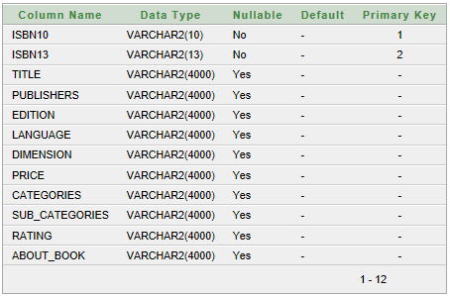


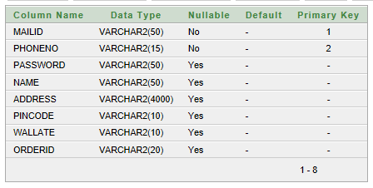

valid.jsp

If not valid show Message

signup.jsp

Successfully
Register
signup.html

signup.html
Name
Uid
Password
Ph no
Others

Userid
Password
Index.html

usermenu.jsp

Search

userhome.jsp

Home|Category|Profile|WishList|Wallate|OrderDetails|logout

Welcome to UserId

