
Event Discovery & Community Engagement Platform
Software Requirements Specification

Version 1.0



Group Id: S26PROJECT69E8B
Supervisor Name : Amjad Iqbal Khan

Revision History
Date (dd/mm/yyyy) | Version | Description | Author
Mon 23 May, 2026 | 1.0 | This document contains | bc210403836
 |  | - Introduction of SRS documents
 |  | - Scope of Project
 |  | - FR & NFR
 |  | - Use Case Diagram
 |  | - Usage Scenarios
 |  | - Adopted Methodology
 |  | - Work Plan

Table of Contents

Contents
Introduction: 4
Scope of Project: 4
In-Scope Features 4
Out-of-Scope Features 4
User Features (Guest & Registered Users) 5
Admin Features 5
Functional and Non Functional Requirements: 5
Functional Requirements (FR) 5
Non-Functional Requirements (NFR) 6
Use Case Diagram(s): 6
Usage Scenarios: 7
Adopted Methodology 8
VU Process Model: 9
Phases of VU Process Model 9
1. Feasibility Study 9
2. Requirements Definition 9
3. System Design 9
4. Implementation 9
5. Testing 9
6. Deployment 9
7. Maintenance 10
Waterfall model: 10
Work Plan 11

SRS Document

Introduction:
The Event Discovery & Community Engagement Platform is a comprehensive web-based application developed to help users discover, explore, and participate in local and online events efficiently. The platform serves multiple user roles including Guest Users, Registered Users, Event Organizers, and Administrators by providing a centralized system for event discovery, registration, management, and community interaction.
The system integrates modern technologies such as interactive maps, responsive interfaces, event categorization, user authentication, and content management systems to provide a seamless user experience. Users can search events by category, location, date, and organizer while administrators can manage events, users, approvals, and analytics through a dedicated dashboard.
This project demonstrates modern software engineering principles including MVC architecture, RESTful APIs, role-based access control, responsive web design, secure authentication, cloud storage integration, and scalable system architecture.

Scope of Project:
The system will support three primary user roles:
- Guest Users – Browse events, search and filter events, and view event details.
- Registered Users – RSVP for events, save favorites, submit reviews, and manage profiles.
- Administrators – Manage users, approve events, manage categories, and oversee the platform.

In-Scope Features
- Interactive event map using Leaflet.js / Google Maps API
- Event search and category-based filtering
- Event detail pages with images and venue information
- User registration and authentication
- RSVP and event registration system
- Favorite/bookmark management
- Reviews and ratings system
- Admin dashboard for event and user management
- Responsive web interface
- Featured events management
- Notification system
- REST API / GraphQL integration

Out-of-Scope Features
- Native Mobile Application Development
- Online payment gateway integration
- Live event streaming
- Offline event management
- AI-powered recommendations
- Multi-language support

User Features (Guest & Registered Users)
- User registration and login
- Browse and search events
- Filter events by category, date, and location
- RSVP and registration system
- Save favorite events
- View event history
- Submit ratings and reviews
- Responsive mobile-friendly experience
- Receive event notifications

Admin Features
- Manage all events
- Approve or reject submitted events
- Manage users and permissions
- Manage categories and featured events
- Moderate reviews and content
- View reports and analytics
- Manage system settings

Functional and Non Functional Requirements:

Functional Requirements (FR)
FR ID | Category | Description
FR-1 | User Registration | Users can create accounts using email and password.
FR-2 | User Login | Registered users can securely log in.
FR-3 | Profile Management | Users can update profile information and passwords.
FR-4 | Interactive Map | System displays events on an interactive map.
FR-5 | Event Search | Users can search events using keywords and filters.
FR-6 | Event Details | System displays complete event information.
FR-7 | RSVP Registration | Registered users can RSVP for events.
FR-8 | Favorites Management | Users can bookmark favorite events.
FR-9 | Reviews & Ratings | Users can submit reviews and ratings.
FR-10 | Event Management | Admin can create, edit, and delete events.
FR-11 | Event Approval | Admin can approve or reject submitted events.
FR-12 | Notifications | Users receive notifications for event updates.
FR-13 | Featured Events | Admin can manage featured events section.
FR-14 | Reports & Analytics | Admin can generate reports and analytics.

Non-Functional Requirements (NFR)
NFR ID | Category | Description
NFR-1 | Usability | System shall provide intuitive and responsive UI/UX.
NFR-2 | Performance | Page load time should be under 3 seconds.
NFR-3 | Security | System shall use JWT authentication and encrypted passwords.
NFR-4 | Scalability | System shall support increasing users and events.
NFR-5 | Reliability | System shall minimize crashes and failures.
NFR-6 | Maintainability | Modular code structure for easier updates.
NFR-7 | Cross-Browser Support | Compatible with Chrome, Firefox, Edge, and Safari.
NFR-8 | Availability | System available 24/7 with minimal downtime.
NFR-9 | Accessibility | Mobile-friendly and accessible design standards.

Use Case Diagram(s):
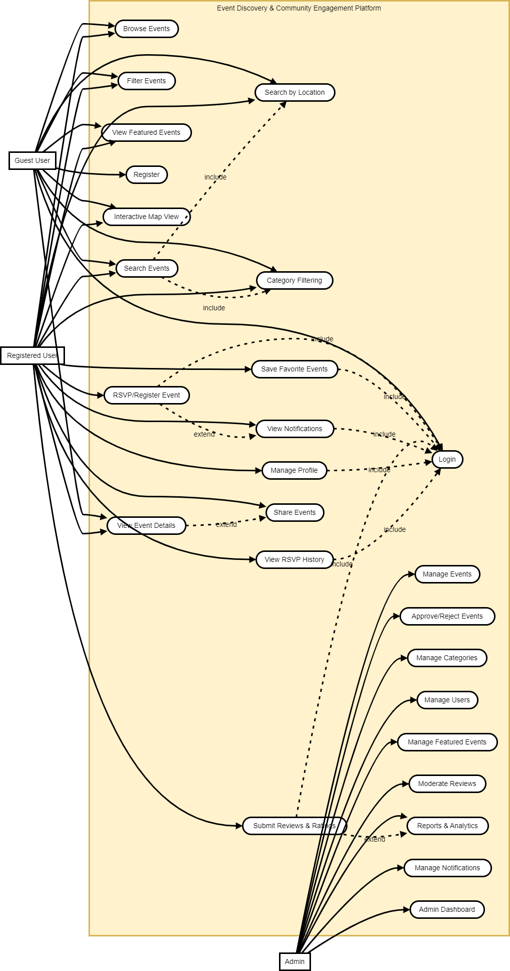

Usage Scenarios:
Use Case Title | Register User
Use Case Id | USER-01
Actors | Guest User
Description | Users create an account to access the system.
Pre-condition | User not logged in
Sequence Of Actions | 1. Click Register 2. Enter details 3. Submit form
Post-condition | Account successfully created
Exceptions | Invalid email, duplicate account

Use Case Title | Login
Use Case Id | LOGIN-01
Actors | Registered User
Description | Users log into the system securely.
Pre-condition | Account exists
Sequence Of Actions | 1. Enter credentials 2. Click Login
Post-condition | User logged in
Exceptions | Invalid credentials

Use Case Title | Search Events
Use Case Id | EVT-01
Actors | Guest User / Registered User
Description | Users search events using keywords and filters.
Pre-condition | System available
Sequence Of Actions | 1. Enter keyword 2. Apply filters 3. View results
Post-condition | Matching events displayed
Exceptions | No results found

Use Case Title | RSVP Event
Use Case Id | RSVP-01
Actors | Registered User
Description | Users register for events through RSVP functionality.
Pre-condition | User logged in
Sequence Of Actions | 1. Open event 2. Click RSVP 3. Confirm registration
Post-condition | RSVP successfully stored
Exceptions | Event full, duplicate registration

Use Case Title | Submit Review
Use Case Id | REV-01
Actors | Registered User
Description | Users submit ratings and reviews for attended events.
Pre-condition | Event attended
Sequence Of Actions | 1. Open attended event 2. Submit review 3. Save feedback
Post-condition | Review successfully submitted
Exceptions | Invalid rating

Use Case Title | Manage Events
Use Case Id | ADM-01
Actors | Admin
Description | Admin manages all event records.
Pre-condition | Admin logged in
Sequence Of Actions | 1. Open dashboard 2. Edit/Create/Delete event
Post-condition | Event updated
Exceptions | Missing required data

Use Case Title | Approve Event
Use Case Id | ADM-02
Actors | Admin
Description | Admin approves or rejects user-submitted events.
Pre-condition | Pending event exists
Sequence Of Actions | 1. Review submission 2. Approve/Reject
Post-condition | Event status updated
Exceptions | Invalid submission

Use Case Title | Manage Categories
Use Case Id | ADM-03
Actors | Admin
Description | Admin manages event categories.
Pre-condition | Admin authenticated
Sequence Of Actions | 1. Add/Edit/Delete category
Post-condition | Categories updated
Exceptions | Duplicate category

Adopted Methodology
As per project requirements, the adopted methodology is the VU Process Model.
The VU Process Model is a hybrid software development methodology combining features of:
- Waterfall Model
- Spiral Model
This methodology provides structured development phases with iterative improvements and continuous risk analysis.

VU Process Model:
The VU Process Model combines the sequential structure of the waterfall model with the flexibility and risk management approach of the spiral model. It ensures proper planning, analysis, development, testing, deployment, and maintenance throughout the software development lifecycle.

Phases of VU Process Model

1. Feasibility Study
- Analyze technical and operational feasibility
- Identify system requirements
- Conduct cost-benefit analysis

2. Requirements Definition
- Gather system requirements
- Prepare Software Requirements Specification (SRS)
- Conduct stakeholder meetings

3. System Design
- Design system architecture
- Prepare database structure
- Create UI/UX wireframes

4. Implementation
- Develop frontend modules
- Develop backend APIs
- Integrate authentication and database systems

5. Testing
- Unit testing
- Integration testing
- System testing
- Bug fixing

6. Deployment
- Deploy application to production server
- Configure hosting environment
- Final deployment verification

7. Maintenance
- Bug fixes
- Feature updates
- Performance optimization

Waterfall model:
The Waterfall Model is a linear software development methodology where each phase is completed before moving to the next phase. It includes requirement analysis, design, implementation, testing, deployment, and maintenance. This model ensures proper documentation, structured planning, and organized project management.

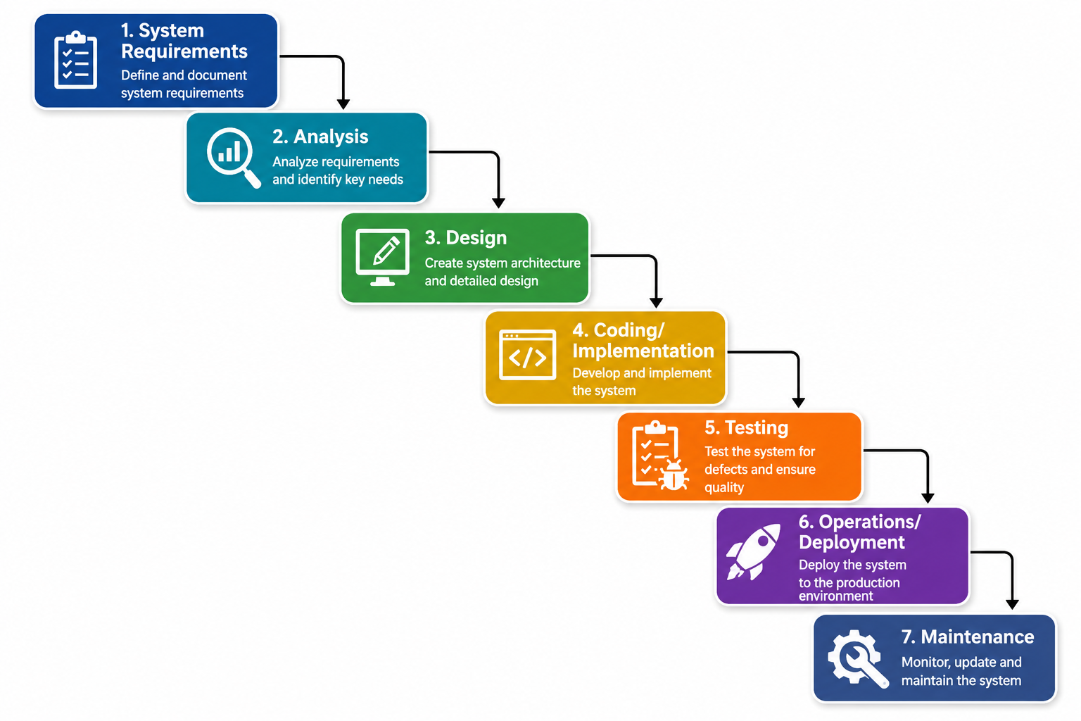

Spiral model:
The Spiral Model is a software development approach that combines the features of the Waterfall Model and prototyping. It focuses on repeating the development process in cycles, called spirals, to gradually build the final product.
Each spiral includes four main steps: planning, risk analysis, development, and review. This model is useful for large or high-risk projects because it allows for continuous feedback, early risk detection, and changes to requirements at any stage.

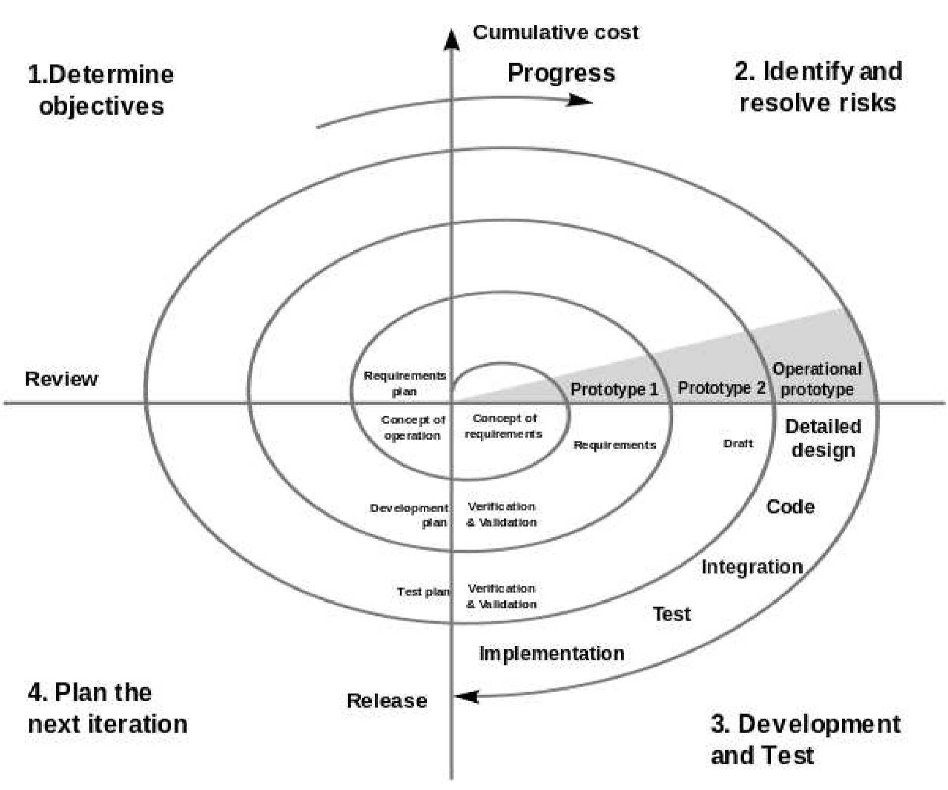

Work Plan
