MediSmart Online Pharmacy
Software Requirements Specification

Version 1.0



Group Id: S25PROJECTEF0D5 (BS170406496)
Supervisor Name :Sohail Aamir

Revision History
Date (dd/mm/yyyy) | Version | Description | Author
22/05/2025 | 1.0 | Software Requirements Specifications, also known as SRS, is the term used to describe an in-depth description of a software product to be developed. It's considered one of the initial stages of the software development life-cycle (SDLC). Think of it like the map that points you to your finished product. | BS170406496
MediSmart Online Pharmacy is an advanced e-commerce platform designed for convenient online purchasing of medicines and healthcare products. The system will feature:
- A secure and AI-enhanced shopping experience
- Robust cybersecurity measures to protect user data and transactions
- AI-driven features to improve user engagement and system security
- A user-friendly interface for both customers and administrators
- A seamless and efficient healthcare product purchasing process.

Table of Contents

- Scope (of the project)
- Functional Requirements Non Functional requirements
- Use Case Diagram
- Usage Scenarios
- Adopted Methodology
- Work Plan (Use MS Project to create Schedule/Work Plan)

SRS Document

Scope of Project:

The scope of the MediSmart Online Pharmacy project is to develop a smart and secure online platform where users can easily buy medicines and healthcare products from anywhere. This system will provide a smooth and safe shopping experience by using artificial intelligence (AI) to help users find the right products, get suggestions, and receive support. It will also have strong security features to protect sensitive information like personal details and payment data. The platform will serve both regular users and administrators—users can search for products, place orders, and upload prescriptions, while administrators can manage products, users, and monitor system activity. Cybersecurity tools will be built into the system to keep all transactions safe and protect against threats. AI will also be used to improve the system’s performance, detect unusual activity, and make the platform smarter over time. Overall, MediSmart will offer a reliable, user-friendly, and secure solution for online medical shopping.

Functional and non Functional Requirements:

Functional Requirements
User Features:
- Users can register, log in securely (with email verification and password protection).
- Users can browse, search, filter, and sort medicines and health products.
- They can add items to a shopping cart and check out using a secure payment system.
- Users can upload prescriptions when required, view order history, and track deliveries.
- AI will suggest products based on user behavior and history.
- A built-in messaging system allows users to contact customer support.
- Users can manage their personal profiles.
Admin Features:
- Admins have access to a dashboard to manage users, products, and orders.
- They can add, edit, or delete products and verify uploaded prescriptions.
- Admins can monitor and process orders, reply to customer queries, and view sales data.
- AI tools will help detect fraud.
- Access is controlled based on roles (e.g., admin, staff).
Cybersecurity Functions:
- Secure login with password hashing and two-factor authentication.
- Protection against SQL injection, XSS, and CSRF attacks.
- All sensitive data and transactions are encrypted
- Role-based access controls are applied for both users and admins.
AI Features:
- AI recommends medicines based on symptoms and purchase history.
- Fraud detection using AI patterns.
- A chatbot answers user queries and provides basic health support.
Non-Functional Requirements
- Security: Strong protection for user data and transactions.
- Performance: Fast response time even with many users or large data.
- Scalability: System can grow to handle more users, products, and data in the future.
- Usability: Easy-to-use interface for both users and admins.
- Availability: System should be accessible 24/7 with minimal downtime.
- Maintainability: Easy to update or fix the system when needed.
- Reliability: System should work correctly without crashes or data loss.
- Compliance: Must follow healthcare and data protection laws.
Use Case Diagram(s):

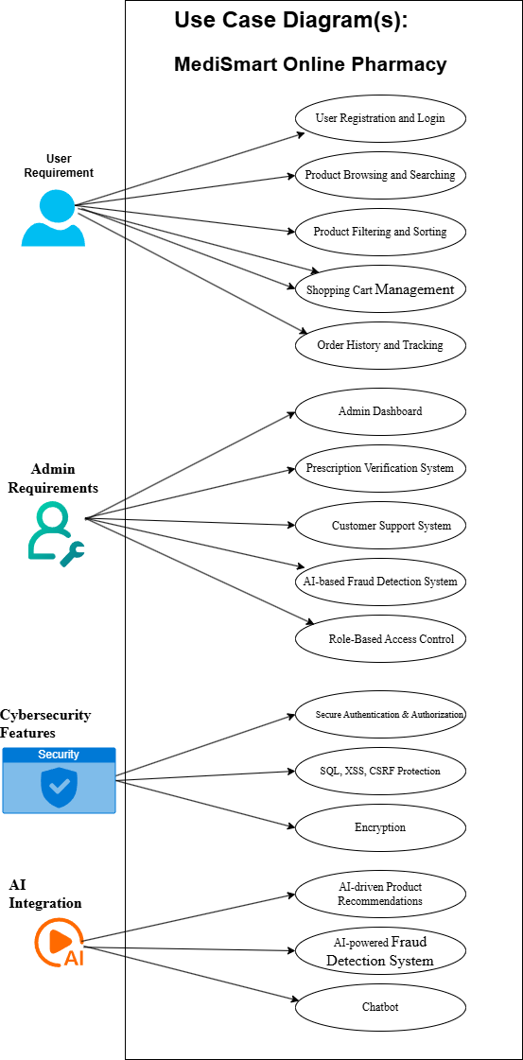
Usage Scenarios:

Use Case Title | User Login
Use Case Id | 001
Actors | User
Description | This use case involves an existing user logging into the web application.
Actions | - User navigates to the login page.  - User enters their credentials and logs in.
Alternative Paths | User forgets password.
Pre-Conditions | User must be registered.
Post Conditions | User successfully logs into their account.
Author | BS170406496
Exception | Incorrect username or password.

Use Case Title | User Registration
Use Case Id | 002
Actors | User
Description | This use case involves a new user registering for an account on the web application.
Actions | - User navigates to the registration page.  - User fills out the registration form.
Alternative Paths | User cancels registration.
Pre-Conditions | N/A
Post Conditions | User account is successfully created.
Author | BS170406496
Exception | Invalid or incomplete registration details.

Use Case Title | Access Admin Dashboard
Use Case Id | 003
Actors | Admin
Description | Admin logs in and accesses the dashboard to manage users, products, and orders.
Actions | - Admin logs in with valid credentials.  - System verifies admin role.  - Admin is redirected to the dashboard.
Alternative Paths | - Invalid login credentials.  - Unauthorized access (non-admin tries to access).
Pre-Conditions | Admin account must exist and be authorized
Post Conditions | N/A
Author | BS170406496
Exception | - Server error during login.  - Database unavailable.

Use Case Title | Secure Authentication and Authorization
Use Case Id | 004
Actors | User, Admin, System
Description | This use case ensures that only authorized users can access the system by verifying credentials and user roles.
Actions | - User enters login credentials.  - System verifies credentials (with password hashing).  - If enabled, system sends OTP or code for two-factor authentication.  - User enters the code and gains access
Alternative Paths | - User enters incorrect credentials.  - Two-factor code is incorrect or expired
Pre-Conditions | User account must exist.
Post Conditions | User is securely logged in.
Author | BS170406496
Exception | - System timeout.  - Server is down.  - OTP not delivered

Use Case Title | AI-Based Product Recommendation
Use Case Id | 005
Actors | User, AI System
Description | The system uses AI to suggest relevant medicines and healthcare products to users based on their browsing history, symptoms, or previous purchases.
Actions | AI analyzes the data and displays personalized product suggestions.
Alternative Paths | N/A
Pre-Conditions | N/A
Post Conditions | Personalized product list is shown
Author | BS170406496
Exception | AI service temporarily unavailable.

Adopted Methodology

VU Process Model is well-suited for the development of the PHP-Based Web Page Speed Analysis Tool for SEO. This approach reduces the risk of failure, allows better planning, and ensures that both security and AI features are well-integrated and tested at each stage of the MediSmart Online Pharmacy system.

Here's why:

- Flexibility:
The VU Process Model is flexible, which means if something needs to be changed or improved in any phase, it can be updated easily. It is not a fixed method, so changes can be made as needed.
- Iterative Development:
This model allows work to be done in cycles (repeated steps). After each cycle, the system is tested and improved. This helps reduce mistakes and makes the system better step by step.
- Collaboration:
The model supports teamwork. All team members can work together easily and clearly understand their roles. This improves communication and helps the project run smoothly.
- Customer Feedback:
Customer opinions are taken after each cycle. This helps make sure the final system matches what the customer wants and needs.
- Adaptation to Emerging Technologies:
The VU Process Model makes it easier to add new technologies. In this project, we are using AI and cybersecurity features, and this model helps us include these technologies without disturbing the whole process.

Requirement Analysis
↓
Design
↓
Development & Implementation
↓
Testing & Evaluation
↓
Risk Analysis & Feedback
↓
Next Iteration Development
↓
Final Integration & Testing
↓
Deployment & Maintenance
VU Process Model,
which is a hybrid model combining the features of both the Waterfall Model and the Spiral Model. The Waterfall model provides a structured and sequential approach, where each phase (like requirement gathering, design, implementation, testing, and deployment) is completed one after the other. On the other hand, the Spiral model adds iterative development and risk analysis to this process.
By using the VU Process Model, we ensure that the system is developed in well-defined steps, but with the flexibility to revisit and improve earlier phases based on feedback and risks. This allows us to follow a disciplined method (like Waterfall) and also adapt and improve (like Spiral) throughout the development process. This approach reduces the risk of failure, allows better planning, and ensures that both security and AI features are well-integrated and tested at each stage of the MediSmart Online Pharmacy system.
WATER FALL MODEL:

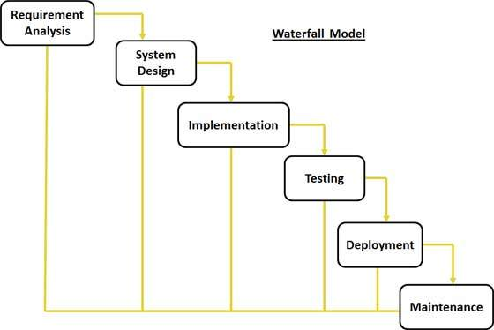

The Waterfall Model was first Process Model to be introduced. It is also referred to as a linear-sequential life cycle model. It is very simple to understand and use. In a waterfall model, each phase must be completed before the next phase can begin and there is no overlapping in the phases. Waterfall model is the earliest SDLC approach that was used for software development. The waterfall Model illustrates the software development process in a linear sequential flow; hence it is also referred to as a linear-sequential life cycle model. This means that any phase in the development process begins only if the previous phase is complete.
SPIRAL MODEL:

1. To eliminate the risk that could be faced in development of software the use of spiral methodology is adopted. For example, the risk might be a resignation from the key person
2. Spiral Model has two dimensions. One is Radial dimension which represents the cumulative cost to date, and the other is angular dimension which represents the progress through the spiral.
3. The spiral model is very sensitive to risks. In this model development and maintenance run in parallel. This method is used for development of large-scale and in-house software.

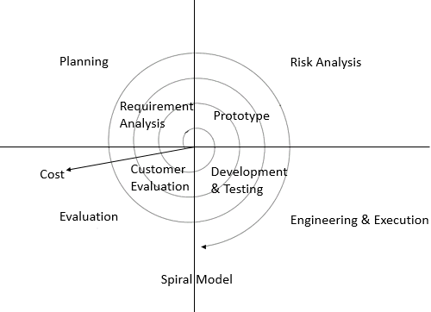

VU PROCESS MODEL:

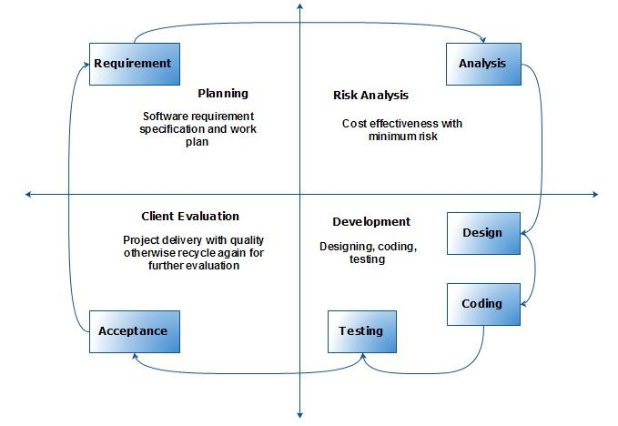
The VU Process Model is a framework used in software development to guide the development process. It stands for Validate and Update, and it emphasizes the iterative nature of software development. The model is often used in conjunction with the V-Model or other software development lifecycle models.
The VU Process Model consists of the following phases:
1. Validate Requirements:
The requirements are validated to ensure they are complete, consistent, and feasible.
2. Validate Design:
The design is evaluated to ensure it meets the requirements and is technically feasible.
3. Validate Implementation:
This phase involves the validation of the software implementation.

Work Plan (Use MS Project to create Schedule/Work Plan)
