RECON AGENT · Settlement Reconciliation
RESPONSIBLE AI · USE CASE 1

Explainability, Fairness, Drift & Observability
How the Recon Agent earns trust on the day's money — not just returns a number.
Every day a card program has to prove the money Visa says it settled matches what the processor actually recorded. When they don't match — an Unreconciled Day — someone digs through raw files by hand. The Recon Agent explains the whole gap in seconds and escalates only the one difference that is a genuine problem. But on money, an answer isn't enough. It has to say why it cleared each penny, prove the explanation is complete, treat every merchant and currency the same, and be seen working. Those four properties are what this document evidences for Use Case 1.
Observability — the foundation: every run and every agent decision is recorded
|
+-- Explainability — per run: why was each pound cleared, and does it add up?
+-- Fairness — across runs: is the same gap judged the same for every merchant / currency?
+-- Drift — over time: are the thresholds still right as the data changes?

Running today — implemented and demonstrable now.
Designed — built into the design; delivers full value on real client data.

01 · Explainability [ Running today ]
WHAT IT IS Every reconciliation comes with the evidence behind it — the gap broken into named, item-level causes — and a deterministic proof that those causes account for every penny. A human can read why a £59.45 difference was escalated while £280.60 was cleared, and audit it.
WHY THE CLIENT CARES A settlement gap has real money and SLA commitments attached. An analyst signing off the day needs a paper trail an auditor or regulator can follow. An unexplained 'the AI says it's fine' gets overridden; an explained, arithmetically-proven decision gets acted on.
HOW THE RECON AGENT DOES IT The math is done by a deterministic engine, never the AI — so the numbers are never in doubt. The engine decomposes the raw difference into a structured facts object (one entry per cause, with the transactions behind it) and emits a check block that proves the components sum back to the raw gap. The agent then reasons over those facts and returns a strict, machine-readable object with a step-by-step walk-through.
Evidence — the decomposition contract every run produces:
"totals": { "visa_net_settlement": 1457.94, "processor_day1_sum": 1110.61, "raw_difference": 347.33 },
"facts": {
"timing": { "total": 280.60, "items": [ { "merchant": "JOHN LEWIS", "amount": 230.00,
"scheme_settle_date":..., "processor_settle_date":... }, ... ] },
"fx_rate_timing": { "total": 7.29, "items": [ { "delta": 6.19, "visa_rate":..., "processor_rate":... }, ... ] },
"rounding": { "total": -0.01, "pct_of_net": 0.0007, "tolerance_pct": 0.01 },
"isa": { "visa_total": 4.26, "processor_total": 4.26, "equal": true },
"residual": { "total": 59.45, "items": [ { "merchant": "UBER US TRIP", "amount": 59.45 } ] }
},
// the proof the agent must not contradict — every penny is accounted for:
"check": { "components_sum": 347.33, "matches_raw": true }

The proof, not just the story: 280.60 + 7.29 - 0.01 + 59.45 = 347.33. The check.matches_raw flag is the difference between 'the AI explained it' and 'the explanation is provably complete.' If it were false, the agent is instructed not to clear — it routes to a human instead.

Explainability with verification — the FX rule: a matched-amount gap of >=5p is only cleared as FX if the rates actually prove it: source x (visa_rate - processor_rate) must match the observed delta within 2p. If the rates don't account for it, the gap is not waved through — it is routed as a residual. Clearing requires proof, not resemblance.
Screenshot 1 · Explainability
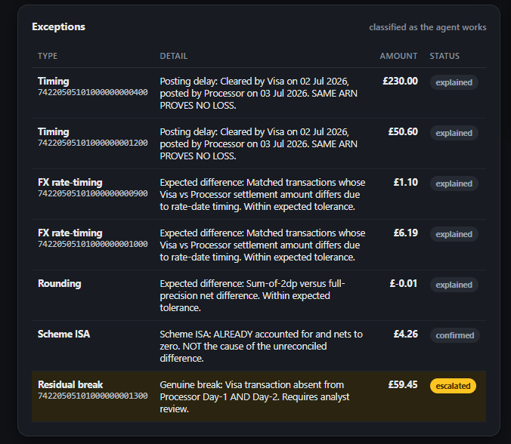
The live exceptions table: every difference carries its type, the ARN, a plain-English reason (e.g. 'Cleared by Visa on 02 Jul 2026, posted by processor on 03 Jul 2026 — same ARN proves no loss'), the amount, and a status pill — explained / confirmed for the harmless components, and escalated for the single £59.45 residual break that 'requires analyst review'.

The Responsible-AI facts the engine is held to:
- A difference is cleared on what explains it — timing, FX, rounding, ISA — never on which merchant or currency it belongs to.
- When the rates don't prove the FX gap, do not clear it — route it.
- If the components don't sum to the raw difference, the agent must not auto-clear.

02 · Fairness [ Testable by design ]
WHAT IT IS Equivalent differences get equivalent verdicts, and no irrelevant attribute secretly drives the outcome. The same gap pattern must be judged the same regardless of whose transaction it is — an attribute that shouldn't affect the verdict must not affect it.
WHY THE CLIENT CARES One platform serves many programs and merchants. If the agent quietly cleared one merchant's differences and escalated an identical gap for another, some breaks would be missed and others over-escalated — invisibly. 'Do you treat every merchant and currency the same?' is a question the client's own customers will ask them.
HOW THE RECON AGENT DOES IT The core rule — a status is decided by where the ARN matches (today's file, the next day's file, or nowhere), the amount delta, and the rate math — never the merchant name or region — is itself the fairness guardrail. It is verifiable with a matched-pair swap test: take one transaction's evidence, copy it identically except the merchant/region, and confirm the verdict does not change.
Test design — matched pairs:
Pair | Evidence held constant | Attribute swapped | Expected | Fair if…
A | ARN in Visa D1, absent from processor D1 & D2 | merchant: UBER → any other | residual / escalate — both | verdict unchanged
B | Matched on D1, delta >=5p, rates account for it within 2p | region: INTL → DOM | FX / clear — both | verdict unchanged
C | Cleared by Visa D1, posted by processor D2 | swap merchant id | timing / clear — both | verdict unchanged

A flip under swap would reveal a bias; a hold is the proof of consistency. Because the verdict is decided purely from match-location, delta and rate math, the correct result is no change.

03 · Drift [ Designed · activates on real data ]
WHAT IT IS The gradual divergence between the world the agent was tuned for and the world it now sees. Data drift = the inputs change (new merchants, a currency we've never seen, shifting FX-rate magnitudes, a rising share of international traffic). Prediction drift = the outputs shift (e.g. the true-break rate climbs, or the auto-clear rate falls), signalling a real change or that the thresholds no longer fit.
WHY THE CLIENT CARES They don't want a tool that is accurate at launch and silently rots. 'How do you know it's still right six months in?' — drift monitoring is the answer, and it triggers a controlled re-tune rather than a surprise mis-clear.
HOW THE RECON AGENT DOES IT The tunable knobs are explicit named constants, not hidden weights:
Parameter | Role | Current value
FX_LABEL_THRESHOLD | matched delta at/above which a gap is worth flagging as FX | £0.05 (5p)
FX_VERIFY_TOLERANCE | how close source x rate-diff must be to clear an FX gap | £0.02 (2p)
rounding tolerance | residual-as-% of net that counts as harmless rounding | 0.01% of net
CCY_EXP | known currencies + their decimal exponent | GBP · EUR · USD · JPY

The monitoring method:
- Baseline — record the input distribution + the cleared / escalated output split on tuning data.
- Watch — periodically compare live traffic + the residual/break mix against that baseline.
- Trigger — flag when the divergence crosses a set threshold.
- Re-tune — adjust the thresholds against fresh data, re-baseline, record the change.
A concrete drift signal already visible in the design: CCY_EXP knows only four currencies. A transaction arriving in an unmapped currency is exactly the kind of data drift the monitor should surface and route for review — a named blind spot the watcher is designed to catch.
Honesty note for the client conversation: the tool runs on synthetic fixed-number data today, so we show the drift design and the real tunable parameters — not a year of trend data we don't yet have. Real client historical settlement data turns this baseline from illustrative to live. That framing is deliberate: it shows we know the difference between a capability that is live and one that activates on their data.

04 · Observability [ Running today ]
WHAT IT IS Being able to see what the agent does — every run, decision, and the reasoning behind it — live. It is also the foundation the other three pillars depend on: you cannot check fairness or detect drift if inputs and outputs were never recorded.
HOW THE RECON AGENT DOES IT — TWO LEVELS On the agent platform (running via Lyzr): every agent run produces a full execution trace — each reasoning step, the read-only tool call, and the tokens — so a decision can be replayed and inspected end-to-end, the operator/audit view used to inspect any run. In the app (running): a /health endpoint reports data directory, dataset date, and whether the agent is configured; each reconciliation carries a per-run session_id (recon-<reconciled_day>) tying its agent call to its day; and the deterministic check block is logged as the run's proof of correctness.
Evidence — the health & run signals available today:
GET / -> { "ok": true, "data_dir":..., "demo_as_of": "today", "lyzr_configured": true }
POST /api/reconcile -> { "findings":{...}, "agent":{...}, "agent_connected": true, "agent_error": null }
session_id = "recon-20260702" // ties this run's agent call to its reconciled day
check = { "matches_raw": true } // the run's proof of correctness, recorded

Evidence — a real per-run execution trace (agent platform): every span is timed, the tool call is visible, and the whole run is replayable.
Recon Daybreak Analyst 17.86s (12 spans · 3 levels deep)
|- Add Messages 154 ms
|- Get Messages 9 ms
|- Search Memories 50 ms
|- Search Summaries 20 ms
|- Get Current Summary 15 ms
|- Search Memories 47 ms
+- Agent Orchestration 15.00 s
|- Generate AI 1.34 s
|- Composio Tool 2.76 s <- read-only escalation tool (Jira)
|- Generate AI 5.38 s
+- Generate AI 4.86 s

Honest status: the execution trace (per-step spans, timings and the tool call) and the /health + per-run signals are running today — per-step latency is already there. The one small planned add-on is an in-app correlation-id line inside our own API, so a request can be traced in our logs as well as on the platform.

Screenshot 4 · Observability
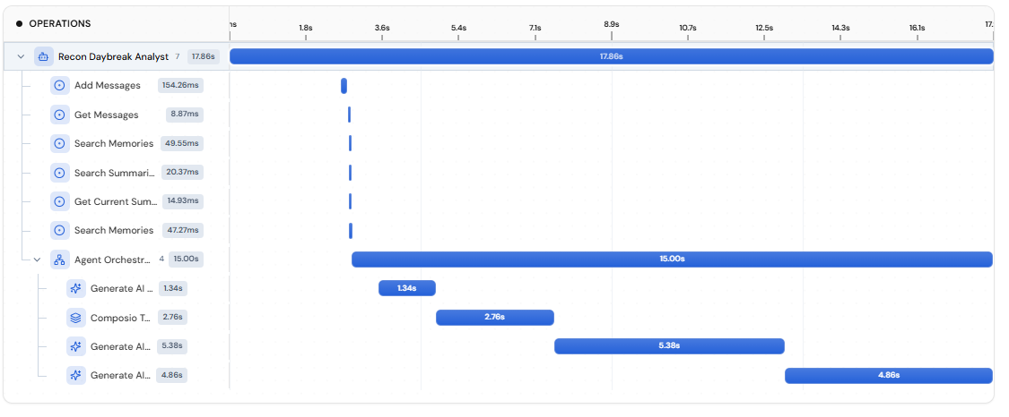
The live per-run execution trace above: 12 spans, 3 levels deep, 17.86s end-to-end — memory/summary lookups, the agent orchestration, each AI generation step, and the read-only escalation tool call, every span timed and replayable.

The human stays in control [ Running ]
Every pillar sits on one non-negotiable rule: the math is deterministic and the judgement is AI — and the pipeline ends with a human. The agent suggests and routes; a person owns the money.
- The agent is read-only on the numbers — it never parses files and never does arithmetic; it reasons over figures the deterministic engine already computed and proved.
- Its only write is raising a Jira ticket for a genuine residual — and that ticket is the escalation to a human analyst, who reviews and resolves it.
- Auto-clear is gated on the proof: if check.matches_raw is false, the agent must route to a human rather than clear.
- Because the engine, not the model, holds the arithmetic, a tampered prompt cannot change the day's figures — it can only change the narration, which the proof still constrains.
Explainability and observability aren't optional extras here — they are what makes the human sign-off meaningful. A person can only approve what they can see, understand, and check adds up.

Evidence · Escalation + human gate
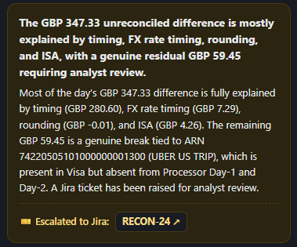
The agent's own narrative closes the loop: it states the £347.33 gap is explained by timing (£280.60), FX (£7.29), rounding (-£0.01) and ISA (£4.26), and that the remaining £59.45 is a genuine break — ARN …1300, UBER US TRIP, present in Visa but absent from the processor's Day-1 and Day-2. It does not clear it: it raises Jira RECON-23 for analyst review.

Summary
Pillar | Status | The one-line proof
Explainability | Running | Every gap is decomposed into named facts and proven complete by check.matches_raw.
Fairness | Testable | Verdict decided from match-location + delta + rate math — never merchant or region; matched-pair swap holds.
Drift | Designed | Explicit tunable thresholds (5p · 2p · 0.01%) + a baseline→watch→trigger→re-tune loop.
Observability | Running | Lyzr per-run execution trace + /health, per-run session_id, and a recorded proof.

The Recon Agent didn't bolt these on — they fall out of how it was built: deterministic self-proving math, AI kept away from the numbers, strict structured output, explicit thresholds, and a human at every write.
Recon Agent · Settlement Reconciliation · Responsible AI — Use Case 1 · Art Technology and Software · Confidential

