Answer at least as many questions as your grade level (first graders answer 1 question, second graders answer 2 questions, and so on).

For questions 1 through 4, circle your answer:

1. How many sides does a square have?
- 1111
- 2
- 100
- 5

2. How many sides does a circle have?
- 2
- 1
- 0
- ∞

3. What is half of 3 x 3?
- 3
- < 3
- cvc
- 5

4. If X + Y = 10, find X:
- 10
- 88
- \/
- /\

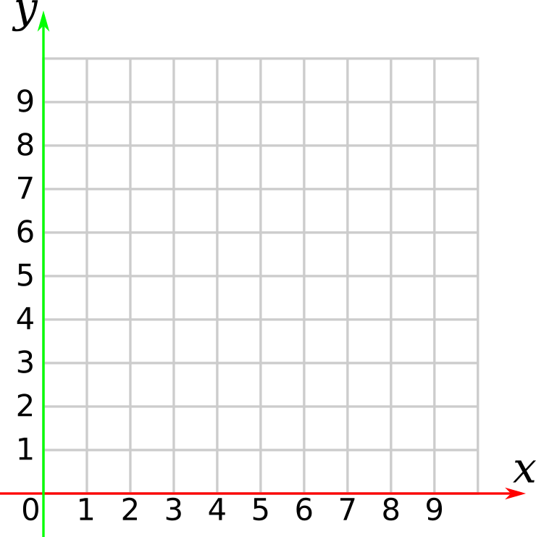
5. Plot the following coordinates:
A: (1, 1) B: (6, 1) C: (6, 6) D: (1, 6)
E: (3, 3) F: (8, 3) G: (8, 8) H: (3, 8)

Draw line segments connecting: ABCDA

Draw line segments connecting: EFGHE

Draw single line segments for:
AE BF CG DH

Facilitator notes

For questions 1-4, all answers are possibly correct.

1. How many sides does a square have?
- 1111 (represents 4 using tally mark unary numerals)
- 2 (an inside and an outside)
- 100 (4 in binary)
- 5 (the 4. from the multiple choice may be circled)

2. How many sides does a circle have?
- 2 (again an inside and an outside)
- 1 (may consider the round perimeter as 1 side)
- 0 (there are no straight segments)
- ∞ (infinitely many infinitesimal segments)

3. What is half of 3 x 3?
- 3 (half of the expression)
- < 3 (half of the expression vertical cut through the x)
- cvc (half of the expression horizontal cut and rotated)
- 5 (including the multiple choice numeral, 4.5 is correct)

4. If X + Y = 10, find X:
- 10 (X is the Roman numeral for 10)
- 88 (The 8-bit ASCII value for X)
- \/ (Combined with the choice below, a 2-line X)
- /\

5. The coordinate plot should look like a cube.

