Monitoring on a shoestring: Example report
Table of Contents

Introduction
This is a report on presentation attendees satisfaction with the presentation ‘Monitoring on a shoestring: How reproducible reporting can help make better use of data’. The report presents data collected via survey responses completed by attendees.
The tables and figures in this report have been generated automatically.
The report was generated on 2026-09-17.

The data
The survey data from this report is taken from the Bonnie’s client satisfaction survey
The reported includes data from survey responses collected on: 2026-08-31.
15 participants completed the survey.
The below table shows the previous AES attendance of respondents.
Previous AES attendance of respondents
Previous AES attendance | Count | Proportion
No - this is my first time | 6 | 40%
Yes - I have been to an AES conference 1 or more times before | 9 | 60%

Overall satisfaction
Respondents were asked to give quick feedback on how satisfied they were with the presentation.
On average, they rated their satisfaction 4.13 / 5 stars.
The proportion of respondents who gave the presentation 1, 2, 3, 4, or 5 stars is shown below.
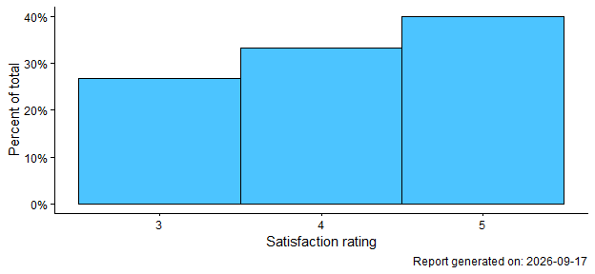
We also asked respondents if they would recommend the presentation to a friend or colleague.
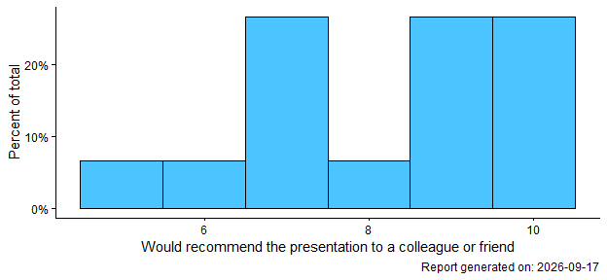

Satisfaction by previous AES attendance
We asked respondents if they had attended an AES conference before. We wanted to know if satisfaction with the presentation differed between those who had attended previously compared to those who had not.
On average, people who have attended at least 1 AES conference previously rated their satisfaction 4.22 / 5 stars and people who have not attended an AES conference before rated their satisfaction 4 / 5 stars.
The below xyz

Detailed feedback
In this section xyz.

What respondents enjoyed
The graph below shows
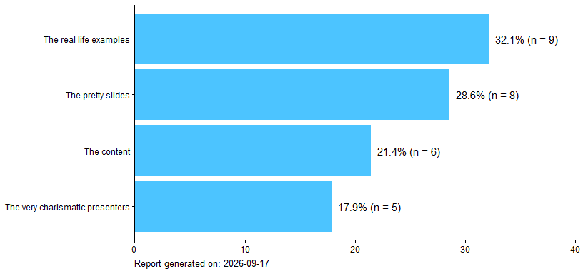

Takeaways from the presentation
We asked respondents to rate how strongly they agreed with the below statements about takeaways from the presentation.
Please note that labels for responses under 5% is not shown on this figure.
