**DECISION TREE CREATION IN MULTI-STAGE GAMES WITH INCOMPLETE INFORMATION**

**Kyrylo Vdovin**

Master’s degree student

Odessa I.I.Mechnikov National University

Odesa, Ukraine

kyrylo.vdovin1@gmail.com

**Introductions**. A game of incomplete information is a game where the players do not have exact knowledge of the game being played. These games mostly occur in ecomonic and political situations, where a variety of features of the environment may not be commonly known. It should be taken into account that that any action in an ever-changing economic environment will entail reactions from opposing players to which one will have to react. Thus, multistage game strategies are considered, provided that the states of the players can change with some probability during the game.

**Aim**. The goal is to analyze and discuss existing methods of construction of decision trees for multi-stage games with incomplete information and search for the optimal Bayesian solution with the maximization of the resulting payoff.

**Materials and methods**. Firstly, it is necessary to formalize randomness in the one-step stage of the game. For this, a fictitious player "Nature" is introduced, which, at a particular stage of the game, assigns to the participants a certain state with a known probability. Thus, the incompleteness of the game information for a particular player is replaced by complete, but imperfect information with probability distribution function. Main idea is to сonsider a multi-stage game as a tree of one-stage games and find a Bayesian balance in each turn. The goal is to calculate the mathematical expectations of the winnings at each node of the tree and find the branch of the tree with the maximum total mathematical expectation.

Discrete state of the game can be described as function:

$$G=G(N,p,T,V, Ω)$$

where:

1. *N* - set of players, $N_{i}∈\overline{1,n}$
2. *p* - states probability distribution function
3. *T* - types of players where *Ti* is *i*-th player’s type
4. V – payoff functions for each player
5. Ω - universe of possible player’s type

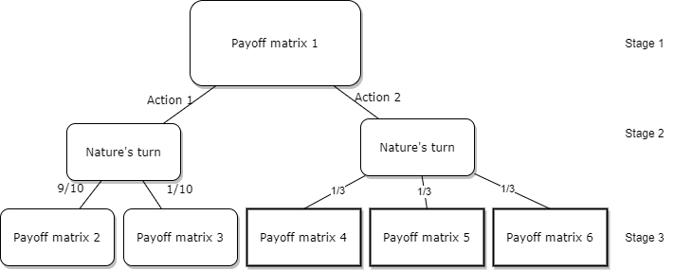It is assumed that players know their own types, but do not know the types of other players. Example of the decision tree can be found in the picture 1.

**Pic. 1. Example of decision tree for 1 player with probabilities**

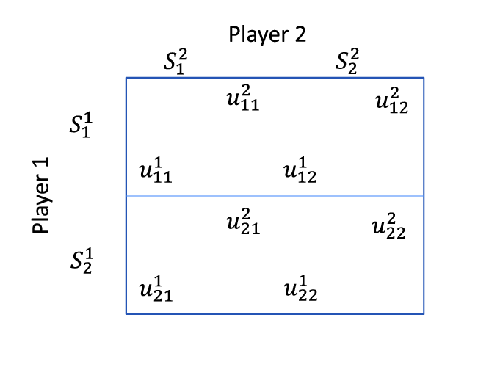Payoff matrix could be described as in picture 2.

**Pic. 2. Example of the payoff matrix for 2 players game.**

After the mathematical expectations for each node are found, the problem is reduced to the stochastic problem of finding the maximum on a tree. This task is easily solved by the existing recursive algorithms.

**Results and discussion.** The creation of stochastic decision trees is a good approach to solve complicated tasks. In this field there are a few good algorithms fo like ID3 for this. However, in real-life tasks trees can have great depth, which leads to a power-law asymptotic growth of complexity. The main solution to this problem is to cut off obviously non-optimal decision branches from the tree, which leads to a significant decrease in the necessary calculations, however, the solution obtained ceases to be strictly optimal, since at a depth greater than the depth of calculation of solutions in non-optimal labels, the solution may be better than the obtained one.

**Conclusions.** During the research, it turned out that the construction of a decision tree can find the optimal solution for many multi-stage coalition-free games with incomplete information. In practice, a good solution is to cut off branches, provided that the depth of viewing the solutions will be sufficient to neutralize the chance that the locally found maximum will be significantly less than the global maximum mathematical expectation of any tree’s branch.

**LIST OF REFERENCES:**

[1] P.R. Milgrom, R. J. Weber “Distributional strategies for games with incomplete information”, Mathematics of operations research, vol. 10, No 4, November 1985

[2] Nahla Ben Amor, Helene Fargier, Regis Sabbadin, Meriem Trabelsi “Possibilistic Games with Incomplete Information”, Proceedings of the Twenty-Eighth International Joint Conference on Artificial Intelligence (IJCAI-19),

[3] Binmore KG, Shaked A, Sutton J (1985) “Testing noncooperative bargaining theory: A preliminary study. American Economic Review 75”: 1178–1180