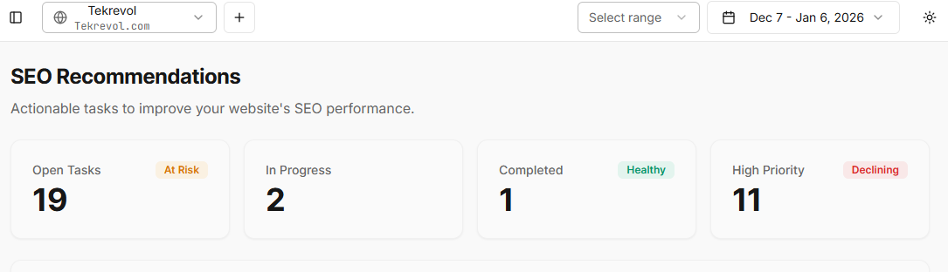

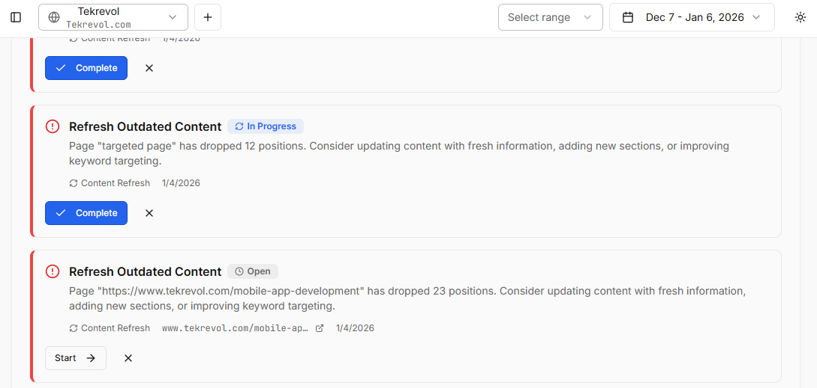

The SEO Recommendations section highlights outdated content, which is useful.
However, in some cases, the proper URL is not mentioned.

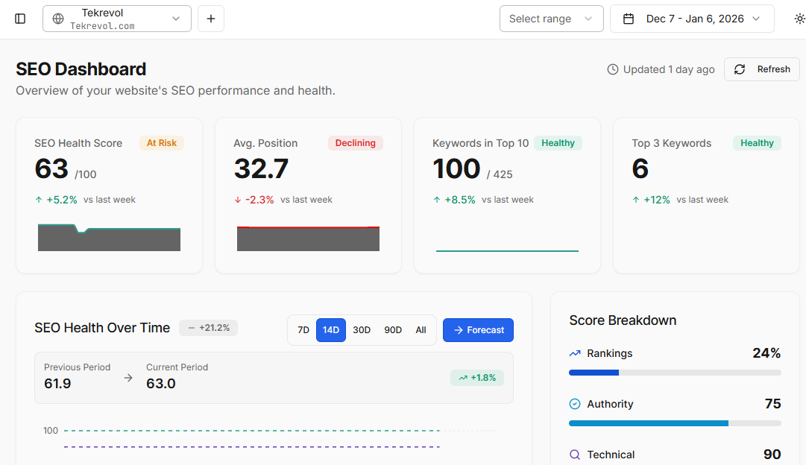

In the Top Search section, the date selector is not working correctly.
When the date is changed, the data does not refresh or update.

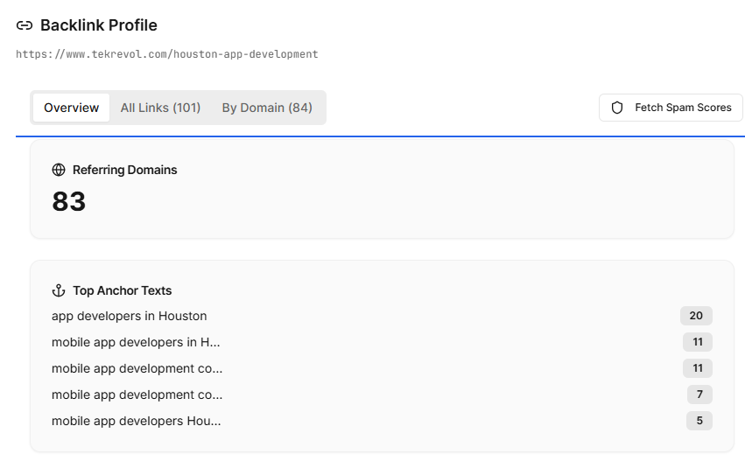
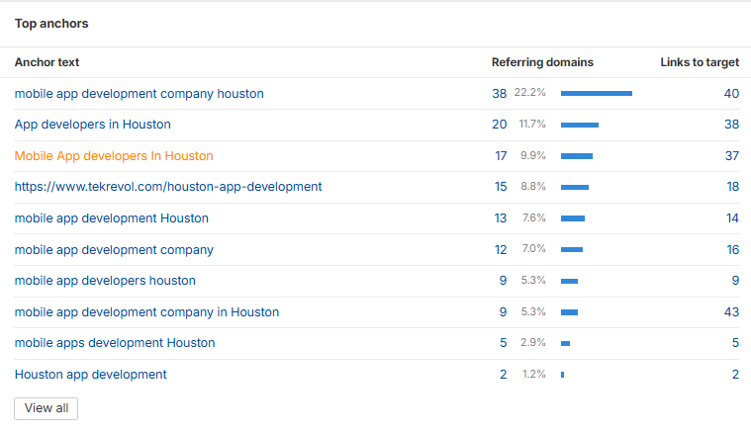
In Ahrefs, the top anchors are visible, but they are not appearing in our SEO dashboard. We are unable to see the actual anchor text properly, and we also do not have visibility of all the anchors. Because of this, we cannot review or analyze the complete list of anchors.

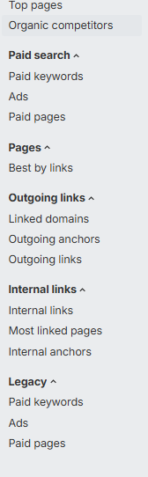
The internal links section are not showing on the specific page.

