**TASK 1**

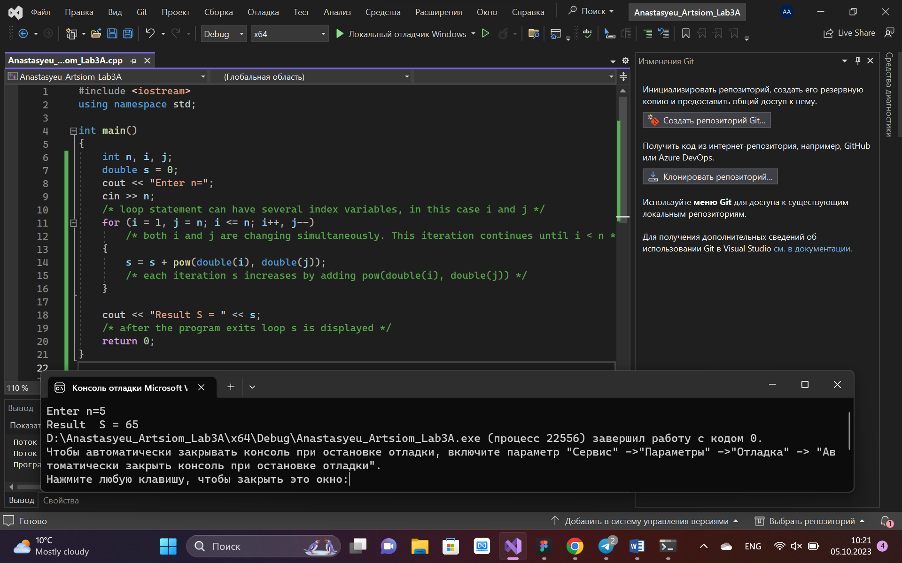

**TASK 2**

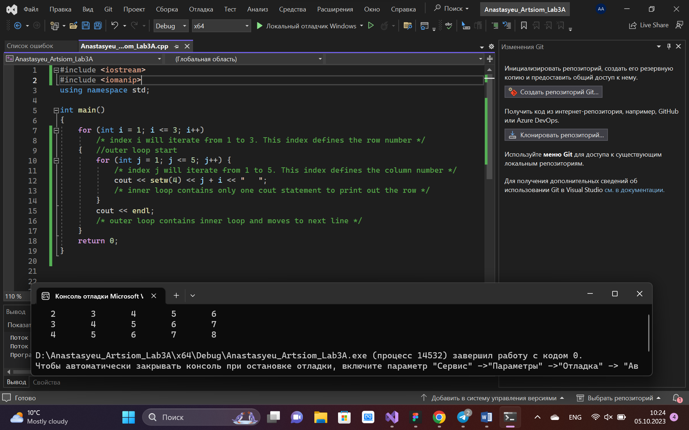

**TASK 3**

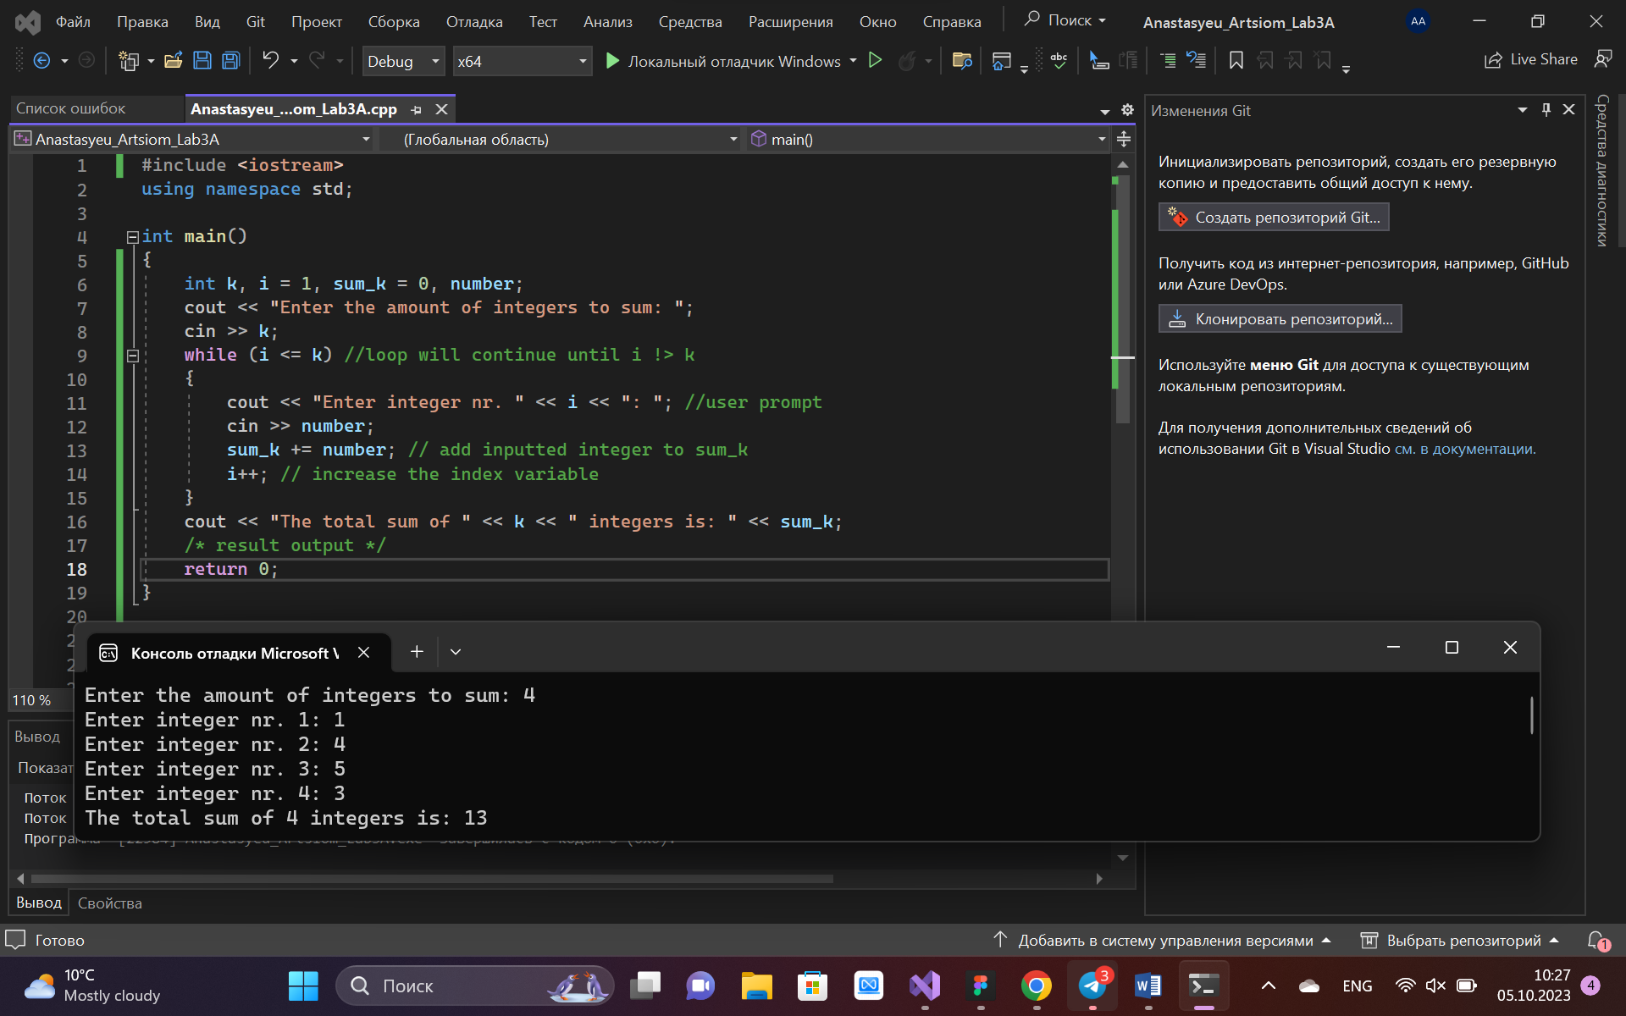

**TASK 4.1**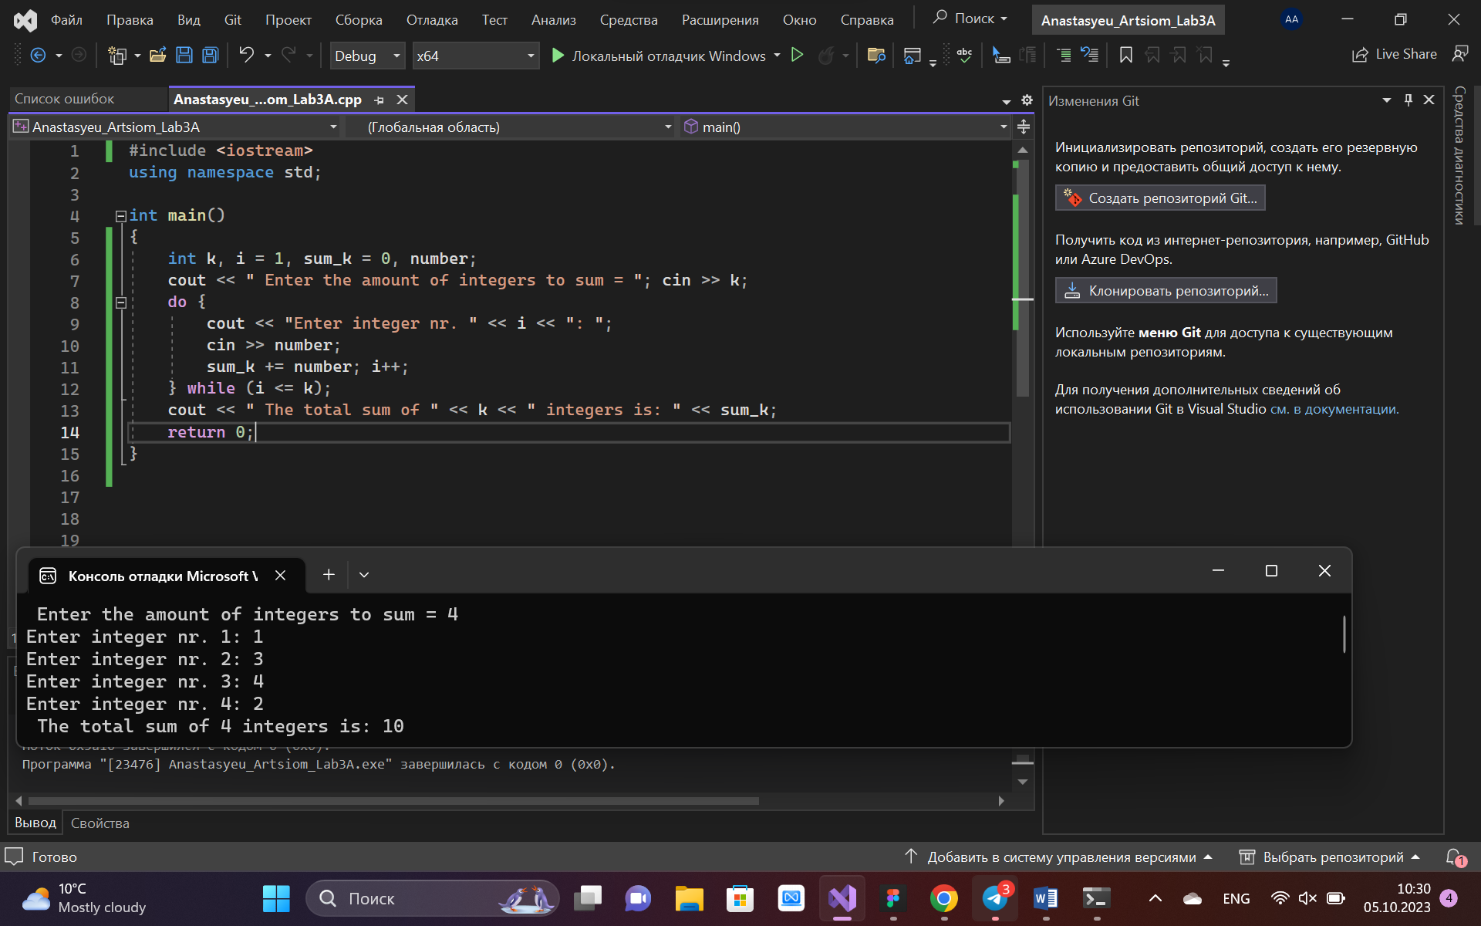

**TASK 4.2**

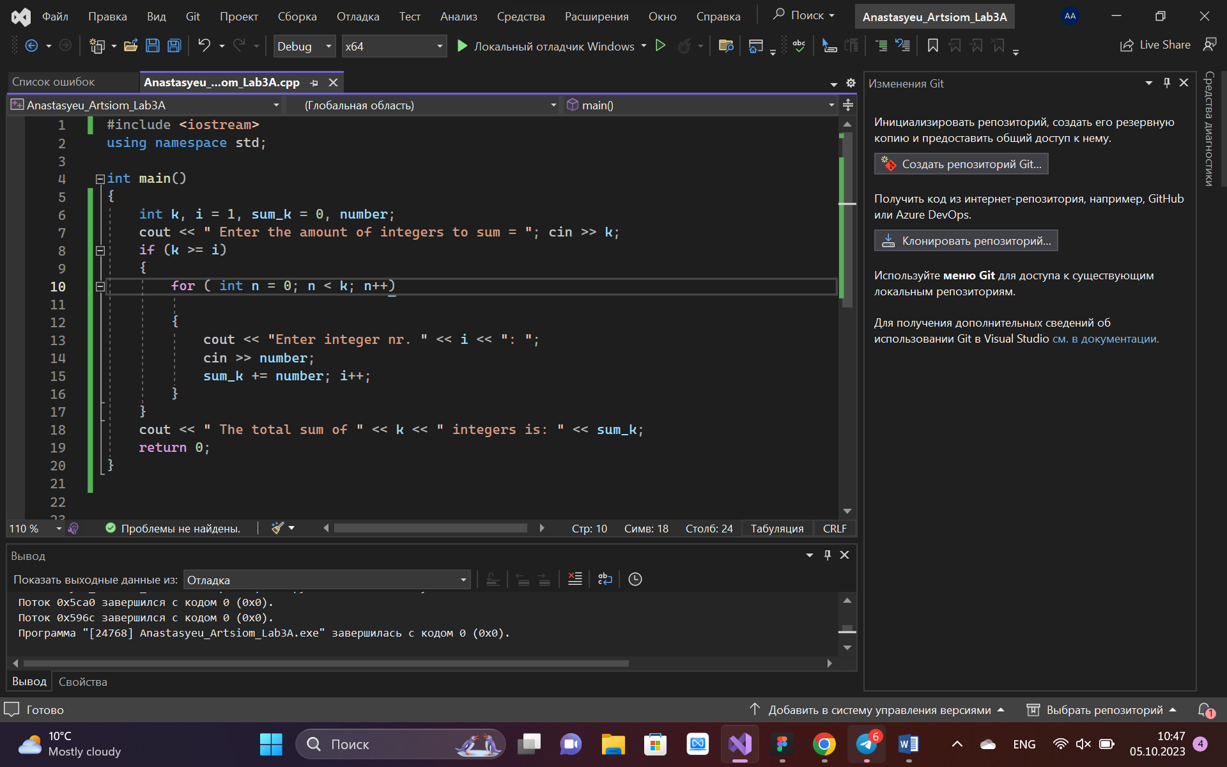

**TASK 4.3**

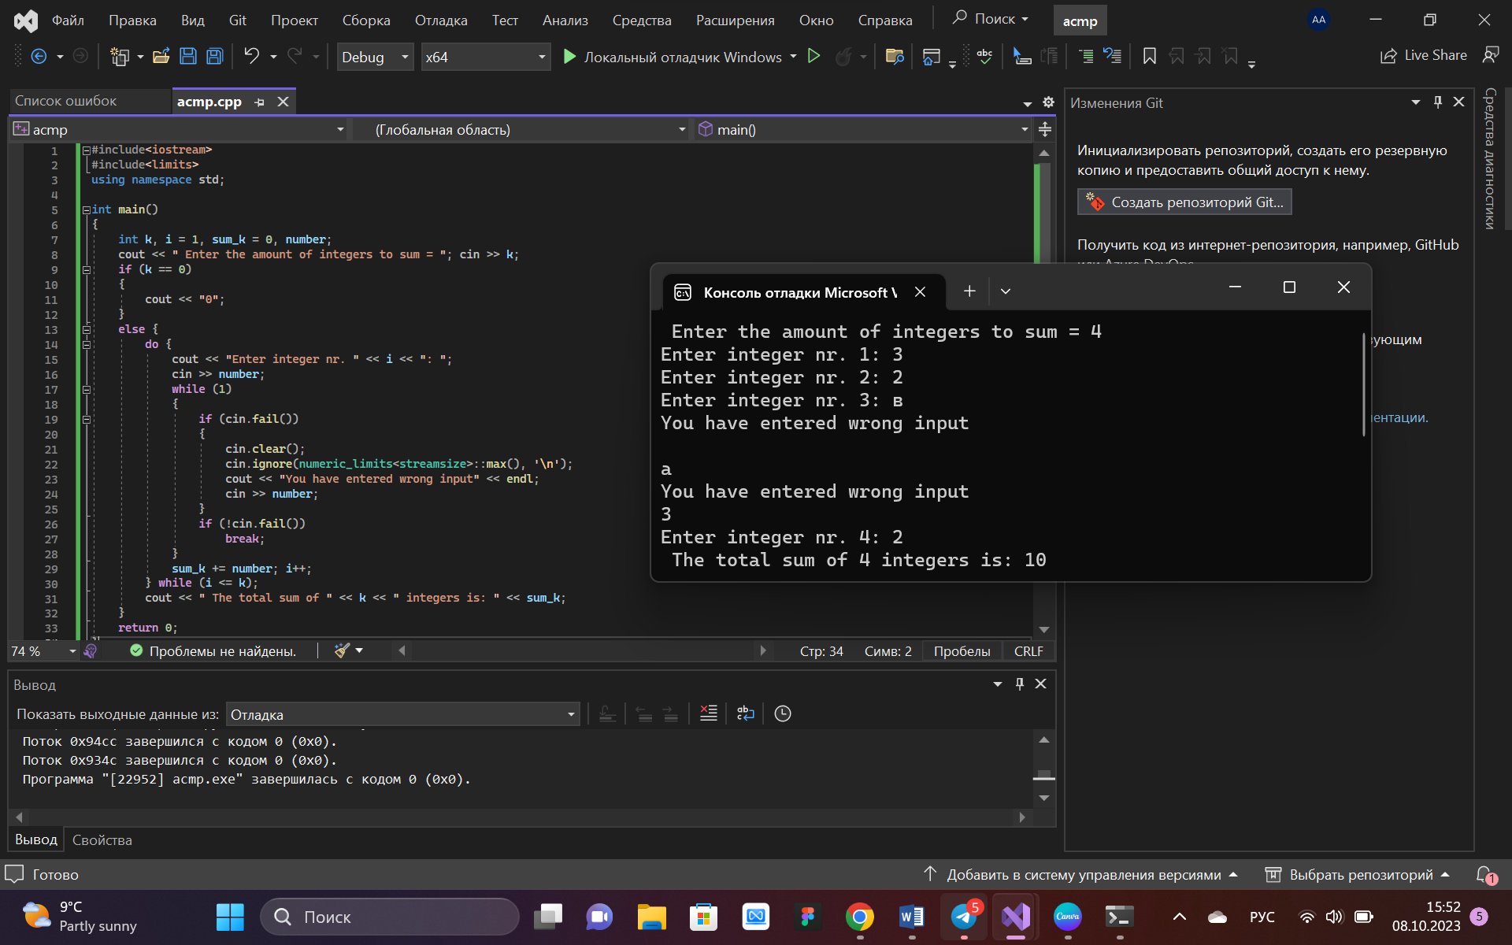

**TASK 5.1**

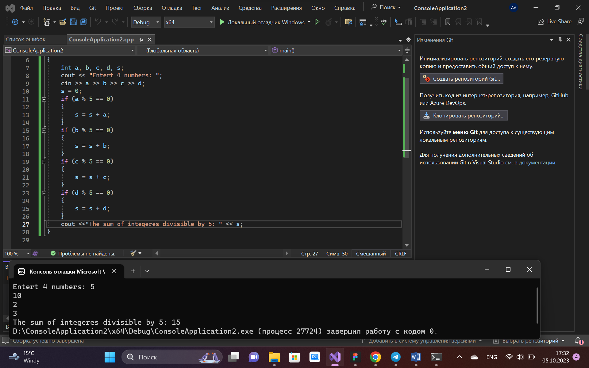

#include <iostream>

using namespace std;

int main()

{

int a, b, c, d, s;

cout << "Entert 4 numbers: ";

cin >> a >> b >> c >> d;

s = 0;

if (a % 5 == 0)

{

s = s + a;

}

if (b % 5 == 0)

{

s = s + b;

}

if (c % 5 == 0)

{

s = s + c;

}

if (d % 5 == 0)

{

s = s + d;

}

cout <<"The sum of integeres divisible by 5: " << s;

}

**TASK 5.2**

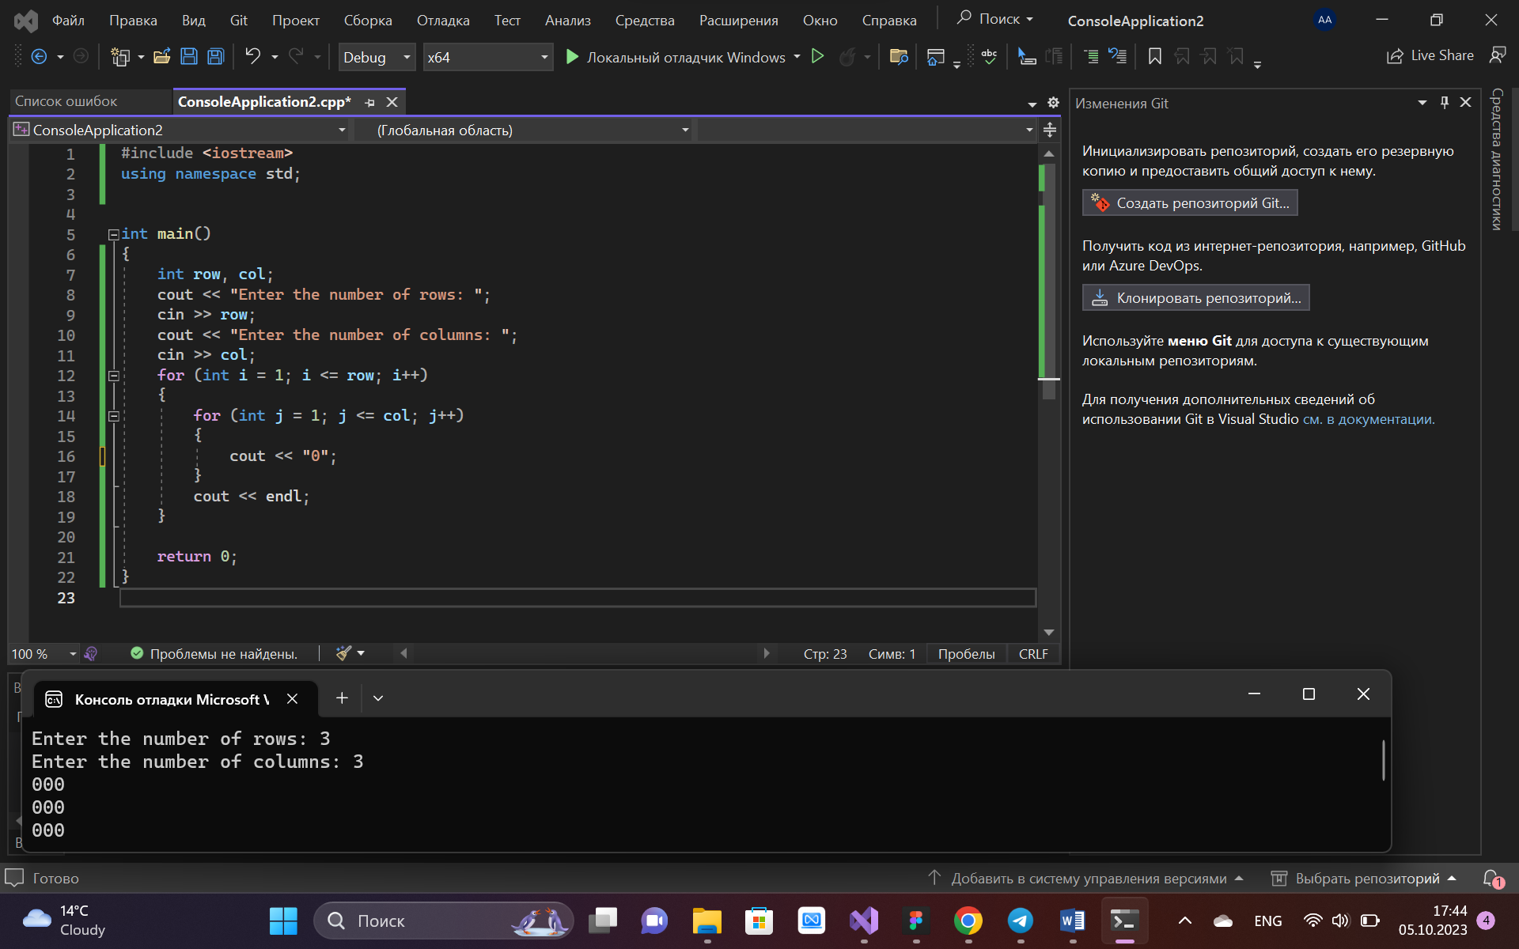

#include <iostream>

using namespace std;

int main()

{

int row, col;

cout << "Enter the number of rows: ";

cin >> row;

cout << "Enter the number of columns: ";

cin >> col;

for (int i = 1; i <= row; i++)

{

for (int j = 1; j <= col; j++)

{

cout << "0";

}

cout << endl;

}

}

**TASK 5.3**

#include <iostream>

#include <iomanip>

using namespace std;

int main()

{

int x, d;

d = 0;

cout << "Dollar exchange for rubles: ";

cin >> x;

for (int i = 0; i < 10; i++)

{

do

{

d = d + 10;

} while (d < 10);

cout << d << setw(5) << d * x << setw(5) << d * x * 1.5 << endl;

}

}

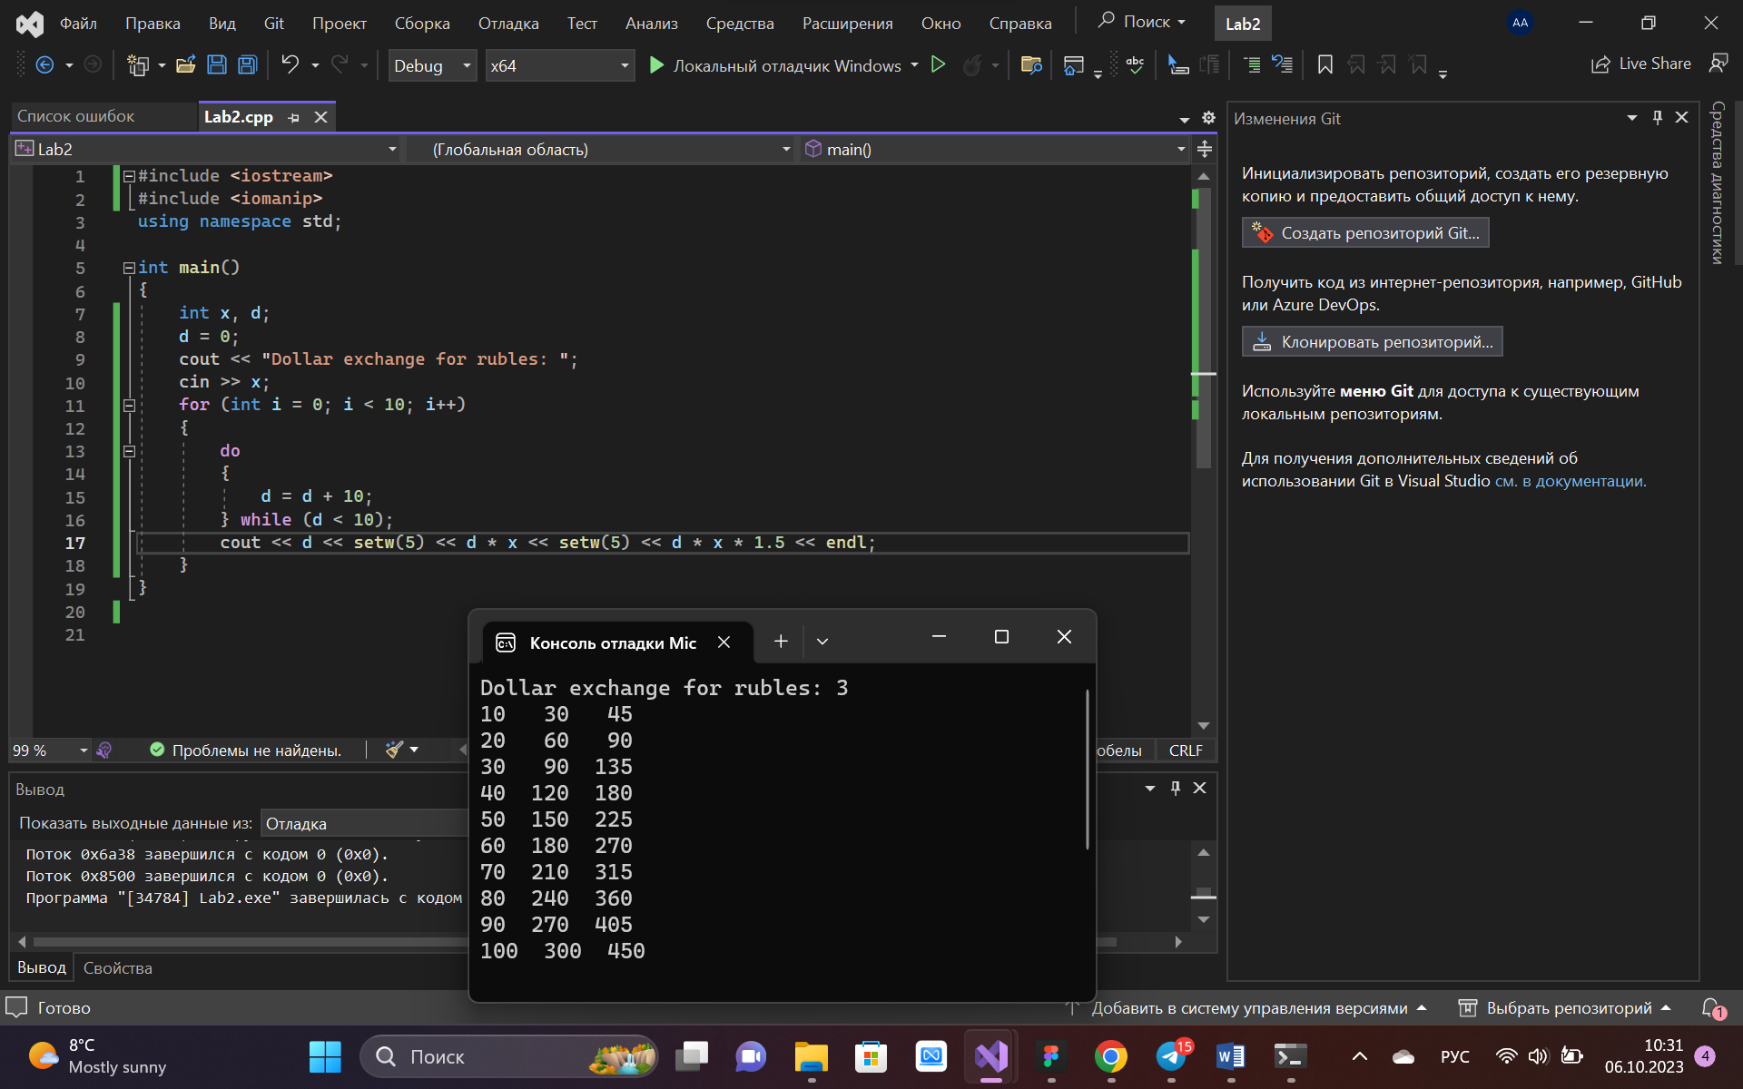

**TASK 5.4**

#include <iostream>

#include <iomanip>

using namespace std;

int main()

{

int d, n;

double a, b, c, e, f, g;

a = 10;

for (int i = 0; i < 9; i++)

{

a = a * 1.1;

cout << a << endl;

}

cout << endl;

a = 10;

b = 10;

for (int j = 0; j < 6; j++)

{

a = a * 1.1;

b = b + a;

}

cout << "the distance of 7 days: " << b << endl;

cout << "Enter the number of days: ";

cin >> n;

e = 10;

c = 10;

for (int m = 1; m < n; m++)

{

e = e * 1.1;

c = c + e;

}

cout << "Total distance for " << n << " days: " << c << endl;

f = 10;

g = 10;

d = 0;

do

{

f = f * 1.1;

g = g + f;

d++;

}

while (g < 80);

cout << "He should stop on the " << d << " day not to exceed 80 km" << endl;

}

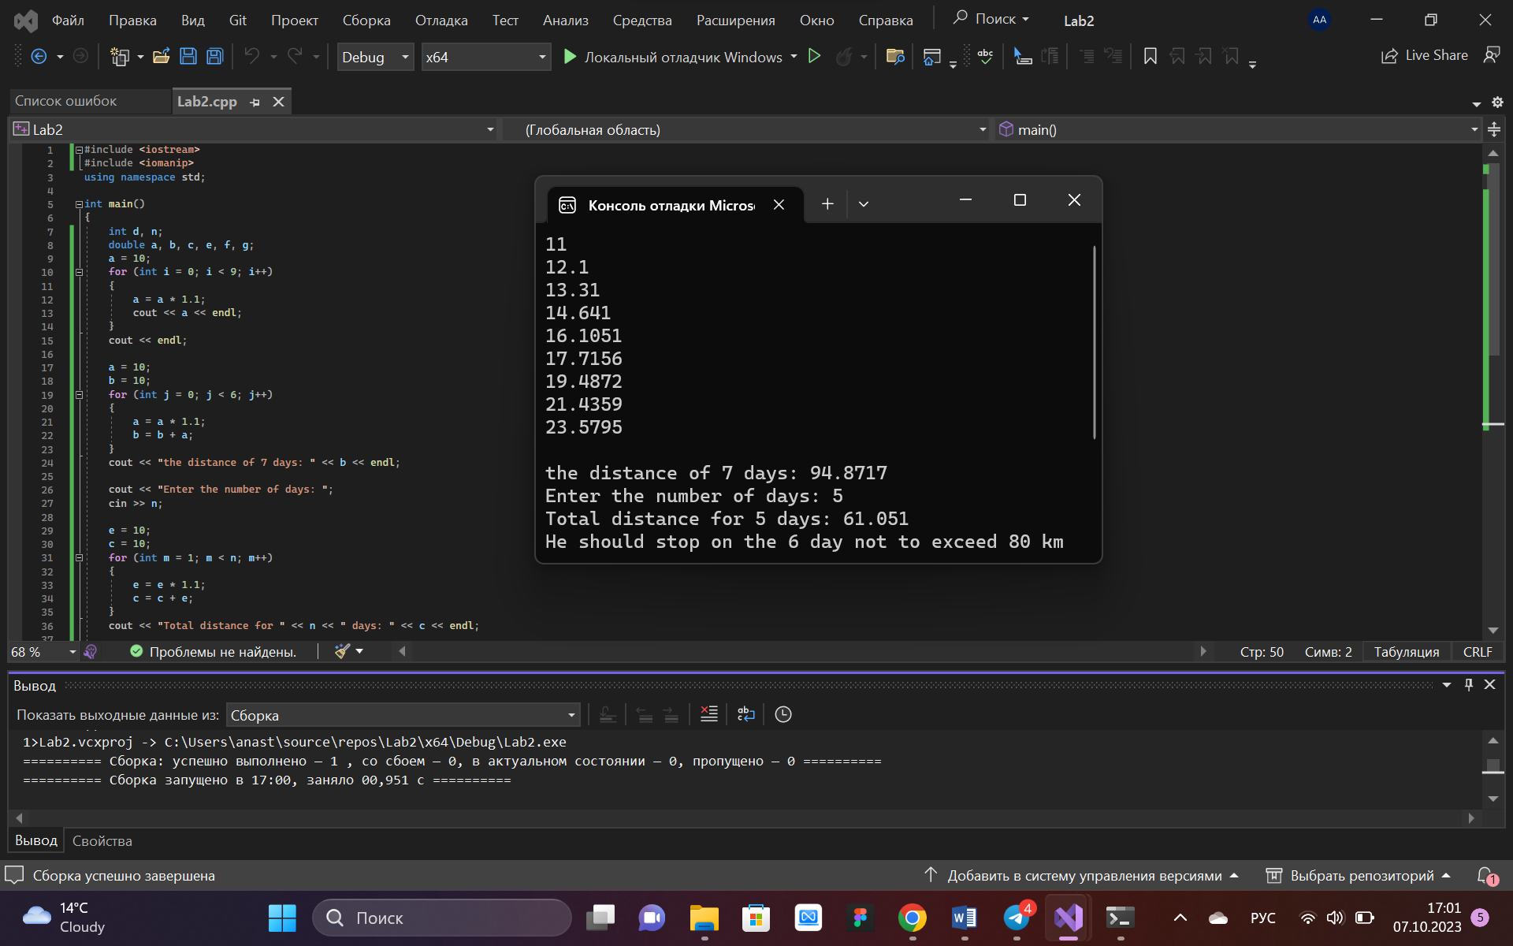

**TASK 6**

At first everything was pretty clear , like nothing to struggle with. First problems appeared with task 4.3 , it made me read some additional information to make the code for this task. Then almost all tasks from task 5 were easy and even interesting , but 5.4 got , there were too many outputs so I got a bit confused , bit also I’ve solved this problem. So the conclusion is : it just requires a little of your time to get focused on the task and you’ll do it.