Мета: здобути знання та практичнi навики роботи з дiалоговими компонентами в середовищi програмування Delphi.
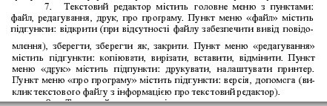
Завдання.

Лiстинг модуля Unit1 (головна форма):
unit Unit1;

interface

uses
Windows, Messages, SysUtils, Variants, Classes, Graphics, Controls, Forms,
Dialogs, Menus, ComCtrls, StdCtrls, Printers, StdActns, ActnList, Unit3;

type
TForm1 = class(TForm)
PageControl1: TPageControl;
TabSheet1: TTabSheet;
MainMenu1: TMainMenu;
N1: TMenuItem;
N2: TMenuItem;
N3: TMenuItem;
N4: TMenuItem;
N5: TMenuItem;
N6: TMenuItem;
N7: TMenuItem;
N8: TMenuItem;
N9: TMenuItem;
N10: TMenuItem;
N11: TMenuItem;
N12: TMenuItem;
N13: TMenuItem;
N14: TMenuItem;
N15: TMenuItem;
N16: TMenuItem;
OpenDialog1: TOpenDialog;
SaveDialog1: TSaveDialog;
N17: TMenuItem;
PrintDialog1: TPrintDialog;
PrinterSetupDialog1: TPrinterSetupDialog;

RichEdit1: TRichEdit;
N18: TMenuItem;
N19: TMenuItem;
PopupMenu1: TPopupMenu;
ActionList1: TActionList;
EditCut1: TEditCut;
EditCopy1: TEditCopy;
EditPaste1: TEditPaste;
EditSelectAll1: TEditSelectAll;
Copy1: TMenuItem;
Cut1: TMenuItem;
Paste1: TMenuItem;
SelectAll1: TMenuItem;
EditUndo1: TEditUndo;
procedure N5Click(Sender: TObject);
procedure N6Click(Sender: TObject);
procedure N7Click(Sender: TObject);
procedure FormActivate(Sender: TObject);
procedure N8Click(Sender: TObject);
procedure N17Click(Sender: TObject);
procedure N14Click(Sender: TObject);
procedure N13Click(Sender: TObject);
procedure FormCloseQuery(Sender: TObject; var CanClose: Boolean);
procedure N15Click(Sender: TObject);
procedure N18Click(Sender: TObject);
procedure N19Click(Sender: TObject);
procedure PageControl1Change(Sender: TObject);
procedure N16Click(Sender: TObject);
private
{ Private declarations }
public
{ Public declarations }
end;

var
Form1: TForm1;

implementation
type myrec=record
REd: TRichEdit;
Ts: TTabSheet;
end;

var FName: string;
i: integer;
m: array of myrec;

{$R *.dfm}

procedure TForm1.N5Click(Sender: TObject);
begin
if OpenDialog1.Execute then begin
m[PageControl1.ActivePageIndex].REd.Clear;
m[PageControl1.ActivePageIndex].REd.Lines.LoadFromFile(OpenDialog1.Filename);
m[PageControl1.ActivePageIndex].Ts.Caption:=OpenDialog1.FileName;
end;

end;

procedure TForm1.N6Click(Sender: TObject);
begin
m[PageControl1.ActivePageIndex].REd.Lines.SaveToFile(m[PageControl1.ActivePageIndex].Ts.Caption+'.txt');
end;

procedure TForm1.N7Click(Sender: TObject);
begin
if SaveDialog1.Execute then begin
FName:=SaveDialog1.FileName+'.txt';
m[PageControl1.ActivePageIndex].REd.Lines.SaveToFile(FName);
m[PageControl1.ActivePageIndex].Ts.Caption:=SaveDialog1.FileName;
end;
end;

procedure TForm1.FormActivate(Sender: TObject);
begin
SetLength(m,1);
m[0].REd:=RichEdit1;
m[0].Ts:=TabSheet1;
i:=1;
OpenDialog1.Filter:='Text files (*.txt)|*.txt|All files|*.*';
SaveDialog1.Filter:='Text files (*.txt)|*.txt|All files|*.*';
TabSheet1.Caption:=TabSheet1.Caption+inttostr(i);
end;

procedure TForm1.N8Click(Sender: TObject);
var r: word;
begin
if PageControl1.ActivePageIndex<>0 then begin
if m[PageControl1.ActivePageIndex].REd.Modified
then begin
r:=MessageDLG('Сохранить изменения в файле '+m[PageControl1.ActivePageIndex].Ts.Caption+'.txt?',mtConfirmation,[mbYes,mbNo,mbCancel],0);
if r=mrYes then
begin
m[i].REd.Lines.SaveToFile(m[PageControl1.ActivePageIndex].Ts.Caption+'.txt');
PageControl1.ActivePage.Free
end else
if r=mrNo then
PageControl1.ActivePage.Free;
end;
SetLength(m,PageControl1.PageCount);
end
else Form1.Close;
end;

procedure TForm1.N17Click(Sender: TObject);
begin
m[PageControl1.ActivePageIndex].REd.SelectAll;
end;

procedure TForm1.N14Click(Sender: TObject);
begin
PrinterSetupDialog1.Execute;
end;

procedure TForm1.N13Click(Sender: TObject);
begin
if PrintDialog1.Execute then
begin
m[PageControl1.ActivePageIndex].REd.Print('');
end;
end;

procedure TForm1.FormCloseQuery(Sender: TObject; var CanClose: Boolean);
var r: word;
i: integer;
begin
for i:=0 to PageControl1.ActivePageIndex do begin
if m[i].REd.Modified then begin
r:=MessageDLG('Сохранить изменения в файле '+m[PageControl1.ActivePageIndex].Ts.Caption+'.txt?',mtConfirmation,[mbYes,mbNo,mbCancel],0);
if r=mrYes then
begin
m[PageControl1.ActivePageIndex].REd.Lines.SaveToFile(m[PageControl1.ActivePageIndex].Ts.Caption+'.txt');
CanClose:=True;
end else
if r=mrNo then begin
CanClose:=True;
end else if r=mrCancel then CanClose:=False;
end
end;
end;

procedure TForm1.N15Click(Sender: TObject);
begin
MessageDLG('FreePad v1.0'+ #13#10+' (c) 2015',mtInformation,[mbOK],0)
end;

procedure TForm1.N18Click(Sender: TObject);
var TabSheetNew: TTabSheet;
NewEdit: TRichEdit;
begin
TabSheetNew:=TTabSheet.Create(Form1);
with TabSheetNew do
begin
PageControl := PageControl1;
Caption := 'NewFile' + IntToStr(PageControl1.PageCount);
end;
SetLength(m,PageControl1.PageCount);
m[PageControl1.PageCount-1].Ts:=TabSheetNew;
NewEdit:=TRichEdit.Create(Form1);
NewEdit.Align:=AlClient;
NewEdit.ScrollBars:=ssBoth;
NewEdit.Parent:=TabSheetNew;
NewEdit.PlainText:=True;
NewEdit.WordWrap:=True;
NewEdit.Name:='DEdit'+IntToStr(PageControl1.PageCount);
PageControl1.ActivePage:=TabSheetNew;
NewEdit.Clear;
m[PageControl1.PageCount-1].REd:=NewEdit;
end;

procedure TForm1.N19Click(Sender: TObject);
begin
N19.Checked:=not N19.Checked;
if N19.Checked then m[PageControl1.ActivePageIndex].REd.WordWrap:=true else
m[PageControl1.ActivePageIndex].REd.WordWrap:=false;
end;

procedure TForm1.PageControl1Change(Sender: TObject);
begin
N19.Checked:=m[PageControl1.ActivePageIndex].REd.WordWrap;
end;

procedure TForm1.N16Click(Sender: TObject);
begin
Application.CreateForm(TForm3, Form3);
Form3.ShowModal;
Form3.Free;
end;

end.
Лiстинг модуля Unit3 (виклик довiдки):
unit Unit3;

interface

uses
Windows, Messages, SysUtils, Variants, Classes, Graphics, Controls, Forms,
Dialogs, StdCtrls;

type
TForm3 = class(TForm)
Memo1: TMemo;
procedure FormCreate(Sender: TObject);
private
{ Private declarations }
public
{ Public declarations }
end;

var
Form3: TForm3;

implementation

{$R *.dfm}

procedure TForm3.FormCreate(Sender: TObject);
begin
Memo1.Lines.LoadFromFile('help.txt');
end;

end.

Скрiншоти програми:
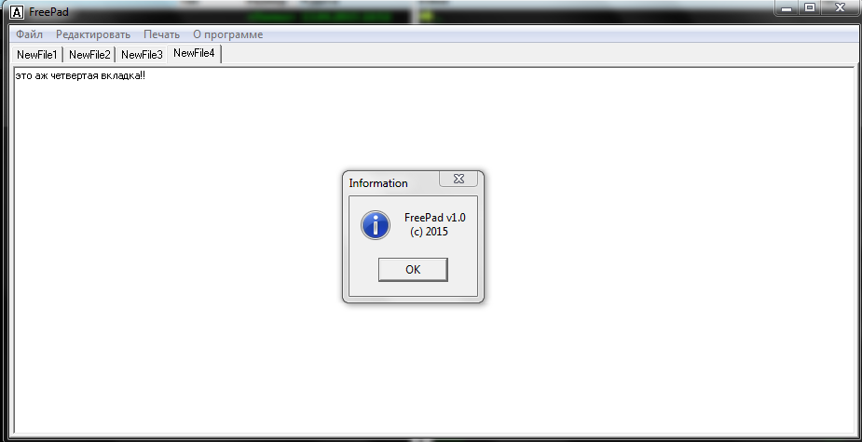
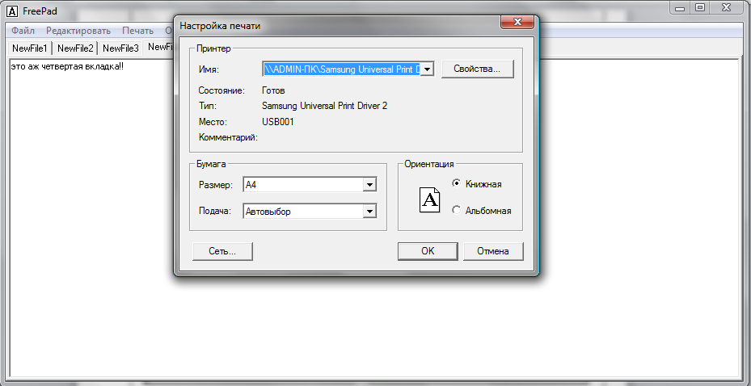
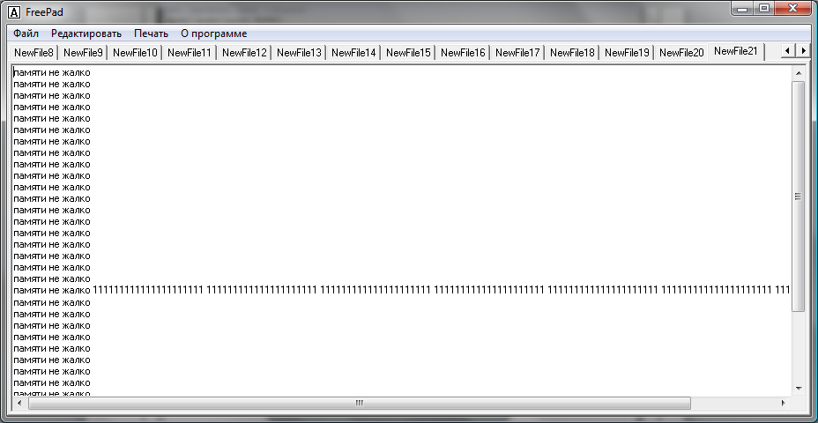
Висновок: здобули знання та практичнi навики роботи з дiалоговими компонентами в середовищi програмування Delphi.

