GMXPBSA 2.1: a GROMACS tool to perform MM/PBSA and computational alanine scanning
C. Paissoniª, D. Spiliotopoulos^{a,b}, G. Muscoª, A. Spitaleri^{a,c,*}
ª Biomolecular NMR Unit, S. Raffaele Scientific Institute , via Olgettina 58, Milan 20132, Italy
^{b} Present address: Computational Structural Biology Biochemisches Institut Universität Zürich, Winterthurerstrasse 190, CH- 8057 Zürich, Switzerland.
^{c} Drug Discovery and Development, Istituto Italiano di Tecnologia, Via Morego 30, Genoa 16163, Italy.
* Corresponding author at: Drug Discovery and Development, Istituto Italiano di Tecnologia, Via Morego, 30, Genoa 16163, Italy. E-mail address: andrea.spitaleri@iit.it

1. Introduction
MM/PBSA is a versatile method to calculate the binding free energies of a protein–ligand complex [1]. It incorporates the effects of thermal averaging with a force field/continuum solvent model to post-process a series of representative snapshots from MD trajectories. MM/PBSA has been successfully applied to compute the binding free energy of numerous protein–ligand interactions [2-5]. The method expresses the free energy of binding as the difference between the free energy of the complex and the free energy of the receptor plus the ligand (end-state method). This difference is averaged over a number of trajectory snapshots [6]. Of note, the MM/PBSA approach allows for a rapid estimation of the variation in the free energy of binding, with the caveat that generally it does not reproduce the absolute binding free energy values. Nevertheless, it usually exhibits good correlations with experiments, thus representing a fair compromise between efficiency and efficacy for the calculation and comparison of binding free energy variations. The theory underlying MM/PBSA approach has been described previously [6]. Briefly, the binding free energy of a protein molecule to a ligand molecule in solution is defined as:
ΔG_{binding} = G_{complex} – (G_{protein} + G_{ligand}) (1)
A MD simulation is performed to generate a thermodynamically weighted ensemble of structures. The free energy term is calculated as an average over the considered structures:
<G> = <E_{MM}> + <G_{solv}> – T<S_{MM}> (2)
The energetic term E_{MM} is defined as:
E_{MM} = E_{int} + E_{coul} + E_{LJ} (3)
where E_{int} indicates bond, angle, and torsional angle energies, and E_{coul} and E_{LJ} denote the intramolecular electrostatic and Lennard-Jones energies, respectively.
The solvation term G_{solv} in Eq. 4 is split into polar G_{polar} and nonpolar contributions, G_{nonpolar}:
G_{solv} = G_{polar} + G_{nonpolar} (4)
GMXPBSA 2.1 calculates G_{polar} and G_{nonpolar} with Adaptive Poisson-Boltzmann Solver (APBS) program [7].
The polar contribution G_{polar} refers to the energy required to transfer the solute from a continuum medium with a low dielectric constant (ε=1) to a continuum medium with the dielectric constant of water (ε=80). G_{polar} is calculated using the non linearized or linearized Poisson Boltzmann equation. The nonpolar contribution G_{nonpolar} is considered proportional to the solvent accessible surface area (SASA):
G_{nonpolar} = γ SASA + β (5)
where γ = 0.0227 kJ mol^{–1} Å^{–2} and β = 0 kJ mol^{–1} [8]. The dielectric boundary is defined using a probe of radius 1.4 Å.
Herein, we present an updated and revised version of the tool, GMXPBSA 2.1 (Fig. 1). We have introduced in GMXPBSA 2.1 the following improvements with respect to the previous version [11]:
- control of the input and output options;
- automatic setup and a posteriori CAS calculations;
- CAS calculations on a single residues or on a set of residues simultaneously;
- handling of multiple protein-ligands MD simulations to allow comparisons between different ligands;
- handling of multiple protein-ligands MD simulations to allow comparisons (e.g. between wild-type complex and non-alanine mutants);
- handling of APBS calculations on a multi core system (distributed calculations in cluster).
- possibility to use custom van der Waals radii;
- check and restart of the failed MM/PBSA calculations;
- statistical analysis of the results.

2. Program usage
2.1 GMXPBSA 2.1 calculation workflow
GMXPBSA 2.1 is a user-friendly suite of Bash/Perl scripts that efficiently streamlines the set up procedure and the calculation of binding free energies for an ensemble of complex structures generated by GROMACS MD engine. The program workflow, (Figures 1 and 2) consists of three different sequential steps comprising:
1. gmxpbsa0.sh:
In this step, the tool exploits the gmxpbsa0.sh script to setup the system and to perform preliminary calculations including:
- check of the required input files and directories;
- extraction of the frames of the complex from the MD simulations, subsequently split in the protein and the ligand components by the GROMACS tools;
- calculation of the Coulomb energy contributions using either GROMACS tools or the “coulomb” program available in the APBS suite, and Lennard-Jones term using GROMACS.
If the computational alanine scanning (CAS) calculation is required, the script performs alanine mutations on the defined residues on every single extracted frames removing the side chains atoms of the target residues up to the beta C atom (CB atom) and then recalculating the Coulomb and the Lennard-Jones energy contributions of the structure containing the alanine mutant. It also generates the grid and the input to perform the APBS calculations for each frame of the simulation. The latter task is critical, since deletion of artefacts in the MM/PBSA calculation requires an exact matching of the grid setup between all the system components (complex, protein and ligand).

2. gmxpbsa1.sh:
In this step, the gmxpbsa1.sh script computes the solvation polar and nonpolar energy contributions using APBS program. These calculations can be distributed on a cluster or on a multi core workstation.

3. gmxpbsa2.sh:
In this last step, the gmxpbsa2.sh script combines for all the frames the single terms, <E_{MM}> and <G_{solv}> respectively, in order to calculate the final binding free energy value. It also checks and tries to fix errors and/or failures occurring in the preceding step 2 (APBS calculations). Statistical analysis is also performed computing average and standard error (SE). The SE is calculated as follows: SE = σ/√N, where σ is the standard deviation and N is the number of structures (MD frames) used in the calculation. The average Coulomb and Lennard-Jones values, the polar and nonpolar solvation terms are calculated along each trajectory. If a value differs from the average more than two standard deviations it is considered as an outlier and the corresponding frame is excluded from the final calculation. However, it is always possible to check for outlier frames, since their reference-numbers are stored in the WARNING.dat file.

2.2 Installation and execution of the program
Once the source code of the program GMXPBSAtool.tar.gz has been downloaded the user should perform the following steps:
- extract the source code in a user defined location, e.g.. /home/myprogram/, by typing tar zxvf GMXPBSAtool.tar.gz; set the GMXPBSAHOME environment variable in bash: export GMXPBSAHOME=/home/myprogram/GMXPBSAtool; change the /home/myprogram to whatever directory is appropriate for your machine; verify write permissions in the directory tree, and execute permissions for the gmxpbsa0.sh, gmxpbsa1.sh and gmxpbsa2.sh scripts. $GMXPBSAHOME should be also added to the PATH.
- In order to perform MM/PBSA calculations, the user has to run the tool by typing $GMXPBSAHOME/<script>, where <script> can be either gmxpbsa0.sh, or gmxpbsa1.sh or gmxpbsa2.sh , according to the calculation step (see section 2.4). Each script will read the INPUT.dat file to perform the MM/PBSA calculation. For instance, if the INPUT.dat file and the directory containing the simulations are located in /home/mysimulations, the user will type $GMXPBSAHOME/<script> in the aforementioned directory. See section 3 for further details.
In order to test the correctness of GMXPBSA 2.1 installation, the tool is distributed with the examples (with shortened trajectories) presented in Section 4 to test the correctness of the installation.

2.3 Input files preparation
In order to perform binding free energy calculations on a ligand-receptor system (where the ligand can be either a protein, a peptide or a small molecule), the user needs first to perform a MD simulation using GROMACS engine 4.5 or later versions. Before starting any GMXPBSA 2.1 calculations, the user should verify the convergence of MD simulations, as lack of convergence might strongly compromise the reliability of the MM/PBSA results, as pointed out in [11]. Along with simulations data, the user should edit the INPUT.dat file, defining all the options on the binding free energy calculations (see section 2.4).
For each system under investigation MM/PBSA calculations require the following input files:
- the trajectory file describing the dynamic of the complex (name_xtc in the INPUT.dat). We encourage the user to strip off the water from the trajectory to speed up calculations. The possible artefacts deriving from periodic boundary condition (pbc) should be removed from the trajectory, using the trjconv GROMACS tool (-pbc whole or -pbc nojump or -pbc res is usually sufficient). The latter step is fundamental before carrying out the MM/PBSA calculations in order to remove the presence of possible broken molecules. The processed trajectory can be checked using a molecular visualizer before performing GMXPBSA calculations.
- the portable binary run input file (name_tpr in the INPUT.dat). This file contains the information on mass, charges and force field parameters used in the MD simulations.
- the index file, with mandatory name index.ndx. This file contains the groups used in the simulations. Three groups are compulsory in order to run GMXPBSA 2.1: the complex, containing the atoms index of the complex (union of the receptor and ligand atoms), the receptor, containing the atoms index of the receptor, and the ligand, containing the atoms index of the ligand. The three group index names can be chosen by the user.
The three files are placed in a directory, whose name will be referred to as root in the INPUT.dat file. Additional files should be present in the root directory in case the MD simulation has been carried out using either a custom GROMACS force field (e.g. including modified amino acid) or custom topologies (i.e. ligand). See section 2.4.2 for further details (keyword use_nonstd_ff and use_topology, respectively). When handling different trajectories, the user should create different root-directories, one for each simulation, and define the name of these directories in the root_multitrj variable contained in the INPUT.dat file. The tool will then automatically perform the MM/PBSA calculations on all the systems defined in the root_multitrj directories. In order to cancel out artefacts for each system (i.e. for each directory) an identical grid setup in the PBSA calculation will be defined.

2.4 INPUT.dat file
The INPUT.dat is the macro file in ASCII format, through which the user can define several options to perform binding free energy calculations. It contains 7 different sections, in which the user has to define the mandatory keywords with the options described in the following chapters and summarized in Table 1.

2.4.1. GENERAL
In this section the user defines the molecular system and the environment path as follows.
- root: the name of the directory that contains the input files necessary to calculate the binding free energy (trajectory, index, tpr and custom force field or topology files).
- multitrj: if set to y more than one system will be analysed. If set to n only the directory named root will be considered.
- root_multitrj: this variable is considered only if multitrj is set to y. It is the list containing the names of the directories that will be analysed (e.g if the user aims to analyse the directories Name1, Name2 and Name3, the command should be set to: root_multitrj Name1 Name2 Name3).
- run: can be either a string or an integer. For example, if the chosen option is “1” the program will create the RUN1_root directory. In this directory GMXPBSA 2.1 will carry out all the calculations and store the corresponding output and an input-reminders. This might be useful when different runs with different parameters for either Molecular Mechanics (MM) or solvation terms (PBSA) analysis are performed.
- RecoverJobs: can be set to n or y. If it is set to y, during the third calculation step GMXPBSA 2.1 will try to recover APBS failed jobs and will try to re-run them; if it is set to n failed jobs are neglected in the final statistical analysis.
- backup: can be set to n or y. If it is set to y (default), GMXPBSA 2.1 will copy the RUN1_root in backup_RUN1_root before analysis and merging of l the energetic terms (MM and PBSA) during the gmxpbsa2.sh step. This is useful when: i) problems arise in the final analysis, ii) the user wants to repeat the analysis.
- Cpath: the full path of the APBS “coulomb” tool. If the variable coulomb is set to coul and no path is defined, GMXPBSA 2.1 will try to locate the binary program only if it is present in the user's path environment.
- Apath: the full path of the apbs program from the APBS suite. The user can skip this option in case the apbs program, which is the executive PBSA solver of APBS suite, is present in the path environment.
- Gpath: the full path of the GROMACS binary tools. The user can skip this option if the GROMACS binary tools path is present in the path environment.
2.4.2 FORCE FIELD
To calculate the Coulomb and Lennard-Jones energy contributions GMXPBSA 2.1 performs a short energy minimization on each frame extracted from the MD simulation, that requires a GROMACS force field. GMXPBSA 2.1 provides three options, ffield, use_nonstd_ff and use_topology.
- ffield: it can be an integer representing the force field used in MD simulations (the list of the force field can be visualized typing in the bash shell the GROMACS tool “pdb2gmx”). The user should set the identical force field used in the MD simulations (Figure 3A). It is possible to perform the CAS calculations. See example 1, hMdmd2-p53 complex (section 4.1).
- use_nonstd_ff: it can be either n or y . If n, GMXPBSA 2.1 will use standard force field parameters as reported in GROMACS, defined in the previous ffield keyword. If y, the complex can be described by a modified force field in GROMACS, the user should add in the root directory the force field files along with the trajectory, index and tpr file. The custom force field should have the GROMACS 4.5 or later version format, with all the parameters files placed in a directory, i.e. amber99sb.ff or oplsaa.ff. Moreover, the custom residuetypes.dat file, which includes all the modified amino acids, should be present in the root directory (Figure 3B). For details, please refer to the GROMACS manual. It is possible to perform CAS calculations. See example 2, PHD-H3 complex (section 4.2).
- use_topology: it can be either n or y. If n, GMXPBSA 2.1 will use either the standard force field from the GROMACS package, defined in the previous ffield keyword, or the custom force field placed in the root directory. If y, GMXPBSA 2.1 will perform the calculations using the user defined custom topologies, namely receptor.itp and ligand.itp files. In this case, the root directory should contain the topology file named topol.top (Figure 3C). This file retrieves the receptor and ligand itp files. If use_topology is set to y, it is not possible to perform CAS, since the modification of the topology files could lead to errors in the modified topology. When the MM/PBSA calculations are performed on different trajectories, each root directory should contain the proper topologies. For details see example 3, Trypsin-Benzamidine complex, described in section 4.3.
- itp_receptor: receptor topology file name. Receptors with more than one chain, require repetition of the keyword for all the chains.
- itp_ligand: ligand topology file name.

2.4.3 GROMACS
The users can define the name of the complex, receptor and ligand as defined in the index.ndx file. They can also set different options for the Molecular Mechanics (MM) analysis in the MM/PBSA calculation, as explained subsequently.
- name_xtc: name of the trajectory file in GROMACS format.
- name_tpr: name of the binary tpr file in GROMACS format.
- complex: name of the complex in the index.ndx file.
- receptor: name of the receptor in the index.ndx file.
- ligand: name of the ligand in the index.ndx file.
- multichain: Useful if in the pdbs extracted from the trajectory there are more than one chains.The option "multichain" must be used ONLY if the string TER is not present at the end of each chain in the comp/receptor pdb files.
- protein_alone: it can be either y or n, depending on whether the user wants perform an energetic estimation of a free protein and to study the CAS mutations. Default is n.
- itp_protein: the name of the itp file of the protein in case “use_topology=y”.
- skip: any integer no lower than 1. If skip is set to the integer N, a structure will be extracted from the trajectory every N frames to be used for the subsequent analysis. In order to have statistical reliability of the calculations, we suggest to use at least 100 frames. For instance, in a trajectory of 1000 frames, if skip = 10, GMXPBSA 2.1 will extract 100 frames that are equally distributed along the simulation.
- min: it can be either y or n, depending on whether the user does or does not perform the energy minimization, respectively. Energy minimization will be performed on each frame before calculating the Coulomb/ Lennard-Jones contributions.
- double_p: it can be either y or n, depending on whether double precision in energy minimization is required, respectively.
- read_vdw_radii: it can be either y or n. In case of y GMXPBSA 2.1 requires the presence of the vdwradii.dat file (containing the Van der Waals radii) in the root directory. In this case the “editconf” gromacs tool will use this file to generate the pqr files and will not compute the radii based on the force field. The default option is n, however, care should be taken when using this option, as the definition of the Van der Waals radii might influence the MM/PBSA results.
- coulomb: GMXPBSA 2.1 can calculate the coulomb energy term either using the APBS “coulomb” tool (option coul) or using GROMACS (option gmx). By default it is set to coul.
- max_warn: Used to set the -maxwarn grompp flag. By default it is set to 3

2.4.4 APBS
The following section allows the user to define the options for the polar (PB) and nonpolar (SA) solvation terms in MM/PBSA calculations. For details, please refer to the APBS manual (http://www.poissonboltzmann.org/apbs/).
- linearized: APBS can calculate the solvation energy by solving the linearized (option y) or nonlinear (option n) Poisson-Boltzmann equation. By default it is set to n.
- precF: can be a digit (either 0, 1, 2 or 3), which controls the size of the grid generated during the APBS calculations (from 0 to 3 the grid spacing is decreased, resulting in more expensive calculations ). By default it is set to 1.
- temp: indicates the temperature at which the APBS calculations are performed. By default it is set to 293 K.
- bcfl: specifies the type of boundary conditions used to solve the Poisson-Boltzmann equation. It can be either sdh, mdh or focu. By default it is set to mdh.
- pdie: defines the dielectric constant of the biomolecule. This is usually a value between 2 to 20, lower values consider only electronic polarization and higher values consider additional polarization due to intramolecular motion. By default it is set to 2.
- extraspace: 5, quantity to add (A°) for each side to get fine-grid dimensions.
- coarsefactor: 1.7, factor to get coarse-grid dimensions.
- grid_spacing: 0.5 fine mesh spacing
- sdie: 80
- chgm: spl2
- srfm: smol
- srad: 1.4
- swin: 0.3
- sdens: 10.0
- calcforce: no
- ion_ch_pos: 1 positive ion charge in electron units
- ion_rad_pos: 2.0 positive ion radius
- ion_conc_pos: 0.15 positive ion concentration
- ion_ch_neg: -1 negative ion charge in electron units
- ion_rad_neg: 2.0 negative ion radius
- ion_conc_neg: 0.15 negative ion concentration
- Hsrfm: sacc srfm for non-polar calculations
- Hpress : 0.00 press for non-polar calculations
- Hgamma: 0.0227 gamma for non-polar calculations
- Hdpos: 0.20 dpos for non-polar calculations
- Hcalcforce: total calcforce for non-polar calculations
- Hxgrid : 0.1xgrid for non-polar calculations
- Hygrid : 0.1ygrid for non-polar calculations
- Hzgrid : 0.1zgrid for non-polar calculations

2.4.5 DISTRIBUTED CALCULATIONS
The user can define the different options for calculations submission to a cluster facility. Since energy calculations for each frame are independent, they can be easily parallelized in a distributed fashion assigning single frames to the available processors. MM/PBSA calculations can be performed either in a workstation exploiting one single core or multi core, or in a cluster exploiting the PBS/TORQUE queue system. The latter option is useful for the analysis of a large amount of frames, whereby GMXPBSA 2.1 submits to a batch queue a series of jobs carrying out MM/PBSA calculations. The number of submitted jobs depends on the mnp keyword and on the total number of frames (total_frames) that are analysed. GMXPBSA 2.1 calculates the number of total jobs to be submitted according to the following rule: total_number_of_jobs = total_frames/mnp. For instance, if the user sets mnp to20 and the trajectory contains 1000 frames, the total_number_of_jobs will be 50, whereby each job will contain 20 PBSA calculations. GMXPBSA 2.1 will then submit to the queue these 50 jobs, monitoring the status (Running, Queue, Hold), checking the completion of each job, and verifying the end of the calculations (jobs failed and/or successful completed). In case of failed jobs, the program will recover them (if RecoverJobs is set to y) and resubmit to the queue as previously described. In case of further failures, GMXPBSA 2.1 will print a warning in a log file, and the failed frames will be excluded from the final MM/PBSA calculations. Finally, if cluster is set to n and mnp is bigger than 1, GMXPBSA 2.1 will use the requested processors without using the PBS system.
- cluster: when the option is set to y GMXPBSA 2.1 performs calculations on a cluster in a distributed fashion taking advantage of the PBS queue manager and divides frames across all processors thus speeding up calculations.
- Q: defines the name of the queue that is used for solvation energy calculations (this is necessary only if cluster is set to y).
- budget_name: the name of the user account in the computing facilities
- walltime: the total maximum wall-clock time during which this job can run (note than 800 means seconds, 80:00 means minutes and seconds and 1:00:00 means hours, minutes and seconds).
- mnp: defines the maximum number of processors used during GMXPBSA 2.1 calculations. We highly recommend to use numbers > 1 in workstations bearing multi core only when a large amount of physical memory is available (at least 2Gb).
- nodes: 1
- mem: 5GB
When performing the calculations in a cluster with the PBS queue manager, the job are submitted as: PBS -l select:$mnp:ncpus:$nodes:mem=$mem.
2.4.6 OUTPUT
The scripts always generate an output file in ASCII format, the user can chose an option that generates the output file in PDF format.
- pdf: generates a PDF file report as output (y or n). To set pdf to y it is necessary to have installed LaTeX.

2.4.7 COMPUTATIONAL ALANINE SCANNING
In this section, the user can perform CAS calculations a posteriori on the trajectory. In this case, the user should specify which residues (ligand and/or receptor) should be modified in alanine.
- cas: if the y option is selected, GMXPBSA 2.1 will perform CAS
The setting for the mutation should contain the following string:
- MUTATION root directory residue_number residue_name [receptor or lig] mutation_name. The keywords receptor or lig are mandatory. GMXPBSA 2.1 automatically creates in the RUN1_root directory a new directory for each mutation ( (root_MUTATION_mutation_name).
In the following, we present some syntax examples of the INPUT.dat file (Table 2):
- “MUTATION PHD 9 ASP receptor ASP9ALA”, indicates that GMXPBSA 2.1 mutates the residue ASP9 of the receptor in ALA.
- “MUTATION PHD 8 ARG lig ARG8ALA”, indicates that GMXPBSA 2.1 mutates the residue ARG8 of the peptide (lig) in ALA.
- “MUTATION PHD 9 ASP receptor RES_9-11”, “MUTATION PHD 10 GLU receptor RES_9-11”, “MUTATION PHD 11 CYZ receptor RES_9-11”, indicates that GMXPBSA 2.1 mutates the residues in the range 9-11 to ALA of the receptor.
It is possible to simultaneously apply all the above combinations in the CAS study, in this case GMXPBSA 2.1 will create for each mutation name a directory.

3. Calculations steps of GMXPBSA 2.1
In the subsequen section we present the three calculation steps performed by GMXPBSA 2.1, a summary of the main calculations and of the main output files generated by the scripts. Further details are reported in the Supporting Material.

3.1 Calculations of Molecular Mechanics terms: gmxpbsa0.sh
In this first step GMXPBSA 2.1 calculates the Molecular Mechanics term (MM) of the MM/PBSA approach, including Coulomb and Lennard-Jones terms. In order to perform the MM/PBSA calculations, each GMXPBSA 2.1 script should read the INPUT.dat file. For instance, if the input files (npt.xtc, npt.tpr and index.ndx and possible additional files) are placed in /home/mysimulations/MD, the corresponding INPUT.dat file should be placed in /home/mysimulations (working directory). The root keyword in INPUT.dat will be MD. In the working directory (/home/mysimulations) the user will run the script:
$GMXPBSAHOME/gmxpbsa0.sh
to calculate the Coulomb and Lennard-Jones energies, the so called E_{MM} terms. In this step GMXPBSA 2.1 will also generate the grid needed to perform the APBS calculations in the second workflow step. By default the grid is generated as follows (Figure 4):
- fine grid: 10 Å added in each direction from the extreme coordinates of the complex;
- coarse grid: 1.7 time larger than the fine grid.
The grid spacing is automatically set to an upper limit of 0.5 Å. Setting run keyword in INPUT.dat to 1, GMXPBSA 2.1 will create RUN1_MD (RUNrun_root). At the end of the calculations, the RUN1_MD directory will contain several output files (described in detail in the Supporting Material). In particular, the RUNrun_root will be organized in three sub-folders:
- STORED_FILES, containing all the files used during the Coulomb and Lennard-Jones energy calculations;
- APBS_CALCULATIONS, containing all the input files necessary for APBS. In this directory, during the second step of the calculation APBS will generate also the corresponding output;
- SUMMARY_FILES for each analysed frame, a strun.rep file is generated, where n is the number of generated frames (n = [Numer of total frames]/skip). These files contain all the energy contributions (Coulomb and Lennard-Jones) of each frame.
In case of error or failure occurring in this step, GMXPBSA 2.1 will stop and will report the possible failure causes in the STD_ERR0 file, that is present in each RUNrun_root.

3.2 Calculations of Solvation energy terms: gmxpbsa1.sh
In this step the PB and SA solvation energy terms of MM/PBSA are calculated. These contributions are calculated typing the following command in the working directory (i.e. /home/mysimulations):
$GMXPBSAHOME/gmxpbsa1.sh
These calculations are often computationally expensive. Depending on the system size and frame numbers they might require hours to finish; e.g. a system composed by 70 amino acids requires 5 min/frame calculation time on a single core.
The APBS calculations are performed by default at a NaCl concentration of 0.15 M and at a temperature of 293 K, however these parameters can be easily changed by the user in the INPUT.dat file. At the end of the calculations, the RUNrun_root directory (i.e. RUN1_MD) will contain several output files (described in detail in the Supporting Material). The output file of each APBS calculation will be stored in the SUMMARY_FILES folder.

3.3 Calculations of MM/PBSA binding free energy: gmxpbsa2.sh
This is the last step of the tool that combines all the energetic terms to compute the MM/PBSA binding free energy value. To this aim it is sufficient to type in the working directory:
$GMXPBSAHOME/gmxpbsa2.sh
This script calculates the average and standard error of the MM/PBSA binding free energy values deriving from the extracted frames. Before calculating the MM/PBSA value, the script will try to recover failed jobs generated in the preceding step (if the variable RecoverJob is set to y). The RUNrun_root directory will contain a series of files that are described in detail in Supporting Material. To facilitate comparisons the file Compare_MMPBSA.dat generated in this step, contains the average energy values plus the standard error SE (both the total energy and the single contributions) of each system.

4 Examples
We run GMXPBSA 2.1 on three different systems in order to test its performance using different INPUT.dat parameters. The first test was performed on cellular regulatory phosphoprotein p53 in complex with oncoprotein Mdm2. This complex is considered as a reference system, as it has been the first to be studied by the MM/PBSA approach [6]. This example requires to use the ffield keyword in INPUT.dat. The second test was performed on the first PHD finger domain of autoimmune regulator protein (AIRE) in complex with a 10 residue peptide corresponding to the N-terminal tail of histone H3 [11]. In this example we perform MM/PBSA calculations on a system bearing modified amino acids (use_nonstd_ff keyword in INPUT.dat). Finally, in the third example we studied trypsin in complex with drug-like molecules (reversible competitive inhibitors benzamidine and 1,3benzamidine [12]). In this example we used the use_topology keyword in INPUT.dat. All the calculations have been carried out on a workstation Intel 3.30 GHz bearing 4 Gb of RAM.

4.1. Example 1: p53 in complex with hMdm2 and CAS
We used GMXPBSA 2.1 to: i) calculate the binding free energy generated by the interaction between p53 and hMdm2; ii) to perform CAS calculations. In this example we apply the standard procedure, where the user gives as input files only the trajectory (xtc), the portable input binary (tpr) and the index (ndx) files (Figure 3a). Before running GMXPBSA we performed 10ns of MD simulation on the wild-type complex using amber99sb-ildn force field. In order to speed up the calculations we removed the water molecules and the analysis was therefore performed on 1678 atoms. The final trajectory contained 1000 frames; in the INPUT.dat file we defined the following parameters: ffield to 6 (amber99sb-ildn force field), skip 50 (20 frames to be considered), linearized n, coulomb coul, mnp 1 and four alanine mutants on the 12-residue peptide of p53 defined in Table 3 (CAS calculations). The first step, gmxpbsa0.sh, required 3 minutes to extract all the MM terms and to setup the grid for the PBSA calculation from 100 frames (20 frames for each system, i.e. the wild type and the four alanine mutants). The second and third steps required 450 minutes and 5 seconds, respectively.

4.2 Example 2: AIRE-PHD1 in complex with histone H3 peptide and CAS
PHD fingers are Zn²⁺ binding domains consisting of 50–80 amino acids that form a two-stranded antiparallel β-sheet followed by an α helix. The first PHD finger domain of AIRE recognizes the unmodified tail of histone H3 to promote the expression of AIRE target genes [13]. We generated 10ns of trajectory of the PHD in complex with a histone peptide corresponding to the first 10 residues of histone H3 N-terminal tail (H3K4me0), using a custom oplsa force field, that was used to define two Zn²⁺ coordinating residues, namely: CYM and HIZ, corresponding to an unprotonated cysteine and a single protonated histidine, respectively. We also performed CAS calculations. We stripped out the water molecules from the trajectory (final number of atoms: 1136). In the INPUT.dat we defined the following parameters: use_nonstd_ff y, skip 1, linearized n, coulomb coul, mnp 1 and two alanine mutants defined in Table 4 (CAS calculations). The PHD directory contains the trajectory (xtc), the portable binary (tpr) and the index (ndx) files, the oplsaa.ff directory and the residuetypes.dat file, which were used to carry out MD simulations (Figure 3b). In this case we performed calculations on a total of 60 frames (20 frames for the wild type and 20 for each of the mutants). The three steps required 2 minutes, 225 minutes and 2 seconds, respectively.

4.3 Example 3: Trypsin in complex with benzamidine ligands
In this example we used GMXPBSA 2.1 to compare the affinity of two ligands towards the same receptor, to this aim we performed MM/PBSA calculations on trypsin in complex with benzamidine and 1,3benzamidine ligands [12]. In this case, in order to carry out MD simulations followed by MM/PBSA calculations, it was necessary to generate the topology file of the benzamidine ligands. We exploited the Amber Antechamber program to calculate the ligand charges and the topology parameter. Once we created the topology files for each ligand, ben.itp and ben2.itp, respectively (see details in Supporting Material) we performed MD calculations (10ns) for each complex system. Thereafter, we used GMXPBSA 2.1 to calculate the binding free energy of the benzamidine-trypsin and 1,3benzamidine-trypsin complexes on the GROMACS trajectories. We stripped out of the water molecules (final number of atoms: 3237 and 3239, respectively). We created two directories called TRY and TRY2. In each directory we put the corresponding trajectory file (npt.xtc), portable input binary file (npt.tpr), and index file with the complex, receptor and ligand group names (index.ndx), and the complex, protein and ligand topologies, topol.top, trp.itp and ben.itp, in TRY1 and in TRY2 directories, respectively (Figure 3c). The main parameters in the INPUT.dat file were the following: use_topology y, skip 100, linearized n, coulomb coul and mnp 1. Calculations were performed on a total of 20 frames (10 frames for TRY and 10 for TRY2). The three steps required 1 minute, 80 minutes and 2 seconds, respectively. Computational alanine scanning cannot be performed in this example since we are using the use_topology keyword.

Table 1. INPUT.dat file to run GMXPBSA 2.1
Keywords | Value | Note | Default
root | Name_of_Directory | String | -
run | Any_Number | Integer | 1
multitrj | “y” “n” | Boolean | n
root_multitrj* | List of directory name | String | -
RecoverJobs | “y” “n” | Boolean | y
backup | “y” “n” | Boolean | y
Cpath | Full_path | String | -
Apath | Full_path | String | -
Gpath | Full_path | String | -
use_topology | “y” “n” | Boolean | -
itp_receptor* | Name_of_topology | String | -
itp_ligand* | Name_of_topology | String | -
use_nonstd_ff | “y” “n” | Boolean | n
ffield* | Number_of_ff_used_in_MD | Integer | -
name_xtc | Name of GROMACS xtc | String | -
name_tpr | Name of GROMACS tpr | String | -
complex | Name_in_index_file | String | -
receptor | Name_in_index_file | String | -
multichain | “y” “n” | Boolean | n
protein_alone | “y” “n” | Boolean | n
itp_protein | Name_of_topology | String | -
ligand | Name_in_index_file | String | -
skip | Any_Digit | Integer | 1
min | “y” “n” | Boolean | n
double_p | “y” “n” | Boolean | n
read_vdw_radii | “y” “n” | Boolean | n
coulomb | “coul” “gmx” | String | gmx
linearized | “y” “n” | Boolean | y
precF | “0” “1” “2” “3” | Integer | 0
temp | Temperature | Integer | 293
bcfl | “sdh” “mdh” “focus” | String | mdh
pdie | Any_Digit in [0:20] range | Integer | 2
coarsefactor |  | Float | 1.7
grid_spacing |  | Float | 0.5
sdie |  | Integer | 80
chgm |  | String | spl2
srfm |  | String | smol
srad |  | Float | 1.4
swin |  | Float | 0.3
sdens |  | Float | 10.0
calcforce |  | Boolean | no
ion_ch_pos |  | Integer | 1
ion_rad_pos |  | Float | 2.0
ion_conc_pos |  | Float | 0.15
ion_ch_neg |  | Float | -1
ion_rad_neg |  | Float | 2.0
ion_conc_neg |  | Float | 0.15
Hsrfm |  | String | sacc
Hpress |  | Float | 0.0
Hgamma |  | Float | 0.0227
Hdpos |  | Float | 0.2
Hcalcforce |  | String | total
Hxgrid |  | Float | 0.1
Hygrid |  | Float | 0.1
Hzgrid |  | Float | 0.1
cluster | “y” “n” | Boolean | y
Q | Name_of_queue | String | -
budget_name | Name_of_budget | String | -
walltime | Any Digit | Integer | -
mnp | Any_Digit | Integer | 1
pdf | “y” “n” | Boolean | n
cas | “y” “n” | Boolean | n

Table 2. Example of CAS parameters as defined in INPUT.dat file
Requested mutation | Name of working directory
MUTATION PHD 9 ASP receptor ASP9ALA | RUN1_PHD_ASP9ALA
MUTATION PHD 8 ARG lig ARG8ALA | RUN1_PHD_ARG8ALA
MUTATION PHD 9 ASP receptor RES_9-11  MUTATION PHD 10 GLU receptor RES_9-11  MUTATION PHD 11 CYZ receptor RES_9-11 | RUN1_PHD_RES_9-11

Table 3. CAS parameters as defined in INPUT.dat file of Example 1
Requested mutation | Name of working directory
MUTATION P53 112 PHE lig PHE19ALA | RUN1_P53_PHE112ALA
MUTATION P53 115 LEU lig LEU22ALA | RUN1_P53_LEU115ALA
MUTATION P53 116 TRP lig TRP23ALA | RUN1_P53_TRP116ALA
MUTATION P53 119 LEU lig LEU26ALA | RUN1_P53_LEU119ALA

Table 4. CAS parameters as defined in INPUT.dat file of Example 2
Requested mutation | Name of working directory
MUTATION PHD 9 ASP receptor ASP9ALA | RUN1_PHD_ASP9ALA
MUTATION PHD 8 ARG lig ARG8ALA | RUN1_PHD_ARG8ALA
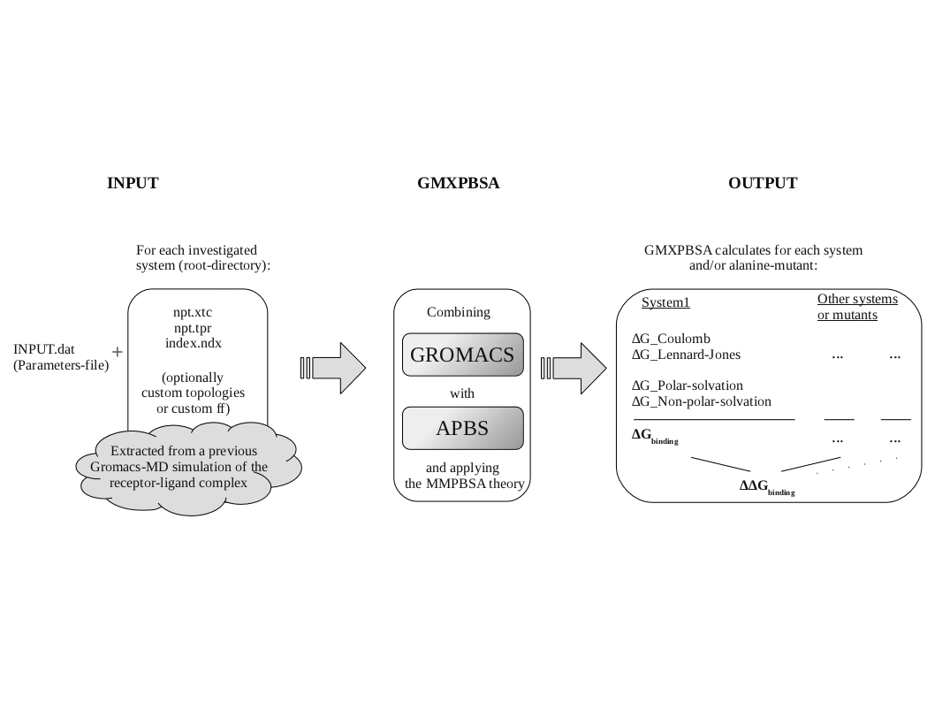

Figure 1 Workflow diagram for GMXPBSA 2.1. Diagram describing the general GMXPBSA 2.1 workflow scheme. GMXPBSA 2.1 combines the GROMACS and APBS programs in order to use the frames extracted from the molecular dynamics simulations and to calculate the binding free energy.

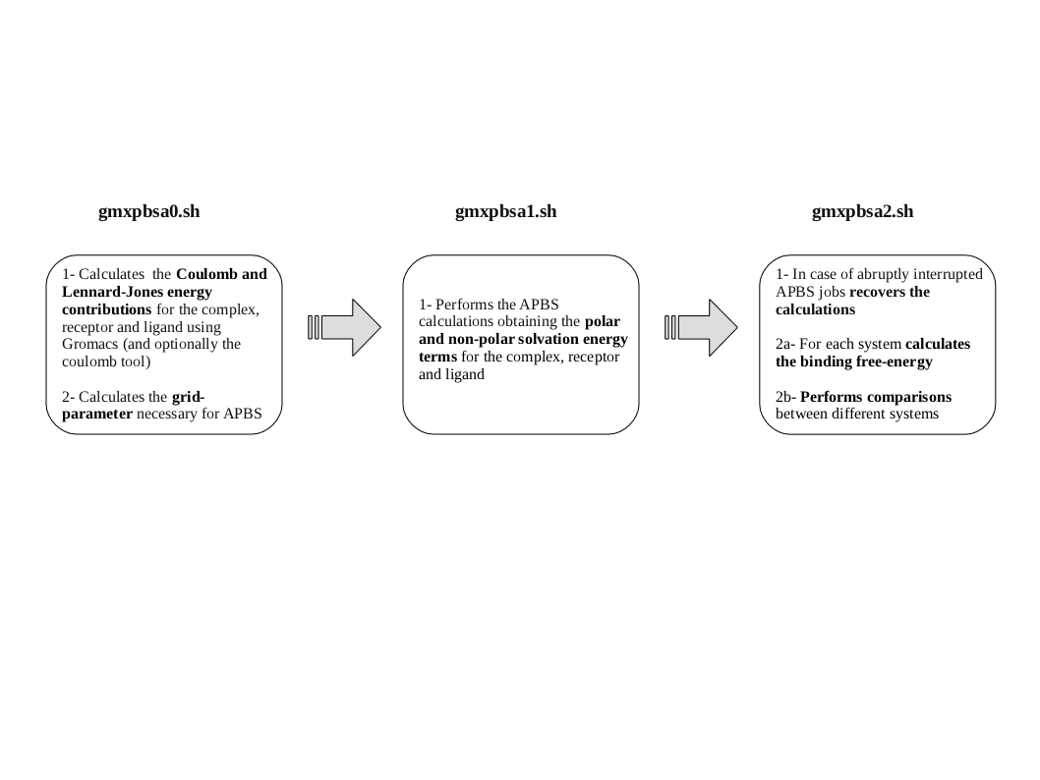

Figure 2 Schematic diagram of the three GMXPBSA 2.1 calculation steps Diagram showing the input files used by GMXPBSA 2.1 and the output files generated during each MM/PBSA step.

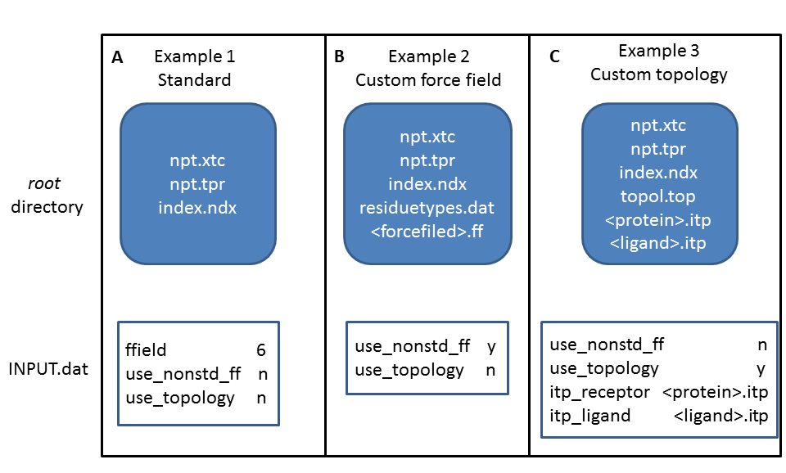
Figure 3 Schematic diagram of the three GMXPBSA 2.1 examples. Diagram showing the input files and the INPUT.dat parameters used by GMXPBSA 2.1 in each example.

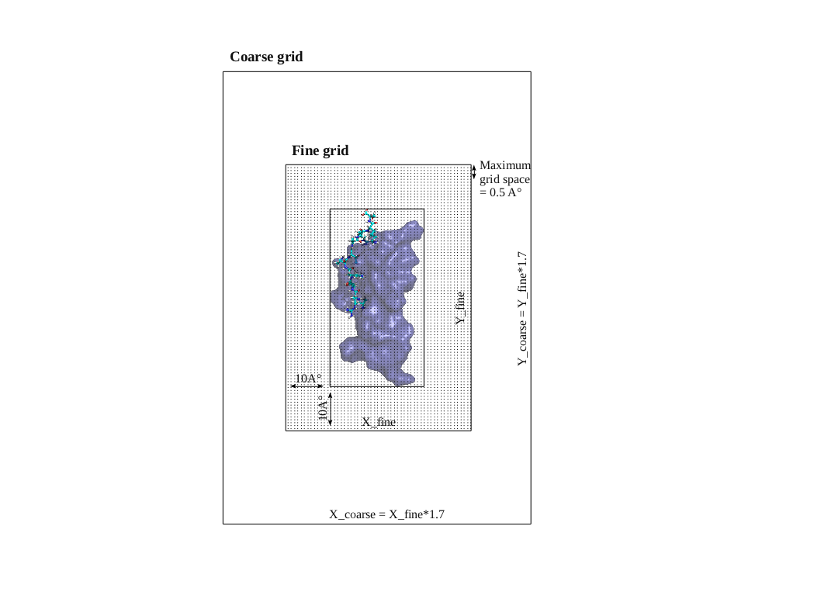

Figure 4 2D-schematic representation of the grid preparation in the apbs calculation. The protein and the ligand are shown in blue surface and licorice, respectively. The fine grid is generated adding 10 Å in each direction from the extreme coordinates of the complex. The coarse grid is 1.7 times larger than the fine grid. In this scheme the z-axis is omitted for clarity.

REFERENCES

[1] MR Reddy, CR Reddy, RS Rathore, MD Erion, P Aparoy, RN Reddy, et al. Free Energy Calculations to Estimate Ligand-Binding Affinities in Structure-Based Drug Design, Curr.Pharm.Des. (2013).
[2] MK Gilson, HX Zhou. Calculation of protein-ligand binding affinities, Annu.Rev.Biophys.Biomol.Struct. 36 (2007) 21-42.
[3] S Huo, I Massova, PA Kollman. Computational alanine scanning of the 1:1 human growth hormone-receptor complex, J.Comput.Chem. 23 (2002) 15-27.
[4] IS Moreira, PA Fernandes, MJ Ramos. Protein-protein docking dealing with the unknown, J.Comput.Chem. 31 (2010) 317-342.
[5] RT Bradshaw, BH Patel, EW Tate, RJ Leatherbarrow, IR Gould. Comparing experimental and computational alanine scanning techniques for probing a prototypical protein-protein interaction, Protein Eng.Des.Sel. 24 (2011) 197-207.
[6] KP Massova I. Computational alanine scanning to probe protein-protein interactions: A novel approach to evaluate binding free energies, J. Am. Chem. Soc. 121 (1999) 8133-8143.
[7] NA Baker, D Sept, S Joseph, MJ Holst, JA McCammon. Electrostatics of nanosystems: application to microtubules and the ribosome, Proc.Natl.Acad.Sci.U.S.A. 98 (2001) 10037-10041.
[8] SP Brown, SW Muchmore. Large-scale application of high-throughput molecular mechanics with Poisson-Boltzmann surface area for routine physics-based scoring of protein-ligand complexes, J.Med.Chem. 52 (2009) 3159-3165.
[9] Bill R. Miller, III, T. Dwight McGee, Jr., Jason M. Swails, Nadine Homeyer, Holger Gohlke, and Adrian E. Roitberg. MMPBSA.py: An Efficient Program for End-State Free Energy
Calculations, J. Chem. Theory Comput. 8 (2012) 3314-3321.
[10] S Pronk, S Pall, R Schulz, P Larsson, P Bjelkmar, R Apostolov, et al. GROMACS 4.5: a high-throughput and highly parallel open source molecular simulation toolkit, Bioinformatics. 29 (2013) 845-854.
[11] D Spiliotopoulos, A Spitaleri, G Musco. Exploring PHD fingers and H3K4me0 interactions with molecular dynamics simulations and binding free energy calculations: AIRE-PHD1, a comparative study, PLoS One. 7 (2012) e46902.
[12] D Jiao, J Zhang, RE Duke, G Li, MJ Schnieders, P Ren. Trypsin-ligand binding free energies from explicit and implicit solvent simulations with polarizable potential, J.Comput.Chem. 30 (2009) 1701-1711.
[13] J Derbinski, J Gabler, B Brors, S Tierling, S Jonnakuty, M Hergenhahn, et al. Promiscuous gene expression in thymic epithelial cells is regulated at multiple levels, J.Exp.Med. 202 (2005) 33-45.
[14] T Hou, J Wang, Y Li, W Wang. Assessing the performance of the MM/PBSA and MM/GBSA methods. 1. The accuracy of binding free energy calculations based on molecular dynamics simulations, J.Chem.Inf.Model. 51 (2011) 69-82.
[15] L Li, C Li, S Sarkar, J Zhang, S Witham, Z Zhang, et al. DelPhi: a comprehensive suite for DelPhi software and associated resources, BMC Biophys. 5 (2012) 9-1682-5-9.

