Assignment #1 Artem Batutin

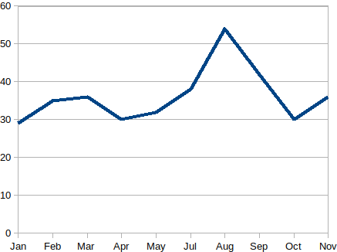
2 –

A) ->

B) Air conditioning uses a lot of electricity.

4 -

