**` Sheet #7: Manipulating the DOM and Events**

The html File has been provided for you on Lea.

The aim is to add functionalities to index.html in a way when the submit button is presses, the information that are entered in the text boxes will be added to the webpage under the form as it is shown in figure-1.

Also have the color of the “Name” text box change to Red when a user enters the box to begin typing and then change to Yellow color when user leaves.   The color should change immediately, no button should be added to the HTML file.

Use Event Listeners to perform the operations. Create functions as required.

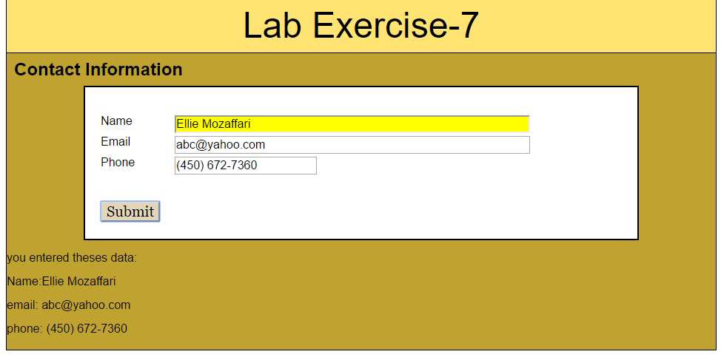

**Figure 1**