Here is compared of spanning trees(source code time line) and TextCompare(TC)

Test 1(test1 and test2)
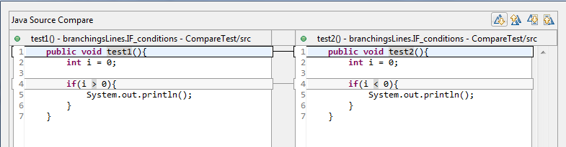

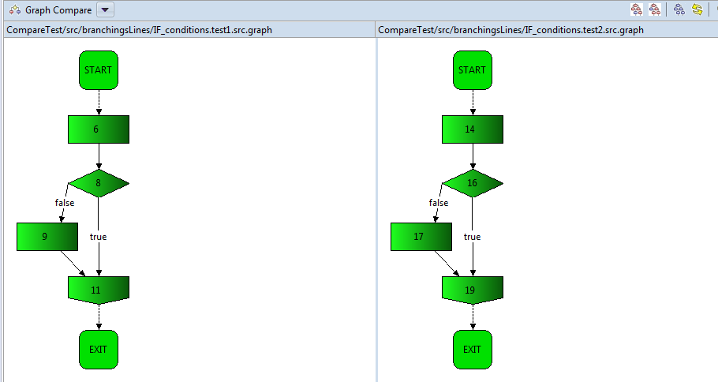

Result: if the business logic is totally different (if conditions) TC find the problem and Graphical compare cannot
Comment: GC is useless to distinguish business logic in this case because if conditions are inside, but graphically it's helpful; To see plagues structured code it helps;

Test2(test2 and test3)
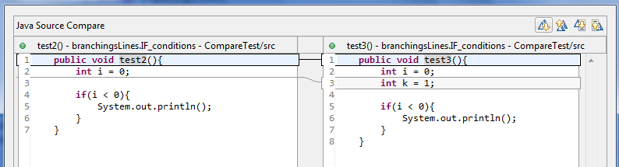

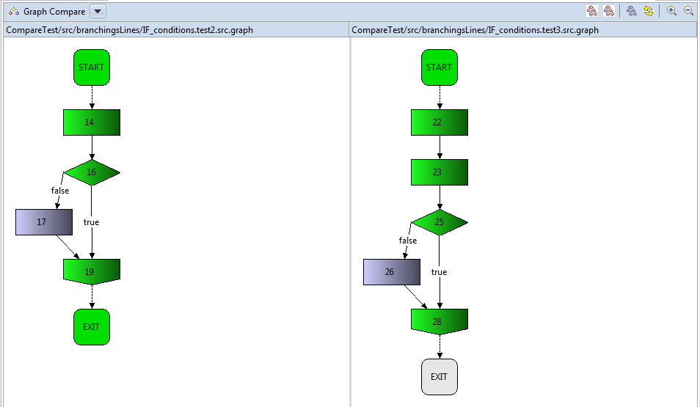
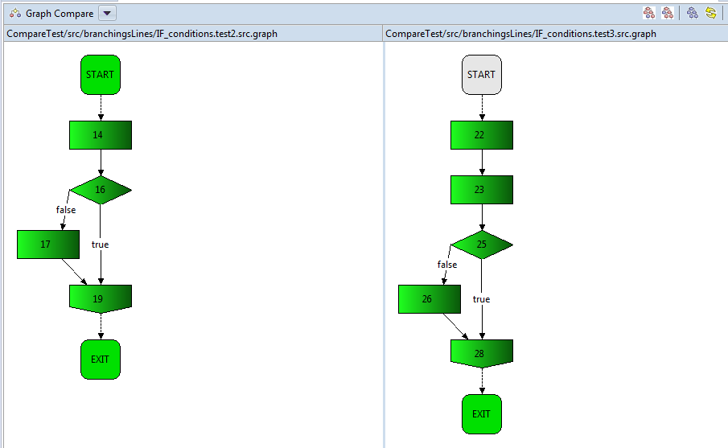
Result: TC finds one line extra, it means time sequence is shifted. But whereas graphical compare is able to find similarity.
Comment: whereas extra lines braking the structure of tree BU TD find difference due to spanning trees algorithms.

Test3(test3 and test4)
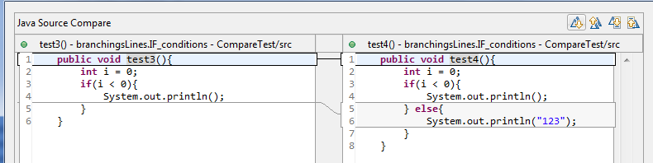
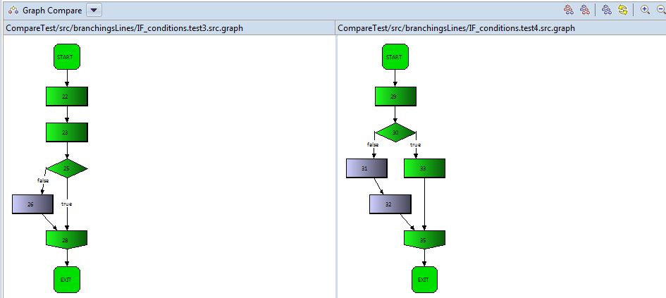
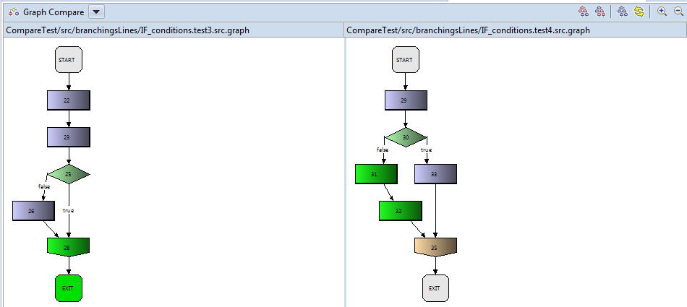

Result: text compare found total difference(but opening else bracket not)
Comment: structure similarity of TD gives 75% (6 nodes out of 8 have been covered)

Test4(test4 and test5)
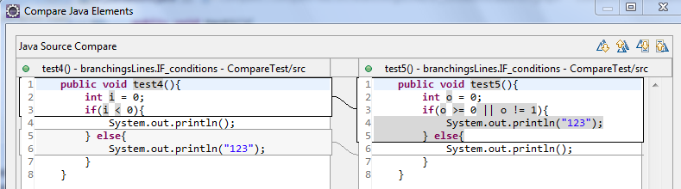
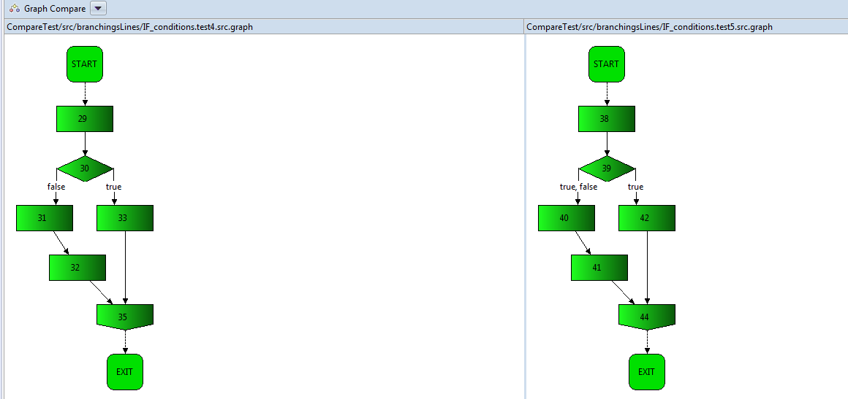

Result: structure is absolute same but logic(variables, conditions, output) is different

Test5(test6 and test7)
