Test 1 (1 and 2)

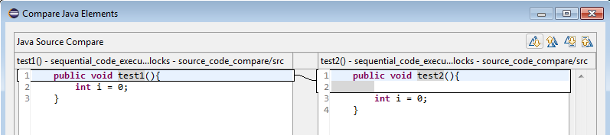
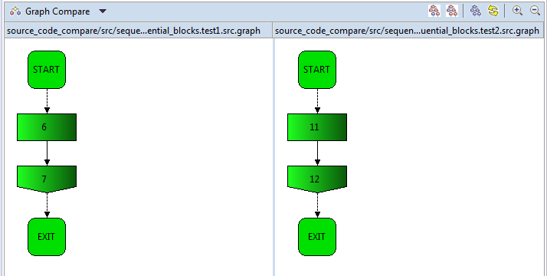
Result: BU&TD: same, text: only one enter-line

Test 2 (1 and 3)
