Test(1- 3)
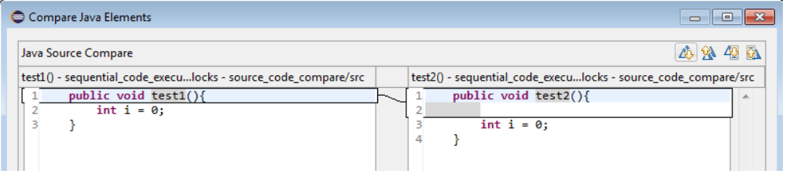
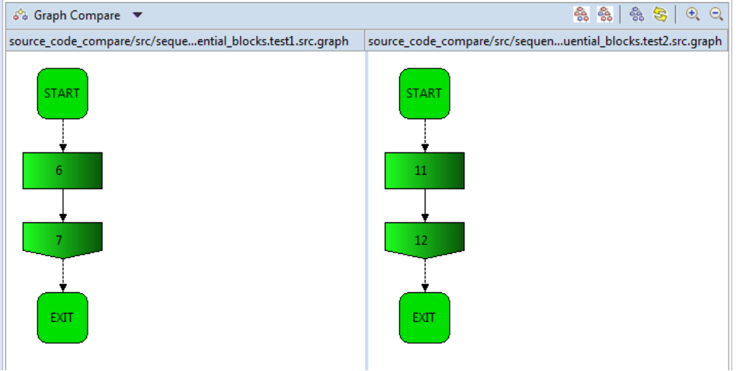
Comment: BU&TD: same, text: only one enter-line

Test 2
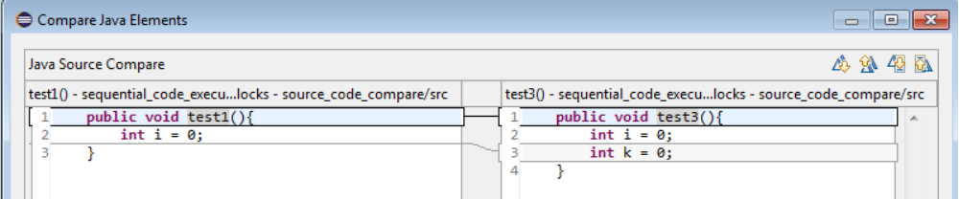
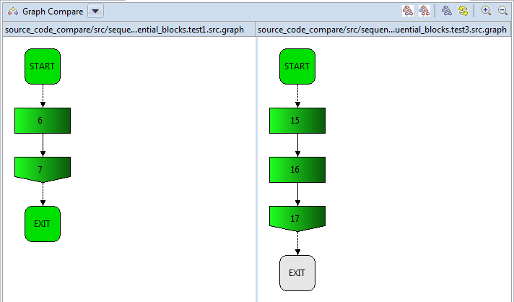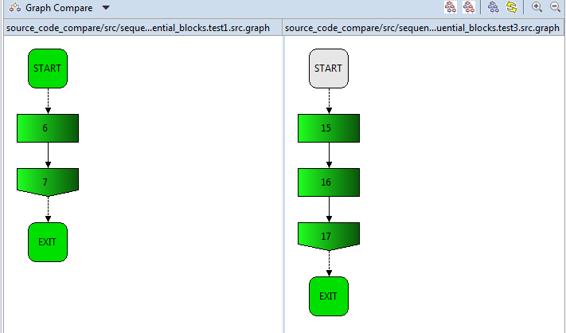
Comment: one line of new code, business logic is different, 20% difference i

