CCPS 607 – Autonomous Mobile Robotics
Lab 1 – Stay on the Surface

Oct 5, 2026 @ 11:59pm
Group 5 - Artemis Lee

Overall Robot Car Design
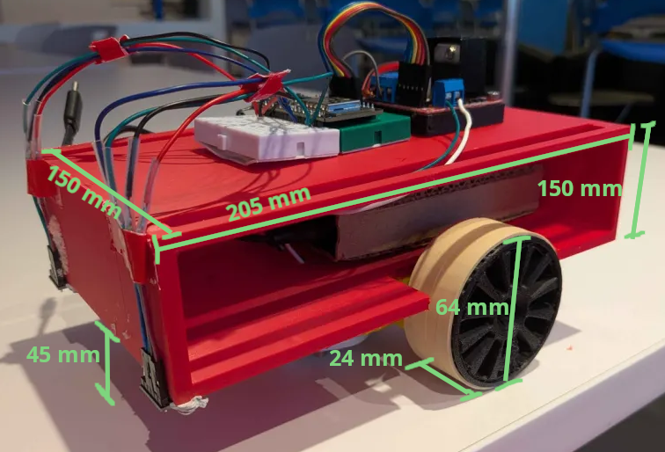
The robot is made from a mix of scrap and purpose-made 3D-printed parts and electronics. The robot’s dimension are shown in Fig 1; The wheels raise the chassis 45mm from the ground, and the wiring above adds approximately another 30-40mm to the height.

The robot steers with two-wheel differential-drive; It was chosen for both simple turning controls and reduction of overall cost. For balance, there is a ball caster placed right in front of the wheels’ midpoint, as seen as the white at the bottom of the chassis in Fig 1.

Fig 1 – Robot car with labeled dimensions

With two-wheel differential-drive steering, the robot uses on-the-spot turns where each wheel moves at the same speed but at different directions. One-the-spot turns has the smallest required surface area needed to turn safely, especially as there should be a safe area between the wheels.

Sensors
For edge detection, two VL53L0X time-of-flight (ToF) sensors are used to sense the distance from the chassis’ bottom to the ground. They were selected for the ability to adjust sensor speed and accuracy and its overall higher precision over others like the TCRT5000.

The two VL53L0Xs are placed at the bottom-front corners of the chassis, facing the ground. A third at the front-centre is not needed, as two at the corners can detect any edge that appears directly in front.

Priority was to place the VL53L0Xs as far away from the wheels as possible, while still protecting them with the chassis; This creates a large enough buffer to account for the slight delay in readings, the time it takes for the motors to change speed/stop, and the robot’s own momentum. Each VL53L0X is also placed directly in front of each wheel’s potential path, to ensure the wheels do not fall off over any other part of the robot.

Algorithm / Strategy
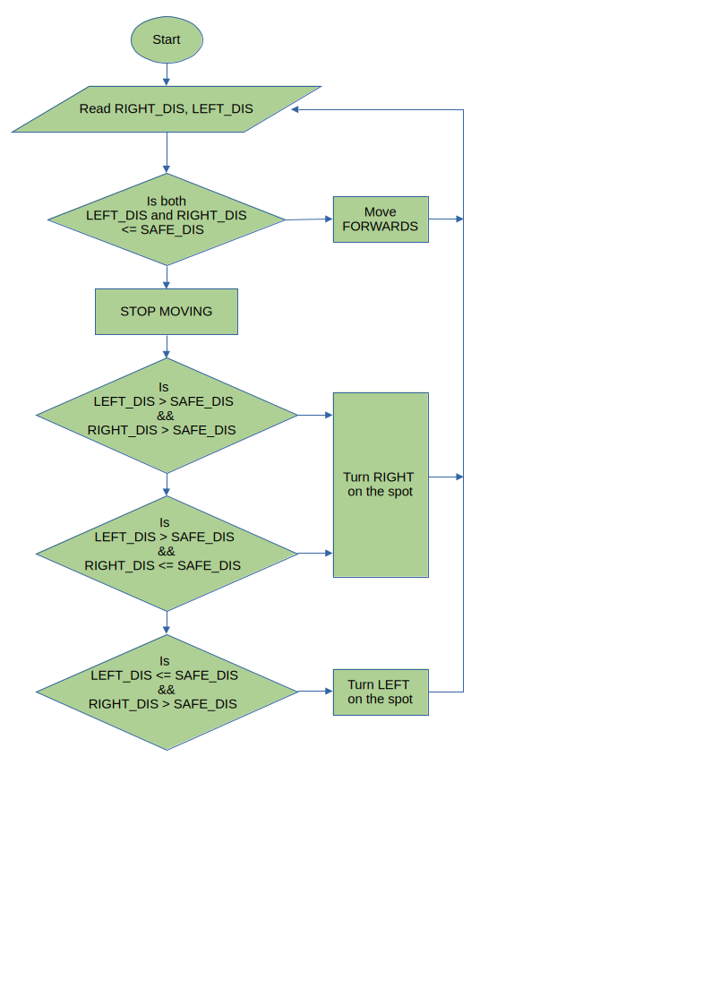
The overall strategy is simple – if the right VL53L0Xs sense a distance greater than what is safe, then the robot needs to stop and turn left; And if the left one senses a large distance instead it should turn right. If both do, then the robot can turn either left or right.

More specifically for this robot, a safe distance is 70mm (45mm + a buffer of 25mm).

It continuously reads the distances from the left and right VL53L0Xs, and only moves forwards when they are both within 70mm. It immediately stops for 300ms the moment any VL53L0X reads a distance greater than 70mm – this ensures that it will never move into an edge, and if it is still facing an edge after a turn, it not move forward but turn again.

The flowchart in Fig 2 left explains the edge avoidance logic as a whole.
Fig 2 – Flowchart of edge avoidance logic

