This is what currently we have done for the railway system:

For the simulation HMI part:

Currently the simulation HIM program can simulate the railway system and the PLC control + Arduino feedback. (2 trains on 2 railway circle)

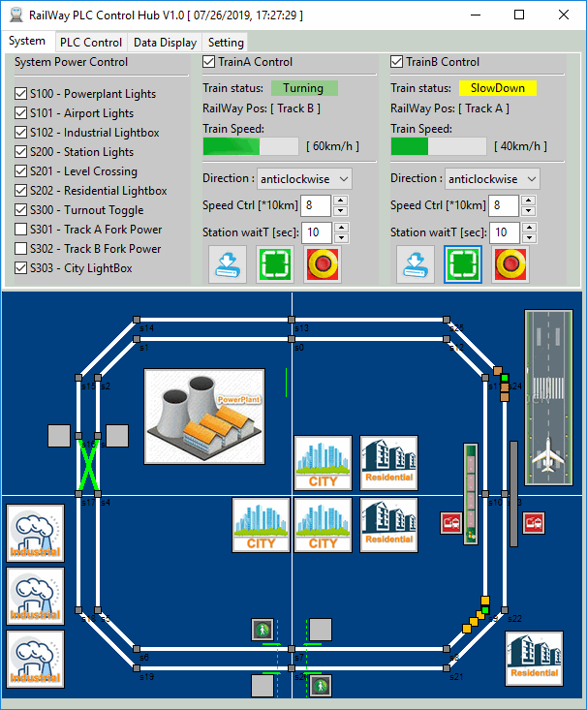

For the ModBus PLC control:

Currently our program can read the S7-1200 PLC input state (I0.X), read and set memory position(x83) state(M0.X) and set the output state(Q0.X). So currently we can control the level crossing, turn off the station light + pressure sensor and change the industrial area light to red. But these action can be detected by the current InTouch HMI(The HMI program running in the CSI PC).

For the PLC ladder diagram:

We can make the simple logic ladder diagram for plc when a input sense voltage high-> the output will turn off after 3 second. But to replace the Arduino, we need some logic like this:

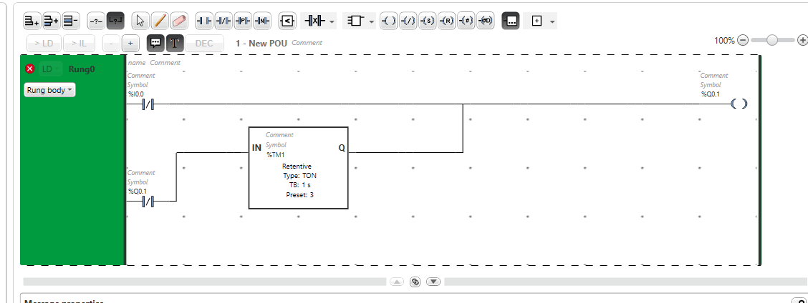

But currently the timer part got a ladder diagram syntax error and I am fixing it. The LD diagram editor can be downloaded from this link:

<https://www.schneider-electric.com/en/download/document/SoMachineBasicV1.6SP2/>

It can also do the simulation without connect to the real PLC.

