HODL Lottery

23th Feb, 2022

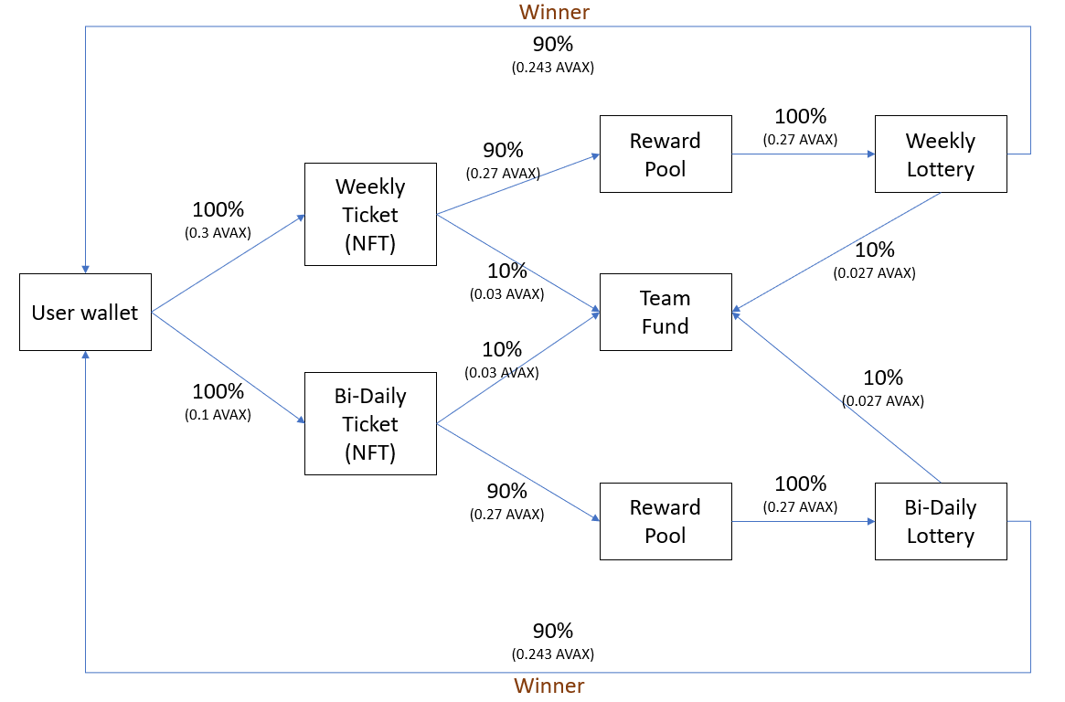

diagram when there is only one participant in the lottery

* **Ticket type**

There are 2 types of tickets: Weekly and Bi-Daily Ticket.

Weekly ticket can only be used in that week. So, user has to buy ticket per week.

Bi-Daily ticket can only be used in that Bi-week. So, user has to buy ticket per Bi-Daily.

* **Price of ticket**

Weekly: 1 AVAX

Bi-Daily: 0.2 AVAX

* **Buy**

User can buy multiple Tickets. The chance of winning increases according to the number of Tickets.

* **Chance of winning**

Chance percent = number of tickets user bought / total number of tickets

First 10 users who bought ticket can get high (3 times more than others) chance.

* **Types of tickets that can enter in each lottery**

Weekly ticket and Bi-Daily ticket can be picked in Bi-Daily lottery.

Bi-Daily ticket can be picked in Bi-Daily lottery.

* **Main lottery logic**

Manager has to input ‘seedInt, seedString, seedAddress’ into smart contract.

Nobody can see this data.

**Picked ticket number** = (hash (seedInt + seedString + seedAddress + currentTime + blockdifficult + blocknumber)) % (total count of tickets)