Introduction
The COVIRS dataset allows a complex, deep analysis of vaccine response. Ryan et al. (2022) found a few variables associated with individual symptoms (e.g., lower TFNa and chills after second dose of Pfizer), but only tested presence/absence of individual symptoms for associations.
Here, I sought to take this line of thinking further by finding groups of participants based on all symptoms, comparing gene expression between the two groups after the second dose of Pfizer (V2), and seeing if any differences can be detected between the same groups at V0 (i.e., before vaccination).
Briefly, two groups were identified - symptomatic and asymptomatic. At V2 (28 days after the second vaccine dose), CNOT7 is significantly underexpressed in the symptomatic group. GSEA found cell signature differences using blood transcriptional modules from Li et al. (2014), identifying NK and B cells as more active in the symptomatic group, partly confirmed by a statistically significant lower B cell count from flow cytometry. At V0 (prior to the first vaccine dose), cell composition differences were unclear, but a few individual genes were significantly differentially expressed, including RNU1-4, an snRNA with unclear function that was overexpressed in the asymptomatic group.

Defining patient groups based on symptoms
Data from Pfizer-vaccinated participants only (i.e., first and second dose) was used in this analysis due to the greater abundance and variety of V2 symptoms, and due to the small number of AstraZeneca-vaccinated participants.
In the clustered heatmap below we can see that there are broadly two groups of participants - those with V2 fatigue, headache, myalgia, and chills (right half), and those without (left half).

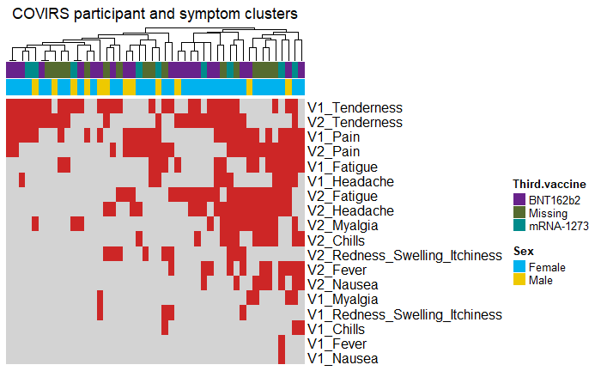
The below two plots are UMAPs of participants by symptoms (each point represents one person). We can see that there are two clusters within the emerging symptomatic group: the top cluster centered approximately at (-0.5, 2.5) and the bottom cluster, centred approximately at (-1, -5). The point labels showing total number of symptoms suggest that they differ in the presence (top cluster) or absence (bottom cluster) of fever and nausea in addition to the other systemic symptoms at V2. This heterogeneity was not accounted for in the differential expression (DE) analysis to follow due to the low sample size and hence low statistical power to confirm differences between these groups.

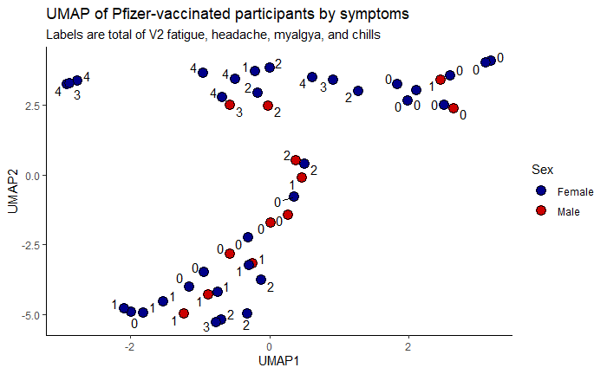
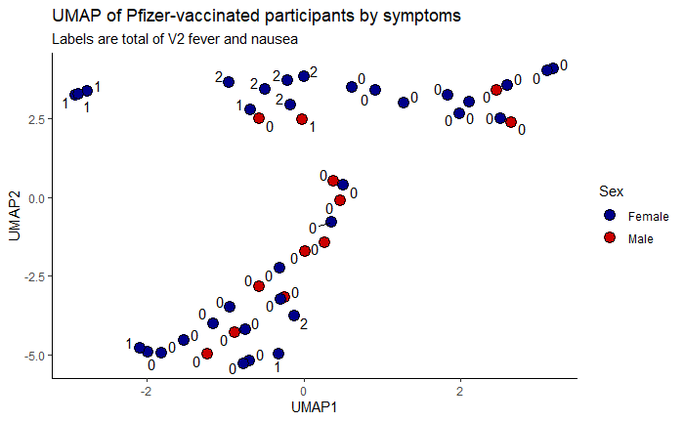

The UMAP below is a transpose of the above: each point here is a symptom. Immediately, we can see that local symptoms (pain, tenderness, and possibly redness/swelling/itchiness) cluster strongly together at both timepoints and are separated from the systemic symptoms. Note that nausea clusters together with the other systemic symptoms.

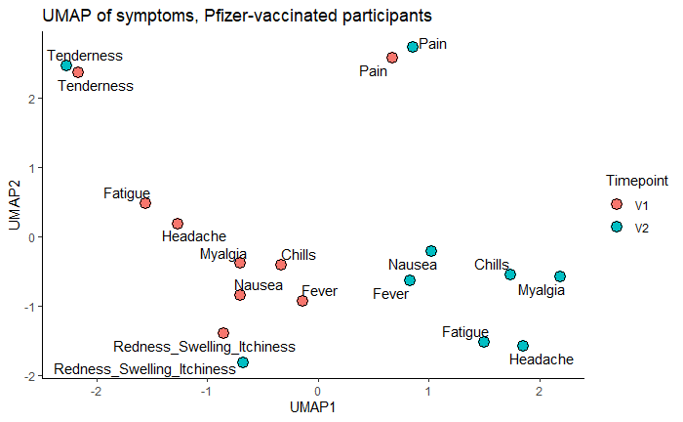

Finally, we can define comparison groups for DE analysis. Having 3 or more of V2 Fatigue, Headache, Myalgia, Chills, Fever, or Nausea (systemic symptoms) defines the symptomatic group (n = 16, 2 males). Having no V2 systemic symptoms and 2 or less of V2 Pain, Tenderness, or Redness/swelling/itchiness defines the asymptomatic group (n = 16, 4 males). There were many more females than males in the COVIRS dataset, so this is not suprising, and Fisher's exact test (not shown) indicates that this group composition is consistent with equal distribution (p = 0.614)

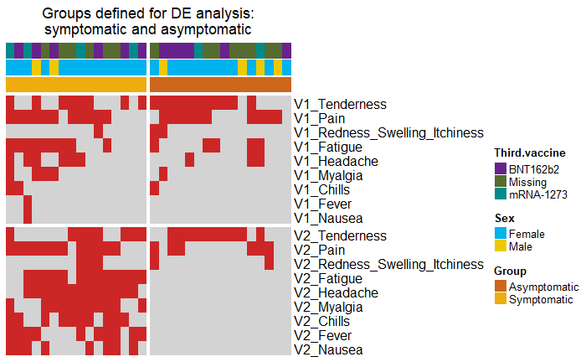
dsag

sdag

Flow cytometry
At V2, blood B cell count is significantly lower in the symptomatic group. This is exaplained by B cells migrating to the spleen to complete their development.

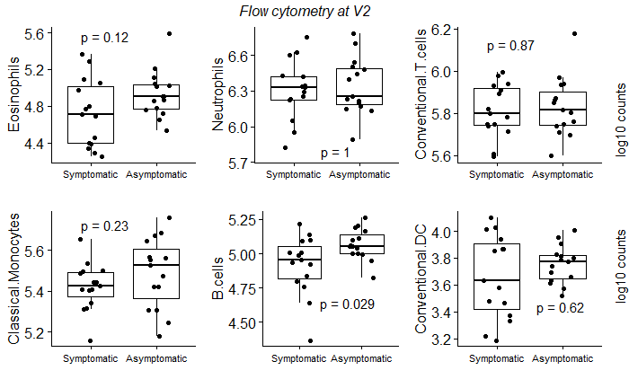
Fadsg

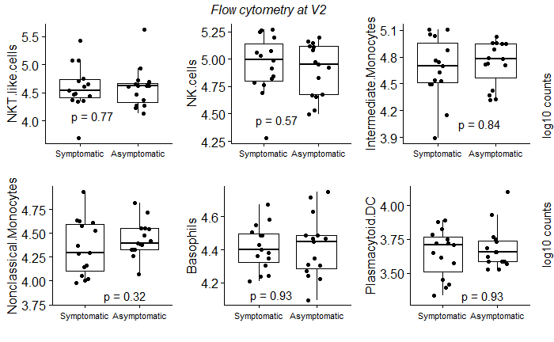
asdg

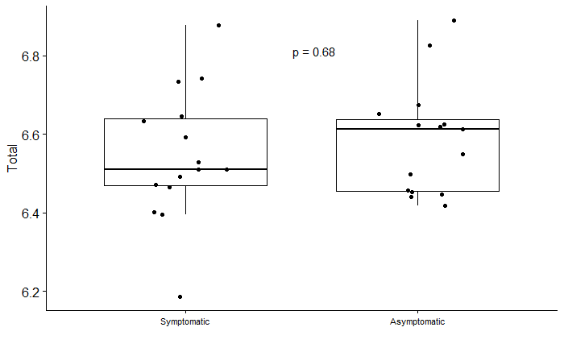
dsag

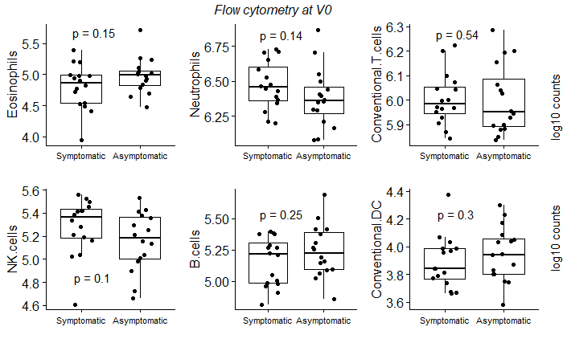
sadg
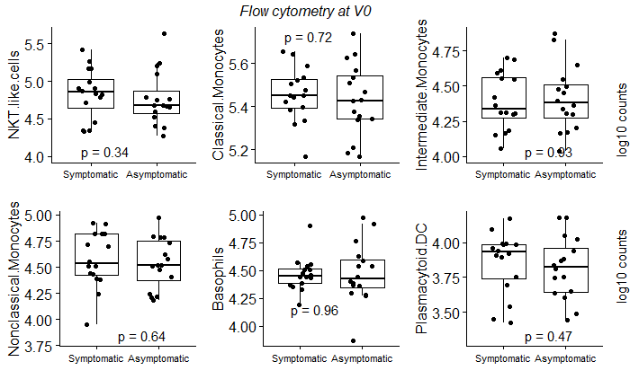
asdf

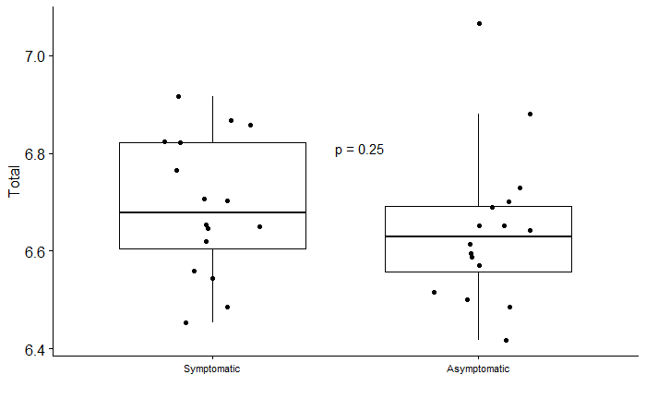
asd

V2 gene set enrichment analysis
Before proceeding, a quick quality check of the data and the analysis is to plot XIST expression by sex. As expected, it is not expressed in males.

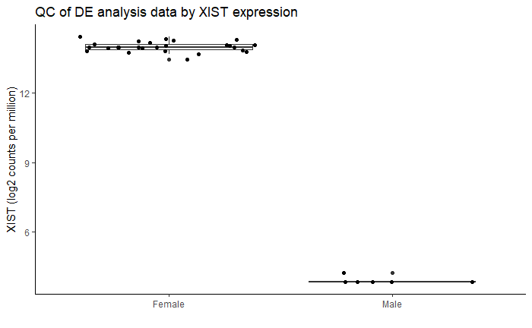
Sdag

Only genes with 100 read counts or more in at least 4 samples (i.e., participants) were kept from the counts matrix, and DESeq2 was used to find differences between the groups while controlling for differences due to sex.

A few genes with positive log2 fold change (i.e., overexpressed in the symptomatic group) are approaching significance (padj <= 0.1). Of genes with negative log2 fold change, only CNOT7 was significant.

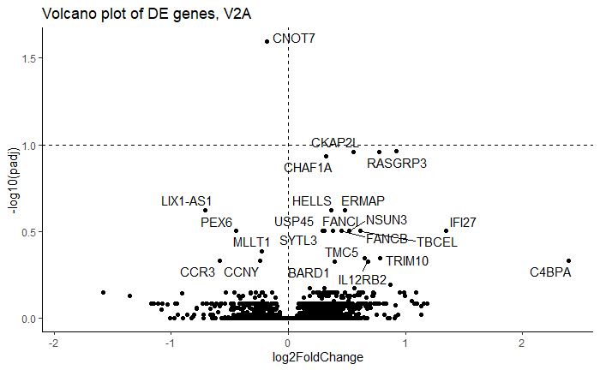
Sadf

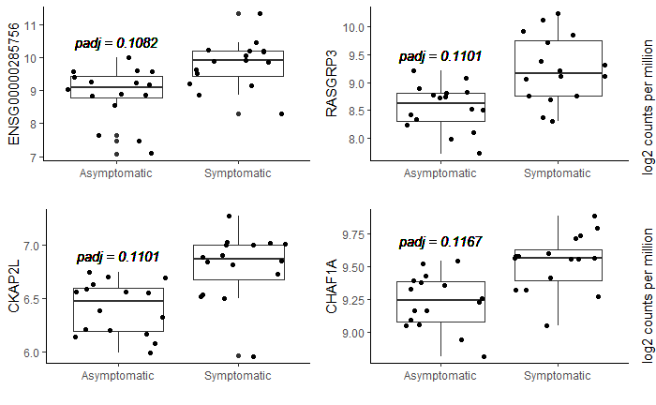
sad

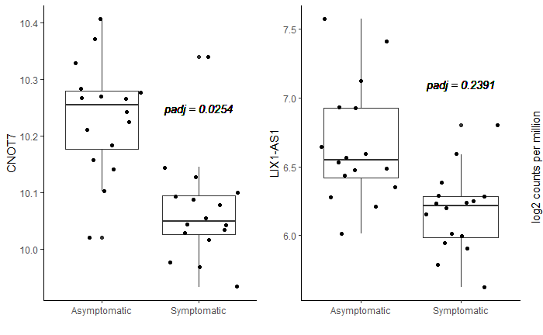
sdag

CNOT7 depletion was reported by Ren et al. (2020) and Guo et al. (2019) to reduce TGF beta 1 production in liver cancer cells and, importantly, increase IFN gamma secretion by NK cells. Are these cells more active in the symptomatic participants? To answer this and other questions about the immune response, and to find expression differences in groups of genes rather than individual genes, a gene set enrichment analysis was conducted.

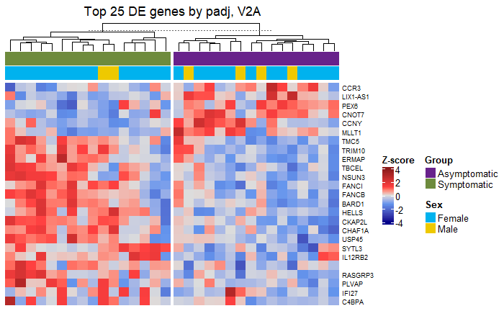
Das

fgsea with MSigDB gene sets was used to conduct GSEA. For the symptomatic group, two differentially expressed Hallmark gene sets are of interest: an increase in the expression of heme metabolism genes, and a decrease in TNFa signalling genes. However, there is a significant decrease in B cell count in the symptomatic group, suggesting that the “enrichment” in heme metabolism genes is merely an artefact of the increased proportion of RBCs and eryhtroblasts in this group.
As for TNFa signalling, scanning the Human Protein Atlas for signle-cell expression of NFKB1 and TNF in B cells suggests that these proteins are not overexpressed in this cell type compared to other immune cells, and hence the decrease in TNFa pathway gene expression is likely not an artefact.
An important note for interpreting volcano plots of gene sets: most of the time, individual genes are not differentially expressed with a sufficient padj (whose value is very low in most cases). These plots are shown to illustrate the very different shapes of the data that are nonetheless assigned similar normalised expression scores and padj values by fgsea.

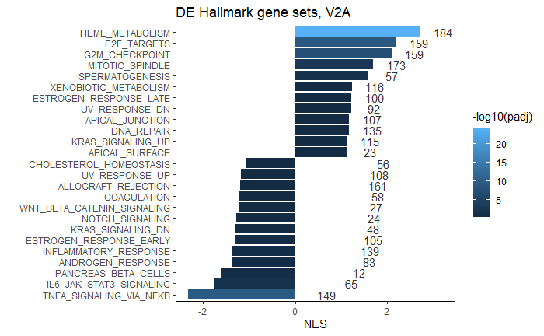
Sda

Next, bone marrow gene sets from Hay et al., 2018 were used to find cell type signatures differentially expressed between the two groups. Once again, erythroblast genes are very strongly and confidently “turned up”, likely an artifact of the increased proportion of eryhtroblasts.

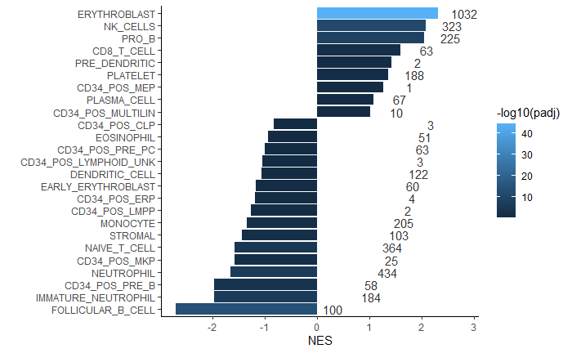
Sadg

Taken together, the three significant B cell signatures indicate more intensive B cell maturation in the symptomatic group: there is a stronger signature of early (Pre-B) cells in the blood, and a weaker blood signature of B cell stages expected to migrate into lymph.

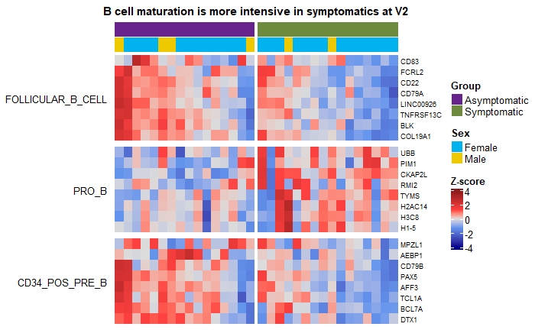
Asd

As expected from the significantly reduced expression of CNOT7, there is a stronger NK cell signature in the symptomatic group (i.e., the cells are more active, as the counts are not significantly different between the groups). Interestingly, the naive T cell signature is down, suggesting that T cells are also further differentiated in the symptomatic group, although there is no corresponding mature T cell signature to support this.

GSEA with BTMs mostly confirms these findings. B cell signature is down in the symptomatic group, agreeing with flow data, and NK cells are more active. The idea that T cells are also differentiating more intensively is supported here (enriched in T cells module). Finally, the reduced neutrophil signature is more solid with BTMs, but the reduced monocyte signature is dubious and only included for reference.

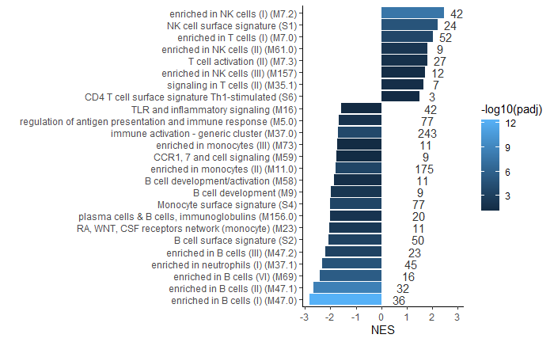
Asd

V0 GSEA
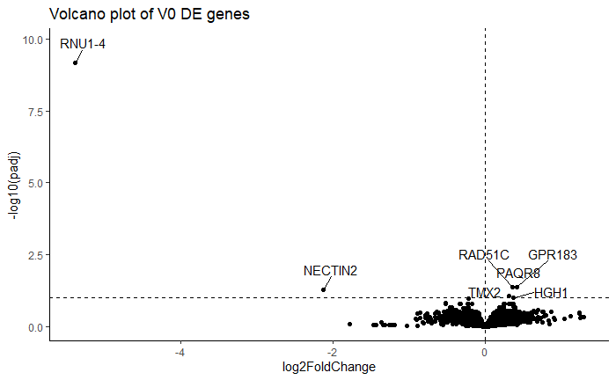
Sda

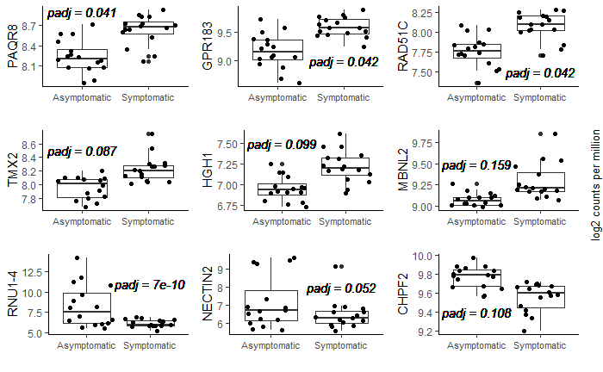
sad

PAQR8: Groh et al. (2022) find that progesterone receptor activates monocyte immunity trained by LDLs
GPR183: required for immune cell maturation through oxysterol chemotaxis in lymph nodes (Daugvilaite et al., 2014)
RAD51C: linked to poor ovarian cancer prognosis, no clear link with immune system (Lu et al., 2020)
NECTIN2: bound by inhibitory T cell receptor (Deuss et al., 2017)
RNU1-4: no clear function or useful references from GeneCards

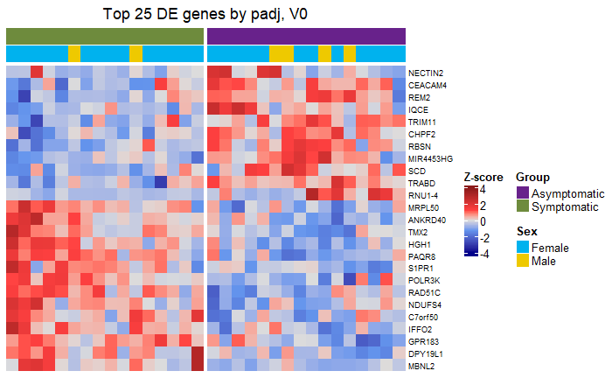
sadf

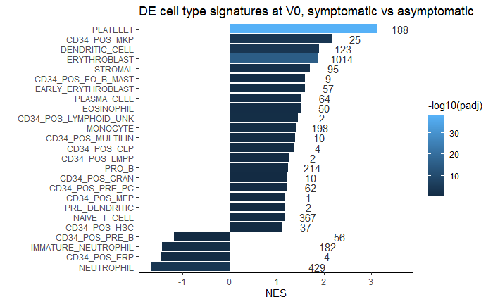
sadf

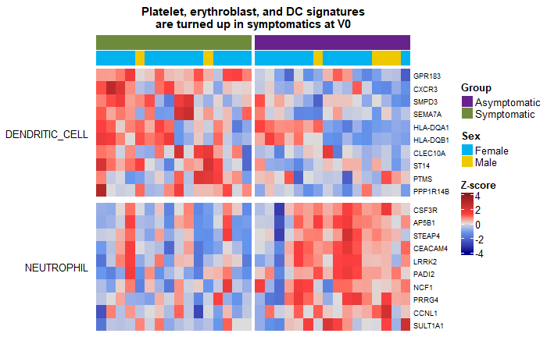
sadf

An increased dendritic cell signature in the symptomatic group is found by FGSEA using both MSigDB and BTMs. Takano et al. (2020) found that NK and dendritic cell migration occurs in the first day after Pfizer vaccination and correlates with local and systemic adverse events, suggesting that the increased BTM signature in this study may be predictive of this migration in the symptomatic group. V2 samples were collected 28 days after the second dose, and the increased blood NK signature suggests that these cells migrate back into the blood in the symptomatic group. PLATELETS???

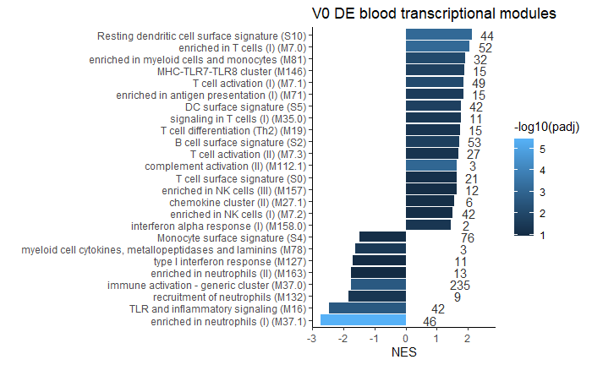
sadf

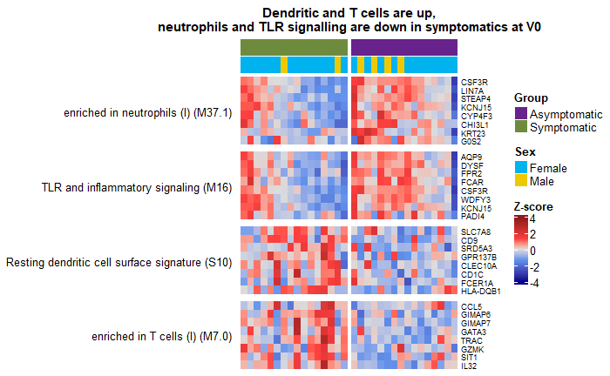
sadf
TLR SIGNALLING???

Summary
This study tentatively suggests that, after the second dose, individuals with strong adverse reactions to the Pfizer COVID vaccine have reduced blood RNAseq signatures of NK cells (possibly with reduced activity via CNOT7 underexpression and stronger TNFa singalling) and a significantly lower blood B cell count (possibly due to migration into the lymph for maturation). There is evidence that early NK and dendritic cell migration to the site of inflammation correlates with symptom severity, suggesting that the increased signature reflects NK cell return to the blood, although this is not seen in flow cytometry data. Prior to vaccination, these individuals have increased signatures of dendritic and T cells, suggesting higher baseline activity, and a reduced neutrophil signature. They also underexpress RNU1-4, a small RNA with no known function.

