**Written report**

**Hyperparameter Configurations Tested**

Learning Rate: [0.001, 0.0005]

Regularization Strength (L2): [0.0001, 0.001]

Hidden Units: [128, 256]

**Model Architecture and Setup**

The autoencoder model used a three-layer configuration:

Encoding Layer: Rectified Linear Unit (ReLU) activation

Central Layer: Rectified Linear Unit (ReLU) activation

Decoding Layer: Rectified Linear Unit (ReLU) activation, with a final output layer using a Sigmoid activation for pixel-wise outputs between 0 and 1.

Loss Function: Binary Cross-Entropy, chosen to improve the quality of binary reconstruction.

**The result:  
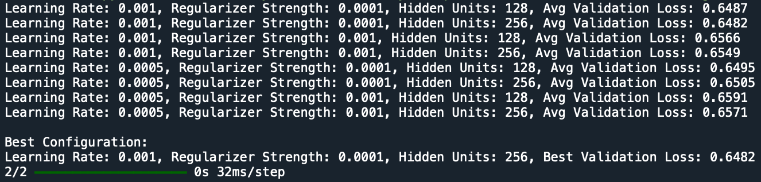**

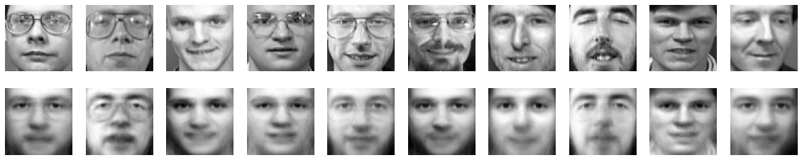

**Optimal Configuration**

The best-performing configuration was:

Learning Rate: 0.001

Regularizer Strength: 0.0001

Hidden Units: 256

Average Validation Loss: 0.6482

**Analysis of Activation Functions and Loss Function**

The ReLU activation in the encoding and central layers effectively captured the dataset’s facial structure features, as ReLU introduces non-linearity and helps the model focus on salient patterns. In the output layer, Sigmoid restricted pixel values to [0,1], essential for pixel intensity data. This combination supports the model’s objective to reconstruct grayscale images with normalized pixel values.

The Binary Cross-Entropy (BCE) loss function provided appropriate guidance for reconstructing binary-like images, where each pixel represents a binary class between dark (0) and light (1). This selection supported precise reconstruction of features and enhanced performance on this grayscale dataset. Lower regularization strengths performed slightly better meaning that flexibility in representing subtle facial variations was beneficial.

**Conclusion**

The hyperparameter tuning process revealed that higher hidden units (256) in the encoding and decoding layers, a learning rate of 0.001, and a minimal regularizer strength of 0.0001 yielded the lowest validation loss. The reconstruction quality of the model is visually good. The reconstructions preserve key facial features and contours which indicates that the autoencoder effectively learned to capture and reproduce the structural details of the original faces. The results reflect a strong model performance, with minimal blur and accurate feature representation.