● FLEET переименовать MANAGED FLEET
============
● Вместо Commercial & technical ship management вставить Greek Branch Representative
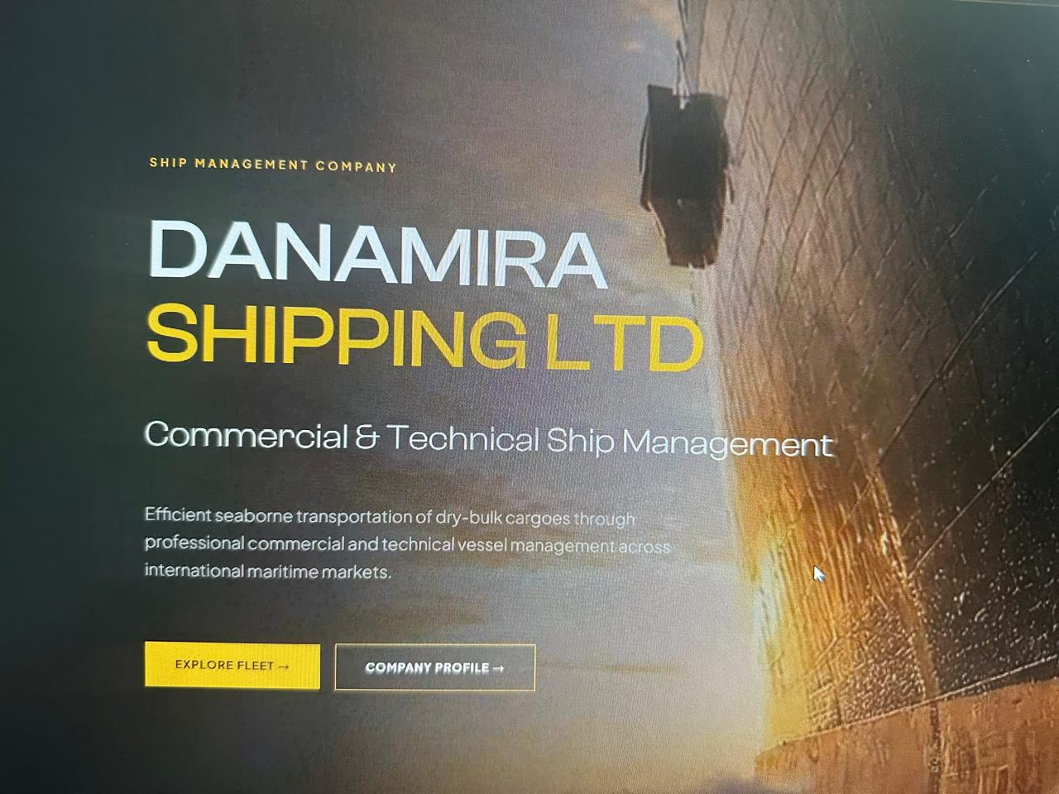

● Вместо Build your maritime career вставить MARITIME CAREERS, а сверху убрать Careers.
●
Shore-based  Join to Shore Team | Onboard  Join to Crew
Application details | Application details
CV / RESUME  Upload CV or professional profile | CV / RESUME  Upload CV or professional profile
COVER LETTER  Describe the motivation and interest in the position | COVER LETTER  Describe the motivation and interest in the position
ADDITIONAL DOCUMENTS  Diplomas, Certificates, supporting documents | ADDITIONAL DOCUMENTS  Diplomas, Certificates, Supporting documents

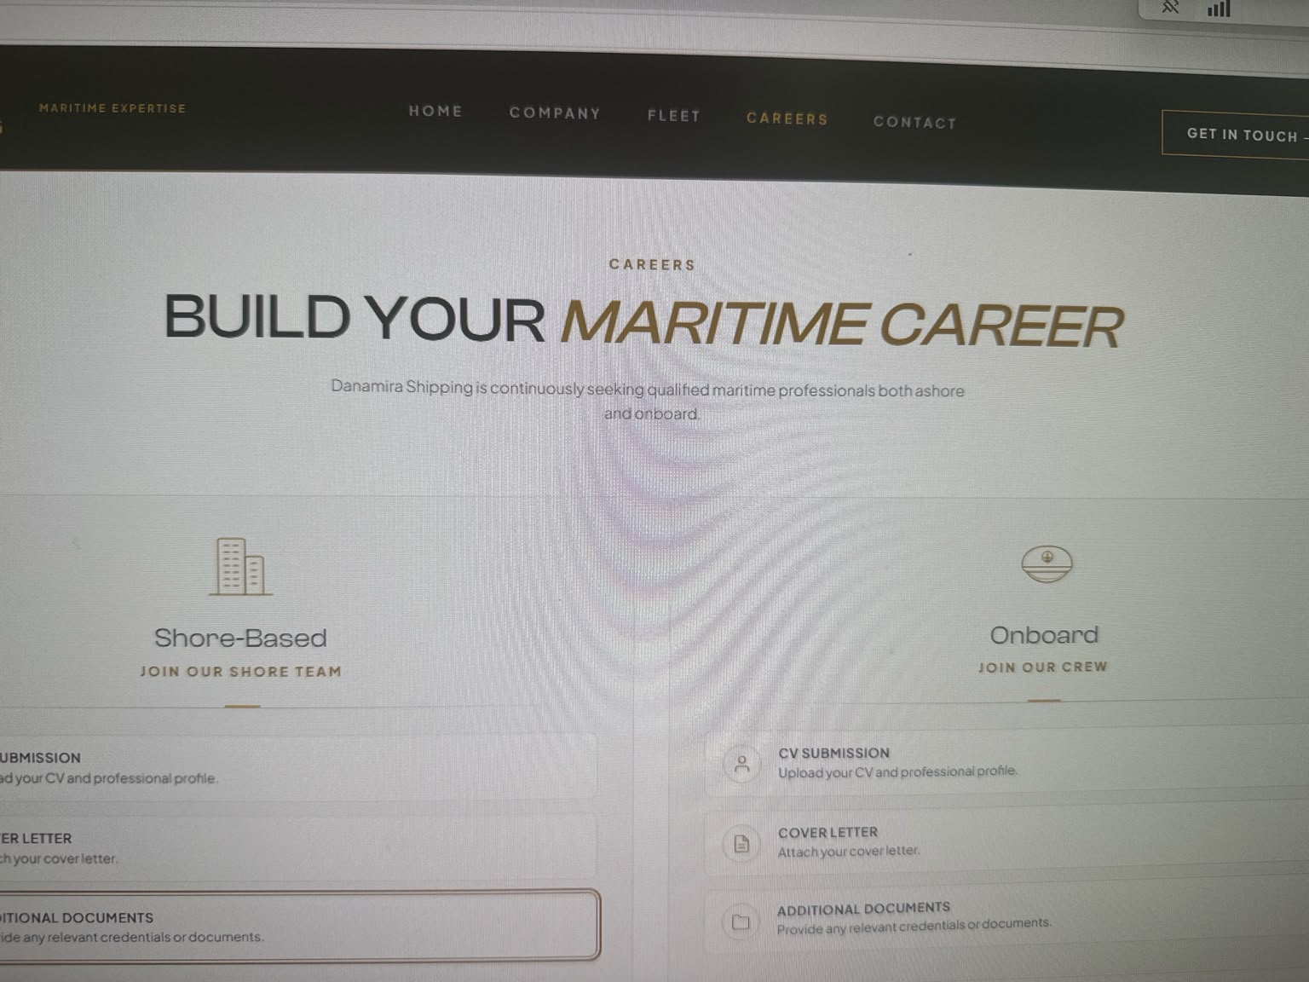

● Вместо Get in touch написать Contact Details
● Вместо Lets discuss your maritime requirements написать MARITIME REQUIREMENTS
● Вместо Our team is ready to support……так далее > написать For enquiries regarding commercial management, sale & purchase, chartering, vessel operations, technical, ISM and safety management.
● С правой стороны где пишется send inquiry > укажите номер телефона TELEPHONE
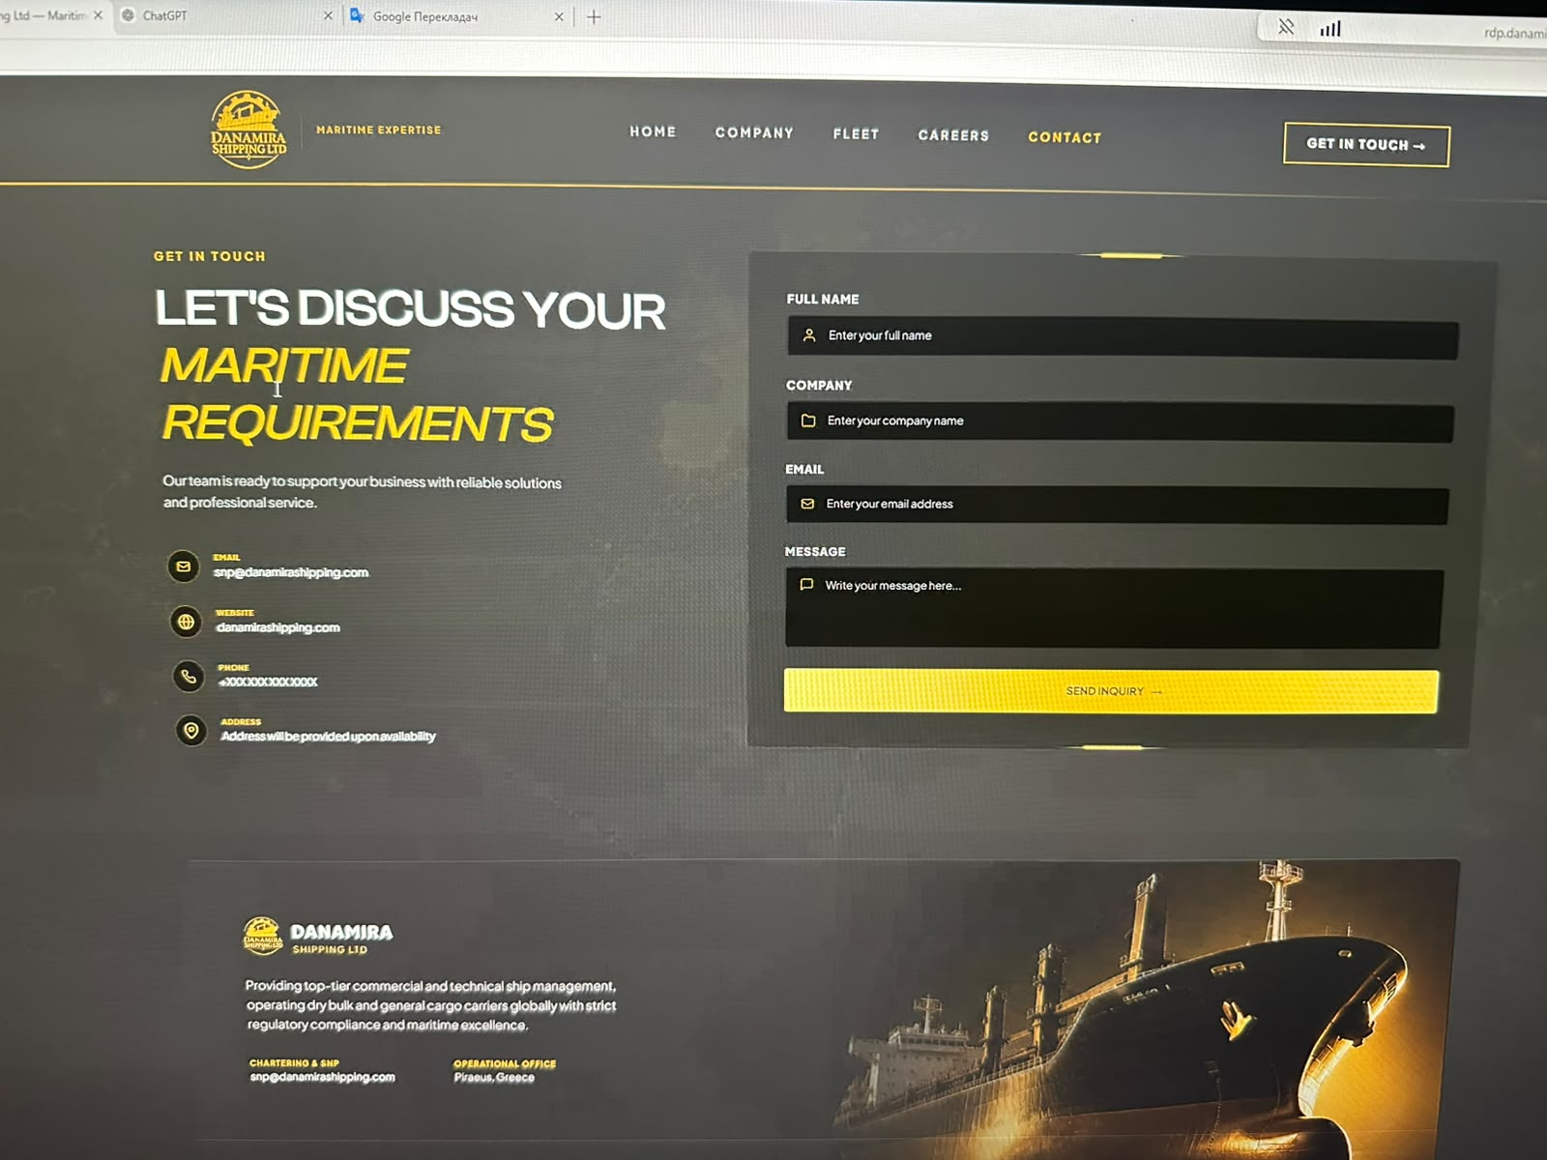
Перестановка

Email:
greece@danamira-shipping.com

Telephone:
+ 30 211 34 56 550
+ 30 211 34 56 555

Website:
www.danamira-shipping.com

Address:
Zeppou 33, 166 75, Glyfada, Greece
МНЕ НУЖНО ПОКАЗАТЬ GOOGLE NAVIGATION MAP

=======
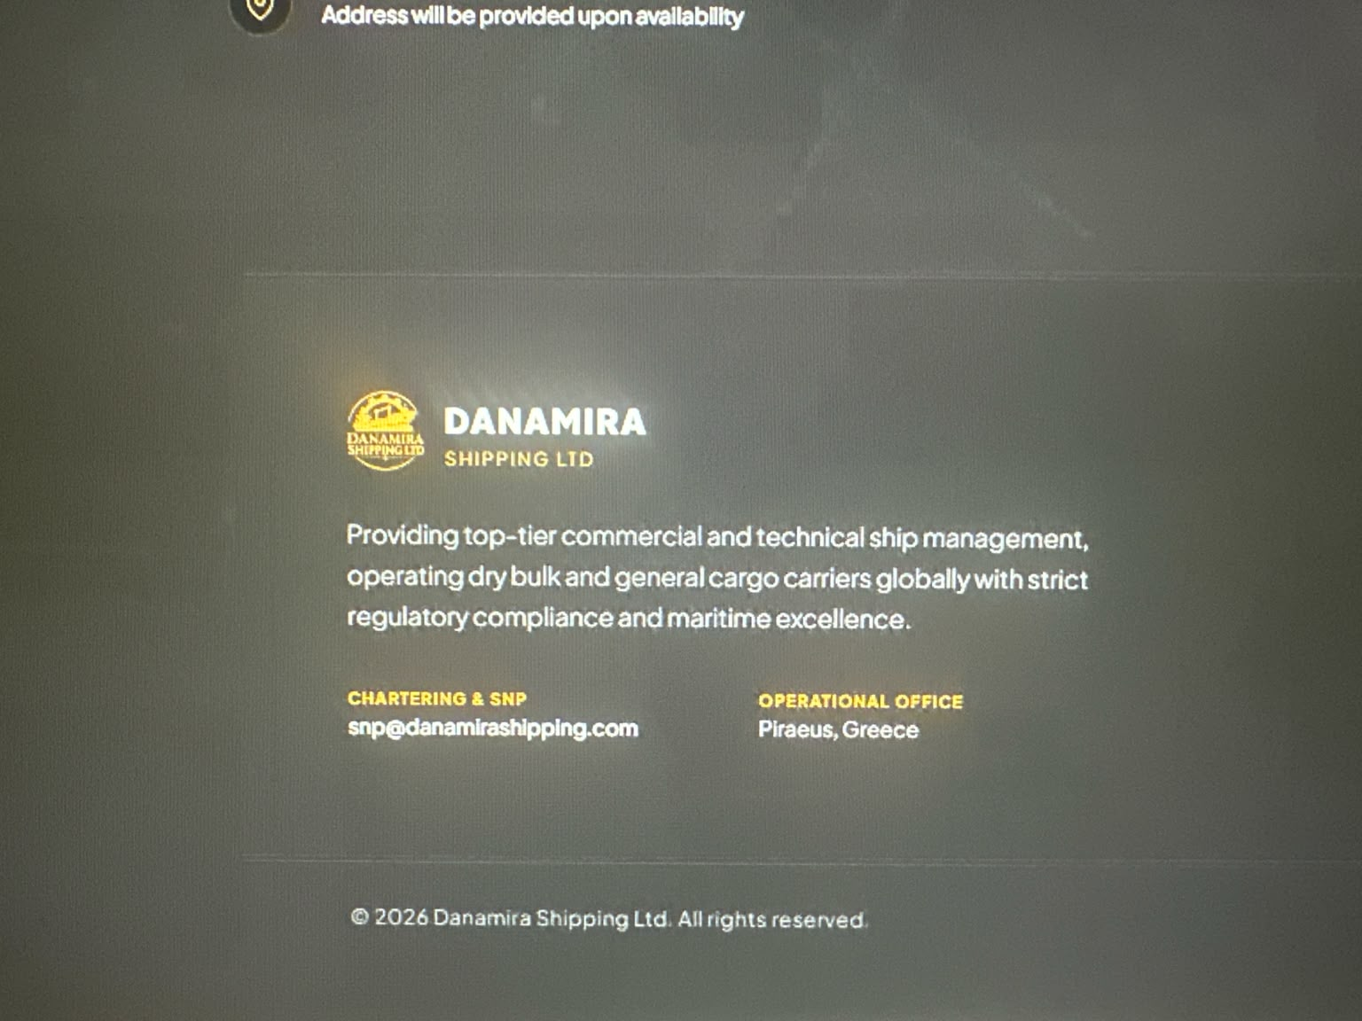

● Название белыми буквами DANAMIRA SHIPPING LTD
● Provides integrated ship management services covering commercial management, sale & purchase, chartering, vessel operations, technical, ISM and safety management and financial & accounting support.

● Email
greece@danamira-shipping.com

Office
Zeppou 33, 166 75, Glyfada, Greece

