+

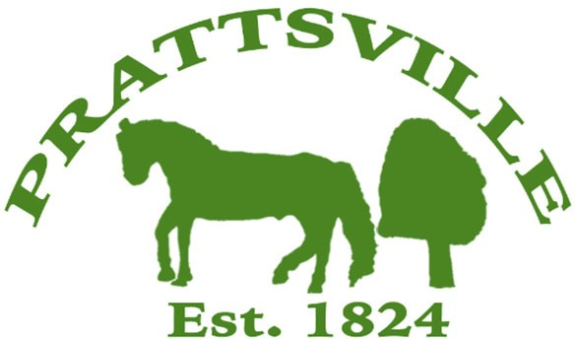
Town of Prattsville Board Agenda
Regular Monthly Meeting
July 14th, 2025

- CALL MEETING TO ORDER
  - Pledge of Allegiance
  - Roll Call
- APPROVAL OF CLERK'S MINUTES
  - Regular Meeting – June 9th, 2025

- APPROVAL OF MONTHLY FINANCIAL REPORT
- COMMENTS FROM THE FLOOR / CORRESPONDENCE FROM THE COMMUNITY

Reports
- Highway
- Water District Report
- Code Enforcement Monthly Report
- WWTP Report
- Tax Collector Report
- Water billing report
- Pratt Rock

New Business

- Zadock Pratt Museum
- Mountain Top Coalition
- Knotweed
- UTV law
- Town Use Form
- Pratt Rock Contract & Resolution

