**ENSF-381**: **Full Stack Web Development Laboratory**

**Lab01**

**Section: L02**

**Group information:**

Eric Tourigny (30215666)

Spiian, Artem (10192898)

**Exercise 1 Output:**

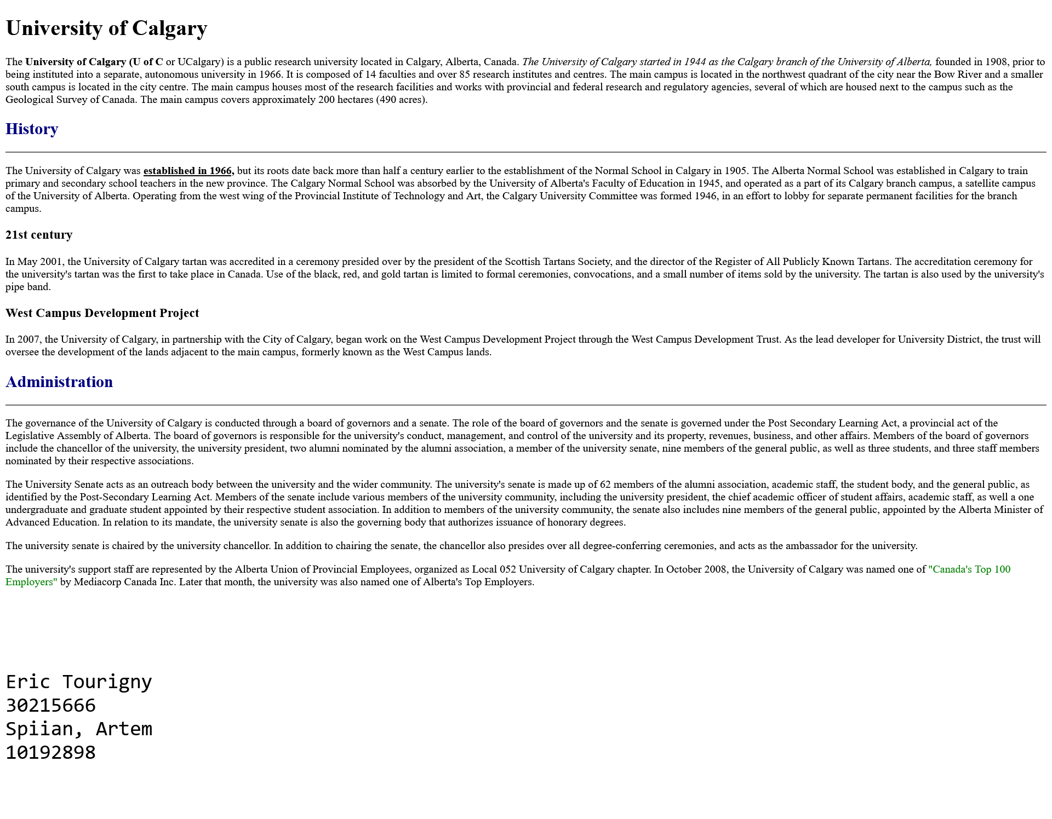

**Exercise 2 Answer:**

1. **The HTML element used for “Faculties” is: div**
2. **Screenshot:**

