**ENSF-381**: **Full Stack Web Development Laboratory**

**Lab03**

**Section: L03**

**Group information:**

Eric Tourigny (30215666)

Spiian, Artem (10192898)

**GitHub Link:**

**Exercise 1 Output:**

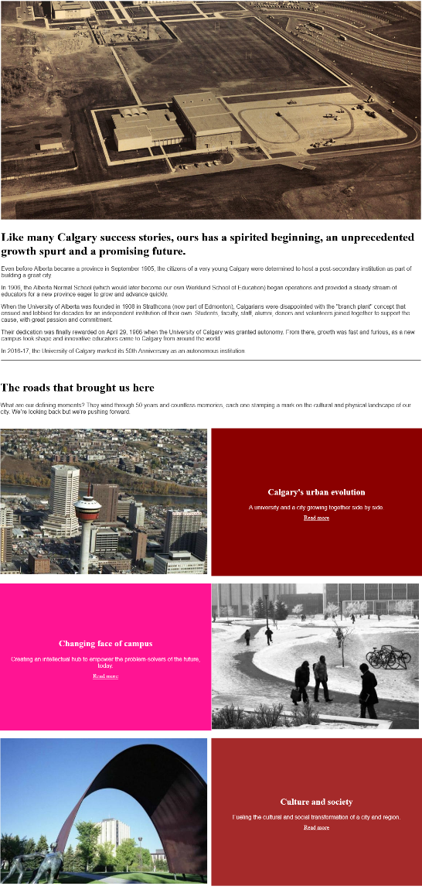

**Exercise 2 Output:**

**Original Layout**

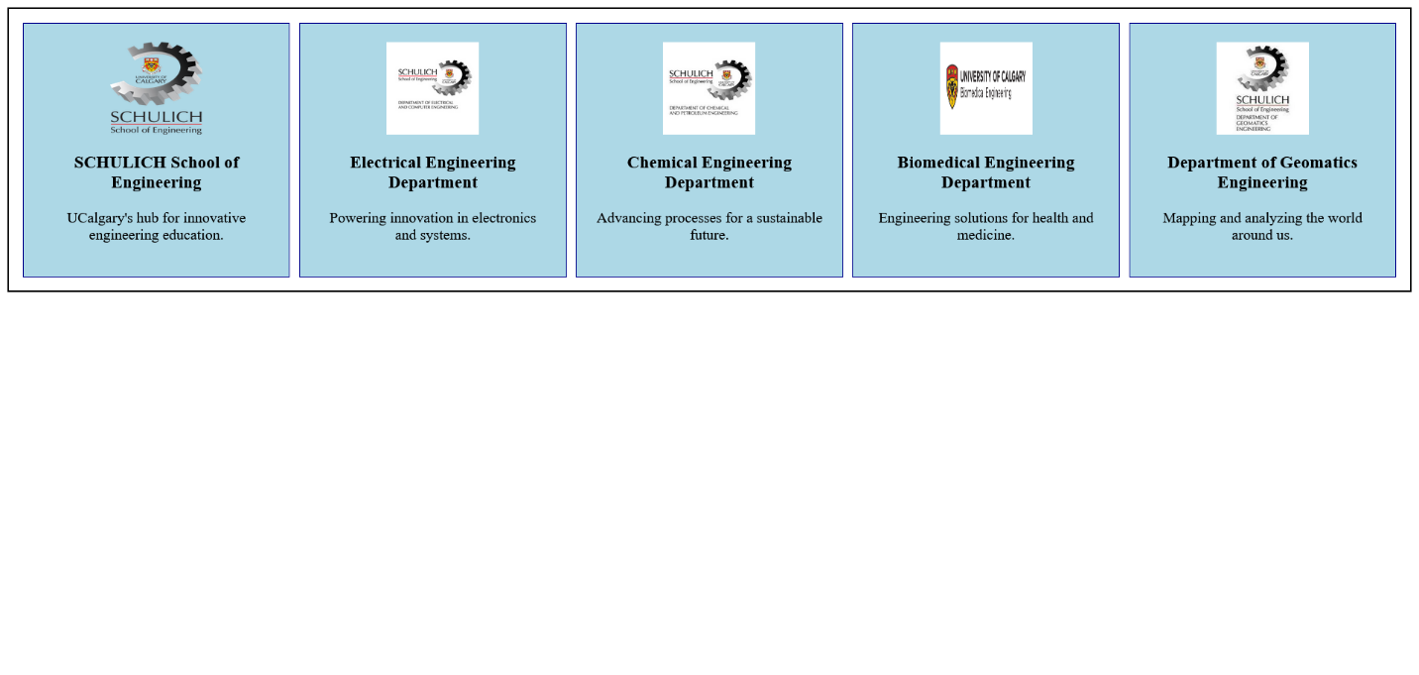

**Flex Direction Column**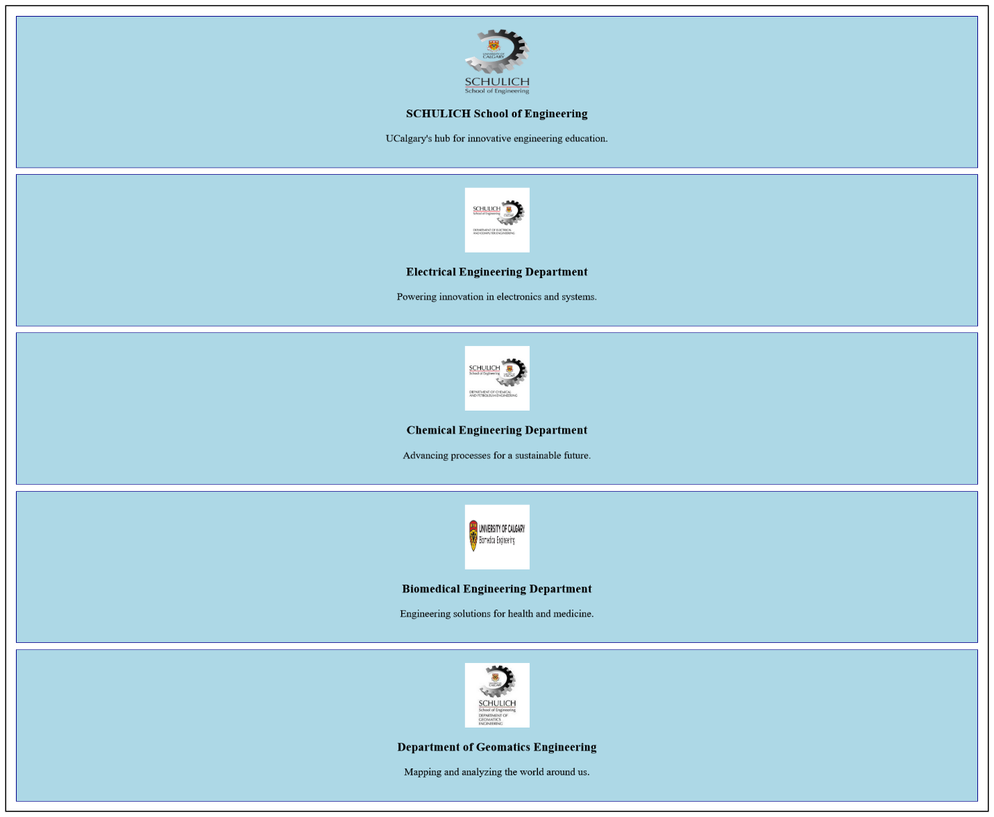

**Flex Direction Row Reverse**

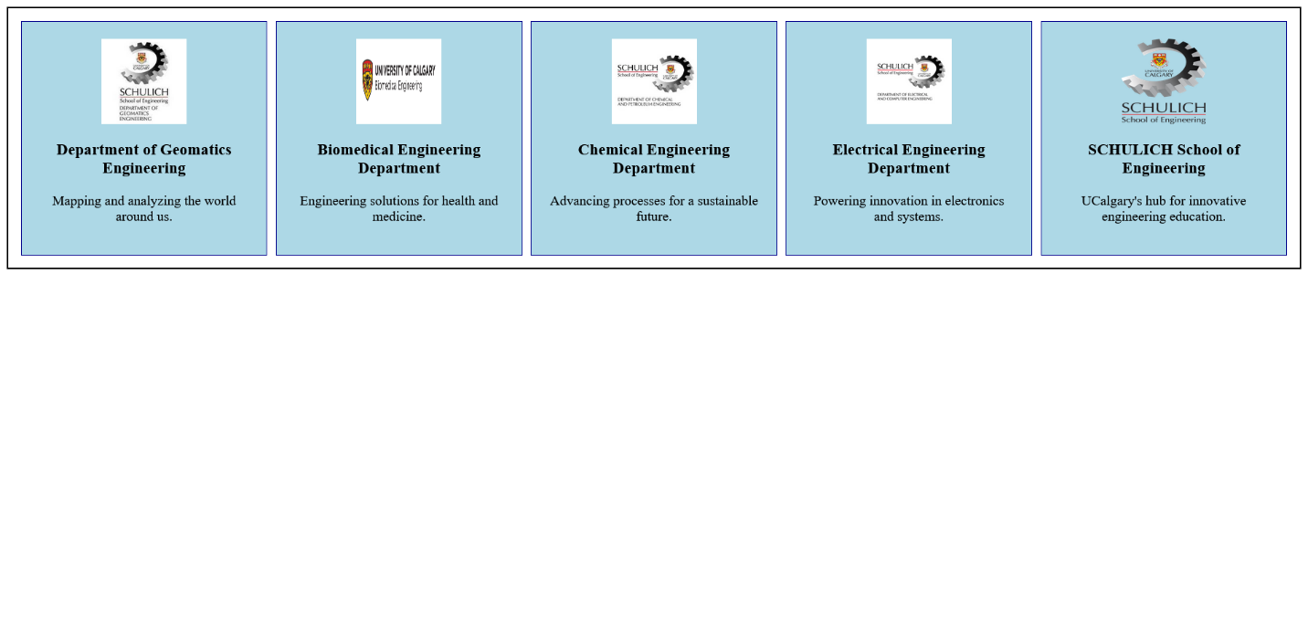

**Flex Direction Column Reverse**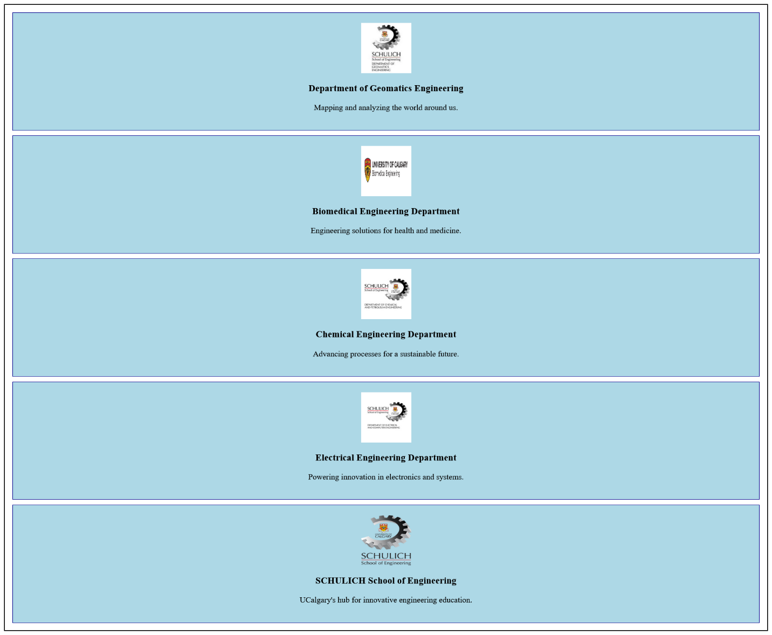

**Wrap Not Enough Space  
**

**Wrap Reverse**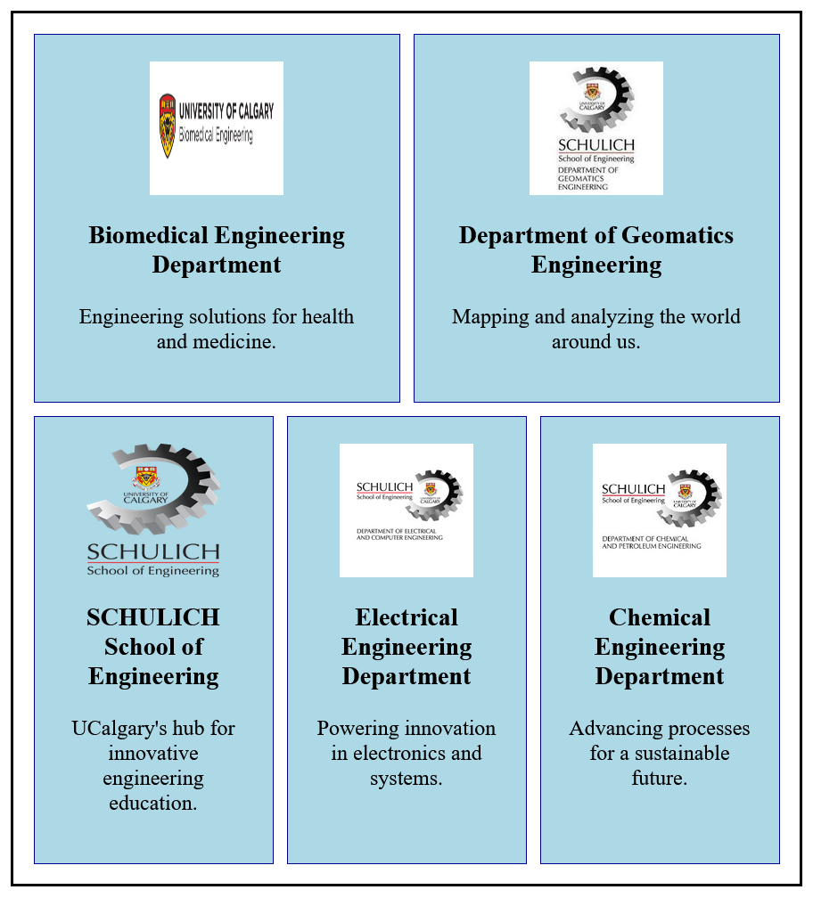

**Ordered** 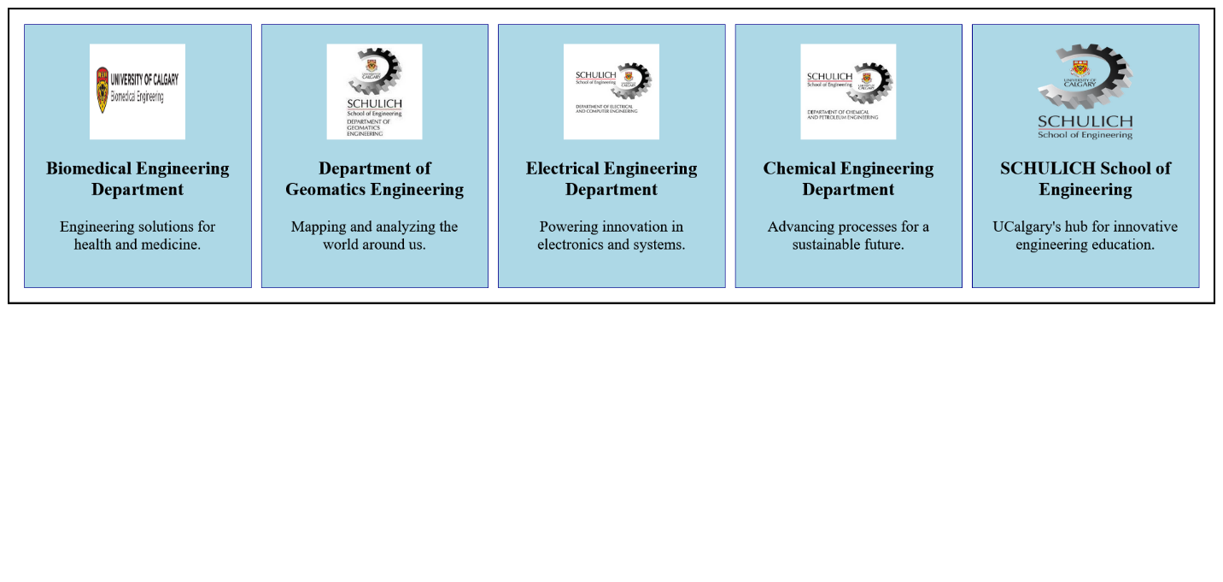

**Exercise 3 Output:**