Assignment No. 1
Write a program non-recursive and recursive program to calculate Fibonacci numbers and analyze their time and space complexity.

Input:
Non-recursive Fibonacci
nterms = int(input("How many terms? "))
n1, n2 = 0, 1
count = 0
if nterms <= 0:
print("Please enter a positive integer")
else:
print("Non-recursive Fibonacci sequence:")
while count < nterms:
print(n1, end=" ")
nth = n1 + n2
n1 = n2
n2 = nth
count += 1
print()
Recursive Fibonacci
def fibonacci(n):
if n <= 1:
return n
return fibonacci(n - 1) + fibonacci(n - 2)
if nterms > 0:
print("Recursive Fibonacci sequence:")
for i in range(nterms):
print(fibonacci(i), end=" ")
print()
print("Non-recursive: Time O(n), Space O(1)")
print("Recursive: Time O(2^n), Space O(n)")

Output:

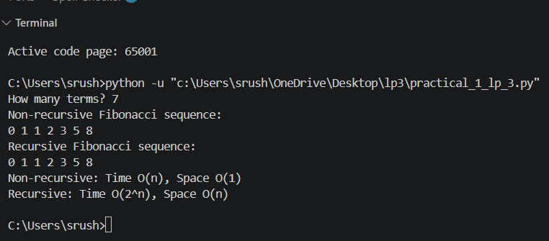
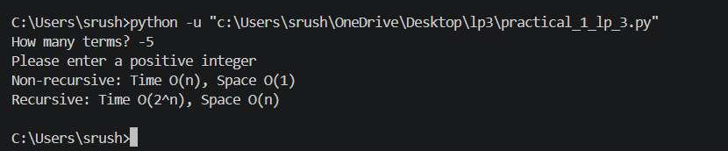
Assignment No. 2

Write a program to implement Huffman Encoding using a greedy strategy.
import heapq

Input:
class Node:
def __init__(self, freq, char=None, left=None, right=None):
self.freq = freq
self.char = char
self.left = left
self.right = right
def __lt__(self, other):
return self.freq < other.freq
def generate_codes(node, code="", huffman_code={}):
if node is None:
return
if node.char is not None:
huffman_code[node.char] = code
generate_codes(node.left, code + "0", huffman_code)
generate_codes(node.right, code + "1", huffman_code)
return huffman_code
chars = {
'A': 5,
'B': 9,
'C': 12,
'D': 13,
'E': 16,
'F': 45
}
heap = []

for char, freq in chars.items():
heapq.heappush(heap, Node(freq, char))
while len(heap) > 1:
left = heapq.heappop(heap)
right = heapq.heappop(heap)

merged = Node(left.freq + right.freq, left=left, right=right)
heapq.heappush(heap, merged)
root = heap[0]
codes = generate_codes(root)
print("Huffman Codes")
print("---------------------------")

for char in sorted(codes):
print(char, ":", codes[char])
total_frequency = sum(chars.values())
total_bits = 0
print("\nEncoded Length of Each Character")
print("----------------------------------")

for char in sorted(chars):
code_length = len(codes[char])
bits = chars[char] * code_length
total_bits += bits
print(char,
"Frequency =", chars[char],
"Code =", codes[char],
"Bits =", bits)
average_code_length = total_bits / total_frequency
print("\nTotal Frequency =", total_frequency)
print("Average Code Length =", round(average_code_length, 2), "bits")
print("Total Huffman Encoded Message Length =", total_bits, "bits")

Output:

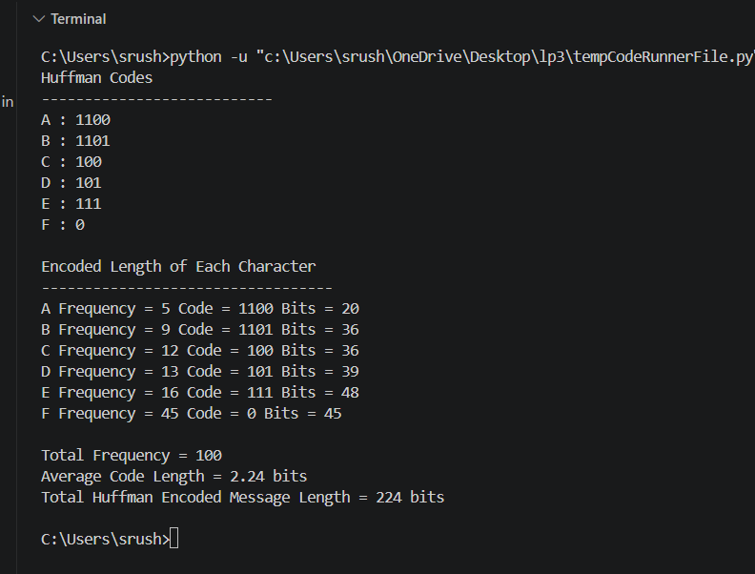

Assignment No.3

Write a program to solve a fractional Knapsack problem using a greedy method.

Input:

def fractional_knapsack(profit, weight, capacity):
n = len(profit)
items = []
for i in range(n):
ratio = profit[i] / weight[i]
items.append((ratio, profit[i], weight[i]))
items.sort(reverse=True)
total_profit = 0.0
for ratio, p, w in items:
if capacity >= w:
total_profit += p
capacity -= w
else:
total_profit += ratio * capacity
break
return total_profit
n = int(input("Enter number of items: "))
profit = []
weight = []
for i in range(n):
p, w = map(float, input(
f"Enter profit and weight of item {i + 1}: "
).split())
profit.append(p)
weight.append(w)
capacity = float(input("Enter knapsack capacity: "))
max_profit = fractional_knapsack(profit, weight, capacity)
print(f"Maximum profit = {max_profit:.2f}")

Output:

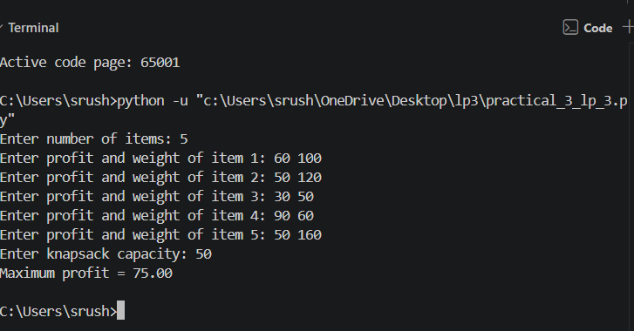

Assignment No. 4

Write a program to solve a 0-1 Knapsack problem using dynamic programming or branch and bound strategy.

Input:

def knapSack(W, wt, val, n):
dp = [0 for i in range(W + 1)]
for i in range(1, n + 1):
for w in range(W, 0, -1):
if wt[i - 1] <= w:
dp[w] = max(
dp[w],
dp[w - wt[i - 1]] + val[i - 1]
)

return dp[W]
n = int(input("Enter number of items: "))
val = list(map(int, input("Enter profits: ").split()))
wt = list(map(int, input("Enter weights: ").split()))
W = int(input("Enter knapsack capacity: "))
if len(val) != n or len(wt) != n:
print("Error: Enter exactly", n, "profits and weights.")
elif W < 0 or any(w <= 0 for w in wt):
print("Error: Capacity must be non-negative and weights must be positive.")
else:
print("Maximum profit =", knapSack(W, wt, val, n))

Output:

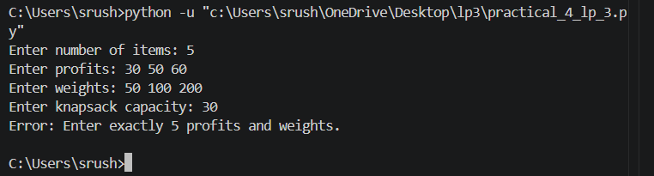

Assignment No. 5

Design n-Queens matrix having first Queen placed. Use backtracking to place remaining Queens to generate the final n-queen’s matrix.

Input:

class NQueens:
def __init__(self) -> None:
self.size = int(input("Enter size of chessboard: "))
self.board = [[False]*self.size for _ in range(self.size)]
self.count = 0
def printBoard(self):
for row in self.board:
for ele in row:
if ele == True:
print("Q",end=" ")
else:
print("X",end=" ")
print()
print()
def isSafe(self,row:int,col:int) -> bool:
for i in self.board:
if i[col] == True:
return False
i = row
j = col
while i >= 0 and j >= 0:
if self.board[i][j] == True:
return False
i -= 1
j -= 1
i = row
j = col
while i < self.size and j < self.size:
if self.board[i][j] == True:
return False
i += 1
j += 1
i = row
j = col
while i >= 0 and j < self.size:
if self.board[i][j] == True:
return False
i -= 1
j += 1
i = row
j = col
while i < self.size and j >= 0:
if self.board[i][j] == True:
return False
i += 1
j -= 1
return True
def set_position_first_queen(self):
print("Enter coordinates of first queen: ")
row = int(input(f"Enter row (1-{self.size}): "))
col = int(input(f"Enter column (1-{self.size}): "))
self.board[row-1][col-1] = True
self.printBoard()
def solve(self,row:int):
if row == self.size:
self.count += 1
self.printBoard()
return
if any(self.board[row]) is True:
self.solve(row+1)
return

for col in range(self.size):
if self.isSafe(row,col) == True:
self.board[row][col] = True
self.solve(row+1)
self.board[row][col] = False
def displayMessage(self):
if self.count > 0:
print("Solution exists for the given position of the queen.")
else:
print("Solution doesn't exist for the given position of the queen.")
solver = NQueens()
solver.set_position_first_queen()
solver.solve(0)
solver.displayMessage()

Output:



