ANALOGUE DIAL READER · FEATURES GUIDE
Gauge Digitizer
Point a camera at an ordinary dial gauge (a pressure gauge, a thermometer, a tyre gauge) and Gauge Digitizer reads the needle and turns it into a number. It also tells you whether that number is safe, getting close to a limit, or out of range, and keeps a record of every reading.
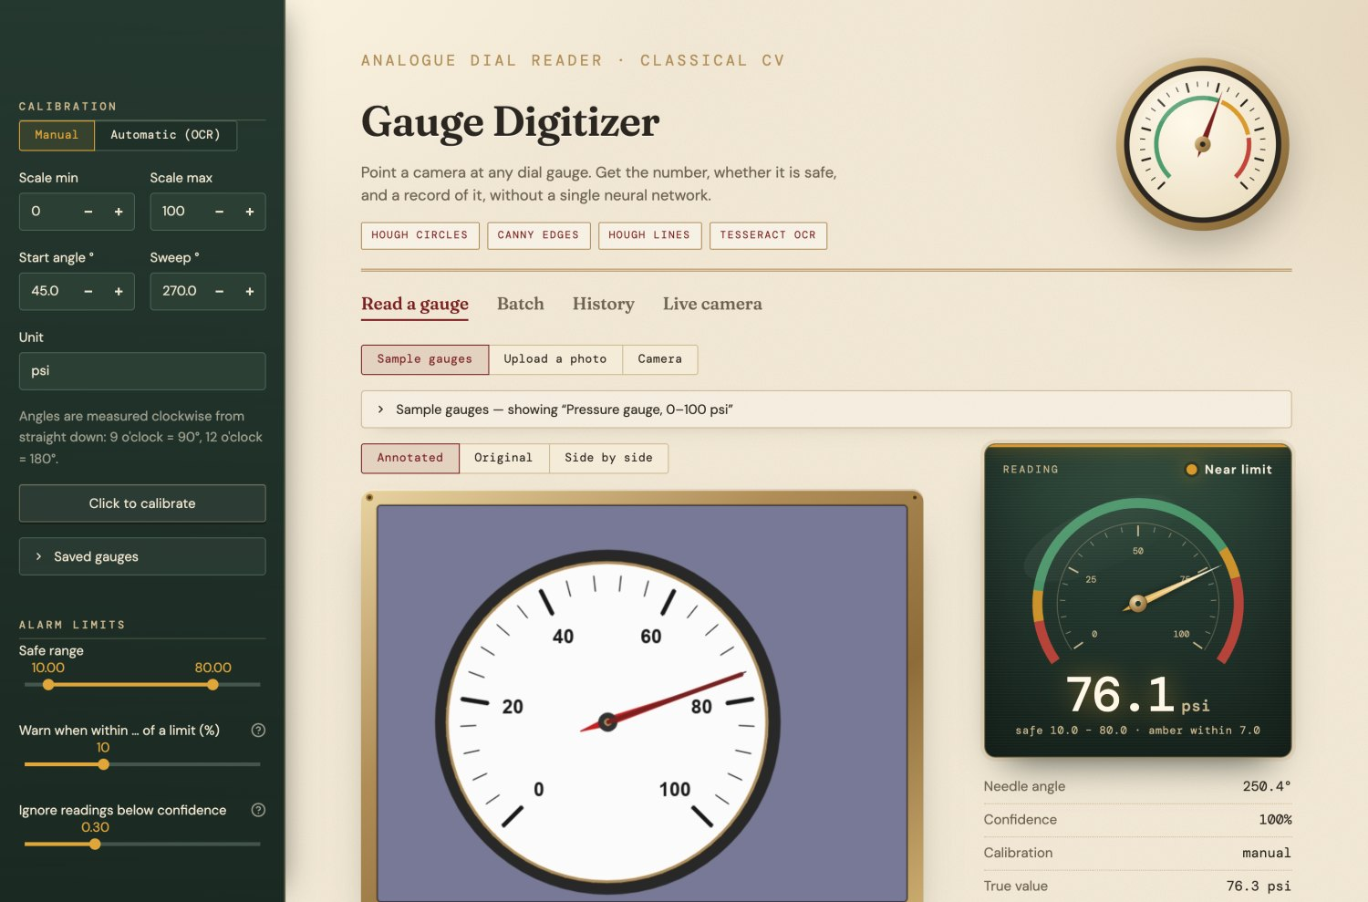
The main screen: your gauge in its brass frame, the reading on the right, and settings in the dark sidebar.
IN THIS GUIDE
1. Reading a gauge: samples, your own photo, your camera
2. The readout: what the number, the lamp and the dial mean
3. Calibration: telling the app about your gauge's scale
4. Alarm limits: green, amber and red
5. Extras: how it was read, the result card, batch, history, live camera, phones
6. Tips, limitations, and how it works

SECTION 1

Reading a gauge
Everything starts on the Read a gauge page. Pick where the picture comes from with the three small buttons under the page tabs: Sample gauges, Upload a photo or Camera.

Try a sample gauge
No gauge to hand? The app comes with 18 built-in examples: six drawn by the computer (with a known exact answer) and twelve real photos from Wikimedia Commons.
- Make sure Sample gauges is selected.
- Open the bar that says Sample gauges — showing ….
- Press Read this gauge under any picture. The app loads the gauge and its scale settings for you.
- Compare the reading with the True value line under the readout: it shows the right answer and how far off the app was.
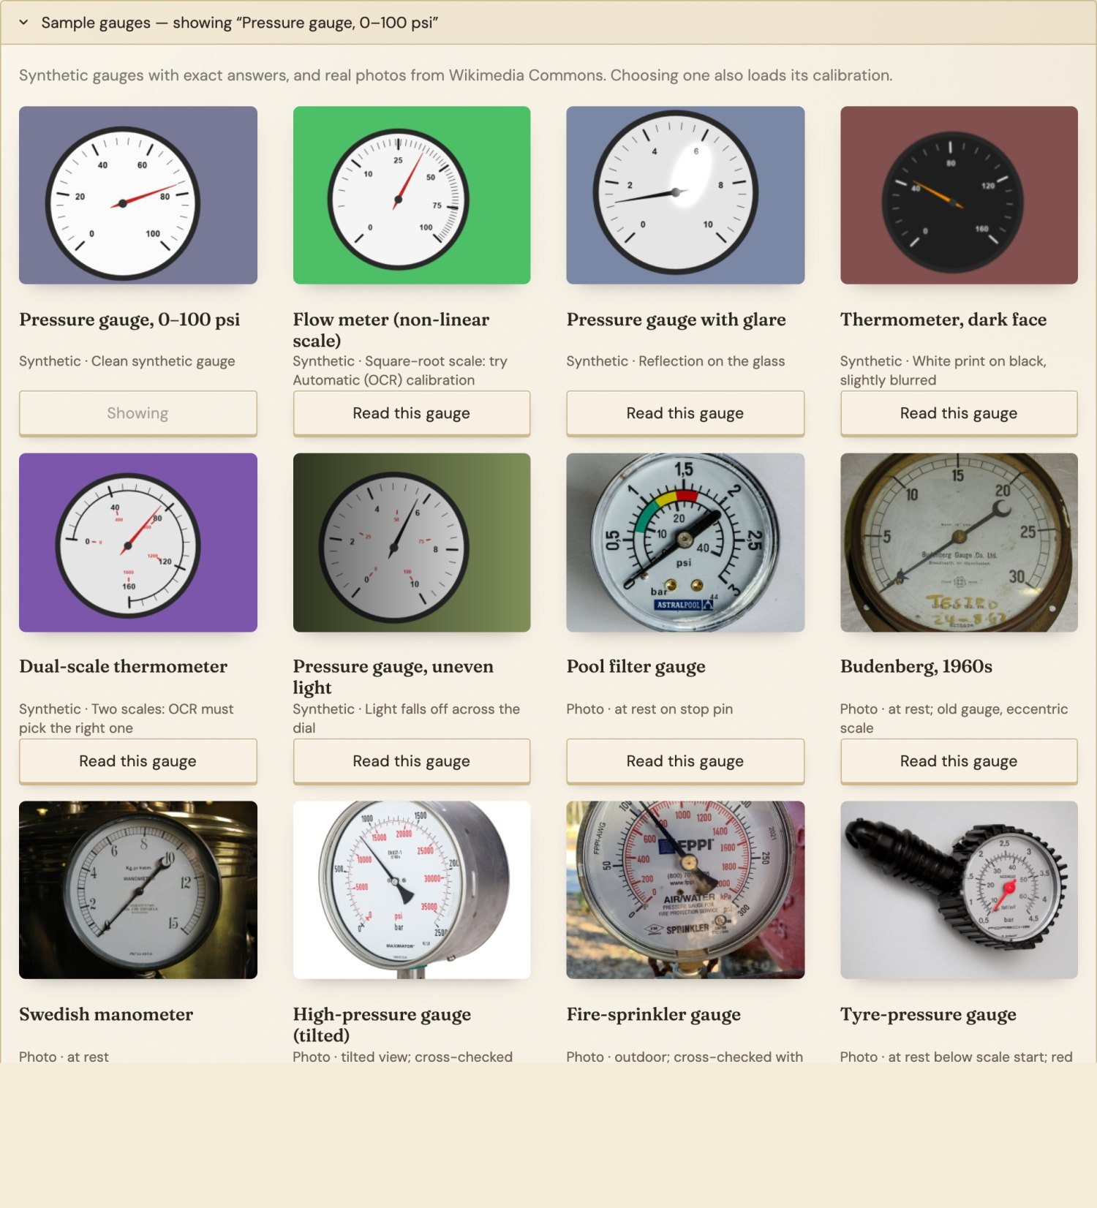
The sample gallery. The note under each picture says what makes it interesting.

Upload a photo
- Choose Upload a photo and press Upload (or drag a picture onto the box). JPG, PNG and WEBP all work.
- Tell the app about the gauge's scale in the sidebar: Scale min, Scale max and Unit. If the first and last numbers aren't at the usual places, set the angles too (see Calibration, below).
- The reading appears straight away and updates whenever you change a setting.
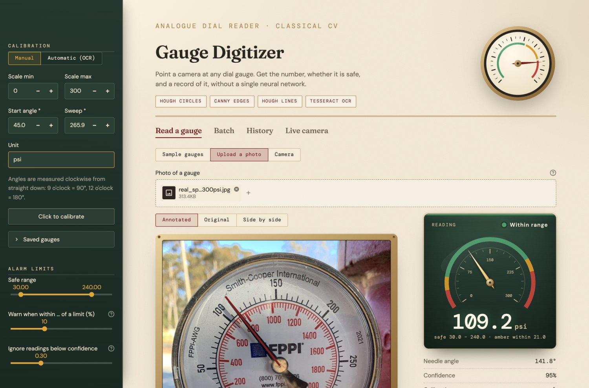
A real fire-sprinkler gauge: the app reads 109.2 psi; the needle is at 110.

Use your camera
- Choose Camera. Your browser asks for permission to use the camera the first time; allow it.
- Hold the phone or laptop so the gauge fills most of the picture and you are looking at it straight on.
- Press Take Photo. The photo is read exactly like an upload. To try again, press Clear photo and take another.
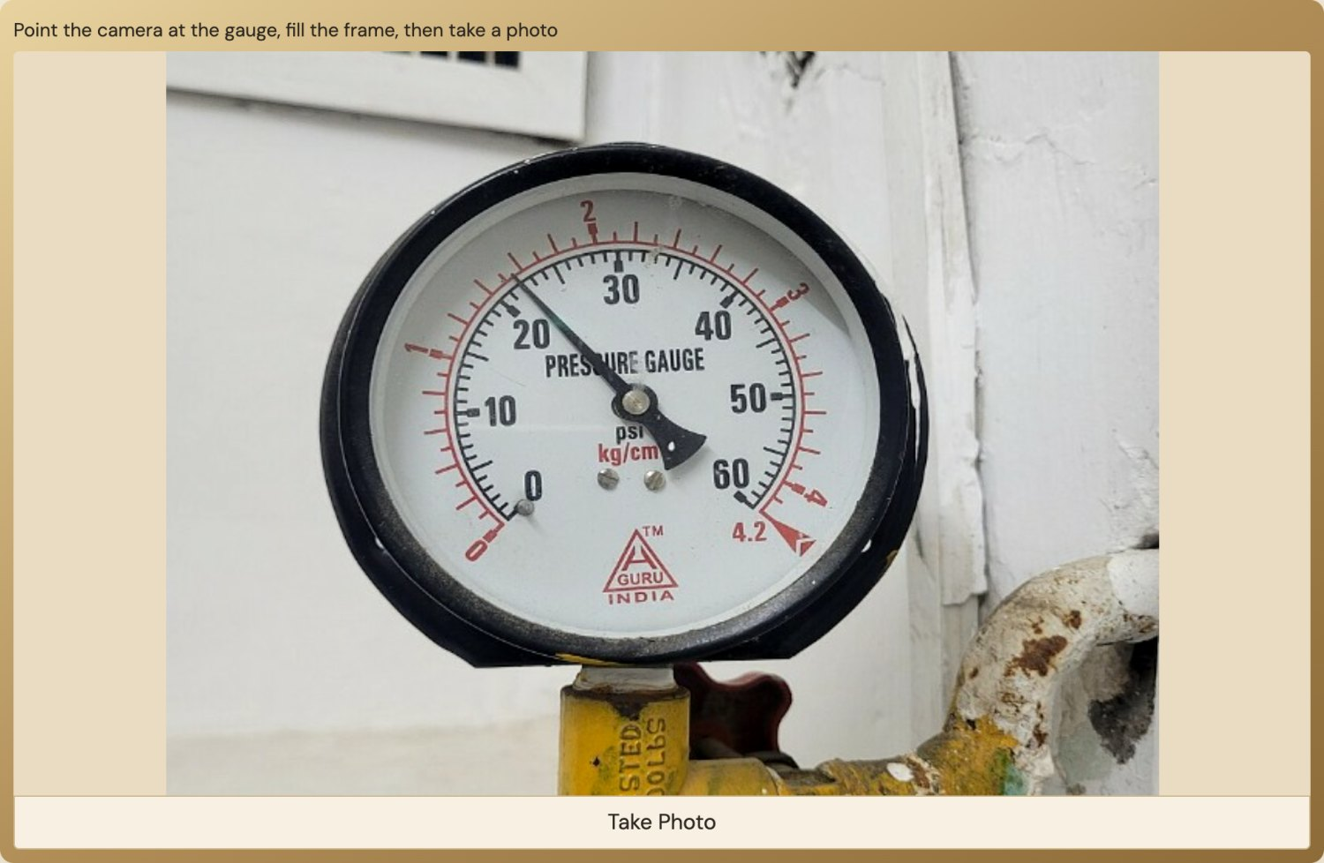  The camera view, with the gauge filling the frame. | 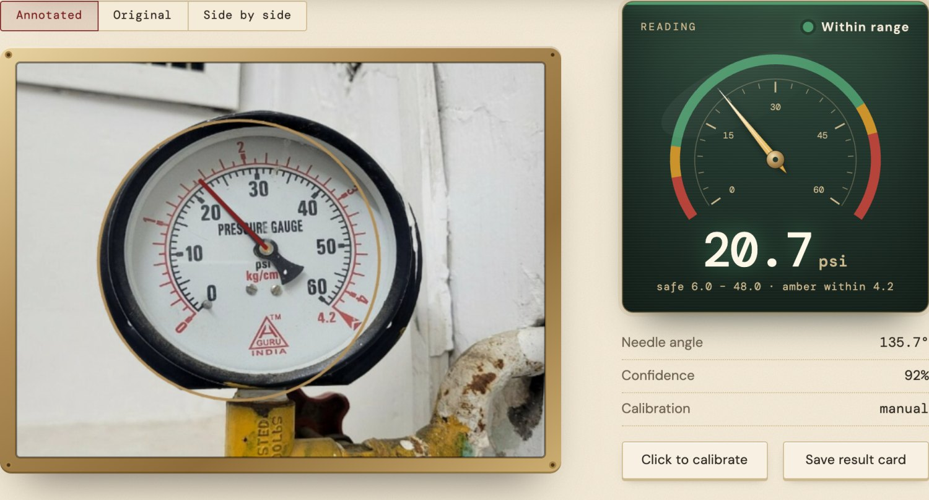  The reading from that photo: 20.7 psi (the needle is at about 22).
ONLINE OR ON YOUR OWN COMPUTER?
Camera takes a single photo. It works everywhere, including the online version and on phones.
Live camera (its own tab) reads continuously, many times a second. It only appears when the app is running on your own computer with a webcam, because an online server has no camera of its own.

Annotated, original, or side by side
Above the picture, choose Annotated to see what the app found, Original to see your photo untouched, or Side by side to compare them. On the annotated picture the brass circle is the dial the app found, the dot is the needle's pivot, and the red line is the needle as the app sees it. If the red line isn't on the needle, the reading can't be right.
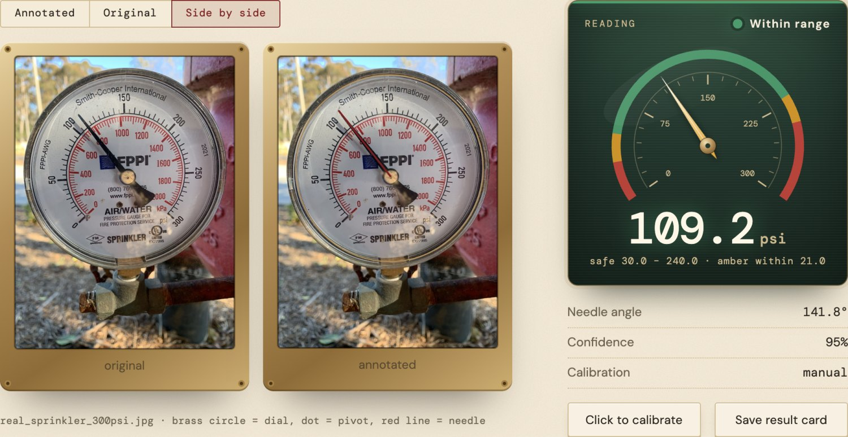
Side by side: your photo, and the same photo with the dial, pivot and needle marked.

SECTION 2

The readout
The dark green panel is the app's own instrument: a small dial that shows the reading, with the number in large digits underneath. When a new reading arrives, the needle swings to it and the digits count up, so you can see the change happen.
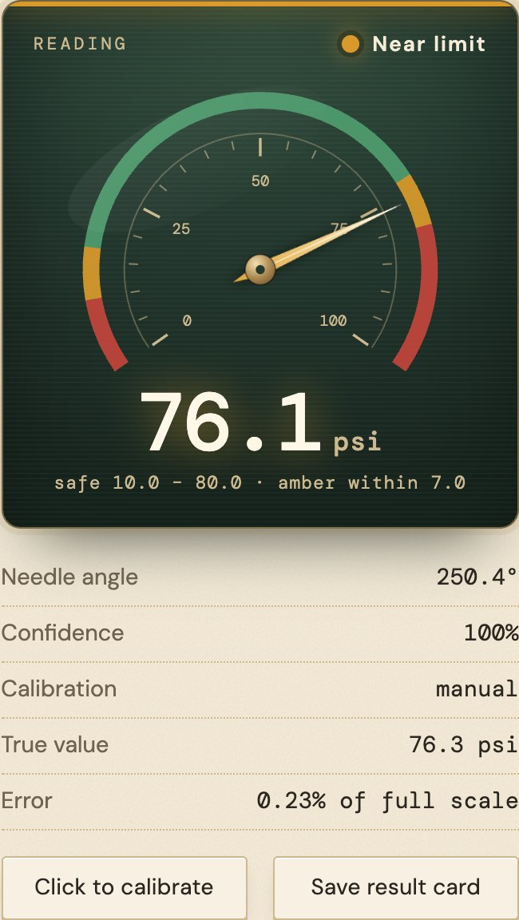
  Big number | The reading, in the unit you set. It counts up whenever the reading changes.
  Lamp | Green: inside the safe range. Amber: still safe but close to a limit (the lamp blinks faster). Red: outside the safe range (the whole panel pulses). Grey (Low confidence): the app isn't sure it found the needle, so it won't raise an alarm.
  Dial | Your gauge's whole scale, redrawn: the coloured ring shows the red, amber and green zones from your alarm limits, and the needle shows where the reading sits within them.
  Needle angle | Where the needle points, in degrees (see Calibration).
  Confidence | How clearly the needle stood out from everything else in the picture. 100% means there was no competing line.
  True value / Error | Only for sample gauges: the right answer, and how far off the app was.

SECTION 3

Calibration
The app measures where the needle points. To turn that into a number it needs to know the gauge's scale: the lowest and highest numbers, and where on the dial they are. That's calibration. Samples come already calibrated; for your own gauge, set it once and save it.

The calibration fields
Scale min / max | The first and last numbers printed on the scale, e.g. 0 and 100.
Start angle | Where the first number sits, in degrees, counted clockwise from straight down: 6 o'clock = 0°, 9 o'clock = 90°, 12 o'clock = 180°, 3 o'clock = 270°. Most gauges start at about 45° (between 6 and 9 o'clock).
Sweep | How far round the scale goes from the first number to the last. Most gauges: about 270° (three-quarters of a circle).
Unit | Just a label for the display: psi, bar, °C …

Not sure about the angles? Turn on Angle grid on the image under Display in the sidebar: spokes every 10° appear on the picture, so you can read the angle of the first and last numbers straight off it. Or let the app work them out for you, as below.

Click to calibrate
The easiest way to set the angles: click on the gauge itself.
- Type the Scale min and Scale max values in the sidebar.
- Press Click to calibrate (under the readout, or in the sidebar).
- Click the first tick of the scale (where the lowest number is).
- Click the last tick (where the highest number is). The start angle and sweep are filled in for you.
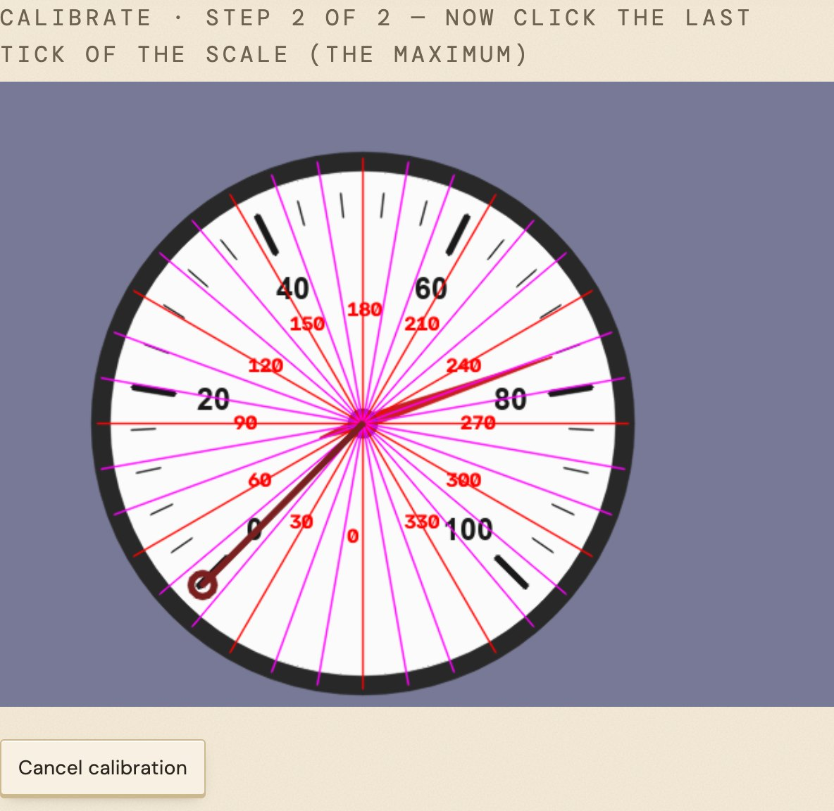
Step 2 of 2: the first click is marked in red; now click the last tick (100).

Automatic calibration (reading the printed numbers)
Switch the sidebar from Manual to Automatic (OCR) and the app tries to read the numbers printed on the dial, work out where each one sits, and build the scale from them. It even notices when the numbers are unevenly spaced (a "non-linear" scale, common on flow meters) and handles that too.
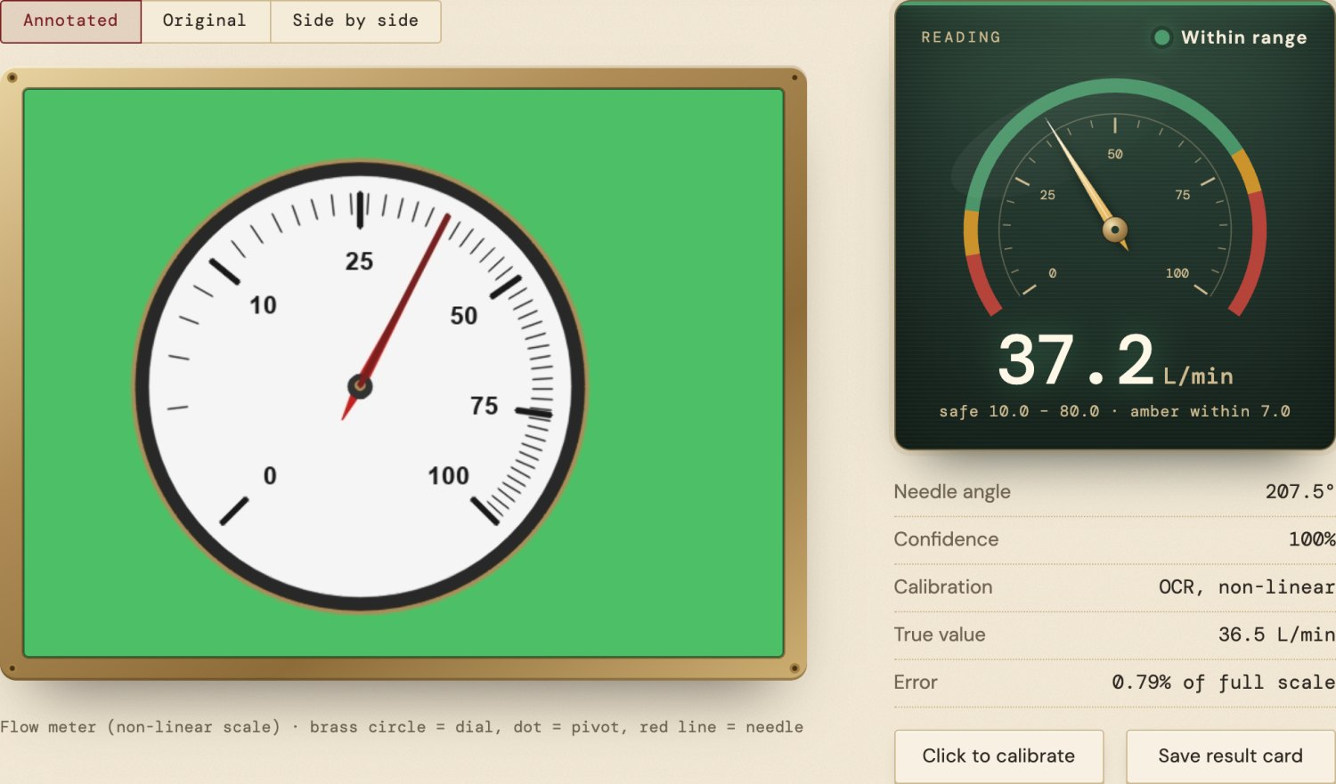
A flow meter with an uneven scale, read automatically: 37.2 L/min (true value 36.5).
BE REALISTIC ABOUT AUTOMATIC MODE
It works well on clean, clearly printed dials, but on real photos it often can't read enough numbers. In our tests it worked on 2 of 12 real photos. When it fails, the app says so and uses your manual settings instead.
It still needs Scale min/max filled in, as a check on the units: many gauges print two scales, e.g. psi and bar.

Saving a gauge
Open Saved gauges in the sidebar to keep a calibration. Save remembers it while the page is open. Download calibration saves it as a small file you can load again any time with Load a calibration file. That's the way to keep it between visits.
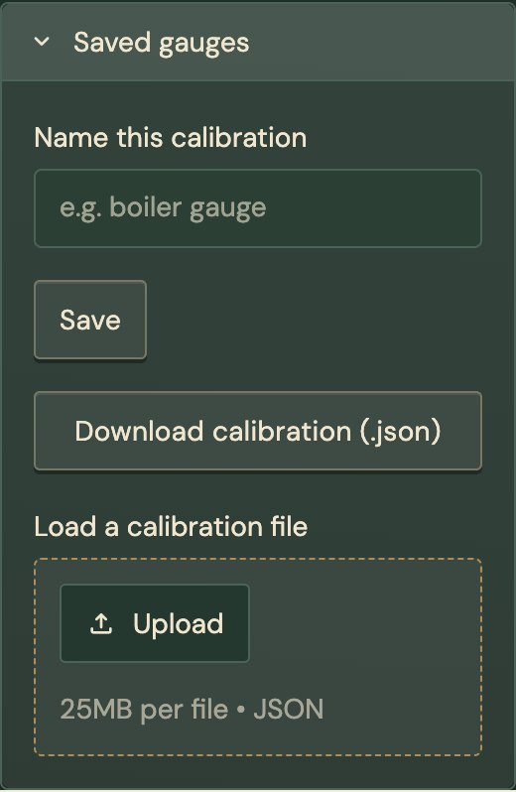

SECTION 4

Alarm limits
Under Alarm limits in the sidebar (the dark panel on the left) you decide what counts as safe. Changes show up straight away as the coloured zones on the readout's dial.
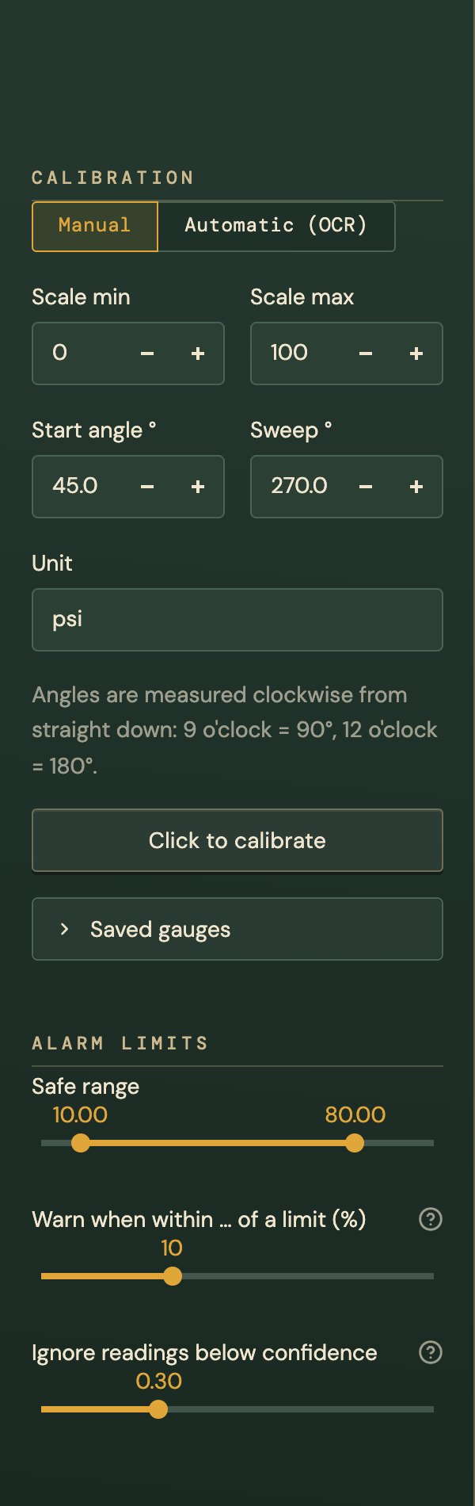 | Every time a reading moves into the red, it's recorded as an alert on the History page (once per event, not once per second).
  Safe range | Drag the two handles to the lowest and highest acceptable values. Outside them the lamp goes red.
  Warn when within … | How close to a limit counts as amber, as a percentage of the safe range. With a safe range of 10–80 and 10%, amber starts 7 units from either end.
  Ignore readings below confidence | Readings the app isn't sure about are still shown, but they won't turn the lamp red, won't be logged as alerts, and won't affect the live average. Raise it if you get false alarms.

SECTION 5

Extras

How it was read
Open How it was read under the picture to see the steps the app went through, as a strip of small pictures: the grey photo, the smoothed photo, the dial it found, the edges, the candidate lines (green ones kept), and the numbers it read if Automatic mode is on. Hover over one and press the expand icon to see it full size.
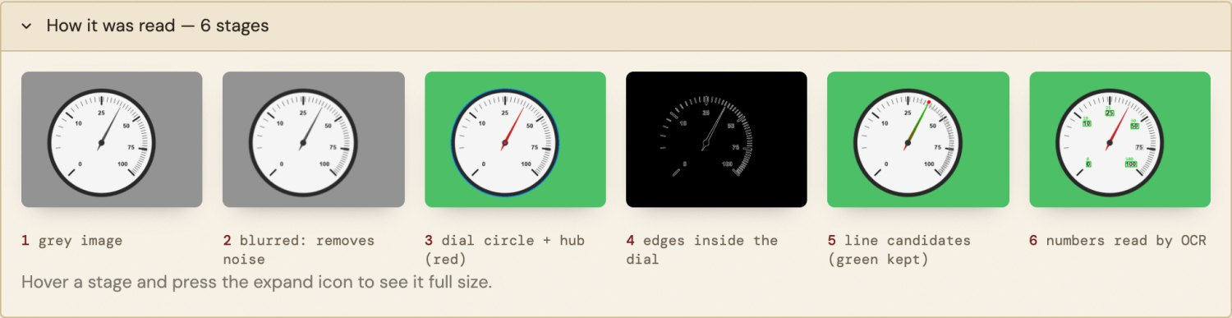
The six stages for the flow meter, from the plain grey photo to the numbers read by OCR.

Explain this reading
Open Explain this reading for the same story in words, with this gauge's actual numbers: where the dial was found, where the needle points, and the arithmetic that turns the angle into the reading.
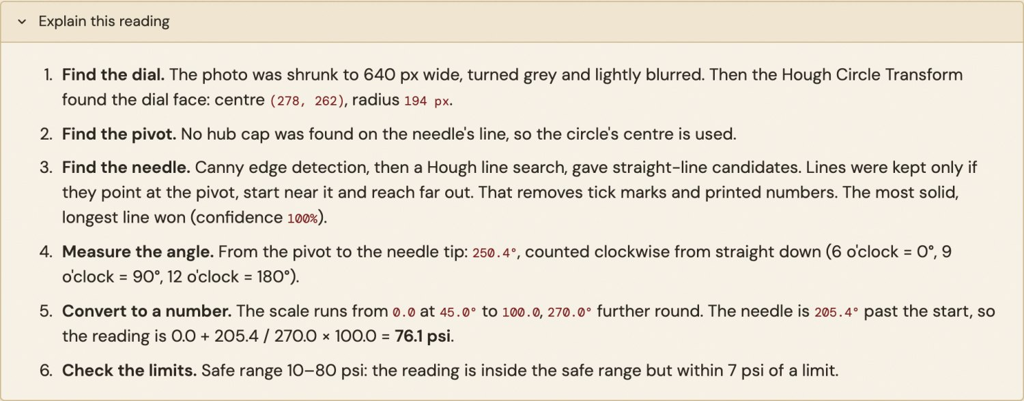

Save a result card
Save result card downloads a picture with the annotated gauge, the reading, its status, the time and the confidence. Handy for sending to someone or keeping as a record.
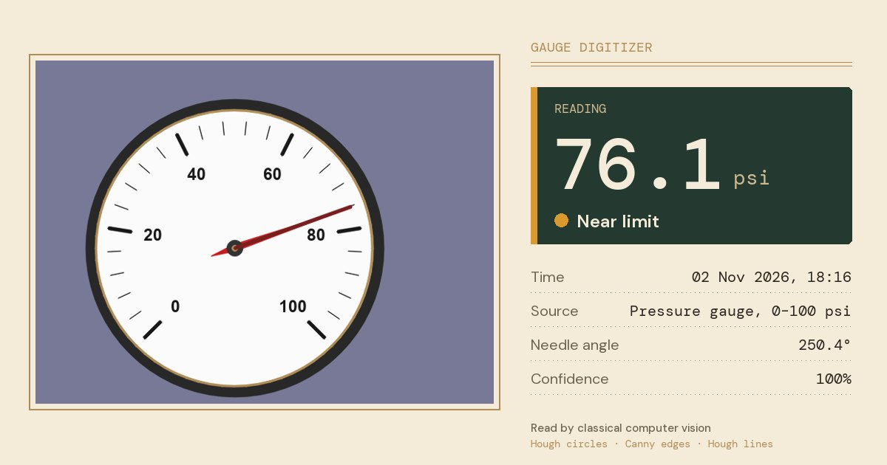

Batch: many photos at once
- Open the Batch tab.
- Set the calibration in the sidebar for the type of gauge in your photos. Every photo uses the same settings, so they should all be the same kind of gauge.
- Upload several photos at once, then press Read … photos.
- You get a table with a small annotated picture, the reading, the status and the confidence for each photo. Download results (.csv) saves it as a spreadsheet file.
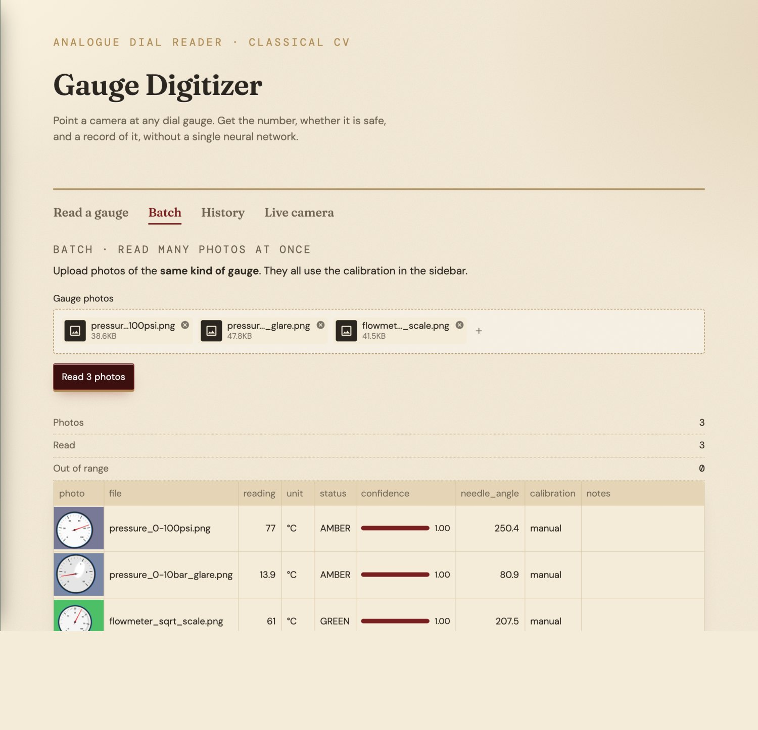

History and alerts
The History tab lists every reading you've taken since you opened the page: samples, uploads, camera, batch and live. The chart shows the readings in order, with the safe range shaded and each point coloured green, amber or red. Below it, Alerts lists each time a reading went out of range.
Download history (.csv) saves everything as a spreadsheet. History is private to your browser tab and is cleared when you close it, so download it if you want to keep it.
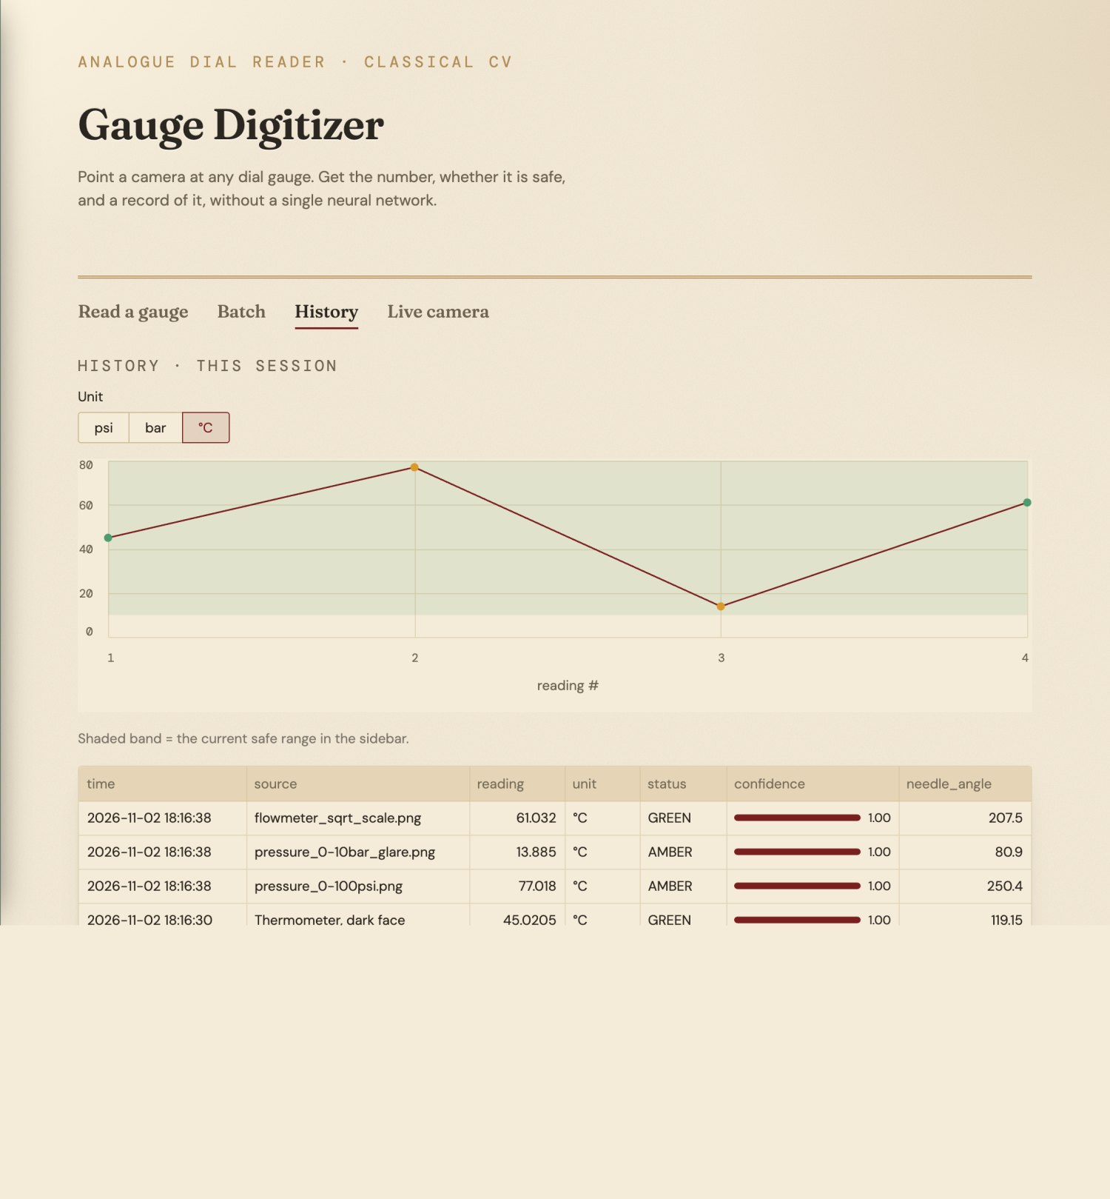

Live camera (on your own computer only)
When the app runs on your own laptop, a Live camera tab appears. Press Start and it reads the gauge continuously from the webcam, about 12 times a second. The number shown is the middle value of the last few readings, so one blurry frame doesn't make it jump. Camera 0 is the built-in webcam; try 1 for a second camera.
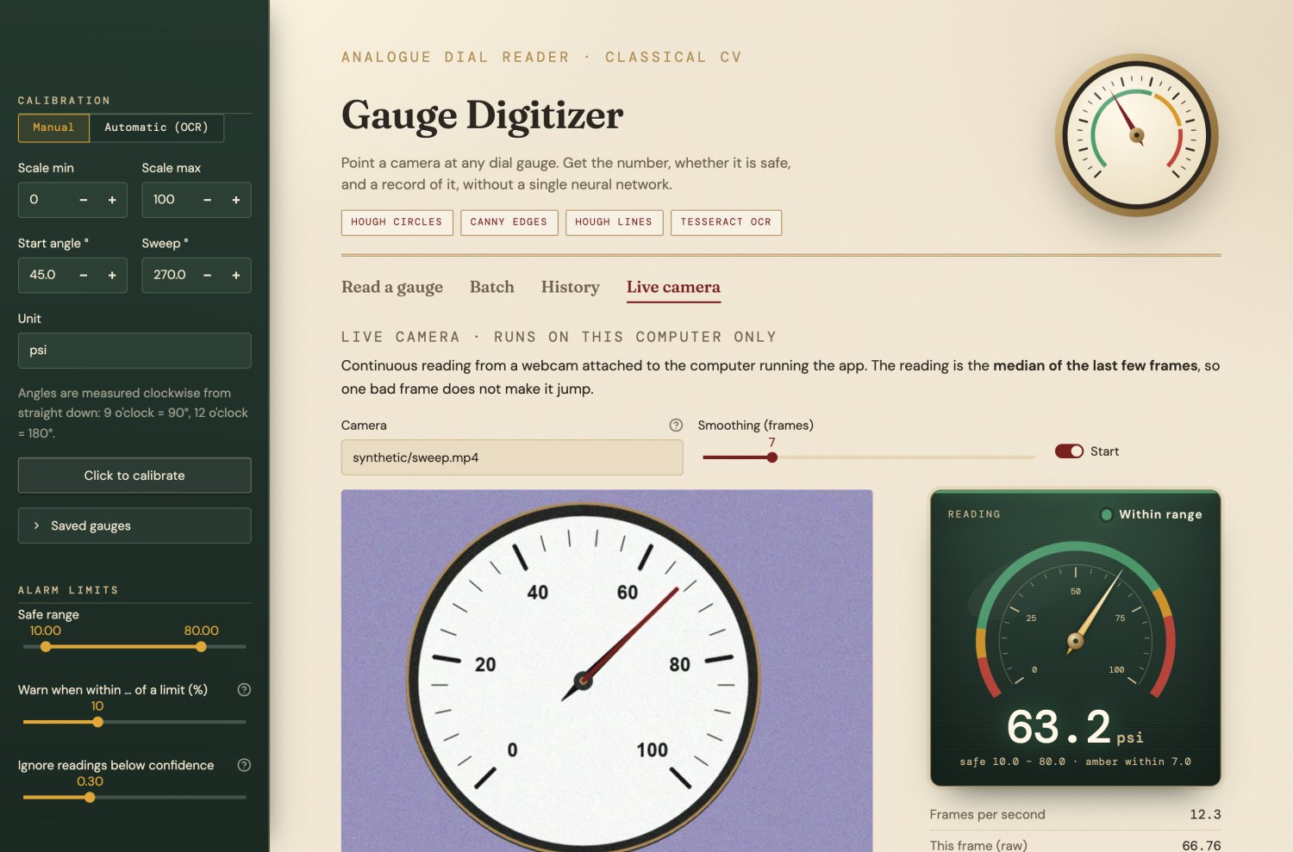

On a phone
The app works in a phone browser. The reading moves to the top, above the picture, and the settings live behind the » button in the top-left corner. Camera uses the phone's own camera.
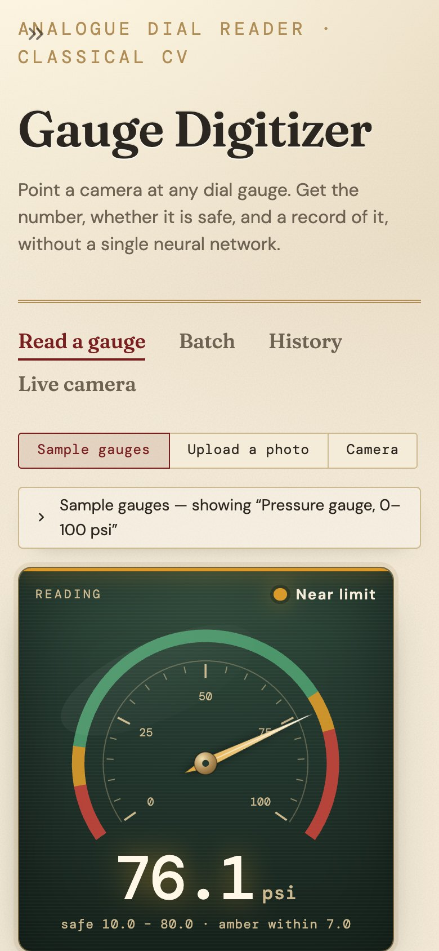
On a phone the reading sits above the picture.

SECTION 6

Tips, limits, and how it works

Tips for good readings
- Fill the frame. The gauge should take up most of the picture. Small gauges in big scenes are the most common cause of wrong readings.
- Look straight at it. Hold the camera directly in front of the dial, not from the side. A tilted view squashes the circle and shifts the angles.
- Avoid glare. Reflections on the glass can hide the needle. Move or tilt slightly until the shine is off the needle and numbers. If the light is uneven, try Even out lighting (CLAHE) under Computer-vision settings.
- Use good, soft light. Daylight or a room light behind you works best; avoid strong shadows across the dial.
- Keep it sharp. Let the camera focus before taking the photo. A little blur is fine; heavy blur isn't.
- Check the red line. On the annotated picture the red line should lie along the needle. If it doesn't, the reading is wrong, whatever the number says.
- Watch the confidence. A grey Low confidence lamp means something in the picture competed with the needle. Retake the photo closer and straighter.
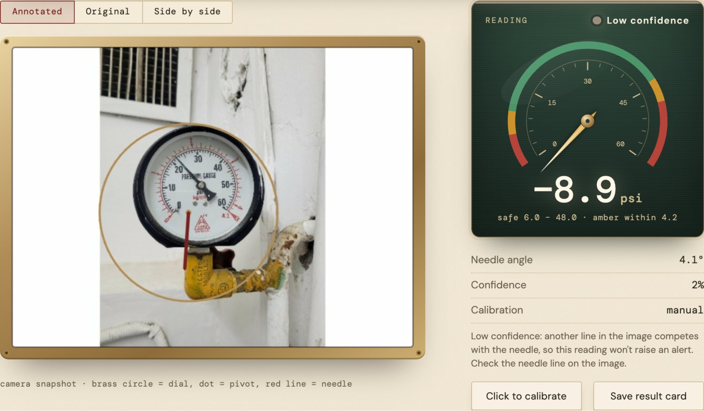
What not to do: the gauge is too small in the frame, so the app locked onto the wrong circle and the red line isn't on the needle. Confidence 2%, so no alarm was raised.

Known limitations
- Gauge shape. It assumes a round dial with one straight needle turning about the centre, and numbers that increase clockwise. Square dials, several needles or anticlockwise scales won't work.
- Accuracy on real photos. On computer-drawn test gauges the error is typically about 0.1–0.2% of the scale. On 12 real photos it averaged about 1.6% and was never worse than 3.4%. That's a small test, labelled by eye, so treat it as a guide rather than a guarantee.
- Automatic calibration is unreliable on real gauges (2 of 12 real photos). Use manual calibration with the angle grid or click-to-calibrate.
- Strong glare, heavy blur, or a needle hidden behind a reflection can lead to no reading or a wrong one.
- It's a demonstration tool, not safety equipment. Don't rely on it for anything where a wrong reading could cause harm.
- Online version: no live video (snapshots only), and history and saved gauges disappear when you close the page unless you download them.

How it works, in everyday words
There's no artificial intelligence or training involved. The app follows four simple steps, the way a careful person would:
- Find the dial. The photo is turned grey and slightly smoothed, then the app looks for the biggest circle in it. That's the gauge face. A second, small circle search finds the cap the needle turns on.
- Find the needle. The app picks out sharp light-to-dark edges, then looks for straight lines among them. It keeps only lines that start at the centre cap and reach far out along something solid. That rules out tick marks and printed numbers. The best one is the needle.
- Measure the angle. From the centre cap to the needle tip, it measures the angle with simple trigonometry, like reading a clock.
- Convert to a number. Using the scale you gave it (or the numbers it read off the dial), it works out what that angle means. For example, a quarter of the way round a 0–100 scale is 25.

CREDITS
Sample photos: Wikimedia Commons contributors, under Creative Commons licences. Full list in samples/SOURCES.md.
Fonts in the app: Fraunces, DM Sans and DM Mono (SIL Open Font Licence). Built with OpenCV, Tesseract and Streamlit.

